A Practical Guide to ‘Free Energy’ Devices

Devices Part 17: Last updated: 23rd August 2009 Author: Patrick J. Kelly

Dealing with the Vehicle Computer

When an mpg. improving device such as an electrolyser is fitted to a vehicle, the result does not always produce better mpg. figures. Older vehicles which are fitted with a carburettor will see an immediate improvement. This is not the case for more recent vehicles which come with computer control of the fuel sent to the engine.

When an electrolyzer is attached to the engine, it causes the fuel burn inside the cylinders to be greatly improved, with a corresponding improvement in engine performance. Unfortunately, the fuel computer is expecting the same amount of unburnt oxygen to come out of the engine, and when it doesn’t detect it, the computer increases the fuel flow rate in an attempt to get back to it’s normal, inefficient method of running. That action cancels the mpg improvement produced by the electrolyzer unless something is done to adjust the operation of the computer.

In the most simple terms, most vehicles which have an Electronic Control Unit (“ECU”) to control the fuel flow are fitted with one of two types of exhaust sensor. The majority have a “narrowband” sensor while the remainder have a “wideband” sensor. The ideal mix of air to fuel is considered to be 14.7 to 1. A narrowband sensor only responds to mixtures from about 14.2 to 1 through 14.9 to 1. The sensor operates by comparing the amount of oxygen in the exhaust gas to the amount of oxygen in the air outside the vehicle and it generates an output voltage which moves rapidly between 0.2 volts where the mixture is too lean, and 0.8 volts when it passes below the 14.7 to 1 air/fuel mix point where the mixture is too rich (as indicated by the graph shown below). The ECU increases the fuel feed when the signal level is 0.2 volts and decreases it when the signal voltage is 0.8 volts. This causes the signal voltage to switch regularly from high to low and back to high again as the computer attempts to match the amount of “too lean” time to the amount of “too rich” time.

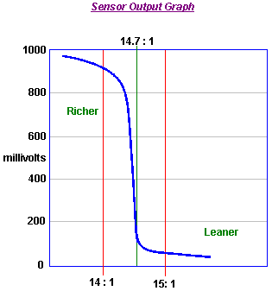

A simple control circuit board can be added to alter the sensor signal and nudge the fuel computer into producing slightly better air/fuel mixes. Unfortunately, there is a severe downside to doing this. If, for any reason, the fuel mix is set too high for an extended period, then the excess fuel being burnt in the catalytic converter can raise the temperature there high enough to melt the internal components of the converter. On the other hand, if the circuit board is switched to a mix which is too lean, then the engine temperature can be pushed high enough to damage the valves, which is an expensive mistake.

Over-lean running can occur at different speeds and loads. Joe Hanson recommends that if any device for making the mix leaner is fitted to the vehicle, then the following procedure should be carried out. Buy a “type K” thermocouple with a 3-inch stainless steel threaded shank, custom built by ThermX Southwest of San Diego. This temperature sensor can measure temperatures up to 1,800 degrees Fahrenheit (980 degrees Centigrade). Mount the thermocouple on the exhaust pipe by drilling and tapping the pipe close to the exhaust manifold, just next to the flange gasket. Take a cable from the thermocouple into the driver’s area and use a multimeter to show the temperature.

Drive the vehicle long enough to reach normal running temperature and then drive at full speed on a highway. Note the temperature reading at this speed. When a leaner mix is used, make sure that the temperature reading under exactly the same conditions does not exceed 180 degrees Fahrenheit (100 degrees Centigrade) above the pre-modification temperature.

David Andruczyk recommends an alternative method of avoiding engine damage through over-lean fuel/air mixtures, namely, replacing the narrowband oxygen sensor with a wideband sensor and controller. A wideband oxygen sensor reads a very wide range of Air/Fuel ratios, from about 9 to 1 through 28 to 1. A normal car engine can run from about 10 to 1 (very rich) to about 17.5 to 1 (pretty lean). Maximum engine power is developed at a mix ratio of about 12.5 to 1. Complete fuel combustion takes place with a mix of about 14.7 to 1, while the mix which gives minimum exhaust emissions is slightly leaner than that.

Unlike narrowband sensors, wideband sensors need their own controller in order to function. There are many of these units being offered for sale for retro-fitting to existing vehicles which have just narrowband oxygen sensor systems. David’s personal recommendation is the Innovate Motorsports LC-1 which is small, and uses the very reasonably priced LSU-4 sensor. This wideband controller can be programmed. Most controllers have the ability to output two signals, the wideband signal suitable for running to a gauge or new ECU, plus a synthesised narrowband signal which can feed an existing ECU. The trick is to install a wideband sensor, with the LC-1 controller and then reprogram it to shift the narrowband output to achieve a leaner mix as shown here:

Actual Air/Fuel Mix | Wideband Output | Original Narrowband Output | Shifted Narrowband Output
9 to 1 | 9 to 1 | Mix is too Rich | Mix is too Rich
10 to 1 | 10 to 1 | Mix is too Rich | Mix is too Rich
11 to 1 | 11 to 1 | Mix is too Rich | Mix is too Rich
12 to 1 | 12 to 1 | Mix is too Rich | Mix is too Rich
13 to 1 | 13 to 1 | Mix is too Rich | Mix is too Rich
14 to 1 | 14 to 1 | Mix is too Rich | Mix is too Rich
14.6 to 1 | 14.6 to 1 | Mix is too Rich | Mix is too Rich
14.8 to 1 | 14.8 to 1 | Mix is too Lean | Mix is too Rich
15 to 1 | 15 to 1 | Mix is too Lean | Mix is too Rich
15.5 to 1 | 15.5 to 1 | Mix is too Lean | Mix is too Lean
16 to 1 | 16 to 1 | Mix is too Lean | Mix is too Lean
18 to 1 | 18 to 1 | Mix is too Lean | Mix is too Lean

This system allows you to set the narrowband “toggle point” very precisely on an exact chosen air/fuel ratio. This is something which it is nearly impossible to do accurately with a circuit board which just shifts a narrowband oxygen signal as you just do not know what the air/fuel ratio really is with a narrowband sensor.

However, for anyone who wants to try adding a circuit board to alter a narrowband sensor signal to produce a leaner mix on a vehicle, the following description may be of help. It is possible to buy a ready-made circuit board, although using a completely different operating technique, from the very reputable Eagle Research, via their website: http://www.eagle-research.com/products/pfuels.html where the relevant item is shown like this:



This unit generates a small voltage, using a 555 timer chip as an oscillator, rectifying the output to give a small adjustable voltage which is then added to whatever voltage is being generated by the oxygen sensor. This voltage is adjusted at installation time and is then left permanently at that setting. Eagle Research also offer for sale, a booklet which shows you how to build this unit from scratch if you would prefer to do that.

I understand that at the present time, the purchase price of this device is approximately US $50, but that needs to be checked if you decide to buy one. Alternatively, instructions for building a suitable equivalent circuit board are provided later on in this document.

If you wish to use a circuit board with a narrowband oxygen sensor, then please be aware that there are several versions of this type of sensor. The version is indicated by the number of connecting wires:

Those with 1 wire, where the wire carries the signal and the case is ground (zero volts)
Those with 2 wires, where one wire carries the signal and the other wire is ground.
Those with 3 wires, where 2 (typically slightly thicker) wires are for a sensor heater, and
1 for the signal while the case is ground.
Those with 4 wires (the most common on current model cars), where there are
2 (slightly heavier) for the sensor heater,
1 for the signal , and
1 for the signal ground.
(Sensors with 5 wires are normally wideband devices.)

Look in the engine compartment and locate the oxygen sensor. If you have difficulty in finding it, get a copy of the Clymer or Haynes Maintenance Manual for your vehicle as that will show you the position. We need to identify the sensor wire which carries the control signal to the fuel control computer. To do this, make sure that the car is switched off, then

For 3 and 4 wire sensors:
Disconnect the oxygen sensor wiring harness,
Set a multimeter to a DC voltage measurement range of at least 15 volts,
Turn on the ignition and probe the socket looking for the two wires that provide 12 volts.
These are the heater wires, so make a note of which they are,
Shut the ignition off, and reconnect the oxygen sensor.

The two remaining wires can now be treated the same as the wires from a 2-wire sensor, one will carry the sensor signal and one will be the signal ground (for a single wire sensor, the signal ground will be the engine block). Jesper Ingerslev points out that the Ford Mustang built since 1996 has 2 oxygen sensors per catalytic converter, one before the converter and one after. Some other vehicles also have this arrangement. With a vehicle of this type, the circuit board described here should be attached to the sensor closest to the engine.

Find a convenient place along the wires. Don’t cut these wires, you will cut the sensor wire here at a later time, but not now. Instead, strip back a small amount of the insulation on each wire. Be careful to avoid the wires short-circuiting to each other or to the body of the vehicle. Connect the DC voltmeter to the wires (the non- heater wires). Start the engine and watch the meter readings. When the engine is warmed up, if the oxygen sensor is performing as it should (i.e. no engine check lights on), the voltage on the meter should begin toggling between a low value near zero volts and a high value of about 1 volt. If the meter reading is going negative, then reverse the leads. The black multimeter lead is connected to the signal 'ground' (zero volts) and the red lead will be connected to the wire which carries the signal from the sensor. Connect a piece of insulated wire to the stripped point of the sensor wire and take the wire to the input of your mixture controller circuit board. Connect a second insulated wire between the signal ‘ground’ wire, or in the case of a 1-wire sensor, the engine block, and the circuit board zero-volts line. Insulate all of the stripped cables to prevent any possibility of a short-circuit:

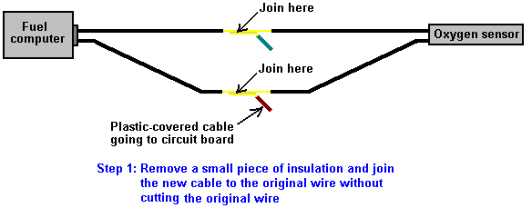

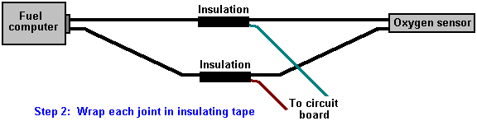

More specific detail
However, the situation is by no means a simple one which allows a single simple adaption which will work on every vehicle for many years. Les Pearson has been investigating this situation in depth for three years along with a friend who is an Electronics Engineer. Having built and tested EFIEs, the oxygen sensor circuit shown below, several versions of MAP controllers, coolant/air temperature hacks, professional systems, etc. and discovered that many vehicle ECUs ("Electronic Control Units") learnt to adapt to the new conditions and return to the highly inefficient excess fuel injection condition. This return to the original fuel injection is different for each design of ECU and there are many different designs.

Les says: "To understand the solution, first you have to understand the dilemma with all the other ECU control tricks. The EFIEs, MAP adjusters, temp hacks etc. do get good results for a short time, and then the performance deteriorates again. Why should this be? It is because the ECU learns to deal with the new situation with them in place. This is because the ECU knows that the feedback from most of it's controls, and sensor's are not linear, nor should they be. All of the electronics, and adjustment methods used by the Hydrogen On Demand people are linear, and that is not an adequate way to deal with the problem.

For example, we may add a couple of hundred millivolts to the oxygen ("lambda") sensor signal in order to return an unduly rich signal to the ECU, and so make it respond with a lower level of fuel injection. This makes the ECU think that the Air/Fuel Ratio is say, 15:1 or 20:1. Now the mass air maps are all wrong, we need to show less air so that the ECU adds less fuel in order to match the fuel trims. We now need to adjust the ignition timing to take advantage of this combustion change. The problem is that all the EFIEs, MAP/MAF adjusters, and attempts at changing timing by manipulating air temp are a static fixed offset, producing just a single change.

An Air/Fuel Ratio of 20:1 is not appropriate under moderate or heavy acceleration when you don't, and usually can't, add enough hydroxy gas to allow for these conditions. A set 15% to 20% leaner setting across the entire fuel map is not appropriate at all loads, and engine speeds. Adding 50 to 75 degrees F to the air temp is not appropriate when the outside air is already at 110 degrees F. The ECU knows this and makes appropriate changes to it's long-term settings, and so it cancels out the changes which our electronic additions have made.

While it may be OK for an experimenter, and mechanic with all the tools at his disposal to play with these techniques, and retune his engines every week or so in order to get great mileage, it is not realistic to expect the average person to do this. The cost in equipment alone, would undermine any fuel savings. Also, most people don't even change their oil at appropriate intervals.

This was my train of thought as I pondered a solution, and began searching. My search was for a control solution which could firstly, alter the air-flow readings, lambda readings, and ignition timing and secondly, respond to changes in engine speed and engine load. To my surprise I found several products already on the market which are capable of doing this, and which have been available for quite some time. People in the engine-tuning industry have been using them for years. They are custom programmable, piggy-back chips. Several companies make them, and while most do not advertise O2 ("lambda") sensor control, many are quite capable of altering it.

We became a distributor for one brand which seemed to be the best fit for our purposes, and we began testing. The results are perfect. We started with an 2002 Saturn SL. The average mpg for this car started at 26 mpg (highway and city combined). We installed the chip, tested several tuning methods, and found the one which worked best. The car now averages 44-46 mpg. This is not special 'grandma driving' to try, and coax a few extra miles per gallon. This is a courier vehicle for a local printer, and it is driven daily like it was stolen. We have all the same benefits of increased torque (pulling power), better throttle response, etc. The car has been driven around for three months now with our programmed chip installed, and it achieves the mid-40s in mpg all of the time. there are no code changes needed, no start-up problems, no driving problems of any kind whatsoever. If you weren't told, you would never know that hydroxy gas was being added, except for the fact that you can go over 500 miles on a single tank of fuel.

The only problem is that this is definitely not a do-it-yourself solution. You need a laptop computer with proprietary software to tune the chip, and the scanning, and diagnostic equipment to know when you have it tuned correctly. However, I have thought of a do-it-yourself solution. It still requires you to buy a few electronic kits, and you need a lot of know-how, but we are circumventing a highly sophisticated control architecture, so anyone who thinks it will be easy, is delusional. The main item is a Digital Fuel Adjuster or "DFA" kit from JayCar electronics based in Australia. Their website is http://www.jaycar.com. The adjuster kit number is KC5385, and you have to have the hand controller to program it, that kit number is KC5386. At the present time, the Adjuster kit costs USD $49.50, and the controller kit is USD $39.50. The adjuster doesn't have an enclosure supplied, but the controller does. You need one controller and two adjusters. The controller can be reused to program multiple adjusters. Once you have the kits, it will take several days of soldering to build them, and it is definitely not a beginner's first-time project.

After the two adjusters and the controller have been built, the first one is wired in to the MAP/MAF sensor signal as shown in the instructions guide. Next the second DFA is used on the oxygen sensor signal. If there are two oxygen sensors, then the DFA is wired through the common ground for the upstream sensors ONLY. This places the voltage offsets in tandem, which makes it unnecessary to use two DFAs (or EFIEs for that matter) for "lambda" control. Now control has been established over fuel maps, and a "lambda" control which is responsive to engine load has been achieved. I believe that these kits also come with an option to make them responsive to rpm.

For ignition timing, the temperature offsets will probably still be necessary, but now you have a fuel control which if tuned properly, the ECU will not learn its way around. I have found that the maps for "lambda" control are very simple. Tune for the leanest Air/Fuel Ratio appropriate at very low loads, and richen up a bit in increments as the load increases. As you get close to full throttle, but before you switch to open-loop operation, your lambda offset should be zero (the stock setting). To tune the air-flow or fuel maps, watch the OBD II scan gauge, and decrease the MAP signal so that your short term fuel trim ("STFT" on a scanner) is no greater than about ± 7% at each load interval. Drive for about 20 minutes, and check that your long term fuel trim ("LTFT") never goes beyond the "7s" either. Now the ECU cannot "see" your changes because the fuel map, and lambda readings "agree" at every load range.

The Jaycar kits are not as sophisticated as the chip sets, but they are about 20% of the cost, if you want to put the time and effort into them. The adjuster itself simply adds to, or subtracts from, whatever voltage runs across them, and it can be set to change that offset value in correspondence to whatever voltage value is present at the signal input pin. You would of course put your TPS signal to the signal input pin. The device itself is very versatile, and could be used for many different applications. If you wanted to use one to control a Pulse-Width Modulator attached to a cell, then that would be possible and it would provide a variable gas rate that responds to changes in engine load. I hope you can put this to good use, and feel free to spread the word around. Perhaps you know someone who could build a similar device or give us a schematic to build one, after looking at a JayCar kit. The only drawback to the kits is that rpm sampling gets a little complex, and while I don't think it is absolutely necessary, it would be beneficial. Although the kits have only 125 data points between the "closed", and "fully open" throttle settings, and do not interpolate between data points, they seem to work very well. The professional chip sets have 96,000 data points between CT ("Closed Throttle"), and WOT ("Wide-Open Throttle"), and they do logically interpolate between set data points. The professional chip sets run about $650 USD programmed, and installed.

I plan to market a pre-programmed chip capable of making any hydroxy system work. While I plan to have a profitable venture with the professional pre-programmed architecture, I also believe in the open source do-it-yourself community, which is where I got started. The chips I plan to sell will be a 'plug and play' device. You send me the info on the type of vehicle you are modifying, and the efficiency data of your cell, and I'll be able to send you a chip that will make your ECU work with those conditions. The Do-it-yourself version would be quite time consuming but, would work for less than one quarter of the price.

I think that the "more is better" hydroxy gas idea that a lot of people are stuck in, is seriously flawed. There is definitely a point of diminishing returns. I tune most systems to deliver about 1 lpm. The lower the amperage you can do this at, of course the better. I have found that not only does it take more amperage to produce higher volumes at a less effective rate of return, but it does not add much to the efficiency of the "boosting". With the cells which I build I get 1 lpm of hydroxy gas at about 8 to 10 amps. I'm using direct DC with a 5-cell, 6 plate array, similar to a "Smack's Booster", but with better plate isolation in the bath. We've spent thousands developing fancier, and slightly more efficient cells. We've used PWMs to get better production, and be able to attenuate gas production with duty cycle. We had a really, really advanced system. Then I applied Occam's razor to it. We can make enough gas to support ultra-lean combustion above fairly low load conditions - so what good is it to be able to decrease when you barely make enough already? The PWM does help, and is relatively inexpensive so we kept that component if the customer wants, but we don't change the duty cycle.

The 6 plate "Smacks" style cell works fine. It is small, easy to build, and is efficient enough for the production we need. Engine control was the biggest issue. I can get great mileage with just a little hydroxy gas, if I can control what fuel table the ECU looks at every load range, and rpm. The problem with EFIEs, and MAP/MAF adjusters is that they tell the computer to look at inappropriate fuel tables at higher load ranges. The ECU picks up on that, adjusts it's long-term fuel trims, and goes back to an unmodified state. If I can make the ECU look at very lean tables at cruise, and then more or less unmodified tables at higher loads it never "sees" the trick. Since we only make enough hydroxy gas to affect low loads anyway, that is all I need to be concerned with. You could think of it as an ultra-lean cruise mode: when you aren't at low cruise you aren't changing anything. When you are cruising you are running at a very lean Air-Fuel Ratio. So far, it works great.

The super fancy system that used a PWM with a duty-cycle controlled by our chip, and made up to 3 lpm at 20amps would have cost over USD $2500 just for the parts, and equipment to cover production cost, and turn a profit, and it only gained us about 10% efficiency. The system we are working on now should be less than USD $1500 as a 'turn-key' system. Our little Saturn just came back at 88mpg on a carefully driven run with this system. It typically gets high 40s to mid 50s in mpg under normal driving conditions.

I have tried adding just 0.6 lpm or so, and letting the ECU trim out to compensate. This has given me mixed results. Sometimes I can get 25% to 30% reduction in consumption, and sometimes it makes no difference at all. It has a lot to do with the ECU's programming, and the driver's habits. I don't really know why it doesn't work all the time theoretically it should. The hydroxy gas makes the petrol more volatile so you should be getting more energy per gram of fuel. That should correlate to higher exhaust gas temperatures, and the ECU should see that and take away some fuel, but sometimes it does just the opposite. The ECU sees a lean condition due to increased Exhaust Gas Temperature at the manifold, and lower temperature at the catalytic converter, and so it richens up the air-fuel mix.

Another possible option that I have not explored would be an EFIE designed to change it's output to a set voltage controlled by the vehicle's throttle position sensor. The challenge here is that it is not a linear change. The steps between load sites would not be equal. They would need to be able to be manually set for what the application needed. The DFAs allow you to do this, and can add voltage just like an EFIE. You can use one DFA for MAP/MAF control, and one for oxygen sensor control. So even with a modified EFIE you would need a DFA or something similar to provide non-linear MAP/MAF control". You can contact Les at lespearson@hotmail.com.

Construction
If you wish to build an oxygen sensor controller circuit, then here is a suggestion as to how you might do it. This description assumes very little knowledge on the part of the reader, so I offer my apologies to those of you who are already expert in these matters. There are many different ways to design and construct any electronic circuit and each electronics expert will have his own preferred way. In my opinion, the way shown here is the easiest for a newcomer to understand and build with the minimum of tools and materials.

The circuit shown here, is taken from the website http://better-mileage.com/memberadx.html, and is discussed here in greater detail. This circuit can be constructed on a printed circuit board or it can be built on a simple single-sided stripboard as shown here:

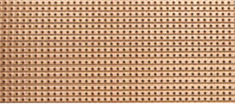
Stripboard (often called “Veroboard”), has copper strips attached to one side of the board. The copper strips can be broken where it is convenient for building the circuit. Component leads are cut to length, cleaned, inserted from the side of the board which does not have the copper strips, and the leads attached to the copper strips using a solder joint. Soldering is not a difficult skill to learn and the method is described later in this document.

When all of the components have been attached to the stripboard and the circuit tested, then the board is mounted in a small plastic case as shown here:

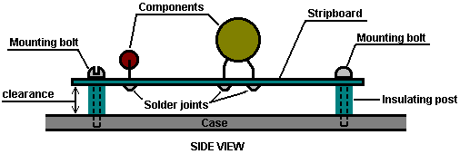

Insulating posts can be made from a short pieces of plastic rod with a hole drilled through its length. The mounting bolt can self-tap into a hole drilled in the case, if the hole is slightly smaller than the diameter of the bolt threads. Alternatively, the holes can be drilled slightly larger and the bolt heads located outside the case with nuts used to hold the board in place. This style of mounting holds the circuit board securely in place and gives some clearance between the board and the case.

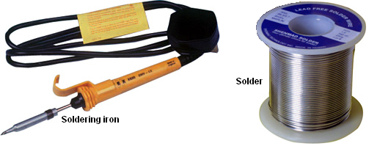

You will need building equipment, namely, a soldering iron, a 12 volt power supply such as a battery pack and an accurate digital volt meter for this project. If the 12 volt supply is a main-powered unit, then it needs to be a well-filtered, voltage-stabilised unit. Lastly, you will need a variable voltage source that can go from 0 to 1 volt to imitate the output from the vehicle’s oxygen sensor when testing the completed circuit board. This is simple enough to make, using a resistor and a variable resistor.

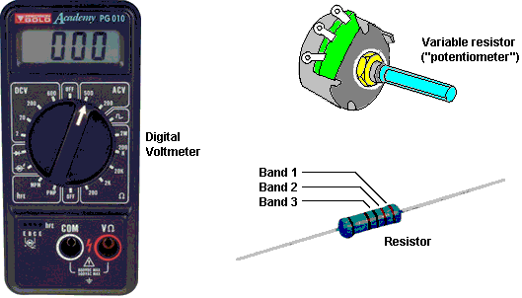

A series of components will be needed for the circuit itself. These can be bought from a number of different suppliers and the ordering details are shown later in this document. Shown above is a resistor. The value of the resistor is indicated by a set of three colour bands at one end of the body. The reason for doing this rather than just writing the value on the resistor, is that when the resistor is soldered in place, its value can be read from any angle and from any side. The component list shows the colour bands for each of the resistors used in this circuit. If you want more information on basic electronics, then read the Electronics Tutorial which can be found at http://www.free-energy-info.co.uk /Chapter12.pdf

Other components which you will be using, look like this:

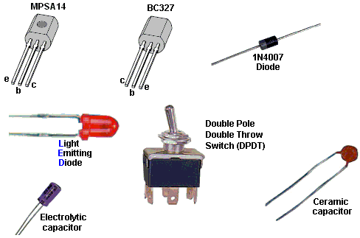

The MPSA14 and the BC327 devices are transistors. They each have a “Collector”, a “Base” and an “Emitter” wire coming out of them. Please notice that the two packages are not identical, and take care that the right wire is placed in the correct hole in the stripboard before soldering it in place.

The 1N4007 diode has a ring marked at one end of the body. The ring indicates the flat bar across the symbol as shown on the circuit diagram, and in that way it identifies which way round the diode is placed on the stripboard.

The Light-Emitting Diode (the “LED”) will be familiar to most people as it is used so extensively in equipment of all types.

The toggle switch has six contacts - three on each side. The centre contact is connected to one of the two outer contacts on its side, which one, depends on the position of the switch lever.

The two capacitors (which are called “condensers” in very old literature) look quite different from each other. The electrolytic capacitor has it’s + wire marked on the body of the capacitor, while the ceramic has such a small value that it does not matter which way round it is connected.

The main component of the circuit, is an integrated circuit or “chip”. This is a tiny package containing a whole electronic circuit inside it (resistors, capacitors, diodes, whatever, ....). Integrated circuit chips generally look like this:

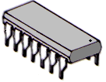

A very common version of this package has two rows of seven pins each and it goes by the grandiose name of “Dual In Line” which just means that there are two rows of pins, each row having the pins in a straight line. In our particular circuit, the chip has eighteen pins, in two rows of nine.

Now to the circuit itself. If you find it hard to follow, then take a look at the electronics tutorial on the web site as it shows the circuit diagram symbol for each component and explains how each device works.

The circuit contains three capacitors, eight resistors, two diodes, one LED, one IC chip, two transistors, one toggle switch and two types of component not yet described, namely: two preset resistors and one rotary switch.

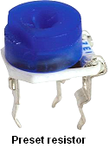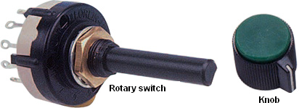

The preset resistor is very small and is adjusted using a flat bladed screwdriver. It is used for making an adjustable setting which is then left unchanged for a long time. The Rotary switch has a central contact which is connected to a row of outer contacts in turn when the shaft is rotated from position to position. The switch shaft is made of plastic and so can easily be cut to the length needed to make a neat installation, and the knob is locked in place by tightening its grub screw against the flat face of the shaft, although some knobs are designed just to push tightly on to the shaft. There is a wide range of knob styles which can be used with this switch, so the choice of knob is dictated by personal taste.

This is the circuit diagram:

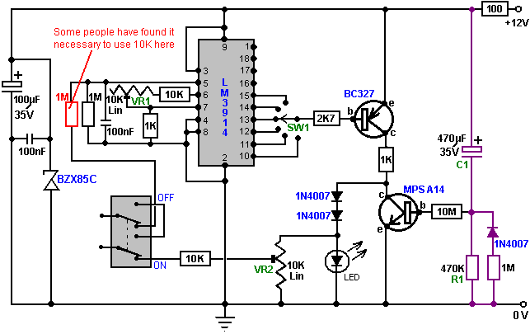

Electronic circuits are normally “read” from left to right, so we will look at this circuit that way. The first components are the 100 microfarad, 35 volt electrolytic capacitor with the tiny 100 nF capacitor across it. These are put there to help iron out any variations in the voltage supply. The BZX85C zener diode is a 24-volt type and it protects the integrated circuit from voltage spikes coming along the +12-volt line from other equipment in the vehicle, preventing the circuit from being fed more than 24 volts for even a fraction of a second as that would damage the integrated circuit.

The next item is the On/Off dashboard switch. When switched to its Off position as shown here:

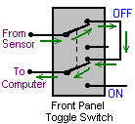

the connection from the oxygen sensor is passed straight through to the vehicle’s fuel computer, bypassing the circuit board completely. This switch allows the whole circuit to be switched Off should you want to do this for any reason.

In it’s On position, as shown in the circuit diagram, the varying voltage signal coming from the oxygen sensor is passed into the circuit, and the output voltage from the circuit is passed back to the fuel computer, instead of the original sensor voltage. This allows the circuit to manipulate the voltage sent to the fuel computer.

The next set of components (four resistors, one ceramic capacitor and one preset resistor) shown here:

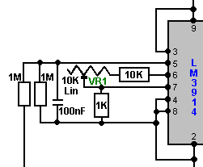

are needed to feed the incoming sensor voltage to the Integrated Circuit chip, and make the chip operate in the way that we want, (the chip manufacturer allows more than one way for the chip to work). You can just ignore these components for now, just understand why they are there.

The Integrated Circuit chip has ten outputs, coming out through Pins 1 and 10 through 18 inclusive:

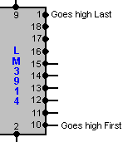

If the input voltage coming from the oxygen sensor is low, then all of these ten outputs will have low voltages on them. When the input voltage rises a little, the voltage on Pin 10 suddenly rises to a high value, while the other output pins still have low voltages.

If the input voltage rises a little higher, then suddenly the voltage on Pin 11 rises to a high value. At this point, both Pin 10 and Pin 11 have high voltage on them and the other eight output pins remain at low voltage.

If the input voltage rises a little higher again, then suddenly the voltage on Pin 12 rises to a high value. At this point, Pin 10, Pin 11 and Pin 12 all have high voltage on them and the other seven output pins remain at low voltage.

The same thing happens to each of the ten output pins, with the voltage on Pin 1 being the last to get a high voltage on it. The circuit is arranged so that Pin 10 provides the output signal for the richest air/fuel mixture for the vehicle, and the mix gets progressively leaner as the output on Pins 11, 12, ... etc. are selected to be fed to the fuel computer.

As there is the possibility of engine damage if the fuel mix is too lean, only six of the outputs are taken on into the circuit. However, if the engine is being fed hydroxy gas from an electrolyzer to improve both the miles per gallon performance and reduce emissions to zero, then it is likely that the engine will run cooler than before and engine damage is most unlikely to occur. It is quite safe to leave the remaining output pins of the Integrated Circuit chip unconnected. However, if this unit is to be used with the Nitrogen Hydroxide cell described in the D18.pdf document, then it is quite safe to connect Pins 16, 17, 18 and 1 and set the rotary switch to ten positions.

The output pin to be used by the remainder of the circuit is selected by the rotary switch mounted on the dashboard:

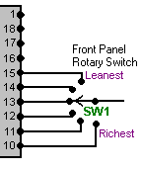

A standard single-pole rotary wafer switch has twelve positions but the switch operation can be restricted to any lesser number of positions by placing the end-stop lug of the switch just after the last switch position required. This lug comes as standard, fits around the switch shaft like a washer, and is held in place when the locking nut is tightened on the shaft to hold the switch in place. The lug projects down into the switch mechanism and forms an end-stop to prevent the switch shaft being turned any further. With six switch positions, the circuit provides five levels of leaner air/fuel mix which can be selected. This should be more than adequate for all practical purposes.

The next section of the circuit is the BC327 transistor amplifier stage which provides the output current for the fuel computer:

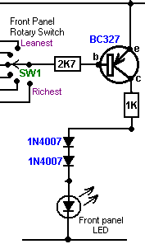

Here, the switch “SW1” connects to one of the output pins of the Integrated Circuit. When the voltage on that pin goes low, it causes a current to flow through the transistor Base/Emitter junction, limited by the 2.7K (2,700 ohm) resistor. This current causes the transistor to switch hard On, which in turn alters the voltage on its Collector from near 0 volts to near +12 volts. The 2.7K resistor is only there to limit the current through the transistor and to avoid excessive loading on the output pin of the IC.

The transistor now feeds current to the LED via the two 1N4007 diodes and the 1K (1,000 ohm) resistor. This causes the Light Emitting Diode to light brightly. The 1K resistor is there to limit the amount of current flowing through this section of the circuit.

Part of the voltage across the LED is fed back to the fuel computer:

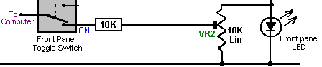

By moving the slider contact on the preset resistor “VR2”, any output voltage can be fed to the fuel computer. This voltage can be anything from the whole of the voltage across the LED, down to almost zero volts. We will use VR2 to adjust the output voltage when we are setting the circuit up for use. In this circuit, VR2 is acting as a “voltage divider” and it is there to allow adjustment of the output voltage going from the circuit to the fuel computer.

The final section of the circuit is the MPSA14 transistor and its associated components:

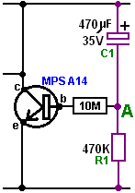

This circuit is a timer. When the circuit is first powered up (by the vehicle’s ignition key being turned), the 470 microfarad capacitor “C1” is fully discharged (if it isn’t, then the oxygen sensor will already be hot). As it is discharged and one side is connected to the +12 volt line, then the other side (point “A”) looks as if it is also at +12 volts. This provides a tiny current to the Base/Emitter junction of the MPSA14 transistor, through the high resistance 470K (470,000 ohm) resistor. The MPSA14 transistor has a very high gain and so this tiny current causes it to switch hard on, short-circuiting the LED and preventing any voltage developing across the LED.

As time passes, the tiny current flowing through the MPSA14 transistor, along with the tiny current through the 3.9M (3,900,000 ohm) resistor “R1”, cause a voltage to build up on capacitor “C1”. This in turn, forces the voltage at point “A” lower and lower. Eventually, the voltage at point “A” gets so low that the MPSA14 transistor gets starved of current and it switches off, allowing the LED to light and the circuit to start supplying an output voltage to the fuel computer. The purpose of the section of the circuit is to shut off the output to the fuel computer until the oxygen sensor has reached it’s working temperature of 600 degrees Fahrenheit. It may be necessary to tailor this delay to your vehicle by altering the value of either “R1” or “C1”. Increasing either or both will lengthen the delay while reducing the value of either or both, will shorten the delay.

We want the time delay to occur if the engine is off for some time, but not to occur if the engine is switched off only briefly. For this to happen, it is suggested that a diode is placed across the timing resistor. This will have no effect when the circuit is powered up, but it will discharge the capacitor when the circuit is powered down. We can slow down the rate of discharge by putting a high-value resistor in series with the discharge diode and that would make the circuit:

Circuit Operation:
Now that we have looked at each part of the circuit separately, let us look again at the way that the circuit operates. The main component is the LM3914 integrated circuit. This device is designed to light a row of Light Emitting Diodes (“LEDs”). The number of LEDs lit is proportional to the input voltage reaching it through it’s Pin 5. In this circuit, the integrated circuit is used to provide a reduced voltage to be fed to the fuel computer, rather than to light a row of LEDs. When the operating switch is set in it’s ON position, the sensor voltage is fed to Pin 5 through a 1 megohm resistor.

The sensitivity of this circuit is adjusted, so that when 500 millivolts (0.5 volts) is applied to Pin 5, the output on Pin 10 is just triggered. This is done by adjusting the 10K linear preset resistor “VR1” while placing a test voltage of 500 millivolts on Pin 5. This LM3914 Integrated Circuit is normally switched so that it samples the sensor voltage. The LM3914 chip provides ten separate output voltage levels, and the circuit is arranged so that any one of several of these can be selected by the rotary switch “SW1”. These output voltages range from 50 millivolts on Pin 1 to 500 millivolts on Pin 10, with each output position having a 50 millivolt greater output than it’s neighbouring pin. This allows a wide range of control over the sensor feed passed to the fuel computer.

The input resistor/capacitor circuit provides filtering of the sensor signal. Because this circuit draws very little current, it is easily knocked out of correct operation through it’s input line picking up stray electrical pulses produced by the engine, particularly the vehicle’s ignition circuit. When the exhaust sensor heats up, the signal becomes cleaner and then the circuit starts operating correctly. The circuit includes a delay so that after start up, the output is held low for a few minutes to simulate a cold sensor. The sensor must be operating correctly before we send signals to the computer. The most common problem, if we don’t have this delay, is that the output will be high simply from the noise on the signal line. The computer will think the sensor is working, because it is high, and will cut back the fuel to make the signal go low. If that were to happen, we would end up with an over-lean fuel input to the engine, producing very poor acceleration.

The front panel LED is not just to show that the device is operating, but forms a simple voltage regulator for the output signal to the computer. When the engine is warmed up and running normally, the LED is lit when the output is high, and not lit when the output is low, so this LED should be flashing on and off.

The earth connection for the oxygen sensor is the exhaust system, which is firmly bolted to the engine. The computer earth is the vehicle body. A difference of just 0.5 volts can make a large difference to the mixture. If the engine is not securely earthed to the vehicle body, then a voltage difference can exist between the two, and in this situation a voltage difference of just 0.5 volts would normally go unnoticed. We can’t afford to have that sort of voltage difference when trying to control the mixture accurately, so some investigation and adjustment is needed.

To do this, start the engine, switch the headlights on to high beam, then measure the voltage between the engine and the body. Use a digital volt meter. Any more than 50 millivolts (0.05 volts) means that there is a bad earth connection which need cleaning and tightening. Modern cars usually have more than one connection so look around. If you have trouble achieving a really good connection, then earth your circuit board directly on the engine rather than connecting it to a point on the bodywork of the vehicle. The most important item is to have a good quality signal voltage coming from the sensor, since the operating range consists of quite low voltages. The components and tools needed for building this circuit are shown later, but for now, consider the setting up and testing of the unit so as to understand better what is needed.

Adjusting on the Bench
When the circuit has been constructed to the testing stage, that is, with all components in place except for the timing capacitor “C1”, and before the power is turned on, plug the Integrated Circuit chip into its socket mounted on the board. Be very careful doing this as the chip can be destroyed by static electricity picked up by your body. Professionals wear an electrical earth wrist strap when handling these devices, so it would be a good idea to touch a good earth point such as a metal-pipe cold water system just before handling the chip.

It is vital that you install the IC chip, the correct way round or it may be damaged. The circuit board layout shows which way round it goes. The chip has a semi-circular indentation at one end to show which end is which, so be careful that the indentation is positioned as shown on the board layout in the section which shows how the board is built. Some manufacturers use a dot rather than a semi-circular indentation to mark the end of the chip which has Pin 1 in it.
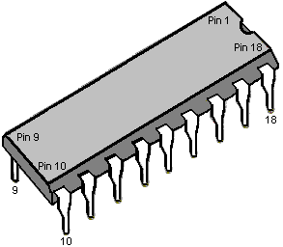
Make up the test voltage device. We need something to give us an adjustable voltage in the range 0 to 1 volt. A very easy way to get this is to use a 10K resistor and a 1K variable resistor (called a “potentiometer” by some people) and connect them across the 12 volt battery, as shown here:

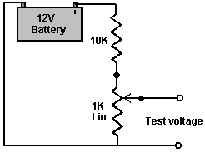

This gives us a voltage in the correct range when the shaft of the variable resistor is turned. Power up the circuit board by switching the 12 volt battery through to the board. Adjust the test-voltage source to 500 millivolts (0.5 volts) and apply it to the board’s input (where the sensor connection will be made when it is installed in the vehicle). Set the switch to the “Richest” position, that is, with the switch connected to Pin 10 of the chip.

Now, using a flat-blade screwdriver, adjust the sensitivity control preset resistor “VR1” so that the output LED is just lit. Leave the preset resistor in that position and adjust the test voltage lower and higher to test that the LED turns on and off in response to the varying voltage at the input to the circuit. The LED should come on at 0.5 volts, and go off just below 0.5 volts. The other outputs, which can be selected by the rotary switch “SW1”, will be about 50 millivolts lower for each position of the switch away from it’s “Richest” setting on Pin 10.

Now, with the output high and the LED lit, use a flat-bladed screwdriver to adjust the preset resistor “VR2” to set the output voltage being sent to the computer to about 1.0 volts. When this has been set, lower the input voltage so that the LED goes out. The output voltage should now be at zero volts. If this is what happens, then it shows that the circuit is operating correctly.

If this board is not in place, the sensor will cause the fuel computer to make the fuel mixture richer so as to maintain a 500 millivolt voltage from the sensor. With the circuit in place and set to its “Richest” setting, exactly the same thing happens. However, if the rotary switch is moved to its next position, the fuel computer will maintain the fuel feed to maintain a 450 millivolt output, which is a leaner fuel-to-air mixture. One step further around and the fuel computer will make the mix even leaner to maintain a 400 millivolt output from the circuit board, which the fuel computer thinks is coming from the exhaust oxygen sensor.

If your circuit board does not operate as described, then power it down and examine the circuit board again, looking for places where the solder connections are not perfect. There may be somewhere where the solder is bridging between two of the copper strips, or there may be a joint which looks as if it is not a good quality joint. If you find one, don’t solder anywhere near the IC chip as the heat might damage the chip. If necessary, earth yourself again, remove the chip and put it back into the anti-static packaging it came in, before repairing the board. If the components are all correctly positioned, the copper tracks broken at all the right places and all solder joints looking good and well made but the board still is not working correctly, then it is likely that the IC chip is defective and needs to be replaced.

Next, install the delay capacitor “C1”. Set the test voltage above 500 millivolts and turn the power on again. It should take about three minutes for the LED to come on. If you want to shorten this delay, then change the timing resistor “R1” for a resistor of a lower value. To lengthen the delay, replace the timing capacitor “C1” with a capacitor of larger value. If you find that the oxygen sensor heats up quickly, then you can reduce the length of the delay. Having too long a delay is not ideal, since the computer will be adding extra fuel to make the mixture richer.

It is suggested that the rotary switch should be set to have only six switch positions (by moving it’s end-stop lug washer), so initially, connect the IC chip output pins 10 through 15 to the switch. You can choose to connect the wires to the switch so that the mixture gets richer when you turn the knob clockwise, or if you prefer, you can wire it in the reverse order so that the mixture gets richer when you turn the knob counter-clockwise.

Testing in the Car
You can now test the device in the vehicle but don’t install it yet. Look in the engine compartment and locate the oxygen sensor. If you have difficulty in finding it, get a copy of the Clymer or Haynes Maintenance Manual for your vehicle as that will show you the position. If your vehicle has two sensors, then select the one nearest to the engine. If your sensor has five wires running to it, then it is a “wideband” sensor which measures both the oxygen content and the amount of unburnt fuel, and unfortunately, the type of circuit described here will not control it.

Start the vehicle and allow the oxygen sensor to warm up for a couple of minutes. Remember that there is a delay built in to the circuit, so after a few minutes you should see the LED start to flash. Rev the engine and the LED will stay on. When you release the throttle, the LED will go out for a while. A flashing LED is what you want to see. The rate of flashing will be somewhere between 1 and 10 times per second, most likely around 2 per second. Confirm that the LED goes out when you switch off the circuit board On/Off switch mounted on the dashboard.

Now comes the exciting bit, cutting the oxygen sensor wire and inserting the controller. Turn the engine off and cut the wire in a convenient place. Use crimp connectors on the wire ends. Use a matching pair on the wire which you just cut, in case you need to reconnect it, as shown here:

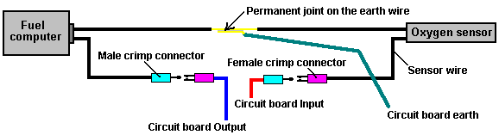

When set up like this, the male connector furthest on the left could be plugged into the female connector furthest on the right and the circuit board removed. Be sure to insulate the sensor and fuel computer plug/socket connections to make quite sure that neither of them can short-circuit to any part of the body. There is no need to insulate the earth connection as it is already connected to the body of the vehicle. Although not shown in the diagram, you could also put a male and female crimp connector pair on the earth cable. If your sensor has only one wire coming from it, then you best earth connection is to a solder-tag connector placed under a bolt on the engine. If you do that, be sure to clean all grease, dirt, rust, etc. off the underside of the bolt head and the area around the bolt hole. Push a paper towel into the bolt hole before doing this to make sure that no unwanted material ends up in the bolt hole and use wet-and-dry paper to really clean the surfaces. The objective here is to make sure that there is a very good electrical connection with shiny metal faces clamped firmly together.

Installing the Controller

Now, install the circuit board in the vehicle. For the 12 volt supply, find a connection which is switched on and off by the vehicle’s ignition switch. Don’t drive the car yet, do this test in the driveway. With the front panel switch in it’s “Off” position, start the car and check that it runs normally. Set the front panel rotary switch to the Richest position (connected to the IC’s Pin 10) and switch the circuit board toggle switch to it’s “On” position. The car is now running with a modified oxygen sensor signal although the mixture is still the same. The vehicle performance should be completely normal. Drive the vehicle with this setting for a while to prove that the system is working reliably before changing to any of the lower settings. When you are satisfied that everything is in order, try the next leanest setting on the rotary switch and see how it runs.

It is important that there should be no hesitation in the engine performance and no knocking or “pinking” as that is an indication that the mix is too lean and the engine is liable to overheat. This circuit is intended for use with an electrolyzer, so your electrolyzer should be set up and working for these tests. The electrolyzer will tend to make the engine run cooler and offset any tendency towards overheating.

Building the Circuit Board

Although the above information has been presented as if the board has already been built, the actual construction details have been left until now, so that you will already have an understanding of what the circuit is intended to do and how it is used.

It is likely that you will know somebody (neighbour, friend, relative,...) who has the necessary equipment and skills. If so, borrow the equipment, or better still, recruit the person to help with the construction. It is very likely that anybody owning the equipment would be very interested in your project and more than willing to help out.

However, the rest of this document will be written on the assumption that you cannot find anybody to help and have had to buy all of the necessary equipment. This project is not difficult to build, so you will almost certainly be successful straight off.

The tools which you will need, are:

1. A soldering iron with a fine conical tapering tip (probably 15 watts power rating)
2. Some “Multicore” resin solder. This is special solder for electronics construction work and is quite different from plumber’s solder which is not suitable for this job.
3. A pair of long-nosed pliers (for holding component wires when soldering them in place)
4. Something for cutting and cleaning wires and stripping off insulation coverings. I personally prefer a pair of “nail” scissors for this job. Others prefer a pair of wire cutters and some sandpaper. You get whatever you feel would be the best tool for doing these tasks.
5. A 1/8 inch (3 mm) drill bit (for making bolt holes in the stripboard and for breaking the copper strips where needed) and a 3/8 inch (9 mm) drill and bit for mounting the switches on the plastic box.
6. A coping-saw or similar small saw for cutting the rotary switch shaft to the optimum length.
7. A small screwdriver (for tightening knob grubscrews).
8. A crimping tool and some crimp connectors.
9. A multimeter (preferably a digital one) with a DC voltage measuring range of 0 to 15 volts or so.
10. (Optional) a magnifying glass of x4 or higher magnification (for very close examination of the soldering)

Soldering

Many electronic components can be damaged by the high temperatures they are subjected to when being soldered in place. I personally prefer to use a pair of long-nosed pliers to grip the component leads on the upper side of the board while making the solder joint on the underside of the board. The heat running up the component lead then gets diverted into the large volume of metal in the pair of pliers and the component is protected from excessive heat. On the same principle, I always use an Integrated Circuit socket when soldering a circuit board, that way, the heat has dissipated fully before the IC is plugged into the socket. It also has the advantage that the IC can be replaced without any difficulty should it become damaged.

If you are using CMOS integrated circuits in any construction, you need to avoid static electricity. Very high levels of voltage build up on your clothes through brushing against objects. This voltage is in the thousands of volts range. It can supply so little current that it does not bother you and you probably do not notice it. CMOS devices operate on such low amounts of current that they can very easily be damaged by your static electricity. Computer hardware professionals wear an earthing lead strapped to their wrists when handling CMOS circuitry. There is no need for you to go that far. CMOS devices are supplied with their leads embedded in a conducting material. Leave them in the material until you are ready to plug them into the circuit and then only hold the plastic body of the case and do not touch any of the pins. Once in place in the circuit, the circuit components will prevent the build up of static charges on the chip.

Soldering is an easily-acquired skill. Multi-cored solder is used for electronic circuit soldering. This solder wire has flux resin contained within it and when melted on a metal surface, the flux removes the oxide layer on the metal, allowing a proper electrical and mechanical joint to be made. Consequently, it is important that the solder is placed on the joint area and the soldering iron placed on it when it is already in position. If this is done, the flux can clean the joint area and the joint will be good. If the solder is placed on the soldering iron and then the iron moved to the joint, the flux will have burnt away before the joint area is reached and the resulting joint will not be good.

A good solder joint will have a smooth shiny surface and pulling any wire going into the joint will have no effect as the wire is now solidly incorporated into the joint. Making a good solder joint takes about half a second and certainly not more than one second. You want to remove the soldering iron from the joint before an excessive amount of heat is run into the joint. It is recommended that a good mechanical joint be made before soldering when connecting a wire to some form of terminal (this is often not possible).

The technique which I use, is to stand the solder up on the workbench and bend the end so that it is sloping downwards towards me. The lead of the component to be soldered is placed in the hole in the stripboard and gripped just above the board with long-nosed pliers. The board is turned upside down and the left thumb used to clamp the board against the pliers. The board and pliers are then moved underneath the solder and positioned so that the solder lies on the copper strip, touching the component lead. The right hand is now used to place the soldering iron briefly on the solder. This melts the solder on the joint, allowing the flux to clean the area and producing a good joint. After the joint is made, the board is still held with the pliers until the joint has cooled down.

Nowadays, the holes in the stripboard are only 1/10 inch (2.5 mm) apart and so the gaps between adjacent copper strips is very small indeed. If you solder carefully, there should be no problem. However, I would recommend that when the circuit board is completed, that you use a magnifying glass to examine the strip side of the board to make quite sure that everything is perfectly ok and that solder does not bridge between the copper strips anywhere. Before powering up the circuit, double-check that all of the breaks in the copper strips have been made correctly. Here is a possible layout for the components on the stripboard:

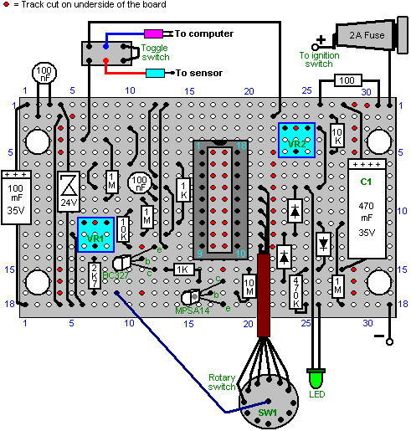

If this board is turned over horizontally, the underside will look like this:

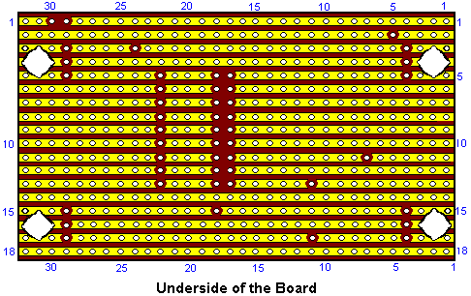

This shows where the breaks in the copper strips need to be made using a 1/8 inch (3 mm) drill bit.

To construct this circuit, cut a piece of stripboard which has 18 strips, each with 32 holes. That is a board size of about two inches (50 mm) by just over three inches (85 mm). Mount the components on the board, working from one end as the installation is easier if you have a clear board to work across. If you are right-handed, then start at the left hand side of the board and work towards the right, installing all components as you go. If you are left-handed, then mount the components starting with the right hand side of the board and working towards the left hand side.

Having said that, it is probably easier if you put all of the wire jumpers in place as the first step. The best wire for this is solid core wire of the type used in telephone wiring, as it is easy to cut, easy to remove the insulation and it lies flat on the board, clear of all of the other holes. So, start with the wire jumpers and then install the electronic components working across the board.

The jumper wires lie flat on the board, and like the other components, have about 2 mm of clean wire projecting through the copper strip before the solder joint is made.

The wires coming off the board should be of the type which have several thin wires inside the insulation, as these are more flexible and withstand the vibration of a vehicle in motion, better than solid core wire. If you have just one reel of wire, then be sure to label the far end of each piece mounted on the board, the moment you have soldered it in place. These labels will help avoid errors when mounting in the case, if you do not have different coloured wires.

The completed circuit board can be mounted in a small plastic box of the type which has a lid held in place by screws. It may be convenient to screw or bolt the case to the underside of the dashboard and then screw the lid in place, covering the mounting screws:

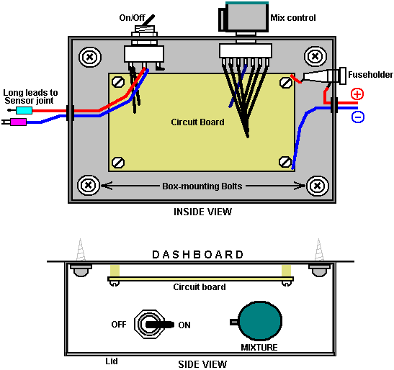

The components in this circuit are not critical and any near-match alternatives can be used. In the event that the MPSA14 Darlington-pair transistor is not available, then two general-purpose high-gain silicon transistors like the BC109 or 2N2222A can be substituted. Just connect them like this:

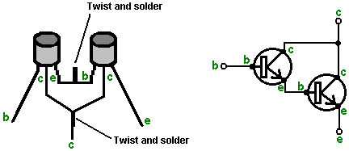

The emitter of the first transistor is connected to base of the second and the two collectors are connected together. If the transistors have metal cases, then make sure the emitter/base connection cannot touch either case as the cases are often connected internally to the collectors. If each transistor has a gain of only 200, then the pair will have a combined gain of 40,000 times. That means that the base current need only be 40,000 times less than the collector current of the second transistor.

The BC327 transistor can be replaced by almost any other silicon PNP transistor in this circuit as the gain does not need to be great and the power rating is very small. The following is a list of the main electronic components needed for the construction of this circuit as described here. There are several suppliers who are able to supply all of these components and the most suitable depends on where you are located. If there is any difficulty, try an internet search, and if that fails, ask for help in one or more of the Yahoo enthusiast groups such as ‘watercar’, ‘hydroxy’ or any of the electronics Groups.

Component | Qty. | US Supplier | Code
Black plastic box with lid, size about 4” x 3” x 2” | 1 | Radio Shack | 270-1803
Stripboard: 18 strips, 32 holes | 1 | Electronix Express | 0302PB16
Double Pole Double Throw toggle switch | 1 | Radio Shack | 275-636
Fuseholder, panel mounting, 1.25” | 1 | Radio Shack | 270-364
Fuse, 2 amp slow-blow 1.25” | 1 | Radio Shack | 270-1262 ?? (3 A)
Rotary wafer switch, 12-way single pole | 1 | Electronix Express | 17ROT1-12
Knob for the rotary switch | 1 | Radio Shack | 274-424
LED, any colour, 5 mm diameter | 1 | Radio Shack | 276-041
IC socket, 18 pin DIL | 1 | Radio Shack | 276-1992
Miniature preset resistor, 10K linear | 2 | Radio Shack | 271-282
LM3914 LED bar driver Integrated Circuit | 1 | Electronix Express | LM3914
BC327 PNP transistor | 1 | Electronix Express | 2N2905
MPSA14 Darlington pair transistor | 1 | Electronix Express | MPSA14
1N4007 Diode or equivalent | 3 | Radio Shack | 276-1103 (2 pack)
BZX85C zener diode, 24 volt version | 1 | Electronix Express | 1N5359
470 microfarad, 35 volt (or higher) axial lead aluminium foil electrolytic capacitor | 1 | Radio Shack | 272-1018
100 microfarad, 35 volt (or higher) axial lead aluminium foil electrolytic capacitor | 1 | Radio Shack | 272-1016
100 nF (0.1 microfarad) ceramic disc capacitor | 2 | Radio Shack | 272-135 (2 pack)
10 megohm 1/4 watt carbon resistor  (Bands: Brown,Black,Blue) | 1 | Radio Shack | 271-1365 (5 pack)
1 megohm 1/4 watt carbon resistor  (Bands: Brown,Black,Green) | 3 | Radio Shack | 271-1356 (5 pack)
470K 1/4 watt carbon resistor  (Bands: Yellow,Purple,Yellow) | 1  or 1 | (Radio Shack)  Radio Shack | use two 1M in parallel or  271-1133 (5 pack 1/2 watt)
10K 1/4 watt carbon resistor  (Bands: Brown,Black,Orange) | 1 | Radio Shack | 271-1335 (5 pack)
2.7K 1/4 watt carbon resistor  (Bands: Red,Purple,Red) | 1 | Radio Shack | 271-1328 (5 pack)  [use 3.3K]
1K 1/4 watt carbon resistor  (Bands: Brown,Black,Red) | 2 | Radio Shack | 271-1321 (5 pack)
100 ohm 1/4 watt carbon resistor  (Bands: Brown,Black,Brown) | 1 | Radio Shack | 271-1311 (5 pack)
Connecting wire: stranded and solid core |  | Local supplier

Electronix Express http://www.elexp.com/index.htm
Radio Shack http://www.radioshack.com/home/index.jsp
And for a UK supplier:

Component | Qty. | European Supplier | Code
Black plastic box with lid, size about 4” x 3” x 2” | 1 | ESR | 400-555
Stripboard: 18 strips, 32 holes | 1 | ESR | 335-010
Double Pole Double Throw toggle switch | 1 | ESR | 218-028
Fuseholder, panel mounting 31 mm | 1 | ESR | 187-115
Fuse, 2 amp 31 mm | 1 | ESR | 190-220
Rotary wafer switch, 12-way single pole | 1 | ESR | 210-012
Knob for the rotary switch | 1 | ESR | 060-22X
LED, any colour, 5 mm diameter | 1 | ESR | 711-540
IC socket, 18 pin DIL | 1 | ESR | 110-180
Miniature preset resistor, 10K linear | 2 | ESR | 998-310
LM3914 LED bar driver Integrated Circuit | 1 | ESR | LM3914
BC327 PNP transistor | 1 | ESR | BC327
MPSA14 Darlington pair transistor | 1 | ESR | MPSA13
1N4007 Diode or equivalent | 3 | ESR | 1N4007
BZX85C zener diode, 24 volt version | 1 | ESR | 726-240
470 microfarad, 35 volt (or higher) axial lead aluminium foil electrolytic capacitor | 1 | ESR | 810-104
100 microfarad, 35 volt (or higher) axial lead aluminium foil electrolytic capacitor | 1 | ESR | 810-096
100 nF (0.1 microfarad) ceramic disc capacitor | 2 | ESR | 871-061
10 megohm 1/4 watt carbon resistor  (Bands: Brown,Black,Blue) | 1 | ESR | 906-610
1 megohm 1/4 watt carbon resistor  (Bands: Brown,Black,Green) | 3 | ESR | 906-510
470K 1/4 watt carbon resistor  (Bands: Yellow,Purple,Yellow) | 1 | ESR | 906-447
10K 1/4 watt carbon resistor  (Bands: Brown,Black,Orange) | 1 | ESR | 906-310
2.7K 1/4 watt carbon resistor  (Bands: Red,Purple,Red) | 1 | ESR | 906-227
1K 1/4 watt carbon resistor  (Bands: Brown,Black,Red) | 2 | ESR | 906-210
100 ohm 1/4 watt carbon resistor  (Bands: Brown,Black,Brown) | 1 | ESR | 906-110
Reel of multi-strand connecting wire 6 amp Red | 1 | ESR | 054-112
Reel of multi-strand connecting wire 6 amp Blue | 1 | ESR | 054-116
Reel of solid core (or local phone wire) | 1 | ESR | 055-111

ESR http://www.esr.co.uk Tel: 01912 514 363

While the components listed above are the parts needed to construct the electronics board, the following items may be needed in addition when testing and installing the board in a vehicle:

Component | Use
Rubber or plastic grommets | To protect wires from rubbing against the edges of the holes in the box
Crimp “bullet” connectors | Male and female, one pair for each sensor wire cut
Mounting bolts, nuts and spacers | To hold the circuit board securely, clear of the box.
Double-sided adhesive tape | For mounting the box on the dash. Alternatively, hardware items for this.
Fuse-box connector | For connecting to the fuse box to give an ignition-switched 12V supply
10K resistor and 1K Linear variable resistor | For bench testing with voltages of up to 1 volt, if these components are not already to hand
Multimeter | For general checking of voltages, continuity, etc.

I should like to express my sincere thanks to the various members of the ‘watercar’ Group who provided the technical information and patient support which made this document possible.

An alternative: As the signal coming from the oxygen sensor to the vehicle’s ECU fuel computer needs to be raised slightly to allow for the much cleaner exhaust produced when a booster is being used, an alternative solution has been suggested and tested. The idea is to add a small, adjustable voltage to the signal already coming from the oxygen sensor. This voltage can be from a single ‘dry-cell’ battery and adjusted with a variable resistor:
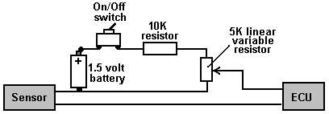

The circuit shown here allows a voltage anywhere from zero to 0.5 volts to be added to the oxygen sensor signal. This must not be done unless a booster is running. Using it without a booster is liable to lead to engine overheating and possible valve damage. This, of course, applies to the previous oxygen sensor signal adjusting circuit as well.

Please Note: This document has been prepared for information purposes only and must not be construed as an encouragement to build any new device nor to adapt any existing device. If you undertake any kind of construction work, then you do so entirely at your own risk. You, and only you, are responsible for your own actions. This document must not be seen as an endorsement of this kind of adaptation nor as providing any kind of guarantee that an adaptation of this kind would work for you personally. This document merely describes what has been achieved by other people and you must not consider it as being a foolproof blueprint for replication by anyone else.

Patrick Kelly
engpjk@tiscali.co.uk
www.free-energy-info.co.uk
www.free-energy-devices.com

