A Practical Guide to Free-Energy Devices Author: Patrick J. Kelly

Chapter 8: Fuel-less Engines

We have been raised with the idea that it is necessary to burn a fuel to produce power which we can use. We are sold coal, coke, timber, paraffin/kerosene, petrol/gasoline, diesel, propane, etc. for us to burn in order to “get” energy. While it is perfectly true that burning these things will indeed result in energy in a form which we find convenient to use in heating, cooling, powering engines, etc. what is carefully avoided is the fact that it is not at all necessary to burn a fuel in order to run the things which we want to power. This ‘inconvenient’ fact has been concealed and denied for more than fifty years now (very surprisingly, by the people who want to sell us these fuels to burn – do you perhaps think that they may have some motive for this, other than our best interests about which they are no doubt, very concerned?).

This chapter is about ‘fuel-less’ motors. Strictly speaking, they are not self-powered but as they don’t burn a fuel of any kind, in everyday language they can be described as ‘self-powered’. In the same way that a solar panel in sunlight uses no fuel and yet puts out electrical power, these motors draw energy from the environment and provide us with mechanical power. In actual fact, power is never “used up” but just converted from one form into another. In the case of our trusty solar panel, some 17% of the radiation from the sun (mainly ultraviolet) is converted into electrical power and 83% goes in heating and other losses, but as we don’t have to supply the sunlight, and the solar panel pours out the electricity which we want without us having to do anything to make it happen, we really don’t care very much about its extremely low efficiency. As far as we are concerned, the electricity flowing from the panel is “free-energy”.

It is really amazing that we have been persuaded that we must burn a fuel in order to get power. Take the case of a heavy-displacement sailing yacht. The skipper can voyage using his inboard diesel engine:

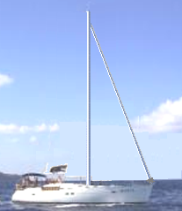

This matches perfectly with the thinking that you need to burn a fuel in order to get power as the yacht is moving along, pushed by the engine which is powered by burning diesel fuel. But, what if the skipper decides to switch the engine off and set the sails?:


Now, the same boat, weighing exactly the same with the same crew, is now continuing the voyage at the same speed, but no fuel is being burnt. The really interesting thing is that while we know this perfectly well, and we are aware that people have sailed right around the world in boats which do not have engines, it does not seem to occur to us that this shows conclusively that it is not necessary to burn a fuel to power some item of equipment or form of transport.

In the case of our yacht, the energy comes from the sun which heats the atmosphere unevenly, causing winds to blow and the yachtsman uses the sails to make those winds power his boat through the water. So, a sailing boat is actually powered by the sun although we don’t usually think about it that way.

There are many hydro-electric “power stations” where electricity is ‘generated’ by machines driven by water pressure. In actual fact, no power is ‘generated’ at all, but instead, the potential energy of the body of water is converted into electricity by having the water fall and spin the shaft of a machine. So, how did the water get up there in the first place? Well, it came from rain. And how did the rain get up there? It rose up there due to evaporation caused by the heat of the sun. So, the bottom line again is that hydro-electric ‘power’ stations are powered by the sun.

Windmills are also powered by the sun. But, and here is the really interesting thing, if I state that it is perfectly possible for a compressed-air engine to produce mechanical power without burning any fuel, then there is an immediate and strong reaction where people will say “Impossible – that is perpetual motion !!” They imply that perpetual motion is impossible but never supply any rational evidence to support that implication. Why then are people so opposed to the idea of perpetual motion? Presumably, because perpetual motion shows clearly that a fuel does not have to be burned to ‘produce’ power and that would not be good for people who sell fuels, and so, we are all told from an early age that perpetual motion is “impossible”.

Well, that does not matter here as we are going to look at compressed-air engines which run off the heat of the sun. That is, they are heat-pumps which are a well accepted engineering fact and they work on wholly accepted standard scientific principles. An ordinary refrigerator outputs three or four times as much heat power as the electrical power driving it, and it could be twice that efficient if it were used properly. This is a Coefficient Of Performance (COP) of 3 or 4, which is supposed to be “impossible” but unfortunately, all refrigerators work like this and you can’t exactly say that refrigerators don’t exist, just because their performance does not appear to fit in with some theories.

Actually, there is no magic involved here as the extra energy is being drawn from the heat content of the air in the immediate locality. The refrigerator is not operating in isolation and there is a heat exchange with the air surrounding it. This outside energy causes the COP>1 performance. In passing, all COP>1 devices operate by drawing energy in from an external source (usually the zero-point energy field) and none of them actually break the ‘rules’ of science. But, enough of that.

The people who don’t want self-powered engines used in the world today, pin their hopes on a continued ignorance of Engineering facts relating to heat pumps. A self-sustaining compressed-air engine is actually running off power from the sun just as sailboats, windmills and hydro-electric power stations do. Sorry folks, no magic here, just bog-standard Engineering. Admittedly, very few people know or realise the implications of this standard Engineering:

1. All work done in compressing air into a storage tank is converted into heat and then lost to the atmosphere, so the energy in the compressed air inside the tank is the same as that produced by atmospheric heating of that air, but as more of it is now in the tank, there is additional potential for work to be done. This extra energy was fed into the air by atmospheric heating before the air was compressed.

The First Law of Thermodynamics states that where heat is converted into mechanical energy, or mechanical energy is converted into heat, the quantity of heat is exactly equivalent to the amount of mechanical energy. We then have the intriguing situation where all of the mechanical energy put into compressing air into a storage tank is lost as heat, and yet, the tank contents now has a higher potential for doing work. This information comes from Engineering textbooks.

2. If the expanded cold air leaving the engine is used to cool the intake air of the compressor, then there will be an added gain when it warms up inside the cylinder, pulling heat in from the local environment.

3. If the heat of compression is transferred to the air container feeding the engine and not given time to dissipate, then there is a further power gain for the engine.

4. If compressed air is allowed to expand rapidly, there is a marked drop in temperature. The Leroy Rogers engine design, shown later in this chapter, uses this fact to create air-conditioning for a car driven by a compressed-air engine.

OK then, in broad outline, the energy available from a tank of compressed air comes directly from the heat contained in the atmosphere, in spite of the fact that we always imagine that the energy in the tank was put there by our energetic pumping.

Let’s check this out by taking a look at some of the engines which use these principle to provide fuel-less operation, starting with the design of Bob Neal. The full patent for Bob’s design is included in the Appendix.

Bob Neal’s Compressed Air Engine.
Bob Neal’s design is a compressed-air operated engine and compressor where the operation of the engine keeps re-supplying the compressed air tank:

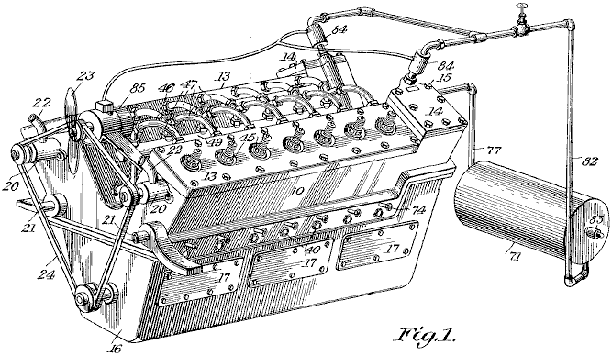

This is a perspective view of the engine and this:

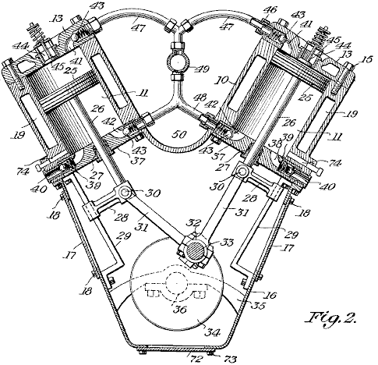

is a vertical transverse cross-section view through the compressor part of the engine. In his patent, Bob has avoided any direct mention of the fact that his engine design is fuel-less. That sort of statement is not popular with Patent Examiners even if it is perfectly true.

Scott Robertson’s Compressor System.
Bob Neal’s system could do with some further explanation, so here is an idea from Scott Robertson whose web site is http://www.aircaraccess.com/index.htm, for a possible working compressor system using a leaf-blower:

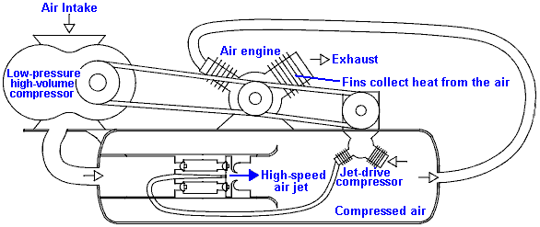

While this looks rather complicated, in reality it really isn’t. Let’s take the different sections in order:

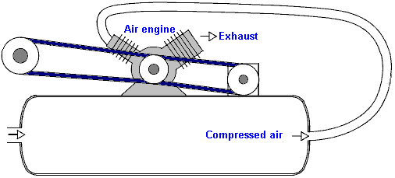

First, you have an ordinary air engine, supplied with compressed air from a pressure tank. This engine exhausts its (cold, expanded) air to the atmosphere. The engine powers two compressors which between them keep the tank full of compressed air.

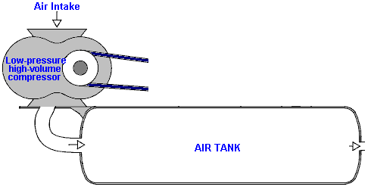

The first compressor is a simple ‘leaf-blower’ type which produces a large volume of low-pressure air. The big question is “how do you get this large volume of low-pressure air into a tank which has high-pressure compressed air inside it?”. Well this seemingly impossible task is performed by the second compressor aided by a cunning, ultra-simple design:

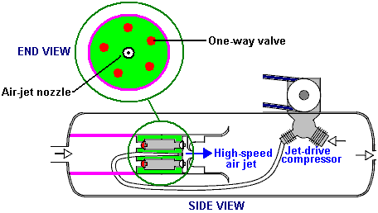

Here, low-pressure air is fed into the low-pressure area marked in pink. Separating it from the high-pressure area is a metal plug marked in green. Set into this plug is a ring of five one-way air valves marked in red. These one-way valves let the low-pressure air into the high-pressure area because of a high-speed jet of air produced by the ‘jet-drive compressor’. At first glance, this seems impossible, but it is actually just an application of a standard Engineering technique. The high-speed air jet is directed through a specially shaped nozzle, creating a local low-pressure zone around the jet:

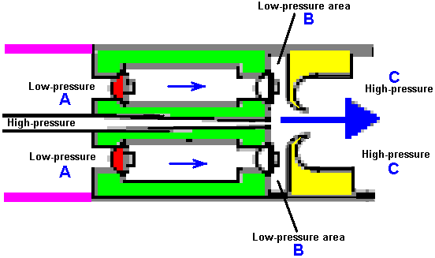

The low-pressure air at point “A” flows through the ring of five one-way valves into the disc-shaped low pressure area “B” and is blasted into the high-pressure area “C” by the high-power air jet ripping through the doughnut-shaped ring marked in yellow. The high-speed air jet causes the low pressure ring “B” by its rapid movement which creates a vortex due to the shape and positioning of the doughnut-shaped ring marked in yellow. This clever arrangement allows large volumes of low-pressure air to be drawn into a tank which contains high-pressure air.

You will also note that the two-stage compressor which generates this high-speed jet of air, has its working area actually inside the tank. This means that the heat of compression is used to heat the air inside the tank and raise its pressure, enhancing the operation further. It should be borne in mind that the new air entering the system has been heated by the sun and contains the energy which powers the system.

Tesla’s Motionless One-way Valve
As it is not widely publicised, many people have never heard of Nikola Tesla’s patent 1,329,559 of 1916 which describes a very clever physical shape which has easy passage of a fluid in one direction but very difficult flow in the opposite direction. This is the shape:

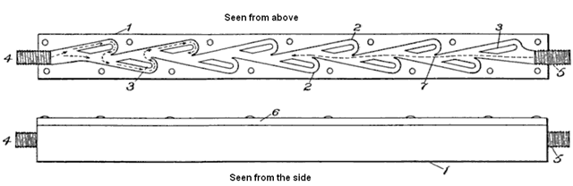

This arrangement is very clever as flow from right to left is free while flow from left to right results in a collision for every loop in the flow path. That is like this:
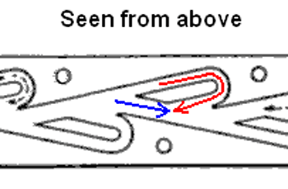
As a result of this, the larger the number of loops, the greater the flow resistance. With the eleven loops ahown in the patent, the resistance to flow is more than 200 times from left to right. There are many different applicatons for such a fluid diode.

The Retro-fit Compressed Air Vehicle System of Leroy Rogers.
The Rogers motor shown here makes no claims to spectacular operation, but in spite of that, Leroy did admit in an interview that this motor does indeed have a greater output than the applied input, provided that the motor is not left just ticking over. This motor is like the US patent 3,744,252 “Closed Motive Power System Utilising Compressed Fluids” by Eber Van Valkinburg shown below. However, the Rogers patent shown here has the distinct advantage that it uses off-the-shelf motors and readily available hardware and there is nothing really exotic or difficult about the Rogers engine that a person couldn’t get from a valve supplier or get a metal fabrication company to construct.

However, while Leroy did state that his design was self-sustaining when going over 30 miles per hour, a key design feature is his very high performance compressor unit which he later patented as shown below. Present day vehicle engines are under-geared and run at fairly low revs. These same engines operate much more efficiently at higher revs, if they are given different gearing. With the Rogers motor, the air contained in the high-pressure tank is sufficient to drive the pistons up and down. Air can be pumped back into the high-pressure tank by a compressor which has a much higher gearing and much lower capacity per piston stroke. The expanded air exiting from the engine is at much lower temperature than the surrounding air and if it captured in a buffer tank and used as the input of the compressor, then recharging the air tank is more efficient, provided that the tank absorbs heat from the surrounding environment, raising it’s temperature inside the tank and so giving an extra boost to the tank pressure, over and above the compression provided by the compressor.

One really nice feature of Leroy’s design is that he envisages it as being an adaption of an ordinary vehicle engine and he provides a considerable amount of practical detail as to how the adaption can be carried out.

Using a RotoVerter (as described in Chapter 2) to drive a compressor would lower the power requirements of the compressor drive to the extent that a motor adaption of this kind should be self-sustaining. The RotoVerter provides a major energy gain in its own right and is particularly suited to driving mechanical loads such as the compressor and it particularly ‘likes’ constant-load applications such as a compressor.

The adapted engine shown in the patent is like this:
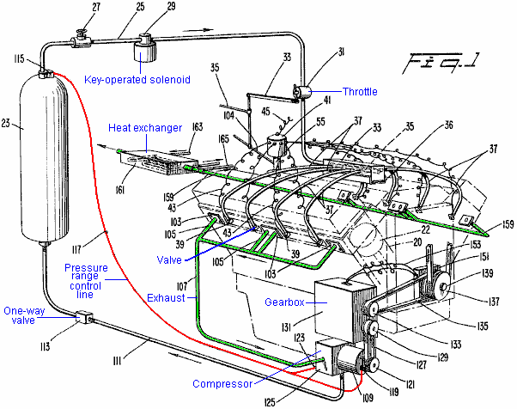

This patent shows how the practical details of running an engine on compressed air can be dealt with. What it does not show is background details of the actual energy flows and the effects of compressing air and then letting it expand. These things are not normally encountered in our daily lives and so we do not have an immediate intuitive feel for how systems like these will operate. Take the effects of expansion. While it is quite well known that letting a compressed gas expand causes cooling, the practical effect is seldom realised.

Leroy’s compressor patent is shown here:

United States Patent 4,693,669 Supercharger for automobile engines
Inventor: Rogers Sr., Leroy K. (Rte. 13, P.O. Box 815-DD, Briarcliff Rd., Fort Myers, FL, 33908)
Publication Date: 15th September 1987

Abstract:
A supercharger for delivering supercharged air to an engine, comprising a shrouded axial compressor, a radial compressor which is located downstream of the axial compressor and a housing. The housing is comprised of four sections, including a section which is a highly converging, ‘frustoconical’ transition duct which favourably directs the discharge of the axial compressor to the inlet of the radial compressor and a hollow, highly convergent, exhaust cone section immediately downstream of the radial compressor which converges into the exhaust port of the supercharger. An annular flow deflector is provided for directing the discharge of the radial compressor into the exhaust cone.

Description:
Superchargers impart additional pressure to the air or the air/fuel mixture of an engine so that the cylinders receive a greater weight per unit volume of air or air/fuel mixture than would otherwise be supplied. As a result, the volumetric efficiency and power output of the engine are improved.

According to prior practices, superchargers generally comprise a single air-blower which forces air or an air/fuel mixture into the cylinders of an engine. Typically, the air-blower is driven by a gear train which is connected to the crankshaft of the engine with a gear ratio of about 6 to 1. These prior types of superchargers have been used extensively in racing engines and radial aircraft engines. However, by reason of their high operating speeds and their gear trains, these superchargers have been considered too complicated, too heavy and too costly for use with mass production engines such as are found in cars and trucks.

Recently, some car manufacturers have been offering turbocharged engines which expand to exhaust gases of the engine through a turbine to drive a centrifugal compressor. Although turbochargers are advantageous in that the turbine can deliver large amounts of power to the compressor, their extreme operating speeds require special bearings, lubrication and maintenance. In addition, turbochargers require special ducting, such as by-pass arrangements, which only add to their cost and maintenance requirements. Consequently, turbochargers are only offered as expensive options in cars.

Further, there is current interest in a new type of car engine which operates from tanks of compressed gas to effect reciprocation of its pistons. An example of such an engine can be found in the U.S. Pat. No. 4,292,804 issued to the same inventor of the present invention. In the referenced patent, at least a portion of the partially expanded exhaust gas from the cylinders is directed to a compressor where it is recompressed and then returned to the storage tanks from whence it originally came. It would be desirable that at least some, if not all of the aforementioned recompression of the exhaust gas could be achieved with a belt-driven, rotary supercharger that is easily manufactured and maintained, yet is capable of providing ample recompression.

Objects of the Invention:
Accordingly, an object of the present invention is to provide a supercharger suitable for improving the performance of engines of cars, helicopters or the like, which supercharger is inexpensive to produce and easy to maintain.

It is another object of the present invention to provide a supercharger which provides sufficient boost without resort to extreme operating speeds and accordingly avoids the costly complications associated with high speed operation.
It is yet another object of the present invention to provide a relatively compact and lightweight supercharger which is inexpensive to manufacture and maintain.

Another object of the present invention is to provide a belt-driven supercharger having a design which provides supercharging compression at relatively low operating speeds.

It is still another object of the present invention to provide a supercharger which can be quite readily disassembled and reassembled for purposes of low cost maintenance and repair.

Still another object of the present invention is to provide a supercharger which can be constructed from mass producible parts to thereby reduce the cost of its manufacture.

It is still another object of the present invention to provide a belt-driven supercharger which provides supercharging compression without resort to a larger number of compressor stages.

Yet another object of the present invention is to provide a rotary supercharger for a gas operated engine, which supercharger is easily manufactured and maintained, yet capable of providing ample recompression of the recirculating drive fluid.

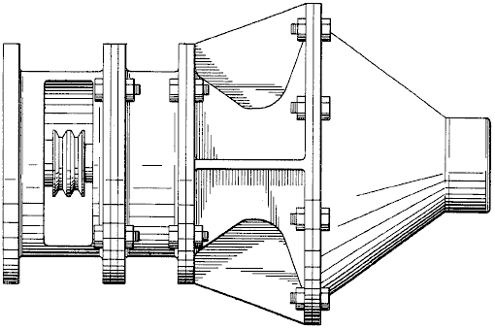

Summary of the Invention:
These and other objects are achieved by the present invention which provides a supercharger comprising a housing having an inlet and an outlet, a shrouded axial compressor and a radial compressor rotatably mounted within the housing, a highly convergent shallow, frustoconical transition duct for favourably directing the discharge of the axial compressor to the inlet of the radial compressor.

In accordance with a further aspect of the invention, the above-described supercharger further comprises an exhaust cone at a location downstream of the radial compressor and a flow deflector for directing the discharge of the radial compressor to the exhaust cone.

In the preferred embodiment, the housing itself comprises four sections: a cylindrical front housing section which defines an axially directed inlet; a second, cylindrical ducting section enclosing the axial compressor; a rear housing section defining the transition duct as well as the inlet and casing for the radial compressor; and the exhaust cone section which defines at its terminus the outlet of the housing. For driving the compressor shaft, a double-tracked pulley wheel is secured to the forward end of the common shaft, which pulley wheel is adapted to receive one or more drive belts from the crank-shaft wheel of the engine. A lateral opening in the front housing section accommodates the connection with the drive belts.

With the disclosed arrangement, compression can be achieved for supercharging purposes without resort to a large number of compressor stages or high operating speeds. Additionally, the design of the disclosed supercharger avoids the need for guide vanes between the axial compressor and the radial compressor. The exhaust cone section also favourably avoids the build-up of back pressure against the radial compressor. The design is also very simple and therefore inexpensive to manufacture and maintain.

Other objects, advantages and novel features of the present invention will become apparent from the following detailed description of the invention when considered in conjunction with the accompanying drawing.

Brief description of the Drawings:
A preferred embodiment of the present invention is described in greater detail with reference to the accompanying drawing wherein like elements bear like reference numerals, and where:

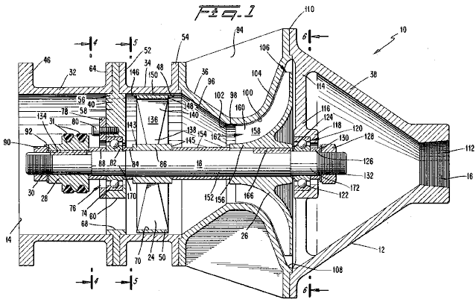

Fig.1 is a cross-sectional side view of a supercharger constructed in accordance with the preferred embodiment of the present invention;

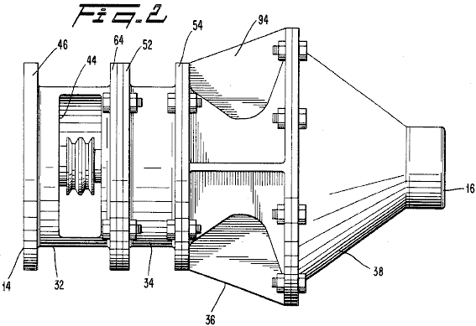

Fig.2 is a side view of the supercharger of Fig.1;

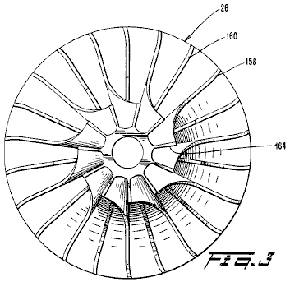

Fig.3 is a frontal view of the impeller of the supercharger of Fig.1;

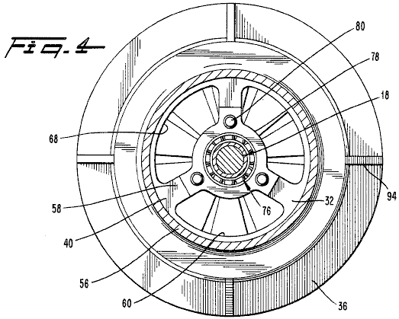

Fig.4 is a cross-sectional view taken along line 4--4 of Fig.1;

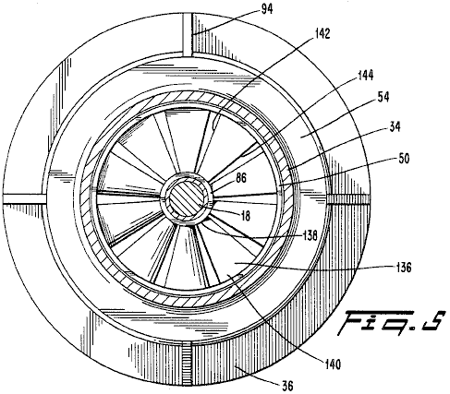

Fig.5 is a cross-sectional view taken along line 5--5 in Fig.1;

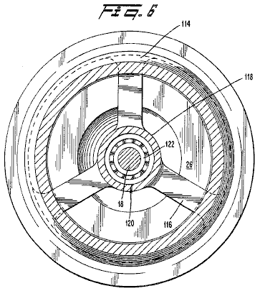

Fig.6 is a cross-sectional view taken along line 6--6 in Fig.1;

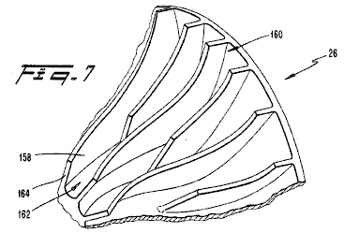

Fig.7 is a perspective view of a segment of the impeller of the supercharger of Fig.1; and

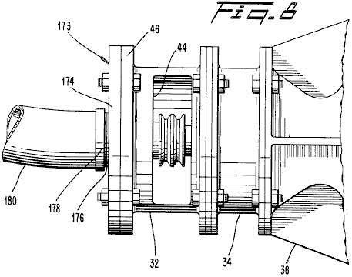

Fig.8 is a partial side view of the supercharger of Fig.1 with an adaptor .

Detailed Description of the Preferred Embodiment:

Referring to Fig.1 and Fig.2, a supercharger 10 is provided for supplying supercharged air to a car engine or the like, so that the engine receives a greater weight per unit volume of air or a fuel/air mixture than would be otherwise supplied. In accordance with a preferred embodiment of the present invention, the supercharger 10 comprises a housing 12 having an axially directed inlet 14 for receiving ambient air and an axially directed outlet 16 for delivering supercharged air to the intake of the car engine. Rotatably mounted within the housing 12 is a shaft 18 on which are secured an axial compressor 24 and a radial compressor 26, which is positioned downstream of the axial compressor. A pulley wheel 28 is secured to a forward end 30 of the shaft for receiving drive belts 31, which drive belts connect the shaft 18 to a pulley wheel on the crankshaft of the engine (not shown). The drive belts 31 deliver torque to the shaft 18 as required for driving the compressors 24 and 26 of the supercharger 10.

Housing 12 is constructed from four sections which are preferably bolted together at flanged connections in an end-to-end relationship. These sections include a front housing section 32, an axial compressor duct section 34, a rear housing section 36 and an exhaust cone section 38. The shaft 18 extends along the longitudinal axis of the housing 12.

The front housing section 32 is a hollow cylinder which extends forward of a front bearing support 40. The front housing section 32 encloses the forward end 30 of the shaft 18 and the associated pulley wheel 28. At its forward end, the front housing section 32 defines the inlet 14 for receiving air from an external source (not shown).

Referring particularly to Fig.2, the front housing section 32 includes a lateral opening 44 on one side in order to accommodate the connection of the drive belts 31 to the pulley wheel 28. The front housing section 32 also includes a forward flange 46 for accommodating the connection of air filters, carburettors, air scoops or the like upstream of the supercharger 10 according to the particular engine layout.

It is to be understood that in the usual engine layout, the supercharger 10 receives air or a fuel/air mixture from an external source through its inlet 14, compresses the air or fuel/air mixture and then delivers it to the intake of the engine.

Referring again to Fig.1, the pulley wheel 28 is interference-fitted upon the forward end 30 of shaft 18 and a key 134 is used to lock the pulley wheel 28 in place. The pulley wheel 28 is preferably a double-track design which is suitable for the attachment of twin drive belts, although a single-belt type pulley wheel would be adequate. The pulley wheel 28 is preferably sized so that the ratio of it’s diameter with respect to the diameter of the drive wheel of the engine's crankshaft provides an effective gearing ratio in the range of approximately two and one-half to four and one-half. Thus at idle, when the car engine is running at approximately 700 rpm, the supercharger 10 is running at approximately 2,400 rpm, and at cruise, when the engine is running around 2,500 rpm, the supercharger 10 is preferably turning over in the range of 6,000 to 8,000 rpm. It is to be noted that although the diameter of the pulley wheel 28 may be substantially reduced in order to achieve a desired gearing ratio, the double-track wheel 28 presents a sufficient sum total of surface area to avoid slippage of the belts 31.

The next adjacent section of housing 12 is the axial compressor duct 34 which is a short cylinder coaxially disposed about the axial compressor 24. Preferably, the axial compressor duct 34 is constructed from cast aluminium, with the interior surfaces 48 machined to assure uniform clearance between the duct 34 and shroud 50 of the axial compressor 24. As with other sections of the housing 12, the axial compressor duct 34 is provided with flanges 52 and 54 for effecting connection to the adjacent housing sections. The axial compressor duct 34 guides air delivered from the front housing section 32 towards the axial compressor 24.

Referring now to Fig.1 and Fig.4, a front bearing support 40 is placed between the front housing section 32 and the axial compressor duct 34. The front bearing support 40 includes an outer annulus 56 and three radial arms 58. Between these arms are defined passages 60 for allowing air to pass through the bearing support 40. The outer annulus 54 is secured by bolts connecting a rear flange 64 of the front housing section 32 and the flange 52 of the axial compressor duct 34. By this arrangement, the front bearing support 40 is rigidly secured to the housing 12 so that loads and shocks to the shaft 18 can be transferred through the front bearing support 40 to the housing 12.

In the preferred embodiment, the outer annulus 56 of the bearing support 40 extends into the region of the inlet 14 of the front housing section 32 in such a way that it’s inner rim 68 coincides with the inner rim 70 of the shroud 50 of the axial compressor 24. In this way, the outer annulus 56 contributes to the guiding of the flow of air toward the axial compressor 24.

An outer raceway 74 of the front roller bearing assembly 76 is secured between the front bearing support 40 and a bearing retainer plate 78, which is secured by the removable bolts 80. In this preferred embodiment, the front bearing assembly 76 is of the sealed, high speed type. A suitable commercially available bearing assembly is marketed under the reference: model Fafnir 405KDD. Preferably, a lower raceway 82 of the front bearing assembly 76 is secured to the shaft 18 with an interference fit. A spacer 84 is provided on one side of the lower raceway 82, which spacer 84 also abuts a hub 86 of the axial compressor 24 in order to position the axial compressor 24 at a predetermined distance downstream of the bearing support 40. Similarly, a spacer 88 is provided on the other side of the lower raceway 84, and it abuts the pulley wheel 28 so as to space apart the pulley wheel 28 from the front bearing support 40 to ensure that there is sufficient clearance between them.

It should be appreciated that the bearing retainer plate 78 allows ready access to the front bearing assembly 76 for purposes of maintenance or repair. To service the front bearing assembly 76, a nut 90 and lock-washer 92 on the forward end 30 of the shaft 18 are loosened and removed together with the pulley wheel 28 and the spacer 88. Then bolts 42 and the bearing retainer plate 76 are removed, leaving the whole bearing assembly 76 exposed for servicing and/or removal.

The rear housing section 36 is connected by bolts to the downstream end of the axial compressor duct 34. Preferably, the rear housing section 36 is constructed from a single section of cast aluminium and includes external longitudinal ribs 94 for enhancing the structural rigidity of the rear housing section 34. The walls of the rear housing section 36 define three elements of the supercharger 10: a highly conical transition duct 96 which favourably directs the output of the axial compressor to an inlet 98 of the radial compressor 26; the inlet 98 of the radial compressor 26, itself; and a casing 100 for the radial compressor 26.

The transition duct 96 is a hollow, frustoconical portion having a half-apex angle (from the generatrix to the axis of symmetry) of approximately 35°. The angle is selected such that the inlet to the radial compressor 26 is as close as possible to the outlet of the axial compressor, without causing undue back-pressure. In the preferred embodiment, the transition duct 96 begins a short distance downstream of the axial compressor 24 and ends at the beginning of the inlet 98 of the radial compressor 26. The highly conical shape of the transition duct 96 is believed to roll-in the higher volume of air being discharged from the more radially outward portions of the axial compressor 24. This rolling-in action is believed to promote a favourable flow regime at the inlet 98 of the radial compressor 26 so that there is no need for inlet guide vanes for the radial compressor 26. It is also believed that the highly conical shape of the transition duct 96 affects upstream flow conditions at the axial compressor 24 in such a way that it’s performance is improved. It has also been found that there is no need for a stator (or exit guide vane) for the axial compressor 24.

In essence, it is believed that the transition duct 96 performs the functions of the exit vanes of axial compressors and inlet guide vanes of radial compressors, but without the pressure losses commonly associated with them. Avoiding these pressure losses and the expected improvement in the performance of the axial compressor, allows the supercharger 10 to impart a higher overall pressure ratio than would otherwise be achieved without the transition duct 96. As a result, adequate compression is achieved at moderate operating speeds without resort to a bank of several axial compressors. It should be understood however, that when connecting the supercharger 10 to a relatively slowly reciprocating diesel or a very large engine, it may be desirable to include two or more axial compressors in order to boost the supercharger's overall pressure ratio. In such cases, the present invention would then include the placement of a transition duct downstream of at least the last axial compressor.

At the inlet 98 of the radial compressor 26, the walls of the rear housing 36 are cylindrical and coaxially positioned around shaft 18. It should be noted that in the preferred embodiment, the surface transition 102 from the transition duct 96 to the inlet 98 is rounded-off.

The casing portion 100 of the rear housing section 36 closely follows the contour defined by blade edges 104 of the radial compressor 26 in a close, substantially sealing manner as is well known in the art of radial compressors. The casing portion 100 of the rear housing section 78 channels air between the rotating blades of the radial compressor 26 so that the blades can impart work to the passing air. The casing portion 100 also defines a discharge outlet 106 for the radial compressor 26.

Just beyond the discharge outlet 106 of the radial compressor 26, the interior surfaces of the rear housing section 36 begin to curve immediately inwardly to provide a transition into the next adjacent section of the housing 12, the exhaust cone 38. In this fashion, the interior surfaces at the rear-most portion of rear housing section 36 and those of the forward portion of the exhaust cone 92 define internally a flow deflector 108. In the preferred embodiment, the flow deflector 108 is closely and concentrically positioned around outlet 106 of the radial compressor 26 so that the air being discharged from the radial compressor 26 does not have the opportunity to diffuse significantly prior to its arrival at the annular flow deflector 108. The annular flow deflector 108 directs the output of the radial compressor 26 into the exhaust cone 38 by providing a smooth surface transition from the interior of rear housing section 36 to the interior of the exhaust cone 38.

The exhaust cone 38 is a highly convergent, hollow, conical section placed immediately downstream of the radial compressor 26 for receiving the output of the radial compressor 26 from the annular flow deflector 108. In the preferred embodiment, the exhaust cone 38 is a single section of cast aluminium which is joined to the downstream end of the rear housing section 36 at a flanged joint 110. Preferably, the exhaust cone 92 converges according to a half-apex angle of approximately 35° and defines the exhaust port 16 at its terminus. A threaded section 112 at the exhaust port 16 allows the attachment of the appropriate external ducting (not shown) leading to the intake of the engine.

During operation of the supercharger 10, the space enclosed by the exhaust cone 92 prevents the build up of an elevated back pressure which might otherwise arise and detract from the operation and efficiency of the radial compressor 26. The enclosed space of the exhaust cone 92 is also of sufficient volume to absorb pulses and to average out unsteady flow conditions so to promote a smooth and continuous output from the supercharger 10.

Referring now to Fig.1 and Fig.6, the exhaust cone 38 includes a rear bearing support 114 which comprises members 116 which extend radially inwardly from the outer walls of the exhaust cone 38. At a radial inward location close to the shaft 18, the members 116 converge to form a cupped annulus which serves as a housing 118 for the rear bearing assembly 120. The housing 118 is open towards the rear face of the radial compressor 24 to facilitate disassembly of the supercharger 10. The rear bearing assembly 120 is the same type and size as the front bearing assembly 76. The inner race 122 of the bearing assembly 120 is set in place on the shaft 18 by spacers 124 and 126 in conjunction with a nut 128 and washer 130 on the rearward end 132 of the shaft 18. In this preferred embodiment, the members 116 are formed to be integral with the walls of the exhaust cone 38.

Referring to Fig.1 and Fig.5, upon rotation, the axial compressor 24 draws air through the inlet 14 and imparts an initial amount compression to the air as it forces the air into the transition duct 96 of the rear housing section 36. In the preferred embodiment, the axial compressor 24 comprises a hub 86, the shroud 50 and a series of ten (10) equally spaced, radial blades 136. Ideally, each blade 136 increases in cord from a root 138 to a tip 140 and includes a trailing edge 142 and a leading edge 144, where these edges are both slightly curved. The blades gradually increase in pitch from approximately 12° at the root 138 to approximately 36° at the tips 140. However, the particular values of pitch and other geometrical aspects of the blades 136 might be varied in accordance with different operating speeds or other parameters as would be apparent to one skilled in the pertinent art and familiar with this disclosure.

The axial compressor 24 is preferably constructed from a single, cast aluminium section with the faces 143 and 145 of the hub 86 being machined for purposes of achieving accurate, axial positioning of the axial compressor 24 on the shaft 18 relative to the housing 12. The faces 146 and 148 of the shroud 72 are also machined flat. Additionally, the outer periphery 150 of the shroud is machined to assure uniform clearance between the shroud and the adjacent interior surfaces 48 of the axial compressor duct 34. Preferably, the axial compressor 24 is secured to the shaft 18 by an interference-fit on to a stepped portion 152 of the shaft 18. The spacers 84 and 154 axially position the axial compressor 24 relative to the front bearing support 40 and the radial compressor 26, respectively.

Dynamic balance test machines of the conventional type may be used to test the balance of the axial compressor 24 prior to its installation. If an imbalance is detected, material can be removed at the outer periphery 150 of the shroud 50 so as to achieve proper balance.

Referring now to Fig.1, Fig.3, and Fig.7, the radial compressor 26 is constructed from a single section of cast aluminium and includes a hub 156 and curved blades 158. Interposed between each pair of blades 158 are a second set of blades 160 which terminate short of the intake 162 of the radial compressor 26 so that the intake 162 is not crowded by both sets of blades. Accordingly, the radial compressor 26 features both a large total number of blades and an intake of relatively small diameter, ad these features enhance the performance of the compressor 26. In the region of the intake 162, the blades 158 present leading edges 164 and undergo a twist into the direction of rotation so as to prevent a favourable angle of attack at the intake 162.

Preferably, the radial compressor 26 is positioned upon the stepped section 128 of the shaft 18 with an interference-fit and locked against rotational slippage by a key 166. The spacer 124 assures clearance between the rear face of the radial compressor 26 and the rear bearing assembly 120.

The shaft 18 is constructed from a hardened steel and is threaded at both ends 30 and 132 to receive nuts 90 and 128, respectively. In addition to the central stepped portion 152, which receives the compressors 24 and 26, the shaft 18 also features stepped portions 170 and 172 for receiving the front and rear bearing assemblies 76 and 120, respectively. The stepped arrangement of the shaft 18 facilitates assembly and disassembly in that the stepped portion 152 of the greatest diameter is centrally located on the shaft 18 and all the stepped portions are greater than the diameter of the threading at ends 30 and 132.

Please note that the bearing supports 40 and 114 are in a fixed position relative to the housing 12 and that the compressors 24 and 26 are held in position between the bearing supports 22 and 40 by spacers 84, 124 and 154, which have predetermined lengths. Consequently, the placement of the compressors 24 and 26 relative to the longitudinal axis of the housing 12 is fixed by the spacers and not by the axial location of the shaft 18 relative to the housing 12. Please also note that the stepped portions 152, 170 and 172 of the shaft 18 are each provided with extra lengths so that the respective components (the bearing assemblies and compressors) can each be situated over a relatively wide range of locations in the respective stepped portions. Thus, the shaft 18 need not be positioned accurately along the longitudinal axis of the housing 12 in order to achieve proper assembly of the supercharger 10. For instance, if nuts 90 and 128 had been tightened differently than they appear in Fig.1, then shaft 18 might have been displaced slightly in the axial direction from where it is shown in Fig.1. However, the relative positioning of the various components on the shaft 18, i.e., the pulley wheel 28, the compressors 24 and 26 and the bearing assemblies 76 and 120, would have remained the same relative to themselves and the housing 12. This feature eases the process of manufacture and accordingly, reduces costs. It also reduces the amount of labour required for reassembly after repair.

In operation, the supercharger 10 is suitably connected at it’s outlet 16 to an intake of a car engine, with the drive belts 31 from the crankshaft of the engine being attached to the pulley wheel 28 of the supercharger 10. Then, as the engine is operated, torque is transferred by the drive belts 31 to the pulley wheel 28 for driving the compressors 24 and 26. Upon rotation, the axial compressor 24 draws air through the inlet 14, imparts an initial amount of compression to the air and discharges it into the transition duct 96 with a swirl. By reason of it’s design, the axial compressor 24 is believed to move a greater volume of air in the region of its blade tips 140 than at it’s more radially inward locations. Accordingly, there is a greater of mass of air situated at the outer annular region behind the axial compressor 24 than at the inner annular region. As the discharge from the axial compressor 24 is caused to leave the axial compressor duct 34, the highly convergent, transition duct 96 is believed to cause the outer annulus of air which is discharged from the axial compressor 24 to roll-in. This action is believed to have two favourable results. First, the roll-in action causes a flow regime to be established at the inlet 98 of the radial compressor 26 such that the need for a guide vane is wholly avoided. Secondly, and of equal importance, the rolling-in action, in conjunction with the large volume of space enclosed by the transition duct 96, is believed to affect the performance of the axial compressor 24 favourably, so that a higher pressure ratio is obtained from it.

Since the overall pressure ratio of the supercharger 10 is the product of the pressure ratios of the two compressors, it can be seen that the increase in performance of the axial compressor 24 results in a corresponding improvement in overall performance of the supercharger. It should also be noted that the deletion of inlet guide vanes for the radial compressor 26 and of exit vanes for the axial compressor 24 greatly simplifies the design of the rear housing section 36 and therefore provides savings in costs of manufacture. It also avoids the pressure losses associated with such guide vanes, which are often quite significant.

Upon leaving the transition duct 96, the pre-swirled flow of air enters the inlet 98 of the radial compressor 26 and then into the compressor 26 itself. In passing through the radial compressor 26, the air is turned and whirled such that the airflow is centrifugally discharged with a substantial radial velocity component, whereupon the resultant flow is abruptly turned by the annular flow deflector 108 and caused to enter the exhaust cone 38. As previously explained, the large volume of space enclosed by the exhaust cone 38 induces flow conditions behind the radial compressor 26 such that elevated back pressures are avoided, pressures which might otherwise impair the performance of the radial compressor 26. Pulses in the output of the radial compressor 26 are also moderated. The air is then delivered in a compressed state to the exhaust port 16 of the exhaust cone 38. The supercharged air then flows down the appropriate intake system of the engine until it reaches the cylinder or cylinders of the engine.

With respect to the application of the supercharger 10 to air-tank powered engines, such as disclosed in U.S. Pat. No. 4,292,804, the supercharger 10 functions in the same manner as described above, but is connected to the engine differently. In the air tank powered engine, at least one of the exhaust manifolds of the engines delivers partially expanded air to a line connected to the inlet 14 of the supercharger 10. Referring to Fig.8, in most of such applications, this line will be of a smaller diameter than the housing 12 at the inlet 14 of the supercharger, such that an adaptor 173 is needed. The adaptor 173 comprises an annular plate 174 having a threaded aperture 176 sized to receive a mating, threaded end 178 of the line 180. The plate 174 is secured to the flange 36 of the front housing section 32 by a plurality of bolts. Because the air coming from the line 180 is usually less than the full capacity of the supercharger, additional air is introduced through the lateral opening 44 along the side of the front housing section 32. In this application, the opening 44 thus serves as an air intake port as well as a means for accommodating the drive belts 31 and must therefore be sized upon the additional criteria that it not be so large as to upset the flow of the incoming air in the line 180. Upon the passage of the air through the supercharger, the air is directed through the exhaust port 16 and into a suitable line connected to it, which line may lead directly to the engine or to the storage tanks of the engine. If directed to the tanks, this recompressed air is used to supplement the required recharging of the storage tanks.

It is to be appreciated that savings in the cost of manufacturing the supercharger 10 are achieved by reason that the housing 12, the bearing supports 40 and 114, the axial compressor 24 and the radial compressor 26 are all constructed from cast aluminium parts and require only a minimum amount of machining. Moreover, the roller bearing assemblies 76 and 120 are commercially available components, and the supercharger 10 is easily assembled. These aspects further reduce the cost of manufacture and render the disclosed supercharger inexpensive to maintain and overhaul. More importantly, the supercharger 10, despite its simple design, provides supercharging at relatively low operating speeds. With it’s lower operating speeds, the service life of the supercharger 10 is extended and the risk of it suffering mechanical failure is reduced. The need for special bearing designs and lubrication is also avoided. Accordingly, the supercharger 10 is highly suitable for mass production and for use in cars, trucks, helicopters or the like.

Eber Van Valkinburg’s Engine.
Eber presents a custom engine based on these principles. His engine uses both compressed air and compressed oil to manipulate pressures within the system and provide an engine which is self-powered. In the Appendix is a slightly re-worded copy of the Eber Van Valkinburg patent, which remarks that “stored energy in a compressed elastic fluid is utilised in a controlled manner to pressurise an inelastic fluid and to maintain such pressurisation. The pressurised inelastic fluid is throttled to the impeller of a prime mover. Only a portion of the output energy from the prime mover is utilised to circulate the inelastic fluid so as to maintain a nearly constant volumetric balance in the system”.

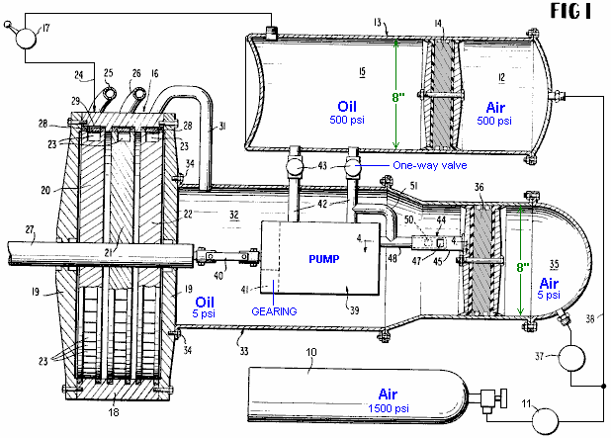

Richard Clem’s Motor.
What is not generally realised is that a hurricane develops excess energy due to its swirling circular movement. The generation of this extra power was observed and documented by Viktor Schauberger of Austria, who also used his observations to great effect. I think that what Schauberger says makes some people uncomfortable as they seem to think that anything “unorthodox” has to be weird and too peculiar to be mentioned. This is rather strange as all that is involved here is a simple observation of how our environment actually works. A hurricane is wider at the top than at the bottom and this concentrates power at the base of the swirling mass of air. This tapered rotation is called a “vortex” which is just a simple name to describe the shape, but any mention of “vortex power” (the power at the base of this rotation) seems to make many people uncomfortable which is most peculiar.

Leaving that aside, the question is “can we use this energy gain from the environment for our own purposes?”. The answer may well be “Yes”. Perhaps this principle is utilised by Richard Clem. In 1992, Richard Clem of Texas, demonstrated a self-powered engine of an unusual type. This engine, which he had been developing for twenty years or more, weighs about 200 pounds (90 kilos) and generated a measured 350 horsepower continuously over the full period of a nine-day self-powered test. Although this engine which runs from 1,800 to 2,300 rpm is especially suited to powering an electrical generator, Richard did install one in a car, and estimated that it would run for 150,000 miles without any need for attention and without any kind of fuel. Richard said that his prototype car had reached a speed of 105 mph. Just after receiving funding to produce his engine, Richard died suddenly and unexpectedly at about 48 years of age, the death certificate having “heart attack” written on it as the cause of death. Remarkably convenient timing for the oil companies who would have lost major amounts of money through reduced fuel sales if Richard’s motor had gone into production.

The motor is unusual in that it is a rotary turbine style design which runs at a temperature of 300ºF (140ºC) and because of that high temperature, uses cooking oil as its operational fluid, rather than water as the oil has a much higher boiling point. To a quick glance, this looks like an impossible device as it appears to be a purely mechanical engine, which will definitely have an operating efficiency which is less than 100%.

In broad outline, the oil is pumped through a pipe and into the narrow end of the cone-shaped rotor. The engine is started by being rotated by an external starter motor until it reaches the speed at which it generates enough power to be sustain its own operation. The rapid spinning of the cone, causes the oil to run along spiral grooves cut in the inner face of the cone and exit through angled nozzles placed at the large end of the cone:

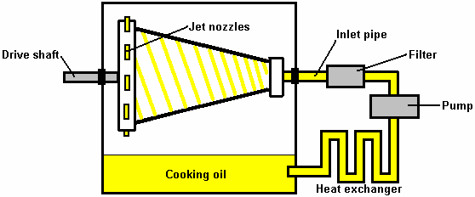

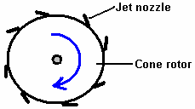

The operating pressure produced by the pump is 300 to 500 psi. Richard did not attempt to patent his engine as US Patent 3,697,190 “Truncated Conical Drag Pump” granted in 1972 as a liquid-asphalt pump is so close in detail that Richard felt that there was insufficient difference for him to be granted a patent:

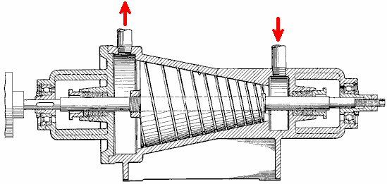

There appears to be considerable scope for anyone who wishes to build or manufacture this engine and it is capable of acting as a heater as well as device for producing mechanical power. This suggests that water purification could be an additional “extra” option for this engine.

Prof. Alfred Evert of Germany has produced an analysis of the operation of the Clem Engine and turbines in this general category. His website http://evert.de/indefte.htm has a good deal of information on the subject.

Josef Papp’s Inert Gas Engine Conversion.
The Hungarian, Josef Papp, invented an unusual engine system which genuinely appears to be very nearly “fuel-less”. His design modifies an existing vehicle engine to operate on a fixed amount of gas. That is to say, the engine has no air intake and no exhaust and consequently, no inlet or exhaust valves. The engine cylinders contain a mixture of gases which have an Atomic Number below 19, specifically, 36% helium, 26% neon, 17% argon, 13% krypton, and 8% xenon by volume. The control system causes the contained gas to expand to drive the pistons down the cylinders and then contract to suck the pistons back up the cylinders. This effectively converts the engine into a one-stroke version where there are two power strokes per revolution from every cylinder.

A small amount of radioactive material is used in the engine, and I have seen it suggested that the engine should be screened to protect the user from radiation. I’m not sure that this is correct, but if it is, then it suggests that a matter to energy conversion is indeed taking place. It seems most unlikely that the minor amount of radioactive material in the engine itself could cause any significant radiation. The patent describes the material as “low-level” which suggests to me, material no more dangerous that the luminous paint that used to be used on the hands of clocks and watches.

Suitable engines must have an even number of cylinders as they operate in pairs. Josef’s first prototype was a four-cylinder, 90 horsepower Volvo engine. He removed the intake and exhaust components and replaced the engine head with his own design. During a thirty-five minute test in a closed room, the engine generated a constant 300 horsepower output at 4,000 rpm. The electrical power needed to run the engine was produced by the standard engine alternator, which was also able to charge the car battery at the same time. Interestingly, an engine of this type, quite apart from having zero pollution emissions (other than heat), is quite capable of operating under water.

Josef, a draftsman and ex-pilot, emigrated from Hungary to Canada in 1957 where he lived until his death in April 1989. There is solid evidence that Josef built an engine of over 100 horsepower (75 kilowatts) that was "fuelled" by a mixture of inert (or “noble”) gases. With no exhaust or cooling system, it had huge torque even at low rpm (776 foot-pounds at only 726 rpm in one certified test). Dozens of engineers, scientists, investors and a Federal judge with an engineering background saw the engine working in closed rooms for hours. This would not have been possible if the engine had been using fossil fuel. There was absolutely no exhaust and no visible provision for any exhaust. The engine ran cool at about 60°C (140°F) on its surface, as witnessed by several reliable observers. All these people became convinced of the engine's performance. They all failed to discover a hoax. Ongoing research in the United States (totally independent of Papp) has proved conclusively that inert gases, electrically triggered in various ways, can indeed explode with fantastic violence and energy release, melting metal parts and pushing pistons with large pressure pulses. Some of the people performing this work, or who have evaluated it, are experienced plasma physicists. Contemporary laboratory work has established that inert gases can be made to explode

In a demonstration on 27th October 1968 in the Californian desert, Cecil Baumgartner, representing the top management of the TRW aerospace corporation and others witnessed the detonation of one of the engine cylinders. In full public view, just a few cubic centimetres of the inert gas mixture was injected into the cylinder using a hypodermic needle. When the gas was electrically triggered, the thick steel walls of the cylinder were burst open in a dramatic way. William White, Edmund Karig, and James Green, observers from the Naval Underseas Warfare Laboratory had earlier sealed the chamber so that Papp or others could not insert explosives as part of a hoax. In 1983, an independent certification test was carried out on one of the Papp engines. Joseph Papp was issued three United States patents for his process and engines:

US 3,680,431 on 1st August 1972 "Method and Means for Generating Explosive Forces" in which he states the general nature of the inert gas mixture necessary to produce explosive release of energy. He also suggests several of the triggering sources that may be involved. It appears that Papp is not offering full disclosure here, but there is no doubt that others who have examined this patent and followed its outline have already been able to obtain explosive detonations in inert gases.

US 3,670,494 on 20th June 1972 "Method and Means of Converting Atomic Energy into Utilisable Kinetic Energy" and

US 4,428,193 on 31st January 1984 "Inert Gas Fuel, Fuel Preparation Apparatus and System for Extracting Useful Work from the Fuel". This patent shown here, is very detailed and provides information on building and operating engines of this type. It also gives considerable detail on apparatus for producing the optimum mixture of the necessary gasses.

At the time of writing, a web-based video of one of the Papp prototype engines running on a test bed, can be found at http://www.youtube.com/watch?v=N4li_z4Jpso although it must be said that a good deal of the footage is of very poor quality, having been taken many years ago. The video is particularly interesting in that some of the demonstrations include instances where a transparent cylinder is used to show the energy explosion. Frame-by-frame operation on the original video shows energy being developed outside the cylinder as well as inside the cylinder, which does seem to suggest that the zero-point energy field is involved. I have recently been contacted by one man who attended some of the engine demonstrations run by Papp and he vouches for the fact that the engine performed exactly as described.

Papp’s Patent US 4,428,193 is shown in full in the Appendix.

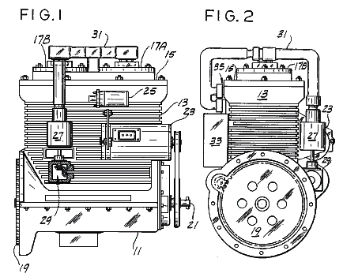
Josef never managed to get his engine design into commercial production before his death, primarily due to the opposition of vested interests. However, his design principles have been picked up and advanced by John Rohner and Haik Biglari.

The “Plasmic Transition Process” is the subject of various patents pending by PlasmERG Inc. of Iowa. John Rohner founded this company in 2008 to be the means to disseminate, develop and license this technology to other motor manufacturers for their own use. This process originally called the "Papp Engine" did run in 1982 and was then lost until John, and his partner Haik Biglari rediscovered it and applied modern science to the system to explain the process and filed their patents, presently pending. The original process was based on information originally patented by the late Joseph Papp, whose patents have now expired. John Rohner, a well known new-product design engineer, was originally contacted in 1979 by his brother Robert, with a schematic for the controller which Papp had designed. Unfortunately, John was busy with several other projects so he turned it over to his brother Tom.

PlasmERG has designed two motors for Own-Equipment-Manufacturers to use. One is an opposed, 2-cylinder, 120 cubic inch engine which produces some 300 horsepower. The second is a 6-cylinder 360 cubic inch engine which can produce around 1,500 horsepower. These motors are being co-developed with a sister company in Canada. John Rohner has personally provided the total investment for this development. As the company moves toward manufacturing, they are seeking investment partners by trading stock for investment. Their first commercial manufacturing plant will cost about 10 million dollars.

An alternative strategy is to create licenses for existing car and truck motor manufacturers until they can fund their own production. The current plan is to provide 500 to 1,000 test sites in underdeveloped nations for water pumping and power generation as "humanitarian" test sites. This should allow the time needed to get production understood and patents completed.

The expected run time of a motor from a single inert gas charge is over 3 months of continuous operation and gas re-charge should cost less than US $50. John stresses that the PlasmERG motor is not, (just as the original Papp engine was not), a "Pulsed Plasma motor". Plasma is not retained and "pulsed" as some people have supposed. What actually happens is that the plasma is recreated with each power stroke and then returns to a steady state gas on each return stroke, from which the name “Plasmic Transition” is derived.

The initial power and creation of plasma for expansion, is produced by a fusion event with a side-effect of a limited "chaotic" fission event causing a “plasmic transition” which is contained in a sealed 2-cycle rotating crankshaft motor.

There are two parallels to Plasmic Transition and power production of this motor. The first is natural lightning, which uses an almost identically similar Plasmic Transition process; and the second is steam which provides the same torque over rotational speed event characteristics. There is nothing in the ordinary internal combustion motor's operation that is comparable to either of these processes. The most crucial part of PlasmERG's motor operation is the Electronic Control System (ECS), comprising the following elements:
- • Programmable micro computers;
- • Radio frequency power generator;
- • HV spark coil initiation driver;
- • Various electromagnetic coil voltage switches providing base (resting) or variable (engine speed) voltages for all cylinder or reaction chamber electromagnetic coils;
- • On-controller DC to 12 volt DC converter;
- • Engine speed DC voltage (accelerator) to programmed variable voltage DC converter,
- • Inter controller communications port;
• Instrument support for user panel and action port which receives commands from the user comprising by not limited to things like Run, Start, Throttle position, Hold speed, Brake application, Brake hard, various motor inputs and fuel container information.

The PlasmaERG’s website is at http://plasmerg.com/ but it needs Internet Explorer to display properly as it has major display problems when Firefox is used.

John Rohner’s Patent Application US 2011/0113772 A1 entitled “Plasmic Transition Process Motor” can be downloaded from www.freepatentsonline.com or from www.free-energy-info.com. It shows a 2-cylinder motor as an example of the operation:

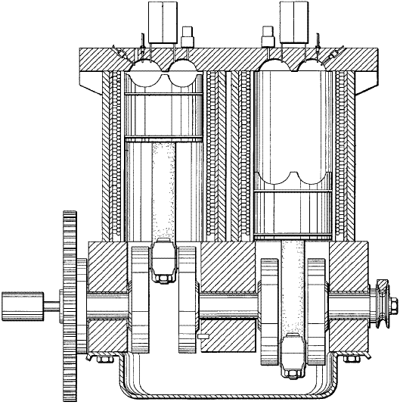

Robert Britt’s Inert Gas Motor.
Robert Britt designed a very similar engine to that of Josef Papp, and he was also awarded a US patent for an engine operating on inert gasses. William Lyne remarks that this engine design may be replicated using a Chevy “Monza” 6-cylinder engine or a VolksWagen 4-cylinder engine. The heads are removed and the new heads cast using the “pot metal” used for “pseudo chrome” automotive trim. That alloy contains aluminium, tin, zinc and possibly antimony and is particularly suitable as the insides of the cavities can be polished to the high reflectivity specified in the patents.

A full copy of Robert Britt’s patent US 3,977,191 is in the Appendix.

Heinrich Klostermann’s Air Plasma Motor.
Both Josef Papp and Robert Britt specified inert gas for operation, but Heinrich Klostermann points out that ordinary air is quite sufficient. His video is at https://www.youtube.com/watch?v=lNSAXbZfnbE at this time. His patent is:

US Patent 7,076,950 18th July 2006 Inventor: Heinrich Klostermann

Internal Explosion Engine and Generator Using Non-combustible Gases

Abstract:
An internal explosion engine and generator having an explosion chamber, a movable member forming one wall of the chamber, a charge of non-combustible gas sealed inside the chamber, means for repeatedly igniting the gas in an explosive manner to drive the movable member from a position of minimum volume to a position of maximum volume, means for returning the movable member from the position of maximum volume to the position of minimum volume, and means coupled to the movable member for providing electrical energy in response to explosion of the gas. In one disclosed embodiment, the movable member is a piston connected to a crankshaft, and it is returned to the position of minimum volume by a flywheel on the crankshaft. In another embodiment, two pistons are connected back-to-back in a hermetically sealed chamber to prevent loss of the explosive gas. In one embodiment, the electrical energy is produced by a generator connected to the crankshaft, and in the other it is produced by a coil positioned near a magnet which moves with the pistons.

US Patent References:
6739131 | Combustion-driven hydroelectric generating system with closed loop control | 2004-05-25 | Kershaw
6272855 | Two cycle heat engine | 2001-08-14 | Leonardi
5899071 | Adaptive thermal controller for heat engines | 1999-05-04 | Stone et al.
4428193 | Inert gas fuel, fuel preparation apparatus and system for extracting useful work from the fuel | 1984-01-31 | Papp
4416113 | Internal expansion engine | 1983-11-22 | Portillo
4306414 | Method of performing work | 1981-12-22 | Kuhns
3680431 | METHOD AND MEANS FOR GENERATING EXPLOSIVE FORCES | 1972-08-01 | Papp
3670494 | METHOD AND MEANS OF CONVERTING ATOMIC ENERGY INTO UTILIZABLE KINETIC ENERGY | 1972-06-20 | Papp
3237847 | Compressor and method | 1966-03-01 | Wilson
2984067 | Variable speed steam engine | 1961-05-16 | Morris

Other References:
Mallove et al., Infinite Energy, Sep./Oct. 2003, vol. 9, No. 51, New Energy Foundation, Inc., Concord, NH, USA.

Description:

BACKGROUND OF THE INVENTION

1. Field of Invention
This invention pertains generally to engines and generators and, more particularly, to an internal explosion engine and generator using non-combustible gasses.

2. Related Art
An internal explosion engine is generally similar in principle to an internal combustion engine except that it uses non-combustible gases such as air, oxygen, nitrogen or inert gas instead of the combustible gases which are used in internal combustion engines. Prior to operation, the gas for operating an internal explosion engine is placed in the explosion chamber of the engine, and the chamber is sealed. During operation, the gas in the explosion chamber is repeatedly compressed, ionised, explosively expanded and contracted to move a piston or rotor or other movable device to convert kinetic energy to mechanical or electrical energy. Once the gas has been loaded into the explosion chamber, the engine can operate for extended periods of time without additional fuel. There is no need for fuel intake on each cycle of operation, as in an internal combustion engine, and there is no exhaust. Examples of internal explosion engines of the prior art are found in U.S. Pat. Nos. 3,670,494 and 4,428,193.

OBJECTS AND SUMMARY OF THE INVENTION
It is, in general, an object of the invention to provide a new and improved internal explosion engine and generator. Another object of the invention is to provide an internal explosion engine and generator of the above character which overcomes the limitations and disadvantages of the engines and generators which heretofore have been provided. These and other objects are achieved in accordance with the invention by providing an internal explosion engine and generator which has an explosion chamber, a movable member forming one wall of the chamber, a charge of non-explosive gas sealed inside the chamber, means for repeatedly igniting the gas in an explosive manner to drive the movable member from a position of minimum volume to a position of maximum volume, means for returning the movable member from the position of maximum volume to the position of minimum volume, and means coupled to the movable member for providing electrical energy in response to explosion of the gas. In one disclosed embodiment, the movable member is a piston connected to a crankshaft, and it is returned to the position of minimum volume by a flywheel on the crankshaft. In another, two pistons are connected back-to-back in a hermetically sealed chamber to prevent loss of the explosive gas. In one embodiment, the electrical energy is produced by a generator connected to the crankshaft, and in the other it is produced by a coil positioned near a magnet which moves with the pistons.

BRIEF DESCRIPTION OF THE DRAWINGS

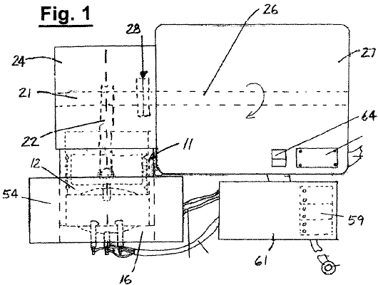
Fig.1 is a top plan view of one embodiment of an internal explosion engine and generator incorporating the invention.

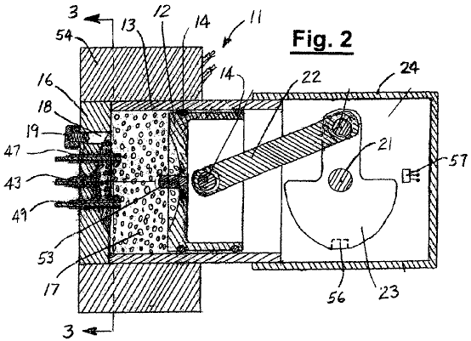

Fig.2 is a cross-sectional view, taken along line 2—2 in Fig.1.

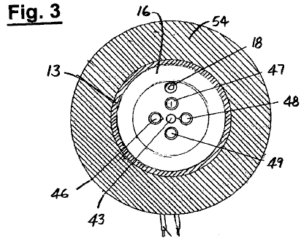

Fig.3 is a cross-sectional view, taken along line 3—3 in Fig.2.

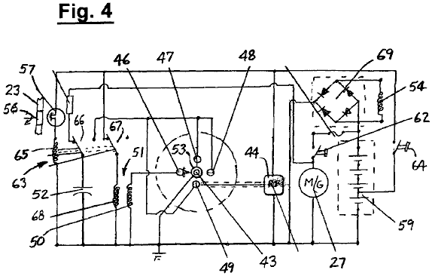
Fig.4 is a circuit diagram of the embodiment of Fig.1.

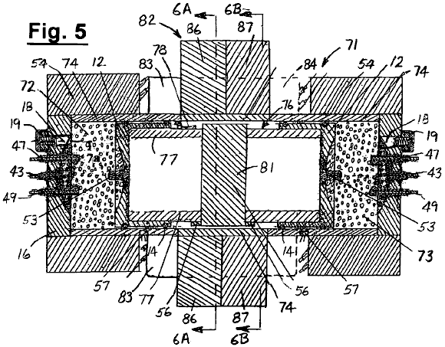

Fig.5 is a centreline sectional view of another embodiment of an internal explosion engine and generator incorporating the invention.

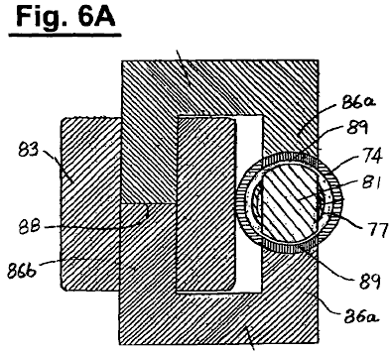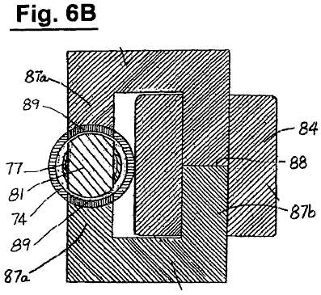

Fig.6A and Fig.6B are cross-sectional views, taken along lines 6A—6A and 6B—6B in Fig.5.

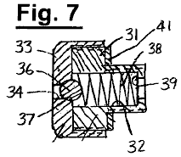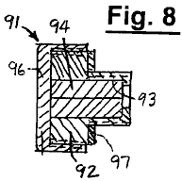
Fig.7 and Fig.8 are enlarged centreline sectional views of valve and plug assemblies for the gas loading port in the embodiments of Fig.1 and Fig.5.

DETAILED DESCRIPTION

As illustrated in Fig.1 to Fig.3, the engine 11 includes a piston 12 in a cylinder 13, with rings 14 providing a seal between the piston and the inner wall of the cylinder. The upper or outer end of the cylinder is sealed by an end plate or head 16, and an explosion chamber 17 is formed between the cylinder head and the piston. An inlet port 18 is formed in the cylinder head for introducing a charge of gas into the explosion chamber, and the admission of gas through the port is controlled by a valve assembly 19. The piston is connected to a crankshaft 21 by a connecting rod 22, and the crankshaft includes a counterweight or flywheel 23. In operation, the piston is driven in a downward direction by the explosion of the gas in the chamber and returned to the firing position by energy stored in the flywheel. The lower end of cylinder 13 is closed by a crankcase housing 24. The crankshaft is connected to the shaft 26 of a generator 27 located outside the crankcase housing by a coupling 28. As discussed more fully hereinafter, the generator can also be driven as a motor for use in starting the engine.

In the embodiment illustrated, valve assembly 19 is a one-way check valve which allows gas to pass into but not out of the explosion chamber through inlet port 18. The valve assembly is shown in greater detail in Fig.7, and includes a body or bushing 31 with an axial bore or passageway 32. The inner end of the valve body is threaded into the port, and a cap 33 is threaded on to the enlarged outer end of the body. The cap includes a passageway 34, with communication between that passageway and passageway 32 being controlled by a ball 36 which is received in a seat 37 on the inner side of the cap. The ball is urged toward a closed position against the seat by a spring 38 which is constrained between the ball and a shoulder 39 at the inner end of the valve body. A gasket 41 provides a seal between the outer portion of the body and the head.

Electrodes are mounted in the head for igniting the gas in the chamber. A high frequency electrode 43 is positioned axially of the chamber and connected to a radio frequency generator 44 for ionising the gas to form a plasma. Electrodes 46–49 are spaced around electrode 43, with electrode 46 being connected to the secondary winding 50 of a spark coil 51 and electrodes 47–49 being connected to a capacitor 52. A contact pin 53 projects from the face of the piston in alignment with electrode 43.

Piston 12 and end plate or head 16 are made from a ferro-magnetic material such as Grade-416 stainless steel, and cylinder 13 is made of a non-ferrous material such Grade-303 stainless steel. A coil 54 is placed around the outer portion of the cylinder and coupled magnetically with the piston to form a reluctance generator.

Means is provided for detecting when the piston is in its top dead centre (TDC) or minimum volume position. This means includes a magnet 56 which is mounted on the counterweight or flywheel portion 23 of crankshaft 21 and a Hall-effect switch 57 which is mounted in a stationary position in the crankcase and actuated by the magnet when it comes into proximity to the switch.

Power for operating generator 27 as a motor to start the engine is provided by batteries 59 which, in the embodiment illustrated, are mounted inside the housing of a controller for the generator 61. The batteries are connected to the motor by a normally-open starting switch 62.

The batteries also provide power for the Radio Frequency generator 44 and for the electrodes 46–49 which ignite the gas in the chamber, with the energisation of those electrodes being controlled by a relay 63. The application of power to the Radio Frequency generator is controlled by an On/Off switch 64, and energisation of relay coil 65 is controlled by the On/Off switch and by the Hall-effect switch 57 which is connected between the on/off switch and the relay coil.

The relay has a first set of contacts 66 which switch capacitor 52 between the power source and the electrodes 47–49, and a second set of contacts 67 which connect the primary winding 68 of spark coil 51 to the power source. The batteries are charged with the current produced in coil 54 by the reluctance generator. That coil is connected to the input of a power rectifier 69, and the output of the rectifier is connected to the batteries.

Prior to operation, a charge of air is introduced into explosion chamber through check valve 19 and inlet port 18. To start the engine, on/off switch 64 is closed, thereby energising the Radio Frequency generator 44 and the primary winding of spark coil 51 and applying charging current to capacitor 52, and starter switch 62 is closed to energise generator 27 as a starting motor. The gas in the chamber is ionised by the RF power applied to electrode 43 to form a plasma.

As the piston makes its upward stroke, the air is compressed and heated, and toward top dead centre, the air is ionised by the. Radio Frequency power applied to electrode 43 to form a plasma. When the piston is at or near top dead centre, the Hall-effect switch 57 closes, energising relay coil 65. When the relay coil is energised, contacts 66 apply the charge which has built up on capacitor 52 to electrodes 47–49, and contacts 67 open to interrupt the current in the primary winding of spark coil 51, producing a high voltage discharge between spark electrode 46 and the contact pin 53 on the piston.

The spark from electrode 46 and the current from electrodes 47–49 flowing through the ionised air ignite the air, causing it to explode and produce a lightning-like pressure wave, with ultraviolet light, ozone and heat. That pressure wave drives the piston in a downward direction, turning crankshaft 21 and generator 27, storing mechanical energy in the flywheel and producing electrical energy from the generator.

After the piston reaches its maximum volume or bottom dead centre (BDC) position the mechanical energy stored in the flywheel causes the crankshaft to continue rotating, thereby driving the piston back toward top dead centre. The same charge of air is ignited over and over again for an extended period of time, and to the extent that any of the air is lost past the piston rings, it is automatically replenished by air entering the chamber through the check valve. Thus, with the piston on its down stroke, if the pressure in the chamber drops below the level set by spring 38, ball 36 moves away from its seat, allowing air to enter the chamber through the inlet port. During the upstroke, the pressure in the chamber holds the ball tightly against the seat, sealing the air in the chamber.

The embodiment of Fig.5 includes a free piston engine 71 which has a pair of explosion chambers 72, 73 at opposite ends of a cylinder 74. This engine differs from the embodiment of Fig.1 in that it has no crankshaft. However, the power producing mechanism is the same, and like reference numerals designate corresponding elements in the two embodiments. The outer ends of the cylinder are closed by end plates or heads 16, and the volumes of the two chambers vary in an opposite or complementary manner as a double ended piston assembly 76 is driven back and forth within the cylinder.

The piston assembly includes a pair of pistons 12 which are connected together in back-to-back fashion by a sleeve 77, with rings 14 providing a seal between the pistons and the cylinder. The pistons have central contact pins 53, and each of the explosion chambers has an inlet port 18 and electrodes 43, 46–49 for ionising and igniting the gas.

As in the embodiment of Fig.1, piston 12 and end plates 16 are made of a ferro-magnetic material, and cylinder 74 is made of a non-ferrous material such as non-ferrous stainless steel or nickel plated aluminium. Sleeve 77 is made of a non-ferrous material such as aluminium. Coils 54 are placed about the outer portions of the cylinder and coupled magnetically with the pistons to form reluctance generators.

Sleeve 77 carries magnets 56 which actuate Hall-effect switches 57 mounted outside cylinder 74 to determine when the pistons are at or near their top dead centre (TDC) positions. A grounding contact 78 carried by sleeve 77 makes sliding contact with the wall of the cylinder to maintain the pistons and contact pins 53 at ground potential.

The piston assembly also includes a relatively large permanent magnet 81 which is carried by sleeve 77 midway between the pistons. A ferro-magnetic core structure 82 provides flux coupling between magnet 81 and stator coils 83, 84 which are located outside the cylinder.

The core structure includes a pair of generally C-shaped cores 86, 87, each of which has pair of relatively short inner arms 86a, 87a which abut against the upper and lower surfaces of cylinder 74 and an outer arm 86b, 87b which is spaced laterally from the cylinder. The ends of the inner arms which abut against the cylinder have a concave curvature which matches the convex curvature of the outer wall of the cylinder, and coils 83, 84 are wound about outer arms of the cores. The cores are formed in two sections, with a split 88 across the outer arms to facilitate assembly.

Steel laminations 89 are embedded in the cylinder wall in contact with the short arms of the cores to complete the magnetic circuit. The laminations are hermetically sealed into the cylinder wall, and in one presently preferred embodiment they are stacks of silicon steel laminations with a thickness of 0.005 inch and a layer of nickel plating less than 0.001 inch thick sealing the stacks.

The stator coils can be used both as the windings of a motor for starting the engine and thereafter as the windings of a generator in which an electric current is produced as the piston assembly oscillates back and forth within the cylinder.

Since the cylinder is hermetically sealed, any gas leaking past the rings of the pistons will remain within the engine, rather than being lost to the outside environment as in the embodiment of Fig.1. In addition to air, suitable gases for use in the embodiment of Fig.5 include inert gases, oxygen, and mixtures of such gases.

With the gas hermetically sealed within the engine, it is not necessary to replenish the gas as often as it would be if the engine were not sealed, and inlet port 18 can be closed with the plug assembly 91 of Fig.8 rather than the valve assembly 19 of Fig.7, if desired. Alternatively, a source of gas can be connected to the inlet port via valve assembly 19 for automatic replenishment of the gas in the chambers as in the embodiment of Fig.1.

Plug assembly 91 includes a body or bushing 92 with a hollow interior 93 which is filled with a rubber insert 94. The inner end of the valve body is threaded into the port, and a cap 96 is threaded on to the enlarged outer end of the body to retain the insert in the plug. A gasket 97 provides a seal between the enlarged portion of the plug body and the end plate or head 16.

Operation and use of the embodiment of Fig.5 is similar to that described above in connection with the embodiment of Fig.1. A charge of the explosive gas is introduced into the explosion chambers through the inlet ports, and stator windings 83, 84 are energised to drive magnet 81 and the remainder of the piston assembly back and forth within the cylinder. As each of the pistons approaches its top dead centre position, the gas in the explosion chamber is compressed, then ionised and ignited so that it explodes and drives the piston assembly back toward the other end of the cylinder. As the magnet carried by the piston assembly moves back and forth within the gap in the core structure, the alternating flux it produces is coupled to coils 83, 84 to produce the output current in the generator windings.

The invention has a number of important features and advantages. It can use explosive fuel mixtures such as air, inert gases and other non-combustible gases which can be rapidly expanded and contracted multiple times to convert kinetic energy into electrical and/or mechanical power. The engine can have one or more explosion chambers with a piston forming a movable wall for changing the volume of each.

The operating gas is preloaded into the chambers, the inlet ports are sealed, and the engine can be operated with the same gas load over long periods of time and multiple explosive expansions and contractions at various frequencies, e.g. 30–60 cycles per second or more, without adding gas to the chambers.

In one disclosed embodiment, the loss of gas due to leakage is prevented by enclosing the engine in a hermetically sealed enclosure. In another, a check valve in the inlet port allows the gas in the chambers to be automatically replenished when the pressure in the chambers drops below a predetermined level. The hermetic sealing is particularly important and desirable if the engine is operated in environments such as outer space or underwater where replenishment gases may not be readily available.

The invention permits a wide range of design flexibility and can provide compact power supplies ranging in capacity from a few kilowatts to multiple megawatts, and it can be used in a wide variety of applications.

It is apparent from the foregoing that a new and improved internal explosion engine and generator has been provided. While only certain presently preferred embodiments have been described in detail, as will be apparent to those familiar with the art, certain changes and modifications can be made without departing from the scope of the invention.

Patrick Kelly

http://www.free-energy-info.tuks.nl/

