Chapter 23: Some Earth Observations

I used to believe that the Earth is a spinning sphere, but it is no longer possible to go on believing that. On the 8th of February 2018, the company Exalt claimed a new distance record for microwave transmission. Microwave transmission is always line-of-sight. The previous record was 225 Km, their present claim is 235 Km or 146 miles. Their transmission is from a 50-foot high tower on a beach in Cyprus, over sea to a similar tower on a beach in Lebanon:

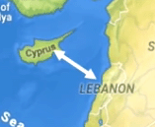

You will notice that the previous record was only five miles less. It is easy to confirm that the company Exalt exists and is offering its equipment for sale. However, their achievement completely destroys the possibility of the Earth being a sphere, in spite of what we have been told all of our lives. The calculation for the curvature of a 25,000 mile circumference sphere can be accomplished easily on the web (or less easily using paper and a pencil):

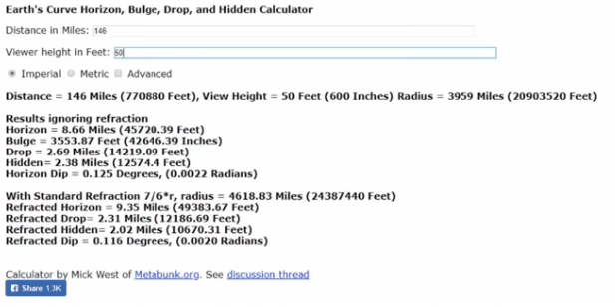

The resulting calculation causes a really major problem:

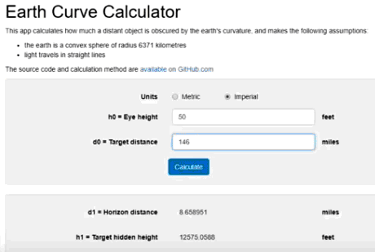

Shown graphically, the Exalt record transmission looks like this:

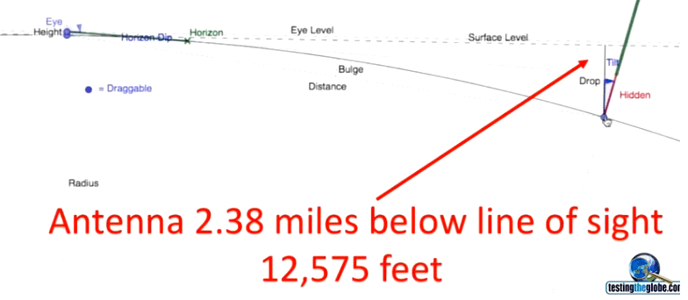

Remember that microwave transmissions are always in a straight line, so the Exalt microwave transmission is physically impossible if the Earth is a spherical globe.

This is further shown by aircraft flight paths. Taking examples shown in the information-packed video shown at https://www.youtube.com/watch?v=dO0a0_MqTTc we have these flights:

The flight from Johannesburg to Perth should be a straightforward 11 hour flight as shown here:

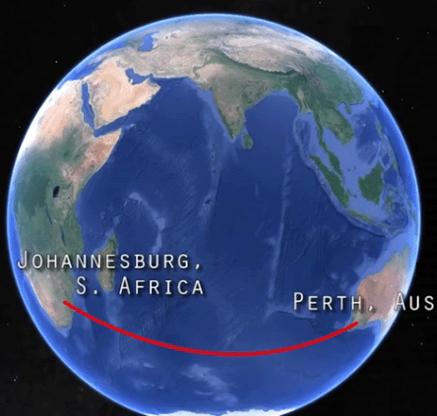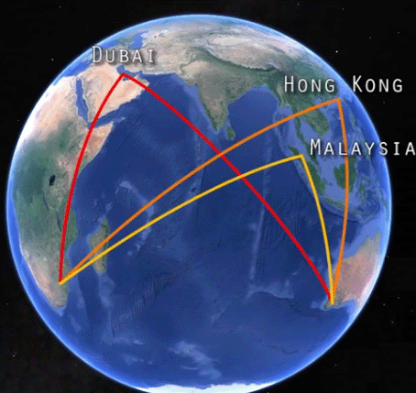

But the actual flight path stops for refuelling at either Dubai, Hong Kong or Malaysia with a flight time of more than 18 hours. On a globe Earth that is mad, but it is realistic if the Earth is flat:

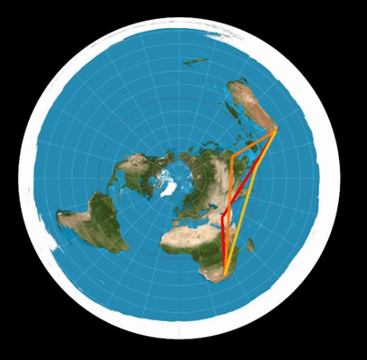

Then, consider the flight from Johannesburg to Santiago which should take about 12 hours. It diverts for refuelling and goes to Senegal taking 19 hours. If the Earth were a globe that would be mad, but if the Earth is flat then it makes perfect sense:

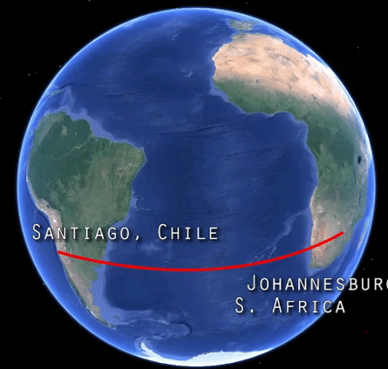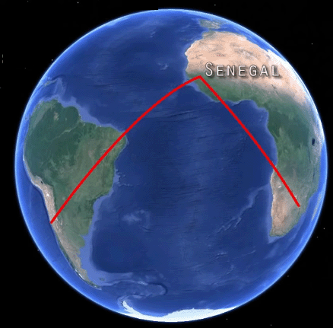

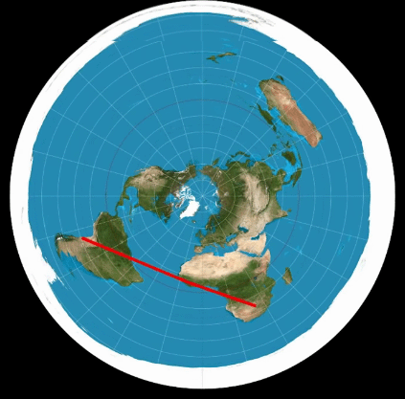

Then consider the flight from Santiago to Sydney – it diverts to Los Angles increasing the expected flight time of 15 hours to 27 hours:

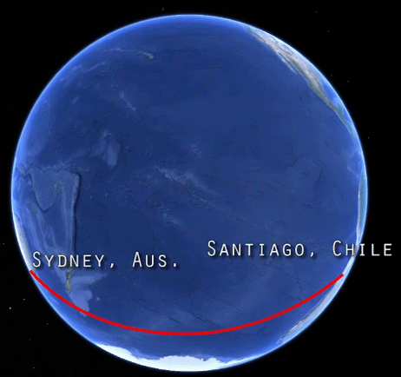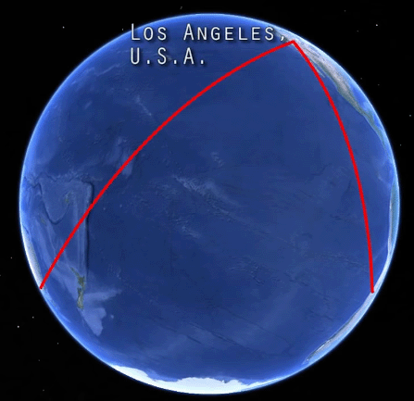

That flight path is shown not to be total madness if the Earth is flat:

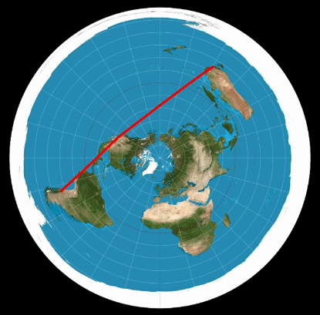

Moving on, there are, of course, many other things which show that the Earth is not a globe. For example, take the Suez Canal which is 100 miles long and joins the Mediterranean Sea to the Red Sea:

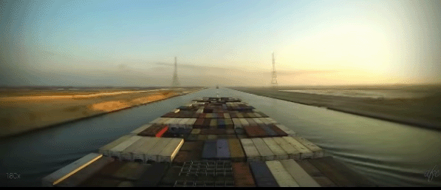

It has no locks and no allowance for the supposed curvature of the Earth was made during its construction. It is one hundred miles of flat waterway. If the Earth were a globe, then the middle of the canal would be 1666 feet higher than either end and instead of a canal there would be a dry mountain in the way. This shows that the Earth is definitely not a globe.

Then there is the matter of a ship sailing away from the land and steering straight out into an ocean. It appears that the ship goes down over a curved ocean, disappearing gradually until only the top of the superstructure is seen. That looks convincing until you look at the ship through a telescope. When you do that, you find that you can see all of the ship again, right down to the water level. What looks like the ship moving down a curved water surface may be highly misleading and the reality is likely to be poor visibility and considerable distance making it impossible to see the details as they really are, which is the ship sailing away on a flat water surface.

Personally, I think that we need to be very careful when considering visual observations which presume that light travels in straight lines, as that is not always the case. For example, it has been shown that light does not always travel in straight lines. Parallel to the ground it is probable that rays of light are straight but they are definitely not always straight when angled upwards. Some surveyors admit that they are unable to determine the heights of mountains with any degree of precision and their measurements may be off by as much as ten percent. Joseph Cater tested that fact using an altimeter which was set to zero at sea level and then driven to the top of a mountain at 42.5 degrees North latitude. The mountain was supposed to have an elevation of 9,269 feet. The altimeter reading agreed closely with the established elevations of towns along the route; elevations which were from 1000 to 4000 feet. However, at the top of the mountain, the reading was only 8,800 feet. The fact that the altimeter was accurate at all places except the top of the mountain (whose official height was estimated by triangulation), shows that light rays at the top of a mountain are not straight. So, perhaps using a telescope to see a ship which appears to have passed over a horizon is not reliable as the rays of light might have been curved parallel to the surface of the earth. Personally, I think that is unlikely but how can anyone test if those light rays are curved or not?

As another example, consider the London to Liverpool railway line. It passes through Birmingham about half way along the route. The journey is about 180 miles and if the Earth were a globe, then the curvature of the Earth would mean that Birmingham would be some 5,400 feet higher than either London or Liverpool. That, of course, is ridiculous. I seriously doubt that a train could manage the journey if that were the case. Common sense tells you immediately that there is no such curvature, and that shows clearly that the Earth is not a globe as described by the people who are lying to us.

Then we have the account published in the 1931 edition of Popular Science which recounts the experiences of a scientist who rose ten miles into the air in an airtight sphere and who reported that he could see the whole Earth and that it was flat with raised edges. There is, of course, the problem that he might be lying, but it does clear up the Bible mention of the “four corners” of the Earth which is not really possible with a sphere:

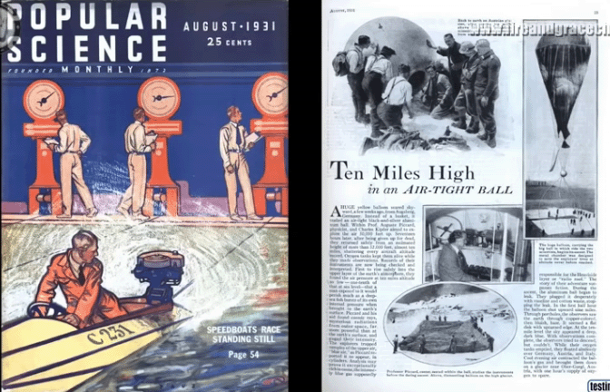

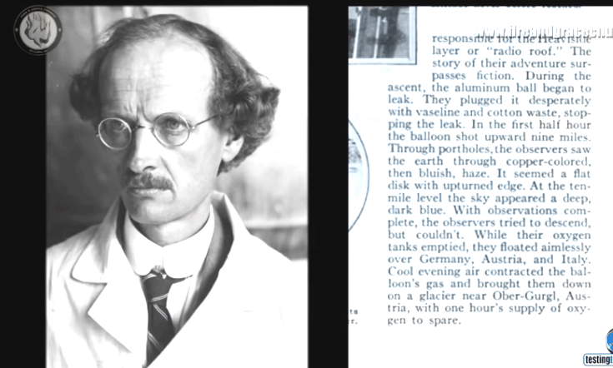

We have been told that the Earth is a sphere of some 25,000 miles circumference at the equator. It appears that the notion of a spherical Earth did not occur until the fifteenth century, and we have the problem that we do not have a single photograph of Earth taken from space. There is, of course, no point in mentioning the ridiculously faked supposed Moon landing in 1969 by the Americans.

Then we have the famous experiment where a swinging pendulum is supposed to show the Earth’s rotation as time goes by:

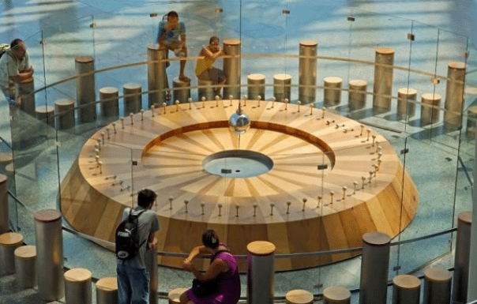

However, we have a problem with this as the pendulum sometimes indicates that the Earth is rotating in the opposite direction to yesterday’s rotation. So, we have to admit that the experiment is actually useless as it does not show anything reliable.

Then there is the Moon which is supposed to reflect sunlight and be eclipsed by the Earth’s shadow falling on the moon. Err,r,r no, The moon does not reflect sunlight, as moonlight is a completely different type of light, nor is it eclipsed by the Earth’s shadow, as you can see some eclipses when both the Sun and the Moon are visible at the same time and that is physically impossible. The Moon has its own light.

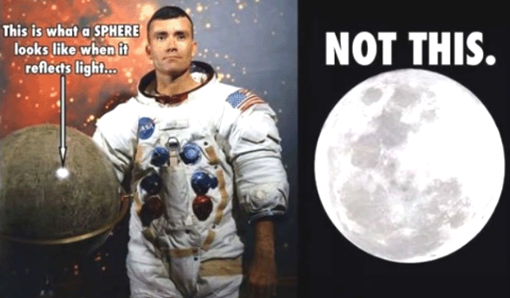

And then, we have the confession of Robert Simmon of NASA who freely admits to having composed the well known Earth image which has been touted ever since in spite of the magically changing size of America:

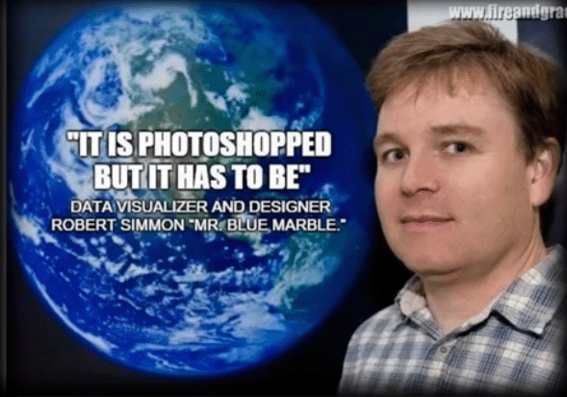

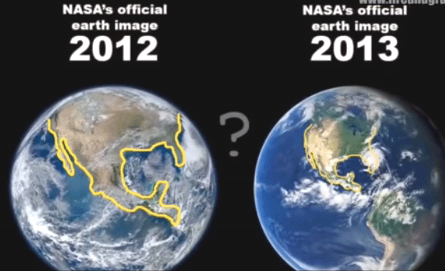

Even more obvious is the copying of imaginary cloud cover, over and over again:

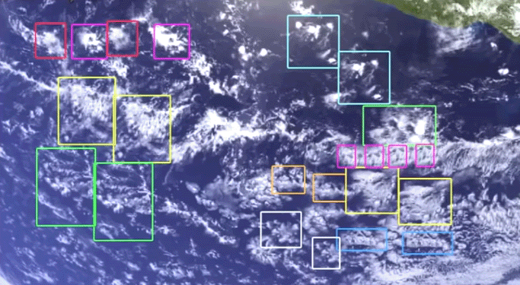

Then we have the problem of the map projection shown here:

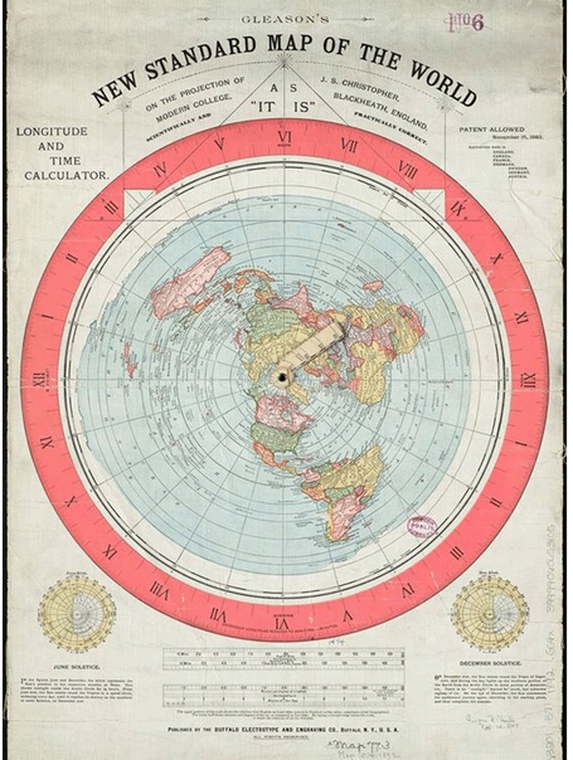

If this map is correct, then the South Pole is not a country surrounded by sea, instead it is a land mass of unknown size, bounded by large vertical cliffs of ice:

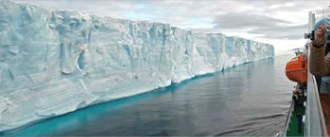

Ships have sailed some 60,000 miles along this wall while trying to circumnavigate the South Pole and they confirm that there is no break anywhere in it. If the earth were a globe, then at just 80 degrees South the circumference of the Earth would be about 12,409 miles and it would be physically impossible to sail 60,000 miles along a continuous coastline near that latitude.

If the Earth were a globe and the Sun a very large body some 93,000,000 miles away, then the North Pole and the South Pole would receive the same amount of sunlight and heat. That is not the case. Near the North Pole summer and winter are very different and they are like this:



While near the South Pole it is just too cold for plants at any time of the year. In fact, at the same distance South of the equator as the United Kingdom is North of the equator, this is what it is like in “summer”:

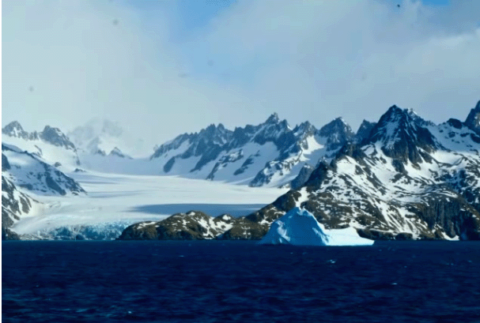

In the UK in summer there are thousands of plants, crops, fruits, etc. and even as far North as the North Pole itself there are animals:



And that is a major contrast to the Southern land mass where it never gets warm enough to melt the ice. The average temperature at the South land mass is minus 50 degrees Centigrade while at the North Pole the average temperature is minus 15 degrees Centigrade.

So, without taking the details any further, we can see clearly, using just common sense, that the Earth is NOT a spinning planet globe.

So why do NASA and others promote these silly notions? There are various reasons. They want an excuse to take for themselves, large amounts of money which they don’t spend on space rockets, orbiting space stations, space shuttles and the like. They also want you to believe all of their lies no matter how silly those ideas are. They want you to feel insignificant – just a tiny part of a tiny planet in an insignificant part of an amazingly large universe. They want you to serve them and be their obedient slave all through your life – aren’t you delighted that these charming people run the world?

It is perfectly clear that the Earth is not a globe or sphere. It is also clear that the Earth is not spinning but is fixed in position. It is highly unlikely that it is possible for an object to “orbit” the Earth. If that is the case, then the International Space Station (“ISS”) is a fiction and it does not exist. Video recordings supposedly taken in “zero gravity” inside the ISS are clearly a series of short recordings inexpertly strung together. Those recordings will have been taken inside one of the “Zero G” aircraft as they simulate a gravity free environment by diving rapidly towards the ground.

Before the Global Positioning Service (“GPS”) was introduced, there was a navigation system for marine users. It was called “Loran C” and did not involve the use of satellites. It is highly likely that there are no satellites in orbit, no matter what anybody says, and if that is so, then the GPS service is run using ground based transmitters. This is something which is quite hard to come to terms with as we have been told all our lives that Earth is a globe spinning in space and surrounded by thousands of satellites which send pictures, communications and other data back to Earth on a continuous basis. However, remember that the people who have destroyed our educational system are dedicated to lying, and even while they admit that they can’t fly above “low Earth orbit” that statement slips in the implication that orbiting the Earth is possible, while in fact, it isn’t. If orbiting were possible, then it would have been much cheaper and more convincing to just record inside the ISS instead of going to all the trouble to produce unconvincing video patched together from many separate short clips.

Then we have the major problem of the moon. Moonlight is quite different from sunlight. The temperature in sunlight is higher than the temperature in nearby shade. The temperature in moonlight is lower than the temperature in nearby shade. That shows clearly that moonlight is not sunlight reflected off a planet called the Moon. The Moon has it’s own light source. Actually, is the Moon really a planet? If it is, then how come that various different amateur astronomers have observed stars through the Moon?

Anyway, let’s step back and check what the situation is:

1. The Earth is essentially a flat disc and not a sphere. I apologise if you have to walk up mountains every day, but on average, the Earth is “flat”. You can be sure of this from common sense measurements and deductions, but the really major confirmation is that the “globe is a sphere” people want to make everybody laugh at the flat-Earth notion rather than examining the facts. The notion of the Earth being a sphere comes from science fiction, reinforced by the Star Trek fiction series, Star Wars and the like. William Shatner, the actor who played “Captain Kirk” in the first Star Trek series started asking questions and he came to the inevitable conclusion that “Science is Science Fiction”.

This artistic graphic:
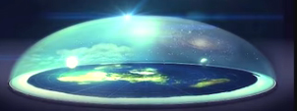

Is probably close to reality. It shows a flat disc Earth covered with a transparent dome called the “firmament” in the Bible, and the Sun and the Moon are shown inside the dome. However, it is likely that there is a substantial amount of additional land outside the white cliffs of ice which are shown retaining the oceans. This notion of a spherical Earth is the first step in confusing the general population in order to make them believe in a totally false fiction.

2. The disc Earth allows sailing circumnavigation East/West or West/East. For that, power has to be applied continuously to the sailing vessel to make it complete the circuit. There is no possibility of a vessel circumnavigating in a North/South direction as the Earth is not a sphere. But that also applies to a satellite orbiting the Earth. The satellite would have to orbit in the same way as a ship circumnavigating the Earth and that would require the continuous provision of power in order to keep the satellite in the air and moving in a circle. That was just not practical when the first satellites were supposed to have been launched, so the notion of a satellite is a pure hoax intended as the next step in confusing people in general.

Further, there are supposed to be some 3000 active satellites in orbit at this time. It has been calculated that if there were even 1500 such notional satellites, then an observer on Earth would see about one hundred of them transit the Moon in an hour or two, even if the satellites were in the ridiculous 22,000 mile high orbit proposed for stationary satellites. There is not the slightest chance of stationary satellites as the Earth is not spinning.

3. As there are no satellites, it is quite clear that the International Space Station is also a hoax. That is also obvious from the suspension wires used in the videos, the clear editing of a whole series of short videos made in a zero-G plane and then patched together to make a supposed ISS video interview. Again, this is another step in trying to confuse people and get them to accept a complete fiction about their surroundings.

4. Then we have the massive fiction of the supposed Moon landing in 1969. That operation is so riddled with errors and inconsistencies that it just can’t be believed. A recording has been found of part of the faking work, the astronauts (actors really) contradict each other on major points, one astronaut has admitted that they never went to the moon, the Moon rock samples have been shown to be fake, etc. etc. However, that fiction was a major step forward in the push to fool the general public into believing their fake description of Earth being a sphere instead of a disc.

5. Then there was the attempt to break through the firmament when Operation Fishbowl and Operation Dominick launched rockets straight up and caused large explosions when the rockets hit the firmament. Those were passed off as launch failures in spite of the fact that the rockets did exactly what they were supposed to do. Those launches were not covered in any detail as there being a firmament above us is highly destructive to their ridiculous fiction. Instead, they invented the Van Allen radiation belt which is supposedly so destructive and dangerous that nobody would really want to go past the firmament, now would they?

6. The Nazi officer Werner Von Braun set up the National Aeronautics and Space Administration (“NASA”) to manage teams of other Nazis who came to America along with him in 1945. NASA receives more than US $50,000,000 per day of taxpayer’s money, to fund it’s operations. It is probably the most untruthful organisation of all time. It’s purpose, apart from being an excuse to fleece the American people, is to reinforce the quaint notion of their supposed universe – a spherical Earth suspended in space, spinning on it’s axis, orbiting around the Sun, …..

7. So, what does NASA say? It says that stars are suns which are far away, many of which are millions of times bigger than the Earth. The Bible says that on a chosen day, the stars will fall to Earth, and that couldn’t happen if millions of stars are millions of times bigger than the Earth. So do you believe NASA or do you believe the Bible? Modern telescopes available to amateur astronomers have improved in quality to such a degree that stars can be seen to be quite different to spherical suns.

8. The clever and cunning people of Tavistock House combine with NASA to produce all sorts of fiction designed to confuse and mislead world population generally. They talk about “space” and I have no idea if space exists or not, nor do I have any idea how to discover that it exists or not. The fact that NASA says that space exists is a strong argument that it does not exist. After all, consider the supposed spherical Earth. It is said to have a radius of about 4000 miles and “science” books show the position and thickness of various layers inside the globe in spite of the fact that the deepest drill hole ever managed went down less than 8 miles and that is only one fifth of 1 percent of the way. So, knowing only 0.2% of the information, “science” states categorically what the other 99.8% of the material is. Mind you, as the whole thing is a fiction and these wonderful people are the authors, they can say whatever they want. So, I have to agree with William Shatner that this is Science Fiction.

9. Dinosaurs are very popular. Unfortunately, it is highly probable that they never existed. The dinosaur bones shown in museums are made up from epoxy resin and ground up bones from other animals. No dinosaur skull has ever been found. It is almost certain that this is another fiction intended to confuse and misdirect people in general.

10. Dinosaurs are supposed to have died out some 65,000,000 years ago. Says who? Is there somebody around who is 65,000,000+ years old and who can remember them dying out? No? Then their age has been estimated from something? Please remember that there are people who are trying to fool us and confuse us and those people don’t mind lying to us.

We are also told that there are some 7,000,000,000 people on Earth at present. Really? Says who? We actually don’t have any way of telling how many people there are and the number could be very much less. The people who are telling us these numbers are deliberately trying to confuse us, so should we really believe what they say?

11. Nuclear weapons are (supposed to be) scary. Two cities in Japan were supposed to have been severely damaged by the first two operational nuclear bombs. The reality is that those two cities were destroyed by extensive fire bombing. Nuclear weapons are a hoax and have never worked. Instead, very large amounts of conventional explosives have been exploded together to produce the blast and video fakery has been used to create the impression of the nuclear cloud. This fiction has been used to frighten many people over a period of many years.

12. Another fiction intended to frighten people was the “Nine-Eleven” attack on the Twin Towers in America. First, that was a false-flag attack organised by Americans. Second, while some 3000 people were murdered in the attack, no aeroplanes were used. The Pentagon attack had an entrance hole in the building wall which was just too small to have been the supposed aircraft. The unexpected collapse of tower 7 was accidentally pre-announced more than 20 minutes before the building actually collapsed. As the unfortunate BBC reporter Jane Standley reported that World Trade Centre “Building 7” had collapsed, the actual building could still be seen standing intact behind her: http://www.youtube.com/watch?v=ltP2t9nq9fI.

Reporting an unexpected building collapse before it occurred, takes some explaining as to how prior knowledge of the event was in the hands of the BBC. The BBC operates a protection racket called the “TV Licence” scam, where people are threatened and coerced into paying an arbitrarily chosen amount of money to this private commercial company. There is actually, not the slightest doubt about this, a fact which was highlighted by the court case of Mr Rooke who was charged with the “crime” of withholding his TV licence fees, and in February 2013, in Surrey in England, the BBC took Mr Rooke to court. However, once the judge saw the evidence presented by Mr Rooke and his team of experts against the BBC, he had no option but to discharge the conviction. Mr Rooke felt that the BBC’s cover up of this evidence was supporting the true terrorists of 9/11 to get away with their crime. He refused to pay his TV licence fee on the basis of Section 15, Article 3 of the UK Terrorism Act which states that it is a crime to provide monetary support to any organisation that engages in or supports terrorist activity. In the opinion of Mr Rooke, by the BBC covering up the evidence about 9/11, they have been aiding and supporting the true perpetrators of 9/11, allowing them to escape justice, and that this is allowing a false version of 9/11 to continue to be used to justify further terrorist activity which is still continuing today. Therefore, in Mr Rooke’s opinion, to provide funds to the BBC through his TV licence fees would in effect be funding an organisation which is supporting terrorist activity, and under Section 15, Article 3 of the Terrorism Act, he would be committing a serious crime if he did this.
If you want full information on the facts surrounding the attack, then see the book “Where Did The Towers Go?” by Dr. Judy Wood.

Please understand that we are being told fiction upon fiction, co-ordinated by the Tavistock people in an attempt to confuse us and distract us, so please don’t be fooled by them.

Patrick Kelly
www.free-energy-info.com

