A Practical Guide to Free-Energy Devices Author: Patrick J. Kelly

Chapter 22: Dealing With Chemtrails

For many years now, aircraft have been used to spray tons of chemicals into the high atmosphere. Initially, the result looks like a harmless vapour trail in the sky, but it is not. Instead, the material sprayed is highly toxic and intentionally destructive, being a mixture of aluminium, heavy metals, radioactive particles and worst of all, nanotechnology micro robots. The sprayed material spreads out to become very widely dispersed and sinks slowly to the ground. People have no option but to breath in this noxious mixture. An air sample should have zero particles of free aluminium but air samples have now been measured with more than thirteen thousand (13,000) particles of free aluminium per litre. Those particles are nano-sized and that size passes through a person’s nasal passage membranes straight into the brain, causing the premature death of brain cells. Alzheimer’s and other degenerative diseases are now four times greater than they used to be, with occurrences being seen in people in their fifties instead of their eighties. The excuse (and it is only an excuse) for this spraying is that it is to oppose global warming. There is no global warming. We are moving into an ice age period which will last more than fifty years. The real purpose of this spraying is to make people stupid and ill.

An ordinary “con” (condensation) trail is caused by the rapid cooling of water vapour and carbon dioxide to form ice crystals and those trails do not normally persist for more than one minute. Chemtrails persist for a very long time and spread out to form a new type of cloud.



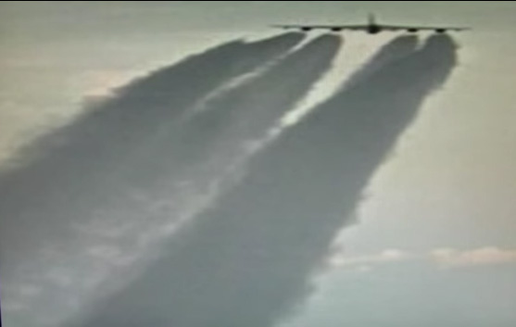





One of these two planes is laying a chemtrail, guess which one. Perhaps a slightly later photograph might help?

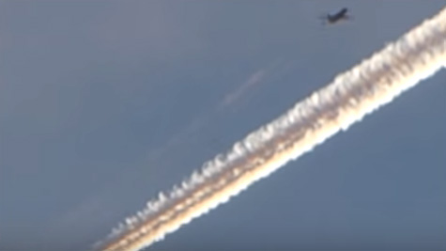

Hint: the contrail fades away quickly while the chemtrail most certainly does not – after all, it is there to poison you so there is a great deal there than just carbon dioxide and exhaust gas. This is what a sky heavily sprayed with chemtrails looks like:



Is this poisoning just in one place – perhaps a restricted test area?













Perhaps we are mistaken and these trails come from ordinary aircraft carrying passengers?

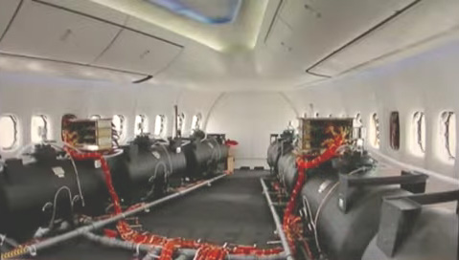

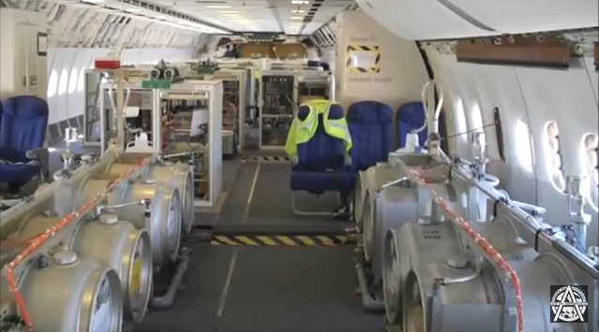

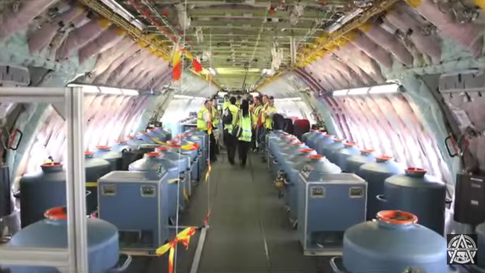

Well, actually, some ordinary commercial passenger flights have aluminium added to the fuel so that they also spray aluminium nano particles in their normal exhaust trail. A chemtrail disperses and hangs in the air for a long period of time while the heavy particles in it drop slowly towards the ground.

Please understand clearly that this is a deliberate attack on you personally. It is universal inoculation with poisons without your permission. It is also a covert operation as you have not been told about it and in passing, you are funding it if you pay tax (which you are forced to do as taxation is a protection racket which you can’t opt out of). So, welcome to our present reality!

However, the good news is that you can do something about it. First of all, the radioactive particles in the air are not just from the chemtrails but also come from the (supposed) accidents at nuclear power stations such as Fukishima, and the highly likely future “accidents” at other nuclear power plants. You can reduce the effect of radioactive particles in your body by using a couple of chemical compounds twice per day. Those are:



Tulsi tea which is also called Holy Basil and the herb Punarnava Mandur, both of which have been found to be highly helpful over many years of use.

However, we would really prefer to get rid of the chemtrail fallout before it reaches us and that can be done by using Orgone energy. Orgone is one of the many names given to the universal life force and it can be used to disperse and reputedly push the contaminants away from the earth.

It is worth watching the video at https://www.youtube.com/watch?v=YNfG5AYJxE0 where this matter is discussed in detail. The presentation is good and the home website of the presenter Sharon Daphna

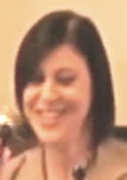

is located at www.thechembow.com where there is a detailed description of how to construct devices which can destroy chemtrails. This is one of many sites which provide instruction on the construction of such things, but it is very clear and straightforward. The objective is to construct a series of “orgonite” truncated pyramids as those can break up chemtrails by creating a vertical vortex of Orgone energy. The video is at https://vimeo.com/127330197.

The things used for this construction are:
A flexible silicone mould to determine the shape and size of the finished device.
A potting compound to bind all the components, mixing cups, disposable gloves and stirring spatula.
One or more crystal - quartz, amethyst, malachite, calcite, or any such crystal.
A small helical, clockwise-wound coil of bare copper wire (which is not a ‘Tesla Coil’).
Small metal pieces such as brass, iron or copper (easily cut from multi-strand copper cable).
Crushed selenite (optional), and paper towels for general cleaning of spills, etc.

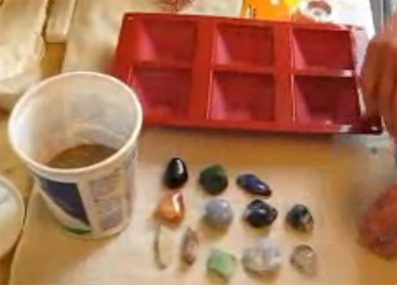

The pyramids are made in two separate sections. First, the potting compound is mixed. As the mixture gives off heat and fumes, this really needs to be done outdoors when the temperature of the day is 60F (18C) or more as the resin needs to be reasonably warm before being used. The resin is then poured into the moulds to fill them part way:

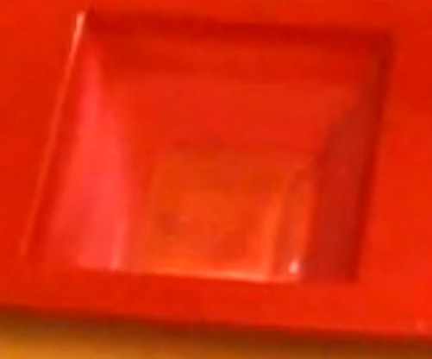

Next, small metal pieces are added - in this case, brass filings (obtained free from a locksmith):

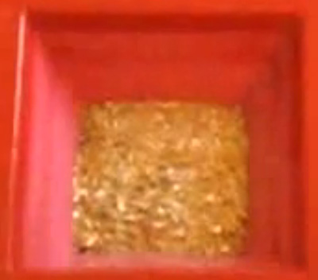

An alternative here would be to use stranded copper wire and cut off very short lengths as each cut produces several short lengths of copper wire. In this construction, a small amount of iron filings is also added to give extra output power:

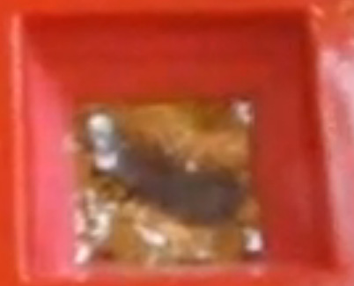

A coil is wound using any diameter of bare, solid copper wire. In this instance, the coils are wound around a pencil with the turns are spread out and only about 5 inches (125 mm) of wire is used per coil:

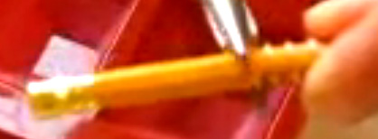

A different type of crystal is added to each of the pyramids and most interestingly, the crystals are laid flat instead of arranging a pointed end to be vertical:

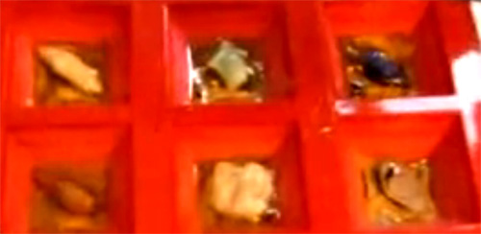

Next, some more resin is added and the small copper coil is added in an upright position. Also, if the main crystal is not quartz, some extra small pieces of quartz are added to give extra operational power:

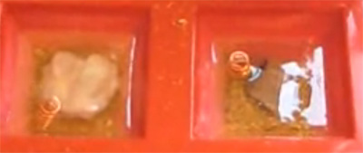

The construction is now left for an hour so that the resin can stiffen up without setting fully. Then some more resin is mixed and poured so that all of the components are covered. Then twenty-four hours are waited so that the resin is set fully, and then the pyramids are removed from the mould:

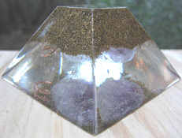

However, this type of pyramid is intended primarily for use around your home, while a more simple version called a “Tower Buster” is made in bulk to deal with wide areas of country. The ones shown above have cleared up the skies around Sharon’s house for a distance of about one mile in every direction, and so are very effective. The more simple version is less pretty but very effective. It is made with a cheaper resin and is made using an ordinary ‘muffin’ baking tray which is lubricated to stop the resin sticking to it:

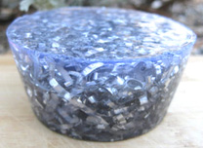

These simple shapes of Orgone are very important. All around developed countries there are now cell phone towers. They vary a bit in their construction, but generally they look like this:

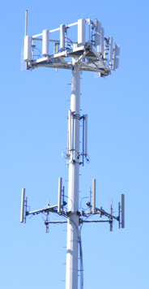

These innocent looking towers transmit both cell phone signals and other signals which are intentionally damaging to humans. It is very important to neutralise these towers and that can be done quite easily by placing an Orgonite Tower Buster anywhere within fifty metres of the tower. The Tower Buster can be buried to make it hard to find, but a Tower Buster will neutralise the harmful signals coming from the tower without preventing the cell phone signals from operating normally.

In other words, by adding a Tower Buster Orgone device to the area of the cell phone tower, you, personally, can improve the living conditions for everyone in your neighbourhood. Orgone enthusiasts also drive around the country, occasionally throwing an Orgone Tower Buster out of the car window so that it lands in bushes or trees. That is called “gifting” Orgone to the area and it clears major regions of chemtrails.

If, for some reason, it is not possible to make orgone pyramids or Tower Busters, then remember the Orgone treatments of chapter 23 where a plastic ring filled with Carbon GaNS water is used to promote the growth of vegetation by boosting Orgone flow where it is needed. Here, the ring is applied to the trunk of a tree:

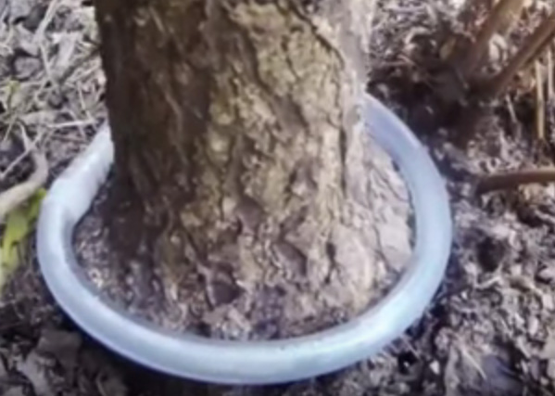

But, there is no reason that I know of why a ring like that should not be used as a Tower Buster or as any other form of Orgone booster. For example, if it is necessary to sit in a chair all day, there is no reason why a GaNS water ring should not be placed around the chair so that the person sitting on the chair receives a boost of Orgone energy when sitting there.

For years, governments denied that they were spraying chemicals on the general population. Eventually, they admitted that they were undertaking “geoengineering” (which involves spraying toxic chemicals on the general population). Interestingly, the American company Monsanto was developing aluminium-tolerant plants during that time. Isn’t it a remarkable coincidence that one of the major chemicals being sprayed is free aluminium - the metal associated with degenerative diseases such as Alzheimer’s and Parkinson’s disease?

As the Earth is entering a period of global cooling which will form one of the many ice ages already experienced by humanity, the ridiculous excuse that aluminium is being sprayed to offset “global warming” is laughable and even more so when it is said that humans are responsible for global warming through the production of carbon dioxide. It is already known that carbon dioxide is not the main global warming gas as that is water droplets in the air. Also, global warming took place well in advance of the industrial revolution which is supposed to have caused it, not to mention the fact that humans come a very poor third in the amount of carbon dioxide produced on Earth, with volcanoes being the leader, and insects and animals coming second, leaving humans a long way behind. Nor is it mentioned that with the amounts of carbon dioxide already in the air, increases no longer have any great warming effect at all. It might be remarked on that carbon dioxide is not a poison. We breath it out and plants need it to grow.

Anyway, if aluminium contaminated soil is a problem for farming, we may have to switch to using mainly aquaphonics where soil is not used and nutrients are fed to the plants through the water. Some versions of that use fish to complement the process in what turns out to be a very effective system:

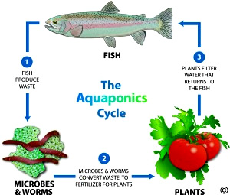

The most direct description for this is probably that fish live and breed in the water. While doing that they produce waste and microbes and worms break down that waste which then forms most of the nutrients needed by the plants. The plants absorb the nutrients and grow and in that process they clean up the water so that the fish have clean water in which to live. That is, of course, a very simplified description of what happens and there is a whole area of expertise involved in the successful running of an aquaphonics system.

The aquaphonics system would need to have a cover to keep any extraneous contaminants being dumped into the atmosphere, and Orgone devices to boost the plants and fish in the system. We may soon be driven to using such systems courtesy of the present spraying of toxins by “the powers that be”. A video on aquaphonics in very difficult temperatures can be seen at: https://www.youtube.com/watch?v=3LnG-ASYL1o&t=21s where the difficult conditions are eased by the use of GaNS material as described in chapter 23. The GaNS material is placed in a bottle which is then suspended in the water tank:

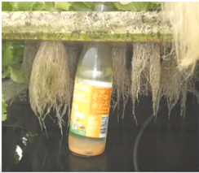

And that inclusion makes a massive amount of difference. Normally, using normal water, the hot weather causes premature shooting of the plants and it also causes weak, discoloured root systems and plants with thin leaves:

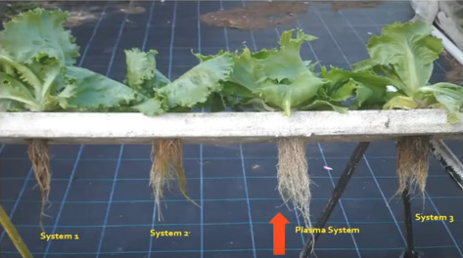

But, with the one 50 cc bottle of GaNS in the 24,000 litre water tank, produced much healthier plants with a normal white root system and a faster maturing time, not to mention the fact that the treated plants were typically three times heavier than the ones with just an ordinary water feed. Another detail is the fact that the fish were much more active and healthy with the GaNS system. After 31 days of growth, the difference in growth is very marked:

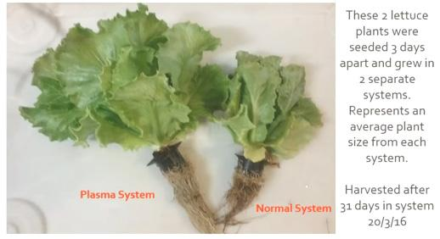

With aluminium contaminated soil, this sort of growing system may become essential.

However, Clif High, who is a very able presenter on the internet, points out that the Sun is now moving through an area of the galaxy which is quite unlike any we have passed through before. In Roman times the Sun was predominantly yellow in colour but since the year 2000 or so, the Sun colour is now much whiter with a much higher level of damaging radiation. On the sixteenth of April 2017 Clif points out that chemtrails in USA are now four or five times higher than ever before and he assumes that this increase is directly related to the new radiation coming from the Sun.

I can confirm that there is a high level of chemtrail spraying in the UK at this time. However, that is an interesting theory from Clif, but if what he says is true, then there would not be the slightest reason for the people doing the spraying to lie about it. They would merely need to say that “due to changes in the radiation reaching Earth from the Sun makes it essential to spray chemtrails in order to offset the additional harmful radiation”, but instead of saying that, they lie through their teeth and swear that they are not spraying chemtrails in spite of the fact that we can all see the chemtrails.

So, I leave it up to you to make up your own mind on whether or not the chemtrails are actually harmful and whether or not you should do something about them.

It has been indicated by various people that part of the attacks on humans is to be extreme weather events with excessive rain, droughts and the like. For that reason you should perhaps consider the following material:

David Wells has developed a small magnetic motor which he discovered has an effect on the weather. He has decided to place the design in the public domain so that it does not get lost or suppressed like a lot of other good ideas have been. Some of the information here comes from Alberto Feliciano who is experienced in building these motors.

Building the Motor: David discovered the effect in 1994 when he built a small replication of Joe Newman’s motor. When he attempted to determine what was going into the motor and what was coming out of the motor, he found that he could not make any sense of his oscilloscope readings. The commutator was creating too much drag, so he replaced it with car contact-breaker points operated via a small wheel rolling on a cam attached to the output shaft of the motor.

He then added a full-wave bridge rectifier and a second battery. This proved to be very satisfactory and no sparks were visible at the contact points. The drive battery would discharge and the battery under charge would charge up. The batteries could then be switched over and that kept the motor running for a long time. This is the electrical circuit:

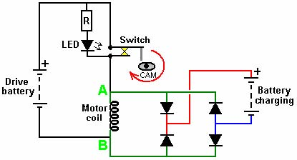

The Current from the drive battery flows through the circuit, powering the coil which both stores energy and causes the motor shaft to rotate. Twice per revolution, the cam on the shaft of the motor pushes the switch contacts open, breaking the drive battery circuit. This causes the energy stored in the motor coil to expend itself in the form of a major voltage spike which pulls point “A” down to a long way below the point “B”. This voltage spike is used to charge the second battery and the diodes need to be able to handle high voltages, say one thousand volts. If the drive battery has a voltage more than 1.3 volts greater than the charging battery, then the drive battery will also feed current into the charging battery when the switch contacts are closed. The LED performs the additional task of preventing the voltage spike from reaching the drive battery when the switch contacts open and this also suppresses the generation of radio-frequency radiation.

The motor is not a standard design. In broad outline, a single rotor is caused to spin by pulses applied to the coil:

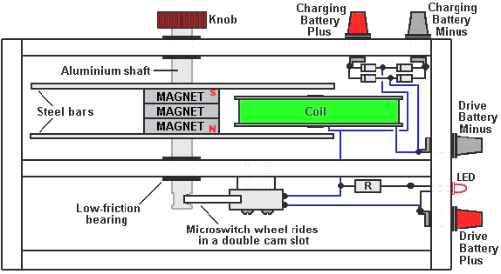

In the version shown in the diagram above, three toroidal (ring-shaped) magnets are stacked together around a central shaft. These dimensions are not in any way critical and magnets up to four inches (100 mm) in diameter have been used very successfully. Mounted on each side of these magnets is a strip of mild steel 1.25” (32 mm) wide and 0.25” (6 mm) thick. The shaft has a knob mounted on it to allow the rotor to be given a spin to get it going. The shaft has two flat faces filed into it and these make that section of the shaft act as a double cam which pushes the shaft of a switching device. The diagram shows a roller micro-switch but the switch of choice for David is contact breaker points from a car ignition system, modified to be pushed by an arm with a roller mounted on the end of it.

The box is constructed from any non-magnetic material such as food-chopping board plastic, timber, plywood, etc. and the box can be left open at the top. Using thick timber causes the motor to run very quietly. None of the dimensions are critical. The internal partition and the side containing the bearing are clamped together in exact alignment and the (push-fit) holes for the ball bearings are drilled exactly square-on using a pillar drill to ensures that there is perfect alignment when assembled:

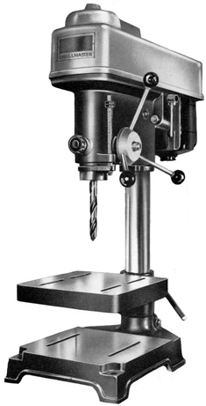

The ring magnet dimensions are not critical in any way. The first ones used had an outer diameter of one and a quarter inches, were a quarter of an inch thick and had a three-eighth inch hole:

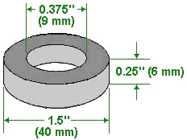

These were stacked three deep:

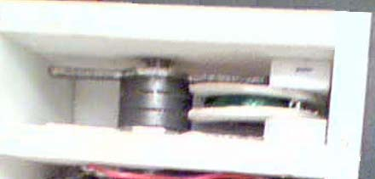

It is not necessary to use more than one magnet but if only one magnet is used, then it is usually necessary to bend the steel strips in order to clear the coil which is about one inch (25 mm) thick at it’s widest point:

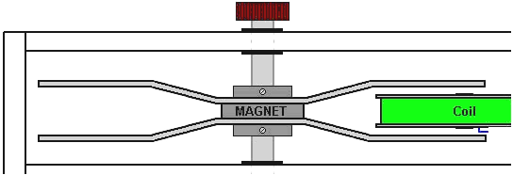

The steel strip needs to be longer to allow room for the bent sections and this in turn means that the box needs to be somewhat wider. The gap between the coil core and the steel strip is anything from 1/8” to 1/4” (3 mm to 6 mm) and that makes the gap between the steel strips about 1.5” (35 mm). Even though there is a strong grip between the steel bar and the magnet, it is necessary to glue them together along the edges using superglue or some other powerful adhesive. This is to make sure that the two steel strips are always aligned with each other. Being made of magnetic material, both strips take up the magnetic polarity of the magnet face to which they are attached. When they spin around, it produces a rotating magnetic field and it is well known that a rotating magnetic field interfaces to the local environment. In this instance the magnetic field is very weak and so the effect is limited.

The way that the coil is wound and the orientation of the magnet(s) is important. initially, we will cover the steps needed for building with a single magnet and then explain what needs to be done when more than one magnet is used. First, establish which face of the magnet is it’s North pole. This is done by hanging the magnet up using a piece of thread as that allows the magnet to rotate without any great turning force from the thread:
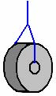

The magnet will eventually settle down in one position. One of it’s faces will be facing magnetic North and that face is the North pole of the magnet as that is the face which is attracted to the Earth’s North magnetic pole. If you don’t know which direction is North, then if you face where the Sun rises in the morning, the North will be on your left hand side. Mark the North-seeking face of the magnet with an “N”.

The coil is now wound. The central core of the coil is recommended to be iron, half an inch (12 mm) in diameter and about one inch (25 mm) long. Iron is chosen because it magnetises easily but does not retain it’s magnetism, and so it is a good material for making an electromagnet, which is what our coil is. It can be quite difficult to get iron nowadays as steel is so popular. However, as steel does not lose it’s magnetism, it is not suitable for our coil core. One very good alternative is the bolt from a masonry anchor, as it has the same magnetic characteristics as iron, is widely available from building supply outlets, not likely to go obsolete and it does not rust:

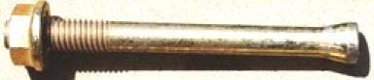

A coil spool is then constructed with a central hole (which is a tight fit for the short metal core) and flanges which are about 3 inches (75 mm) in diameter. The wire used to wind the coil is not at all critical, but it should weigh about one pound (450 grams) and it can be enamelled copper wire, plastic covered or varnished wire. The whole of a standard 500 gram reel of enamelled copper wire could be used. The direction of the coil turns is important and winding should be as shown here:

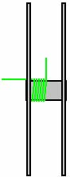

While this diagram shows gaps between the turns, this is only to make it easier to see the direction of the winding and the actual winding has each turn touching the turns on each side of it. The number of turns depends on the thickness of the wire. The thinner the wire, the greater the number of turns, and the lower the drive current will be. The turns are made from the left hand side of the bobbin to the right hand side and back again until all of the wire has been wound. David feels that it is important that the final turn should exit the bobbin 180 degrees away from the start of the first turn. I am not aware of any factor which would form the slightest basis for this, but then again, there is no particular reason why this should not be done.

One suggested wire size is American Wire Gauge No 22 which is the UK Standard Wire Gauge No. 23, with a wire diameter of 0.7 mm. A 500 gram reel of 22 swg wire contains 140 metres of wire which has an overall DC resistance of 7.5 ohms. However, as the coil is pulsed rather than fed a continuous current, the AC impedance of the coil is far more important, and that depends on the coil shape, core material and the number of turns in the coil. The way that the coil is wired up is important and it should be as shown here:

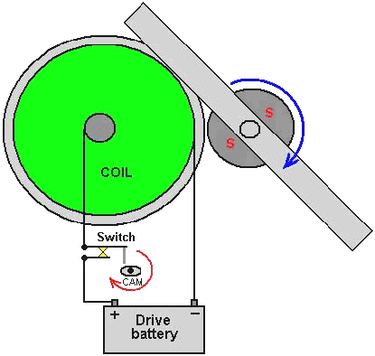

The diagram above only shows the direct coil connections and the additional LED and rectification components including the battery on charge, are not shown. The cam switching is arranged so that the current to the coil is applied when the steel strip is vertical and then cut off again just as the steel strip reaches the core of the coil, this makes the steel strip operate in the magnetic attraction mode which keeps it spinning, at about 500 rpm for the build shown above.

There are various ways of achieving the switching. You can make a cam out of almost any rigid material and attach it to the aluminium shaft by drilling a slightly under-sized hole in the end of the shaft and screwing a standard small bolt into the soft aluminium:

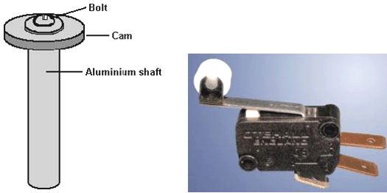

A standard micro switch as shown above can be used to do the switching with the switch mounted so that it’s roller runs along the face of the cam. While micro switches operate with tiny forces, if you feel that there might be undue friction at the bearing of the roller, then a flat arm version of the switch can be used, either with a straight lever or with a shaped lever:

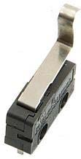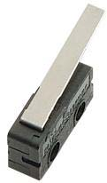

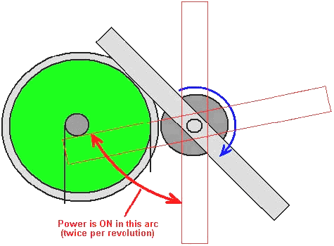

David believes that mechanical switching causes a sharper break in the current than using semiconductors for controlling the power supplied to the coil and a fast switch-off appears to be important in this application. The cam itself should be separate from the shaft and attached to it with a screw or bolt which can be loosened to allow the angle to be easily adjusted. It is very important for weather control that the switch-off occurs just as the leading edge of the steel strip reaches the edge of the coil’s core. Some experimentation will be needed to find the cam shape which switches on and off at the correct positions of the steel strip.

As it is more convenient not to have to bend the steel strips, using more than one magnet is a popular idea. This requires some care. Firstly, these magnets can be very powerful and because magnetic forces can’t be seen, it is not unusual for people to get caught by the surprisingly large attraction between two magnets or between a magnet and a piece of magnetic metal. Fingers can easily be injured even if care is taken, so wear strong “rigger” style gloves and when putting two magnets together do it at an angle and when the magnets touch, slide them into the required position and do not bring them together square on:

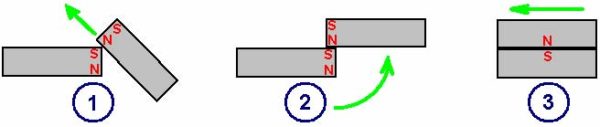

Even with the technique shown here, this is an opportunity for you to show off your muscle strength because the forces involved are very high when strong magnets are involved, so be careful. Step 1 is to bring the magnet in at an angle so that the two North poles push apart and oppose the pull between the incoming North pole and the stationary South pole. This reduces the devastating attraction very considerably. The movement needs to be slow as it is easy to damage one or both of the magnets if they are allowed to touch at speed, and they are capable of accelerating very fast once they get close to each other.

The step 2 position has the North-South attraction greatly reduced as only a tiny percentage of each magnet is involved in the pull towards each other. Also, there is a level effect to help you control the movement.

Finally, the incoming magnet is slid carefully into full contact with the stationary magnet and as the direct pull of the magnets is not involved in this movement, it is not too difficult to manage safely.

That is just the physical method of getting two strong magnets together without damaging yourself or the magnets. It does not deal with how the magnets are positioned relative to each other. In practice, magnets can have many separate poles on different faces. This is something which tends not to be noticed as most applications will work well with a wide range of different multiple-pole configurations. However, in this application, we want the optimum arrangement if we use more than one magnet.

To assess the magnets accurately, identify the magnetic poles as already described. Then, place a magnet face down in a plastic bowl and float the bowl in a container of water. This provides a very low-friction bearing which allows the magnet to rotate freely in a horizontal direction. In theory, the magnet should have no inclination to take up any particular orientation, and if that is the case, then that is very good. In practice, it is quite likely that given time, the magnet will rotate and take up a definite East-West orientation. If this happens, mark the side which points East. Repeat this for all of the magnets to be used, and when putting them together to form a stack, make sure that all of the “East” marks are exactly above each other. That gives the best possible magnetic stack which can be made from those magnets.

There are, of course, many different ways to construct this type of motor, and this is an example of one of them where the bearing alignment is achieved without drilling but by clamping directly on top of the edge of the housing with only part of the locking nut and washer gripping the top edge of the box as shown here:

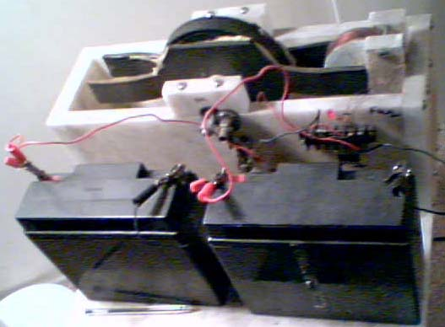

In this example, a twelve-volt battery is used to drive the motor and a second twelve-volt battery is used to absorb the voltage spike produced, which incidentally, charges the battery and consequently, the batteries can be swapped over from time to time. This arrangement is nearly 100% efficient.

It is not necessary to run off twelve volts and it has been found quite satisfactory to use a small 3-volt mains unit to drive the device, especially with a coil wound from fairly fine wire (which requires less current to run it) and in that instance, the charging battery was replaced with a resistor whose job was solely to soak up some of the voltage spike and ease the load on the switch.

The value of the resistor used to limit the current through the LED depends on the voltage used and if a current of about 10 milliamps were required, then a 820 ohm resistor for a twelve-volt system or a 330 ohm for a three-volt supply would be expected. However, David says that a resistor of about 3K ohms should be used. Using a 2.7K resistor would give an LED current of about 4 milliamps during the two-thirds of each revolution when the LED is not being short-circuited by the switch. The light coming from the LED is not going to be bright at that current level, but the inclusion of the LED is due to it’s effect on the circuit and not for producing light.

David suggests using a diode bridge rated at 400 volts and 6 amps. This is possible but I would suggest using four separate diodes such as the 1N4007 or the 1N5408 both of which are rated at 1,000 volts and higher current and which are very cheap because they are so popular. Wiring them as shown in the physical layout diagram gives a very neat arrangement. The terminals shown are the type which allow wire attachment with plugs or a screw-down clamp on a (clockwise wound) turn of bare wire. These terminal posts, the diodes, resistor and LED can be got from any electronic components supplier. A supplier local to you can be found with a Google search.

Using the Motor: This design of motor has not been used for weather modification for a long time and so there are no definitive rules on its use at this time. The effects vary from place to place, probably due to the differences in the local environment.

It is normal to mark on the box, the direction in which the motor “points”. This is determined by considering the magnet as being a wheel rolling down a road, and the direction of travel is considered to be the direction in which the motor is “pointing” and that is then marked with an arrow:
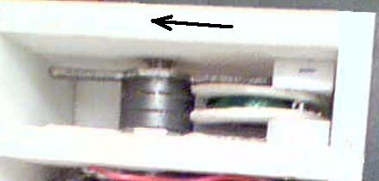

The motor can be operated with this arrow pointing in any direction. However, it is usual for it to be pointed North or any direction in 45 degree steps away from that, i.e. North-East, East, South-East, South, etc.

Experimentation is needed to see what (if any) effect is produced in your locality by the motor. In David’s location, when the motor is pointed East it clears away the cloud cover. This usually happens in three to ten minutes. Turning the motor to face in the opposite direction brings the clouds back and causes rain but this takes much longer than clearing the clouds away, typically about half an hour. Please remember that the direction is highly dependent on location. In the New Mexico area of America, the reverse is true as pointing East causes rain and pointing West clears the skies. The machine loses power during new and full moons, but that can be corrected by raising the input voltage.

Alberto’s experiences: Aiming the machine to tame a hurricane is not difficult. It is important that we do not leave the machine running in the same direction endlessly, This is a brand new science and it not yet known if these low-powered machines have long-distance effects (I believe that they do but this has not yet been proved).

It is my experience that pointing the machine towards the incoming, high-altitude winds, will stop the rain. High altitude wind directions and ground level winds are almost always different, so don't go by your local weather forecast of the wind direction. The best way to find out which way the high winds are moving is by looking at a satellite image. The web site at http://www.intellicast.com/Global/Satellite/Infrared.aspx?location=PLXX0055 shows the wind patterns anywhere in the world and clicking on any map location gives an expanded view of that area.

Note: When the wind is described as “North-Easterly” that means that it is originating in the North East and blowing from that direction towards the South West.

This “Colour Arrows” diagram can be printed and placed on your machine:

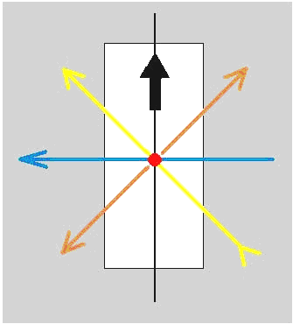

The operation of this machine is not just one simple push in one direction against the weather. The machine has several effects simultaneously. The black arrow in the diagram indicates the direction in which the machine “runs”, that is, if the magnet were a wheel resting on the ground, it is the direction that the magnet would move.

The Yellow Arrow: the machine generates effects in several directions. The most important one is in the direction of the yellow arrow (45 degrees to the left of the running direction of the machine). The effect causes both a push away from the machine in the direction of the yellow arrowhead and at the same time, a pull in towards the machine, also causing movement in that same direction.

I (Alberto) am located in the tropics. If I pull from the North, I will be making rain (floods if I am not careful), because the masses of air to the North of my latitude are colder. The prevailing winds (these are seasonal winds that blow predominantly from a single general direction over a particular area in the Earth's atmosphere) will combine with the machine's force and will steer the mass of cold air to your right or left, depending on the wind direction. So, when pulling, we need to take the high altitude wind direction into account so that the mass of cold air doesn't miss us when it gets here. One of my favourite ways of making rain is by bringing together a mass of hot air and cold air. If it's hot in the country, then pull in a cold front. When the cold front I have been pulling arrives the warm air already here has it’s temperature lowered which causes it to release it's moisture, and we get rain. Warm air always holds more moisture than cold air and when they meet, the warm air releases it's moisture. You must understand that this process takes time, about two or three days because we are dealing with the relatively slow movement of large masses of air.

If it is cool in your country, you can pull warm air in from the South at an angle to the prevailing winds and that should create the same effect. It can't be done directly, though... you have to do it using vectors. When we are pulling the cold front towards us it keeps on moving in it's original direction as well, and it's natural tendency will be to continue on that path. So we aim the box to pull the edge of the cold front so that we attract it and change it's course enough that it may pass over us when it arrives into our general area. I have done this by yellow arrow pulling for a few days on the outer edges of the cold front I needed to attract, adjusting the aim occasionally to bring it down closer each time, compensating for the cold front's movement. It worked very well and produced much rain.

This is a touchy subject. If we push or pull too much, it will create flooding. No more than a few hours of force should be applied at a time in the beginning, at least until you get familiarised with what your machine can do. You will be pleasantly surprised when you discover the effects which it can create.
If we apply a Yellow push towards a cloud, it will more than likely disappear. The same happens with a Yellow pull. Cloudbusters work the same way and if we point one of them directly at a cloud it makes it dissipate. I have noticed that when I am running the machine North-West for any extended period of time, a column of clouds will form running alongside the Yellow arrow line about 800 miles to the left of my location. When you run your machine you affect the weather in many places at once, so please go easy with your machine as nobody likes floods.

The time of day can help or hinder your attempts in rain-making. For a while I had some success aiming toward the Texas drought area, running 30 mins at nightfall and then again 30 mins the next morning at sun-up (until the seasonal high-winds changed). I created some nice thundershowers there the next day. We have also had success making rain when running two machines against each other, one in the North and the other 2,000 miles South, running “yellow push” against each other. It made really nice rain in a large area between the two machines after about 36 hours.

The Other Arrows: I have observed that there are four lines of force, not just the black and the yellow. You will see the Blue and Orange lines of force at work when you begin playing with the clouds above you, moving them this way and that. Don't be surprised if no one believes that it is you who's doing it. The clouds seem to like to group in some of the divisions more than others when you point with the Yellow arrow into the high altitude incoming wind. You'll see. The Orange line keeps me wondering because it seems to depend on how the others react to the direction of the wind. It will work one way when you move the machine in one direction and in another way when you again move the machine. It seems to act as some kind of magnetic boundary. In 2009, hurricane ‘Bill’ came by during a new moon (the machine loses power during new and full moons, but that can be corrected by raising the input power by a couple of volts, it can also be boosted by having a quantity of aluminium nearby). This was before we knew about the Yellow line and before the machine was modified for higher power. The hurricane escaped being dissipated but it got pushed out to sea where it couldn't do any damage. Since then, I simply don't let those systems develop into hurricanes any more because I can reach them from thousands of miles away. If I want to get rid of a hurricane I apply a Yellow push towards it remembering to adjust the aiming every few hours because of the storm's movement. If I'm trying to destroy a hurricane, then one or more hours at a time, but it really depends on how far away the storm is from me. Some storms and hurricanes which are about 3,000 miles away begin showing signs of being affected by my machine in about 3 hours and have taken about 7 more hours after that to dissipate. I always have to do follow-up work the next day on that same location because the storm will always try to get started again. After that it's gone for good. Tropical storms Ana, Erika, Nora and Patricia were eliminated by my machine. It also considerably weakened hurricane Rick in only a few hours from 185 mph (300 kph) to 65 mph (105 kph) before it made landfall. All of these occurred in 2009. We rely on internet satellite images to verify our work. The images are delayed by anything from 15 to 45 minutes, so you really can't see the effects of what you are doing until about an hour later. I almost always see exactly what I expect when the images are displayed.

Aiming: Now that you have read the basics we can get back to aiming the machine. Aiming will never be perfect, at least not with these first-generation weather machines which we are using, but it will be close enough to get the desired results. Up to now I have used only the Yellow arrow to affect the weather. This may change as we learn more about how the machine operates. Let's get ready to aim the machine. There are various ways of doing this, and the following is just one of those ways:

a. Mount your machine and it’s batteries on a movable board, or even better, a large plastic lid. This allows you to turn the whole thing around without having to alter the wiring. The edge of the machine should align exactly with the edge of the board so that we can use the edge of the board or lid to aim the machine.

b. Using a protractor, draw a complete circle with a diameter of about eight inches and mark it like this:

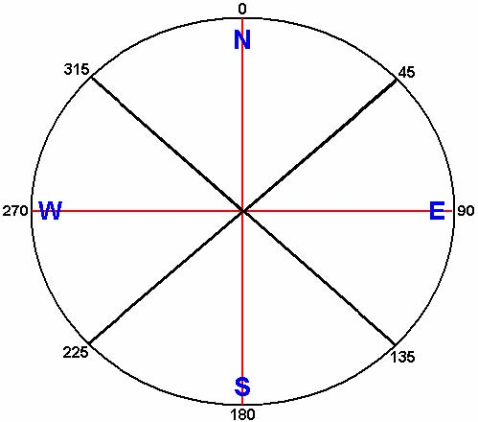

and while this diagram only shows angles marked every 45 degrees, you mark yours off with additional ticks at 5 degree intervals. This diagram is then ready to be taped to the table or floor where you normally keep the machine.

c. Use a compass to find magnetic North. Do this from several places in the room and remember that the machine's magnet and any other magnet or large metal object will interfere with the reading. Use something on a wall of the room, or alternatively, a tree outside to use as a sighting line for magnetic North and line up your protractor diagram very accurately so that the 0 degrees (North) line is aimed directly towards magnetic North.

d. Decide whether you are going to push or pull when using the Yellow arrow and make a note of your choice.

e. If you live in a hurricane area of America, keep your WeatherRadio with you throughout the day. These radios are normally kept on standby mode and will be silent until a special alert emergency signal is transmitted from the National Weather Service. A timely warning could help you save lives, and one of those might even be your own.

f. Log your computer in to the weather map web site mentioned above. It is important that we have an appropriate map on the screen. That means a map where the latitude and longitudinal lines are straight and not rounded following the curvature of the Earth. We need a flat kind of map, not a rounded one. If a rounded map is used for aiming we will never hit our target. Once we have the right map on our PC screen, we bring desired area to a comfortable size so that both our location and the target are visible.

g. We place one of the corners of an envelope on our home and line the edge up with the target weather system.

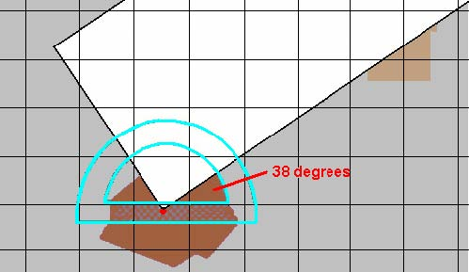

h. We place the protractor centre, (the hole on the bottom part), on top of the corner of the envelope, line up the protractor with the grids on the map so that it is level with pointing north on the map and read the angle between our location and the target and write the angle down.

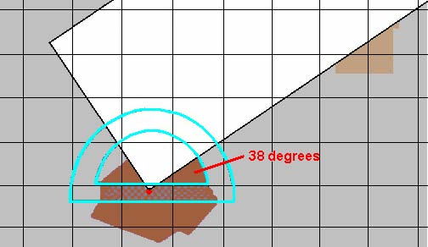

For example, let’s say that the angle is 38 degrees as shown above, and we want to push that weather system away with the Yellow line of our machine. One way to work out how to position the machine in order to do this is a matter of common sense. This method uses simple addition and subtraction to determine the angle to use – it is not a difficult thing to do. The angle between the line to our target and the direction to North is 90 degrees minus our measured 38 degrees. This is 52 degrees. In other words, the line to our target is 52 degrees to the right of North:

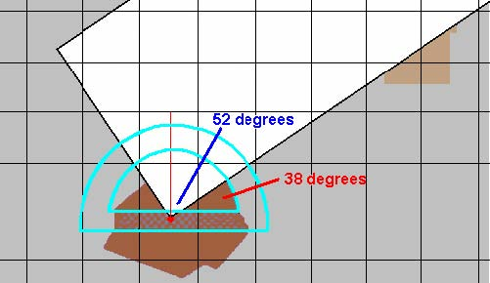

Remember how the Yellow arrow is positioned to the main North – South axis of the machine:

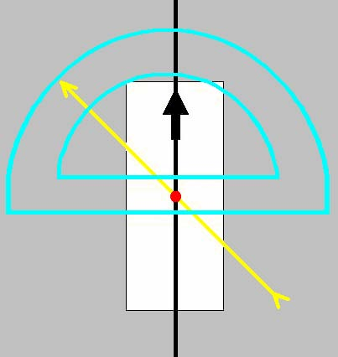

The Yellow arrow points 45 degrees to the left of the North – South line. So it is 45 degrees further away from our target than the North is:

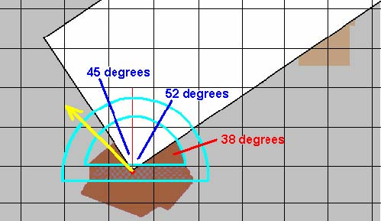

- i. So, to aim the Yellow arrow directly at our target, we need to turn the machine round to the right. If we turned it round 45 degrees to the right, the Yellow arrow would be pointing due North. But we want it to point a further 52 degrees to the right, so we need to turn it through 45 plus 52 degrees and that is 97 degrees. As the edge of the machine is pointing directly North before we move it, it too needs to swing round through this same amount of 97 degrees, and so, when correctly positioned, it will look like this:

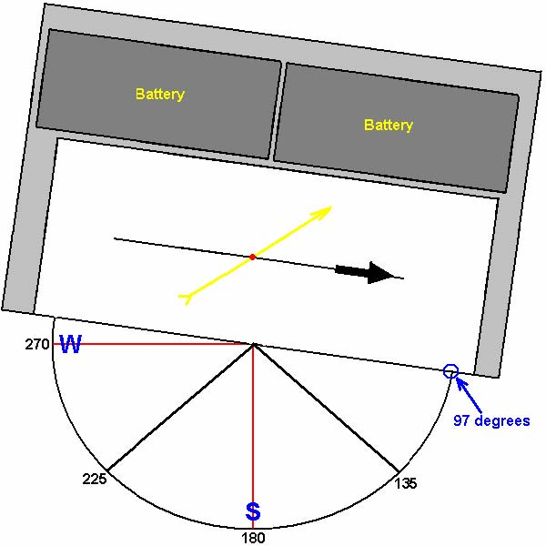

If we had set the edge of our board directly on the East – West line, then the Yellow arrow would be pointing up to the right at 45 degrees. But we have turned the board round to the right by a further seven degrees, lowering the direction of the Yellow arrow by a further seven degrees to the 38 degrees which we measured with our protractor and envelope. The machine is now set exactly where we wanted it to point.

j. Start the machine operating, start a timer and write your notes: Date, Time of day, Target, Reason for running, Time that you started running, High altitude wind direction, etc. Watch the sky and the satellite images on your computer and enjoy the show.

k. Turn off the machine when done, please.

l. Check your results shortly afterwards on the satellite websites. Remember to check the delayed images using the actual time written in your notes during which you were using the machine. Anything else will invalidate your data. I always stick to GMT times to avoid confusion. It is probably worth while giving some more aiming examples. Suppose that our target had been to the left of our home instead of the right:

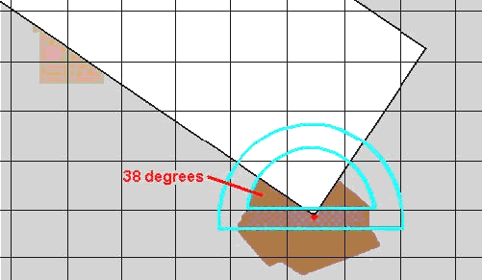

With the machine pointing directly North, the Yellow arrow would be pointing at 45 degrees on the left, so we nee to turn the machine slightly to the left. The amount will be 45 degrees minus 38 degrees, which is 7 degrees:

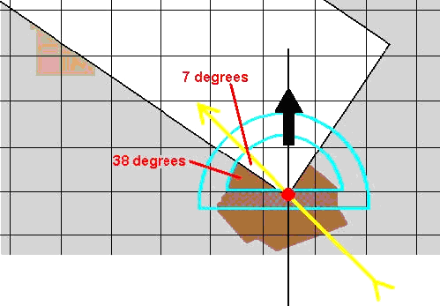

So, when we turn the machine slightly to the left it will sit on our protractor drawing like this:

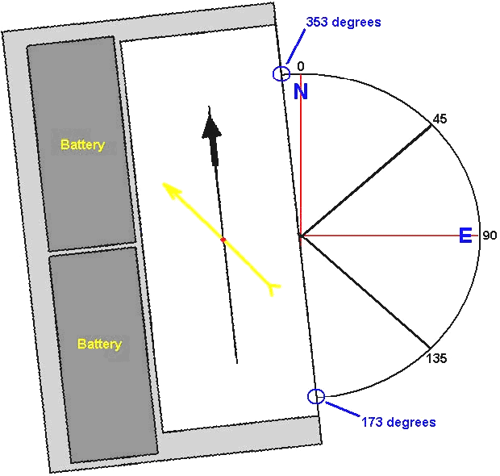

In either of these two examples, if we wanted to pull with the yellow (rather than push as we have been doing), then we just turn the machine round by exactly 180 degrees, to face in exactly the opposite direction.

If you build one of these machines, then please be aware that it is not a toy and what you do will affect other people, so please have a responsible attitude at all times and use the machine to benefit everybody and harm nobody.

Patrick Kelly
www.free-energy-info.tuks.nl
www.free-energy-info.com

