A Practical Guide to Free-Energy Devices Author: Patrick J. Kelly

Chapter 21: Reversing Genetic Modification

It is not widely known, but the universe is powered by the zero-point energy field and all life forms are powered by an intelligent life force which has been called by different names by the men who discovered it and learned how to use it. Perhaps the most widely known name for this force is “Orgone” and it can be concentrated and directed by certain physical shapes as described by Dan Davidson in his book Shape Power. The force has unlimited power and with a concentrator made of concentric stainless steel pipes called a Joe Cell, it can power a vehicle without the need for any kind of fuel. With a concentrator shaped as a pyramid, it can preserve foods, discourage harmful insects, or recuperate old or sick animals. With a small and simple electrical device it can affect the weather up to a thousand miles away.


In recent years, Mehran Tavakoli Keshe (pronounced ‘Kesh’) has developed another, powerful way of concentrating Orgone energy through the use of processed water. Keshe has invented a range of new names for different parts of his various processes and as these new names are unfamiliar, they have made his techniques difficult to understand. He has produced devices for dealing with ill health and injury, accessing Orgone for power production, and techniques for dealing with growing food and other plants where the conditions are difficult. This last item is particularly important as it is capable of overcoming defects in grain and so can restore grain to its original, robust form. This is important as Genetically Modified “GM” or “GMO” alterations to grain are effectively ‘defects’ as far as the original grain is concerned and so the process can remove the “GM” alteration and restore the grain to its original robust state. This can be accomplished by soaking the grain and keeping it near Keshe’s modified water before planting the grain.

This brings us to the Keshe modifications of water. The technology is confusing for newcomers as there are several different ways of producing Keshe modified water, each with a different outcome and different potential applications. The term which Keshe has invented for all of these modified waters is “GaNS water” where “GaNS” is his term for a material produced during his treatment of water.

This is a new technology and I am not yet expert in it, but as far as I am aware, in the most simple broad outline, the procedure is:

1. You make a GaNS electrode by immersing copper wire in cold, diluted caustic soda for two or three days. Caustic soda is dangerous stuff, so you wear gloves and goggles when working with it. The wire is then rinsed off in distilled water.
2. You perform electrolysis on water containing sea salt (from your local supermarket), using your GaNS-coated copper electrode and another electrode made of zinc, (or copper, iron, or whatever). That produces genuine GaNS material in the container.
3. After a 24 to 48 hour period of zero-applied-current electrolysis the electrode plates are removed from the container which is then left undisturbed for a further 24 to 48 hours, during which time the GaNS material sinks to the bottom of the container.
4. Pour off most of the water (keeping it for re-use in case you want to make more GaNS material later). As the GaNS material is mixed with the last little bit of your sea-salt electrolyte, you need to add distilled water to the container, agitate the contents gently and after the GaNS material settles again, pour out as much of the water as possible.
5. That rinsing off process is repeated for at least 5 times and preferably 10 times in order to get clean, salt-free GaNS material.
6. The GaNS material is very valuable. It has indefinite life and can make any number of sets of GaNS water by filling the container with distilled water and leaving it there for at least 24 hours. The resulting GaNS water has spectacular properties. Fifty ccs of the water in a bottle left floating in 24000 litres of water energises the water with Orgone and makes an enormous difference to an aquaphonics farm. When placed in a plastic tube it feeds Orgone energy to growing plants (or to humans). I know very little about Keshe technology which is unfamiliar to say the least. Remember that you can make as much GaNS material as you want AND you can make as much GaNS water as you want from every dose of GaNS material that you make.
Using a carbon rod for one electrode in the electrolysis does NOT produce GaNS material. The “GM” Genetically Modifications made to seed can be reversed by placing the seed in a bucket of water and floating the bucket in a container of GaNS water for 24 hours. The GaNS for this work is made with zinc as one of the electrodes.

1. Now, expanding the detail on these steps it must be understood that the basic process for making any variety of GaNS material requires the use of one GaNS coated electrode and one contributor electrode of a pure metal. The most commonly used metal is zinc which produces what is called ‘Carbon’ or ‘Carbon Dioxide’ GaNS. The initial task is to get a GaNS-coated electrode. These can be bought from places such as chriz (dot) baker (at) hotmail (dot) co (dot) uk or you can make one yourself. There are various methods for the GaNS plating of a copper wire or plate.

The most common processing is done by immersing the copper in a caustic soda (Sodium Hydroxide) solution and leaving it for two or three days. Some people prefer to start the process with heat and then leave the solution to cool as the process continues. No matter what the chosen process is, you definitely need to wear protective gloves and goggles as caustic soda is serious stuff, especially when hot:

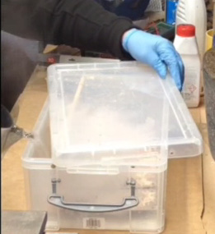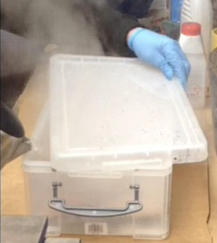

If a copper plate is being treated, then both sides need to be in contact with the caustic soda solution, so to achieve that a low table of wire mesh is used to hold the underside of the copper plate clear of the base of the treatment box. When the processing is completed, the copper plate will be black on all faces.

2. When the copper electrode is ready and completely black all over, rinse it off using clean water, holding the plate in a pair of pliers. You still need gloves and goggles when doing this and when disposing or storing the caustic solution for use again.

Originally, sea water would have been used in the next step of processing, but nowadays, due to contamination, it is recommended that a mixture of distilled water and dried sea salt is used instead. The salt concentration is not at all critical but I would suggest that 10% salt by weight as an absolute upper limit. The processing method is to suspend the GaNS electrode about 70 mm away from a zinc plate with both supported in the salt solution. The two electrodes form a battery in the salt solution and so a short-circuiting wire is connected between the two electrodes using either a soldered connection or a crocodile-clip wire. In either case, the connection must be kept out of the water in order to avoid the process being altered by the metal of the clips or solder. A current will flow along the short-circuiting wire due to chemical action.

No electrical energy source of any kind is applied to the plates, but the required processing continues slowly on its own. Keshe is not joking when he says that patience is a major requirement when making GaNS. When the processing has continued long enough (probably 48 hours), the GaNS material is left floating on the surface of the water and the electrodes are removed from the salt solution.

3. When left alone, the GaNS material gradually sinks to the bottom of the container and is left alone for a further 24 hour period.

4. The water used in making GaNS is salty and so it is poured off very carefully and replaced with distilled water:

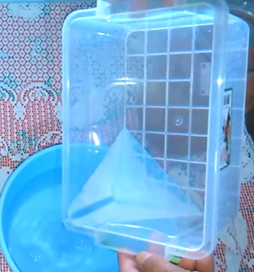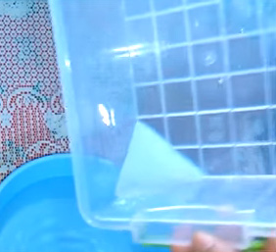

5. That water replacement and pouring is done several times to remove the salt, and finally, the container is filled with distilled water and left for 24 hours during which time the GaNS at the bottom of the container charges the new water with Orgone energy, turning it into “GaNS water”.

6. This GaNS water is what can return seed to its original state. The water can also be used very effectively in growing vegetables and fruit, reviving dying plants and causing major improvements in the size and quantity of produce treated with the water when growing. Obviously, during the period when the GaNS water is gaining its extraordinary power, other containers can be processed in order to increase the amount of GaNS material available for use and a good deal of GaNS water is needed if farming levels of seed are to be treated before planting. A recommended method for treating grain is to place the grain in a bucket, top up the bucket with water and place the bucket inside a larger container filled with GaNS water. After twenty-four hours, the enhanced grain is ready to be planted. The GaNS material remains potent for weeks and can be used to charge up many, many jars of distilled water to produce GaNS water ready for use.

In passing, it should be mentioned that in all likelihood, a pyramid erected over a sack of grain should have the same effect in returning the grain to its original healthy state. For that, it is only necessary to have the eight straight edges which form the pyramid, as the sides can be left open since the Orgone energy flows along the edges. One of the straight base lines of the pyramid needs to be exactly North-South in direction and by “North” what is meant is Magnetic North which varies gradually every year, and so a compass is used to determine the exact alignment. There are more details in chapter 9.

Sodium Hydroxide is sold as “Lye”, “drain cleaner” or “Caustic Soda”. Please be aware that caustic soda is highly dangerous and pouring hot water on it is a potentially reckless thing to do. Consequently, great care needs to be taken when doing that – using a covered container with the lid covering almost all of the top of the container before the hot water is poured in. Have vinegar to hand in case of accidental exposure to the caustic soda, wear protective gloves and goggles, and place the lid back on the container as soon as the water has been poured. Do not breath in the steam which occurs when hot water is poured on caustic soda.

There are various videos worth watching: https://www.youtube.com/watch?v=iRQfYtSHFiY&t=93s or https://www.youtube.com/watch?v=DLMC3AYmUJg&t=393s or
https://www.youtube.com/watch?v=l-u7RLuDNfQ . Essentially, keeping your material to be plated in a caustic soda environment for a long, long time is the most important factor.

It needs to be understood that “GaNS water” has a strong Orgone concentrating effect. That effect can be used most effectively by various techniques for vegetable and fruit growing. A pyramid has been shown to draw the groundwater table up towards the surface of the soil, and if the pyramid is large enough and made from the best materials, the water level can actually exceed the ground level. It is likely that the same effect happens with a loop of plastic pipe filled with GaNS water and placed on the ground. That method of filling a plastic tube ring with GaNS water in order to enhance the Orgone flow around a tree is used like this:

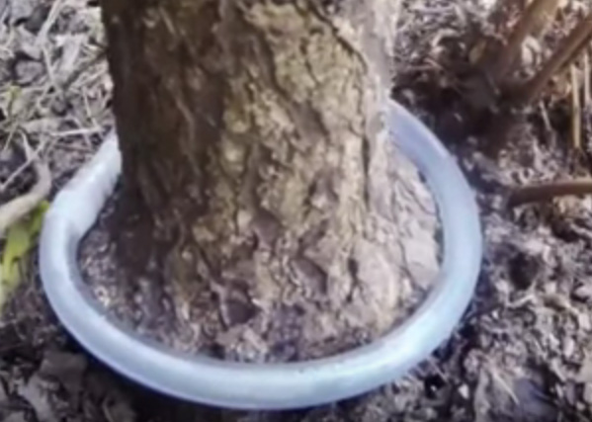

For this, a piece of hollow plastic tube is used to connect the ends of the tube after it is filled with the GaNS water:

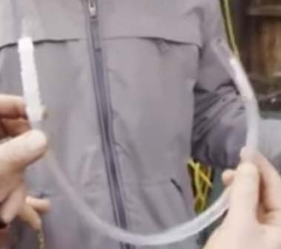

In the example above, a smaller diameter tube has also been used, and the smaller tube has been filled with copper GaNS water which is made by substituting a strip of copper for the zinc metal when making the GaNS material. Copper GaNS water is considered to be different to Carbon GaNS water and although with different salt concentrations the resulting colour can be light blue, dark blue or brown. However, Carbon GaNS water is recommended for most plant-growing work.

For example, this container which is being used to grow tomato plants, has small yellow plastic spheres filled with GaNS water suspended around the plants:

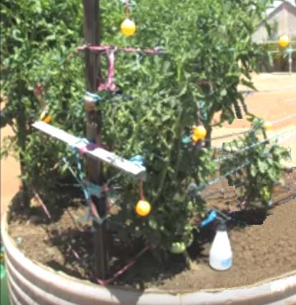

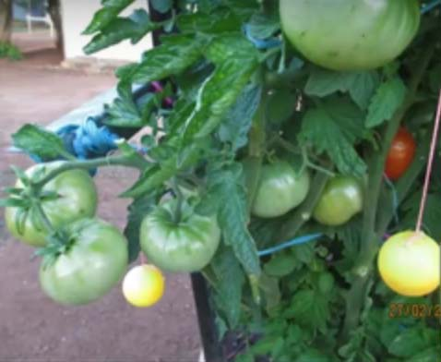

You need to understand that there are many possible variations when using Orgone energy with growing plants and this particular gardener uses Carbon GaNS water in the lower spheres and Copper GaNS water in the spheres which are hung higher up. The idea is to generate an increasingly powerful Orgone field as the plants grow higher. In this instance, the effect of the orgone flow around the tomato plants spills out sideways and enhances the growth of other plants growing in the ground near the tomato container. The gardener waters his plants with water which has been stored for some time with GaNS containers floating in the water. Other gardeners who use GaNS water spheres also insert a small coil of GaNS coated copper wire inside the spheres in the belief that doing so will enhance the Orgone concentrating effect of the spheres.

So, to recap, the effective material used is GaNS water. That is very clean water which is left for 24 hours on top of GaNS material which has been rinsed off many times after creation. The GaNS material itself is not used directly in spite of the fact that it stays active for many months and can make great quantities of GaNS water. I’m told that GaNS water can also be used in many health-related treatments, but that is not the subject here. The GaNS material should never be touched with bare skin, nor should it be eaten.

Patrick Kelly
www.free-energy-info.tuks.nl
www.free-energy-info.com

