A Practical Guide to Free-Energy Devices Author: Patrick J. Kelly

Chapter 23: A Ten Kilowatt Generator

Chas Campbell of Australia has demonstrated his self-powered flywheel generator which uses a mains electric motor driving a generator through a series of shafts with flywheels mounted on each shaft. When that design gets up to speed, powered by the mains supply, Chas transfers the electrical input of the motor from the mains to the generator output, making the system self-powered. Chas now presents his latest system which drives a ten kilowatt generator, and this time, the main flywheel is mounted in a horizontal position instead of the original vertical position.

In this design, the generator rests on a concrete slab supported steel base plate which is 300 mm square and 10 mm thick. In common with all of the diagrams in this ebook, none of the following diagrams are to scale and are only intended to show the general arrangement for each device. Bearing that in mind, the base plate is like this:

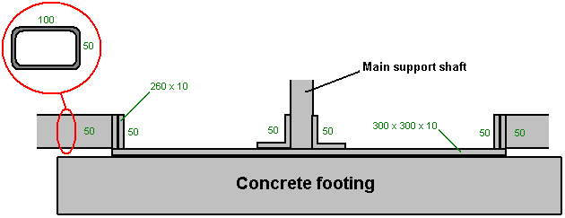

This base plate is prevented from moving or tipping over by four arms, each constructed from pairs of 100 x 50 x 6 mm box sections. Each of these arms has a 300 x 100 mm plate 10 mm thick welded underneath the ends of the box sections and that plate is held in place by an anchor bolt which attaches the arm securely to the ground. The arms are bolted to each of the four 260 x 50 x 10 mm steel plates which are welded 10 mm in from the edges of the base plate.

The vertical shaft which supports the main flywheel with its sixteen inch diameter pulley wheel is attached to the centre of the base plate with three short sections of 50 x 50 mm angle iron welded to the base plate.

The main flywheel is the simplified sixteen-sided flywheel which Chas designed to make shipping of a completed generator a compact, one-crate operation as well as making it easy for a home constructor to fabricate.

The base arrangement looks like this:
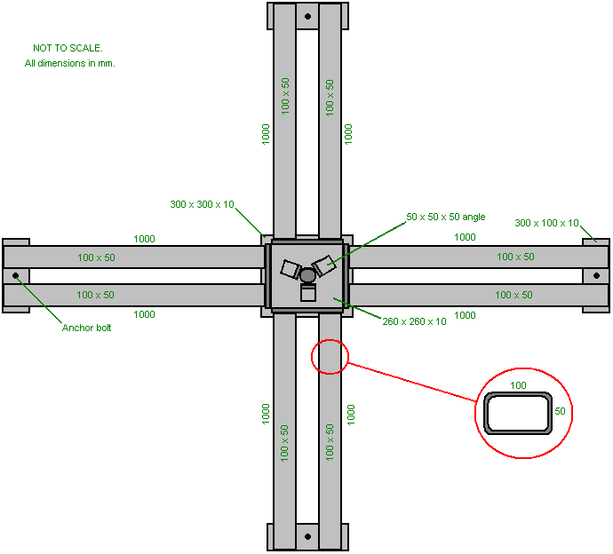

The overall concept is like this:

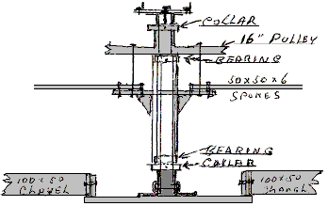

The main flywheel has a diameter of two metres (six and a half feet) and is a central hub with an axle, eight spokes of 50 x 50 mm steel box section welded to a 200 mm diameter hub and to the rim of the wheel. What is unusual about this design is that the axle bar is stationary and the flywheel rotates around it:

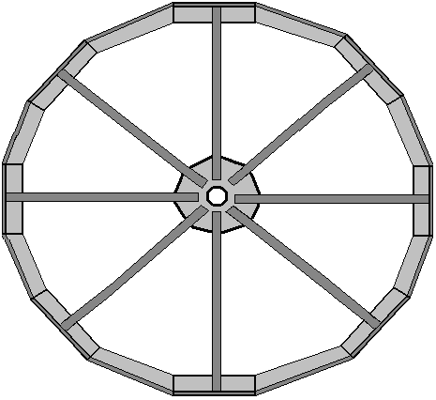

For this construction, each of the eight spokes has a square-cut length of 100 x 100 x 8 mm angle iron welded to it. The angle iron which weighs about 12.276 Kg per metre is shaped like this:

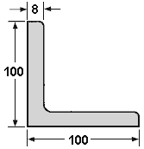

Welding is easy to learn and it is a brilliant method of construction … but it has one major problem. When a joint is made the two pieces of steel melt and merge together. This can happen in a tenth of a second. Don’t put your finger on the joint to see if it is still hot, if it is, then you will get a painful burn and that should remind you not to do that again. That heat is the problem, because when steel gets hot it expands, and when it cools down it contracts. That means that if you were to set up a piece of steel at exactly a right angles and weld the pieces together then as the joint cools down it contracts and pulls the joint out of alignment:

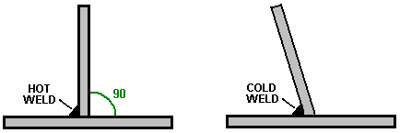

Please don’t imagine that you can just push the vertical piece back into position as that isn’t going to happen because the joint is instantly very, very strong. Instead, you use two quick welds of equal size, with the second one being 180 degrees opposite the first one:

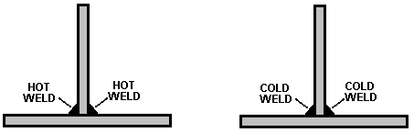

Then, as the welds cool down, they pull in opposing directions and while it produces stresses in the metal, the vertical piece stays vertical. Let the welds cool down in their own good time, taking perhaps ten minutes to cool properly. Do not apply water to the welds to speed up the cooling as that actually alters the structure of the steel and you really don’t want to do that.

With two spokes welded to the central hub the basic construction will look like this:

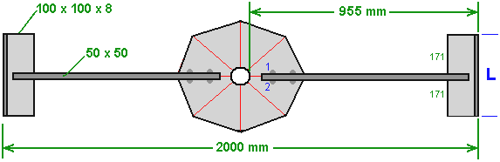

The spokes are made with 50 mm x 50 mm steel box section which has good rigidity in all directions. As the overall diameter is 2000 mm that means that the length around the rim will be 2000 x 3.1416 = 6283 mm (if construction is very accurate) and the rim angle iron will have a weight of about 77.13 kilos (170 pounds) which means that in the later stages of building this flywheel most people will need a second person to help lift and manoeuvre it into position. The flywheel weight can easily be increased at any later date by welding additional steel pieces to the inside of the rim – just remember to keep the wheel perfectly symmetrical and balanced around the axle by always matching any additional piece with an identical piece exactly opposite it (that is, 180 degrees away around the rim).

When attaching the 50 x 50 mm box sections to the hub plate be sure to align them exactly and clamp them in place very firmly with steel clamps and double check the position before welding them. This is done by drawing accurate parallel lines on each side of the existing lines, 25 mm out, so that when the 50 x 50 steel is clamped in place, those lines show that the positioning is correct. Also, be very sure that you make two opposing welds to avoid the pieces being pulled out of position. So, in the diagram above, when weld “1” is made, then weld “2” is made immediately so that they can cool down together and heat distortion avoided.

We now need to work out the length of the strip of angle iron marked as “L” in the diagram above. The overall circumference is 6283 mm and it will be divide up into 16 equal lengths, so each length will (hopefully) be 392 mm long. We start by attaching square cut 392 mm lengths to the ends of the box-section spokes and then cut a template in some stiff material such as 3 mm Medium Density Fibreboard. This is done by sliding the flat template material under two successive rim pieces and marking the shape, showing the angles and lengths involved:

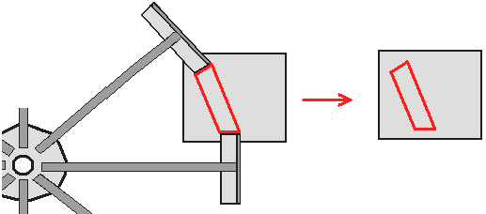

Cut out the template shown in red in the diagram above and check it for accuracy between the two steel pieces to make sure that it is correct before using it to mark the piece of angle iron which will be welded in place to close the gap in the wheel rim. The angle iron has the slanted faces cut and then verticals are marked on the vertical face and those are cut separately. Check the piece in place and if the fit is not perfect, use the angle grinder to make the fit as good as possible.

