A Practical Guide to Free-Energy Devices Author: Patrick J. Kelly

Chapter 23: Reversing Genetic Modification

It is not widely known, but the universe is powered by the zero-point energy field and all life forms are powered by an intelligent life force which has been called by different names by the men who discovered it and learned how to use it. Perhaps the most widely known name for this force is “Orgone” and it can be concentrated and directed by certain physical shapes as described by Dan Davidson in his book Shape Power. The force has unlimited power and with a concentrator of concentric stainless steel pipes called a Joe Cell, it can power a vehicle without the need for any kind of fuel. With a concentrator shaped as a pyramid, it can preserve foods, discourage harmful insects, or recuperate old or sick animals. With a small and simple electrical device it can affect the weather up to a thousand miles away.


In recent years, Mehran Tavakoli Keshe (pronounced ‘Kesh’) has developed another, powerful way of concentrating Orgone energy through the use of processed water. Keshe has invented a range of new names for different parts of his various processes and as these new names are unfamiliar, they have made his techniques difficult to understand. He has produced devices for dealing with ill health and injury, accessing Orgone for power production, and techniques for dealing with growing food and other plants where the conditions are difficult. This last item is particularly important as it is capable of overcoming defects in grain and so can restore grain to its original, robust form. This is important as Genetically Modified “GM” or “GMO” alterations to grain are effectively ‘defects’ as far as the original grain is concerned and so the process can remove the “GM” alteration and restore the grain to its original robust state. This can be accomplished by soaking the grain in Keshe’s modified water before planting the grain.

This brings us to the Keshe modifications of water. The technology is confusing for newcomers as there are several different ways of producing Keshe modified water, each with a different outcome and different potential applications. The term which Keshe has invented for all of these modified waters is “GaNS water” where “GaNS” is his term for a material produced during the treatment of water. GaNS water is the water left over during the GaNS production method, and the method is to conclude the processing and then leave the GaNS floating on the surface of the water, as it then gradually sinks to the bottom of the container and the water above it has become a powerful concentrator of Orgone energy.

The water used in the processing to produce GaNS is salty and so it is siphoned off very carefully and replaced with distilled water. That replacement is done several times to remove the salt, and finally, the container is filled with distilled water and left for 24 hours during which time the GaNS at the bottom of the jar charges the new water with Orgone energy. That water is what can return seed to its original state. The water can also be used very effectively in growing vegetables and fruit, reviving dying plants and causing major improvements in the size and quantity of produce treated with the water when growing.

The version of the water used in agriculture is called the “CO2” or Carbon version of GaNS water and one of the ways that it can be made is with a form of electrolysis using a carbon rod as one electrode and zinc metal as the other electrode. The jar used to be filled with sea water, but nowadays seawater is considered to be somewhat radioactive and so a mixture of sea salt in distilled water is recommended instead. There are many different concentrations of salt water which will work but each produces a somewhat different result. In the demonstration below, zinc-plated roofing strip is being used although solid zinc would be much better, and the salt water is distilled water added to 100 grams of sea salt and brought up to 1 litre total volume before being placed in the jar:

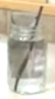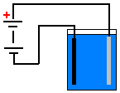

The processing of the water in the jar takes one hour and the “GaNS” comes off as a white material. The wires are clamped to the jar using plastic clips and current is passed through the water causing white material to come off the carbon rod which is connected to the negative of a power supply. The voltage applied to the container causes different effects, so the voltage is kept low (perhaps 5 volts or less) and the current flow is determined by the amount of salt in the water. The level of current flow affects the result, so some people pass the current through a Light-Emitting Diode in order to reduce the level of current flow. The GaNS material itself is never touched or consumed.

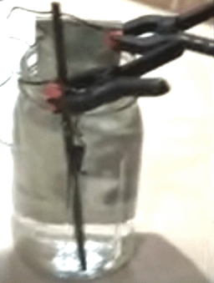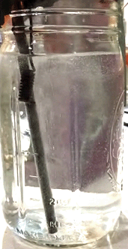

The white GaNS material builds up with time:

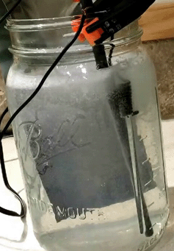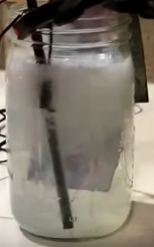

While the overall technique looks like electrolysis, it actually is not electrolysis as the final result after an hour is like this:



You will notice the solid looking layer on top of the water. Keshe calls this paste-like layer “GaNS” but it, itself is not used, it is actually the replaced water which is used in agriculture. After the container has been left alone for some time, the GaNS sinks to the bottom. It is left undisturbed for 24 hours and then the water is carefully replaced with distilled water. The water replacement is done five to 10 times in order to get a good clean water layer above the GaNS material. Then the container is left alone for twenty-four hours, which intensifies the power residing in the water. Obviously, during that resting day, other containers can be processed in order to increase the amount of “GaNS water” available for use and a good deal of the water is needed if farming levels of seed are to be treated before planting. A recommended method for treating grain is to place the grain in a bucket, top up the bucket with water and place the bucket inside a larger container filled with GaNS water. After twenty-four hours, the enhanced grain is ready to be planted. The GaNS material remains potent for weeks and can be used to charge up many, many jars of distilled water to produce GaNS water ready for use.

In passing, it should be mentioned that in all likelihood, a pyramid erected over a sack of grain should have the same effect in returning the grain to its original healthy state. For that, it is only necessary to have the eight straight edges as the sides can be left open since the Orgone energy flows along the edges. One of the straight base lines of the pyramid needs to be exactly North-South in direction and by “North” what is meant is Magnetic North which varies gradually every year, and so a compass is used to determine the exact alignment. There are more details in chapter 9.

It needs to be understood that “GaNS water” has a strong Orgone concentrating effect. That effect can be used most effectively by various techniques for vegetable and fruit growing. A pyramid has been shown to draw the groundwater table up towards the surface of the soil, and if the pyramid is large enough and made from the best materials, the water level can actually exceed the ground level. It is likely that the same effect happens with a loop of plastic pipe filled with GaNS water and placed on the ground. That method of filling a plastic tube ring with GaNS water in order to enhance the Orgone flow around a tree is used like this:

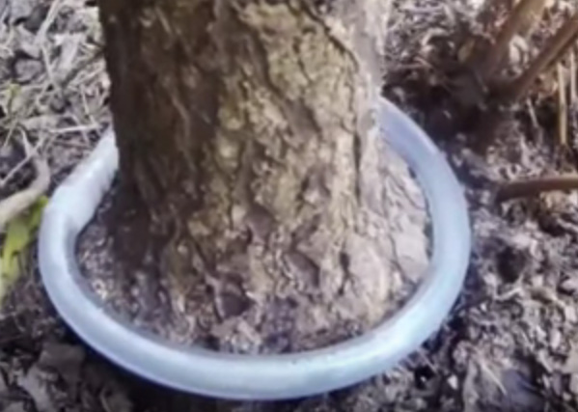

For this, a piece of hollow plastic tube is used to connect the ends of the tube after it is filled with the GaNS water:

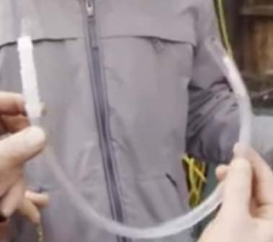

In the example above, a smaller diameter tube has also been used, and the smaller tube has been filled with copper GaNS water which is made by substituting a strip of copper for the zinc metal when making the GaNS material. Copper GaNS water is considered to be different to Carbon GaNS water and although with different salt concentrations and current flows the resulting colour can be light blue, dark blue or brown. However, Carbon GaNS water is recommended for most plant-growing work.

For example, this container which is being used to grow tomato plants, has small yellow plastic spheres filled with GaNS water suspended around the plants:

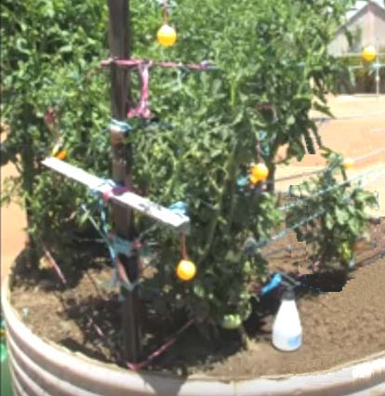

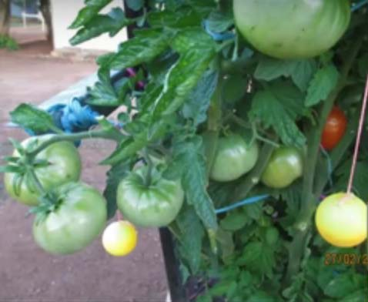

You need to understand that there are many possible variations when using Orgone energy with growing plants and this particular gardener uses Carbon GaNS water in the lower spheres and Copper GaNS water in the spheres which are hung higher up. The idea is to generate an increasingly powerful Orgone field as the plants grow higher. In this instance, the effect of the orgone flow around the tomato plants spills out sideways and enhances the growth of other plants growing in the ground near the tomato container. The gardener waters his plants with water which has been stored for some time with GaNS containers floating in the water. Other gardeners who use GaNS water spheres also insert a small coil of GaNS coated copper wire inside the spheres in the belief that doing so will enhance the Orgone concentrating effect of the spheres.

So, to recap, the effective material used is GaNS water. That is very clean water which is left for 24 hours on top of GaNS material which has been rinsed off many times after creation. The GaNS material itself is not used directly in spite of the fact that it stays active for many months and can make great quantities of GaNS water. I’m told that GaNS water can also be used in many health-related treatments, but that is not the subject here.

Patrick Kelly
www.free-energy-info.tuks.nl
www.free-energy-info.com

