HERMANN PLAUSON

US Patent 1,540,998 9th June 1925 Inventor: Hermann Plauson

CONVERSION OF ATMOSPHERIC ELECTRIC ENERGY

Please note that this is a re-worded excerpt from this patent. It describes in considerable detail, different methods for abstracting useable electrical power from passive aerial systems. He describes a system with 100 kilowatt output as a “small” system.

Be it known that I, Hermann Plauson, Estonian subject, residing in Hamburg, Germany, have invented certain new and useful improvements in the Conversion of atmospheric Electric Energy, of which the following is a specification.

According to this invention, charges of atmospheric electricity are not directly converted into mechanical energy, and this forms the main difference from previous inventions, but the static electricity which runs to earth through aerial conductors in the form of direct current of very high voltage and low current strength is converted into electro-dynamic energy in the form of high frequency vibrations. Many advantages are thereby obtained and all disadvantages avoided.

The very high voltage of static electricity of a low current strength can be converted by this invention to voltages more suitable for technical purposes and of greater current strength. By the use of closed oscillatory circuits it is possible to obtain electromagnetic waves of various amplitudes and thereby to increase the degree of resonance of such current. Such resonance allows various values of inductance to be chosen which, by tuning the resonance between a motor and the transformer circuit, allows the control of machines driven by this system. Further, such currents have the property of being directly available for various uses, other than driving motors, including lighting, heating and use in electro-chemistry.

Further, with such currents, a series of apparatus may be fed without a direct current supply through conductors and the electro-magnetic high frequency currents may be converted by means of special motors, adapted for electro-magnetic oscillations, into alternating current of low frequency or even into high voltage direct current.

DESCRIPTION OF THE DRAWINGS
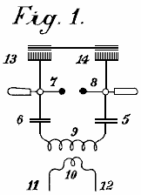

Fig.1 is an explanatory figure

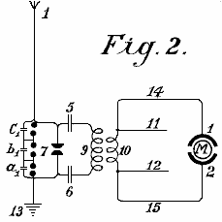

Fig.2 is a diagrammatic view of the most simple form.

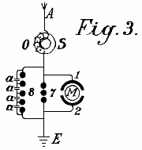

Fig.3 shows a method of converting atmospheric electrical energy into a form suitable for use with motors.

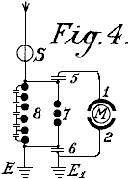

Fig.4 is a diagram showing the protective circuitry.

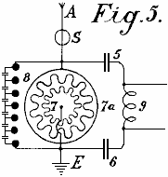

Fig.5 is a diagram of an arrangement for providing control

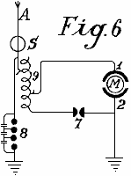

Fig.6 is an arrangement including a method of control

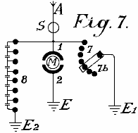

Fig.7 shows how the spark gap can be adjusted

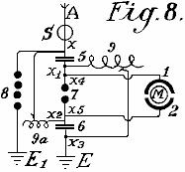

Fig.8 shows a unipolar connection for the motor

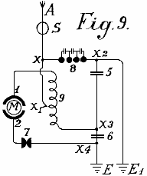
Fig.9 shows a weak coupled system suitable for use with small power motors

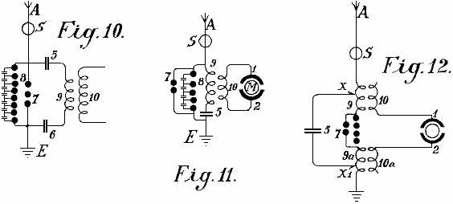

Fig.10, Fig.11 and Fig.12 show modified arrangements

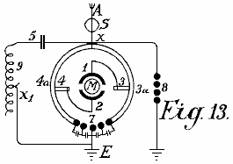

Fig.13 shows a form of inductive coupling for the motor circuit

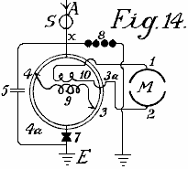

Fig.14 is a modified form of Fig.13 with inductive coupling.

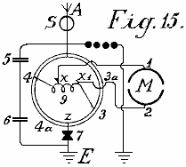

Fig.15 is an arrangement with non-inductive motor

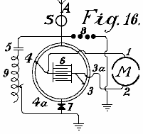
Fig.16 is an arrangement with coupling by capacitor.

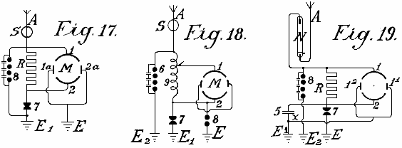
Fig.17, Fig.18 and Fig.19 are diagrams showing further modifications

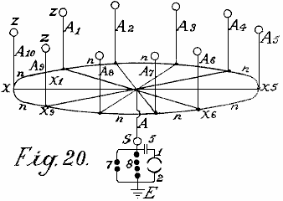

Fig.20 shows a simple form in which the aerial network is combined with special collectors

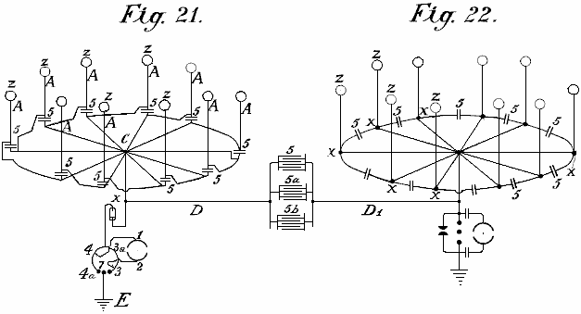

Fig.21 shows diagramatically, an arrangement suitable for collecting large quantities of energy.
Fig.22 is a modified arrangement having two rings of collectors

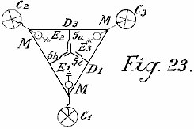

Fig.23 shows the connections for three rings of collectors

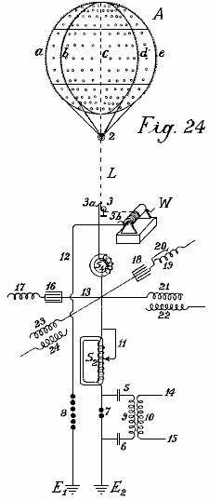

Fig.24 shows a collecting balloon and diagram of its battery of capacitors

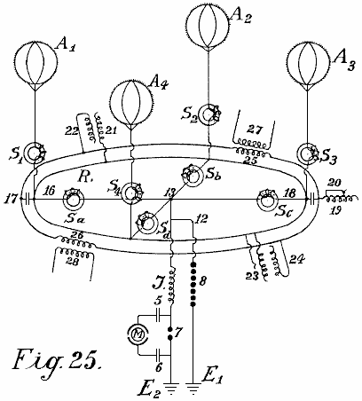

Fig.25 and Fig.26 show modified collector balloon arrangements.

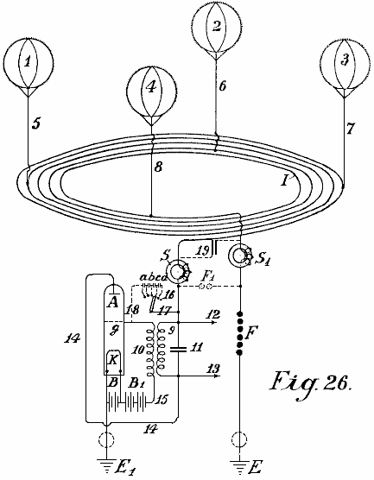

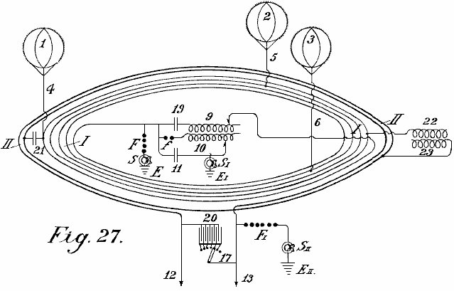
Fig.27 shows a second method of connecting conductors for the balloon aerials.

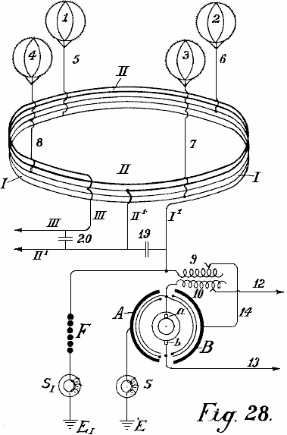

Fig.28 shows an auto-transformer method of connection.

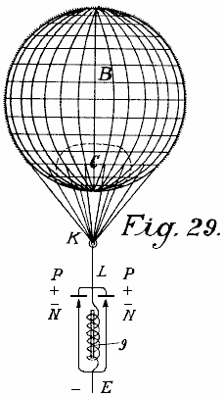
Fig.29 shows the simplest form of construction with incandescent cathode.

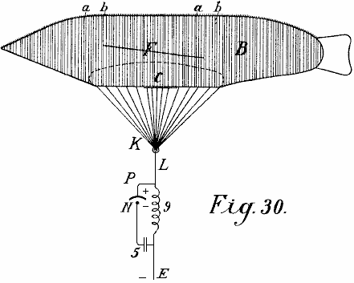

Fig.30 shows a form with a cigar-shaped balloon.

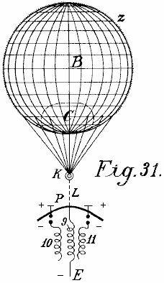

Fig.31 is a modified arrangement.

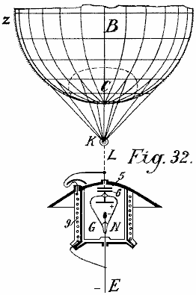

Fig.32 shows a form with cathode and electrode enclosed in a vacuum chamber.

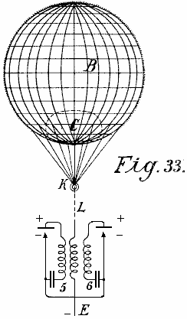

Fig.33 is a modified form of Fig.32

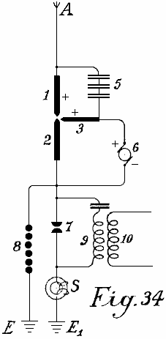

Fig.34 shows an arc light collector.

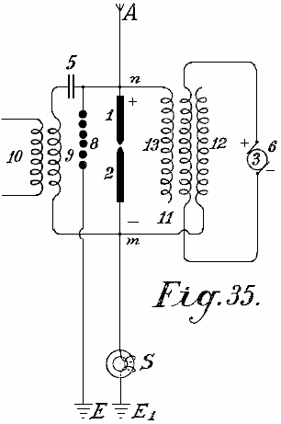
Fig.35 shows such an arrangement for alternating current

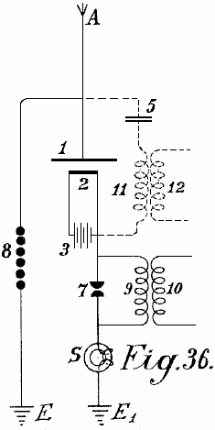

Fig.36 shows an incandescent collector with Nernst lamp

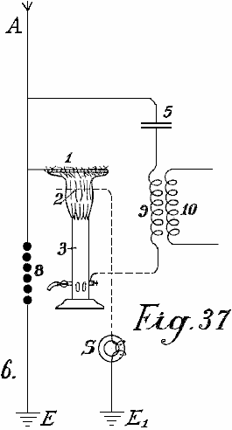

Fig.37 shows a form with a gas flame.

____________________________________________________________________________________________

Fig.1 illustrates a simple diagram for converting static electricity into dynamic energy of a high number of oscillations. For the sake of clarity, a Wimshurst machine is assumed to be employed and not an aerial antenna. Items 13 and 14 are combs for collecting the static electricity of the influence machine. Items 7 and 8 are spark-discharging electrodes. Items 5 and 6 are capacitors, 9 is the primary winding of an inductive coil, 10 is the secondary winding whose ends are 11 and 12. When the disc of the static influence machine is rotated by mechanical means, the combs collect the electric charges, one being positive and one negative and these charge the capacitors 5 and 6 until such a high voltage is developed across the spark gap 7-- 8 that the spark gap is jumped. As the spark gap forms a closed circuit with capacitors 5 and 6, and inductive resistance 9, as is well known, waves of high frequency electromagnetic oscillations will pass in this circuit.

The high frequency of the oscillations produced in the primary circuit induces waves of the same frequency in the secondary circuit. Thus, in the primary circuit, electromagnetic oscillations are formed by the spark and these oscillations are maintained by fresh charges of static electricity.

By suitably selecting the ratio between the number of turns in the primary and secondary windings, with regard to a correct application of the coefficients of resonance (capacitance, inductance and resistance) the high voltage of the primary circuit may be suitably converted into a low voltage high current output.

When the oscillatory discharges in the primary circuit become weaker or cease entirely, the capacitors are charged again by the static electricity until the accumulated charge again breaks down across the spark gap. All this is repeated as long as electricity is produced by the static machine through the application of mechanical energy to it.

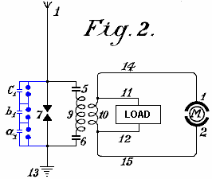

An elementary form of the invention is shown in Fig.2 in which two spark gaps in parallel are used, one of which may be termed the working gap 7 while the second serves as a safety device for excess voltage and consists of a larger number of spark gaps than the working section, the gaps being arranged in series and which are bridged by very small capacitors a₁, b₁, c₁, which allow uniform sparking in the safety section.

1 is the aerial antenna for collecting charges of atmospheric electricity, 13 is the earth connection of the second part of the spark gap, 5 and 6 are capacitors and 9 is the primary coil winding. When the positive atmospheric electricity seeks to combine with the negative earth charge via aerial 1, this is prevented by the air gap between the spark gaps. The resistance of spark gap 7 is lower than that of the safety spark gap set of three spark gaps connected in series a which consequently has three times greater air resistance.

Therefore, so long as the resistance of spark gap 7 is not overloaded, discharges take place only through it. However, if the voltage is increased by any influence to such a level that it might be dangerous for charging the capacitors 5 and 6, or for the coil insulation of windings 9 and 10, the safety spark gap set will, if correctly set, discharge the voltage directly to earth without endangering the machine. Without this second spark gap arrangement, it is impossible to collect and render available large quantities of electrical energy.

The action of this closed oscillation circuit consisting of spark gap 7, two capacitors 5 and 6, primary coil 9 and secondary coil 10, is exactly the same as that of Fig.1 which uses a Wimshurst machine, the only difference being the provision of the safety spark gap. The high frequency electromagnetic alternating current can be tapped off through the conductors 11 and 12 for lighting and heating purposes. Special motors adapted for working with static electricity or high frequency oscillations may be connected at 14 and 15.

In addition to the use of spark gaps in parallel, a second measure of security is also necessary for taking the current from this circuit. This is the introduction of protective electromagnets or choking coils in the aerial circuit as shown by S in Fig.3. A single electromagnet having a core of the thinnest possible separate laminations is connected with the aerial. In the case of high voltages in the aerial network or at places where there are frequent thunderstorms, several such magnets may be connected in series.

In the case of large units, several such magnets can be employed in parallel or in series parallel. The windings of these electromagnets may be simply connected in series with the aerials. In this case, the winding preferably consists of several thin parallel wires, which together, make up the necessary cross-sectional area of wire. The winding may be made of primary and secondary windings in the form of a transformer. The primary winding will then be connected in series with the aerial network, and the secondary winding more or less short-circuited through a regulating resistor or an induction coil. In the latter case it is possible to regulate, to a certain extent, the effect of the choking coils. In the following circuit and constructional diagrams , the aerial electromagnet choke coil is indicated by a simple ring S.

Fig.3 shows the most simple way of converting atmospheric electricity into electromagnetic wave energy by the use of special motors adapted for high oscillatory currents or static charges of electrical energy. Recent improvements in motors for working with static energy and motors working by resonance, that is to say, having groups of tuned electromagnetic co-operating circuits render this possible but such do not form part of the present invention.

A motor adapted to operate with static charges, will for the sake of simplicity, be shown in the diagrams as two semi-circles 1 and 2 and the rotor of the motor by a ring M (Fig.3). A is a vertical aerial or aerial network. S is the safety choke or electromagnet with coil O as may be seen is connected with the aerial A. Adjacent to the electromagnet S, the aerial conductor is divided into three circuits, circuit 8 containing the safety spark gap, circuit 7 containing the working spark gap, and then a circuit containing the stator terminal 1, the rotor and stator terminal 2 at which a connection is made to the earth wire. The two spark gaps are also connected metallically with the earth wire. The method of working in these diagrams is as follows:

The positive atmospheric electric charge collected tends to combine with the negative electricity (or earth electricity) connected via the earth wire. It travels along the aerial A through the electromagnet S without being checked as it flows in the same direction as the direct current. Further, its progress is arrested by two spark gaps placed in the way and the stator capacitors. These capacitors charge until their voltage exceeds that needed to jump the spark gap 7 when a spark occurs and an oscillatory charge is obtained via the closed oscillation circuit containing motor M. The motor here forms the capacity and the necessary inductance and resistance, which as is well known, are necessary for converting static electricity into electromagnetic wave energy.

The discharges are converted into mechanical energy in special motors and cannot reach the aerial network because of the electromagnet or choke. If, however, when a spark occurs at spark gap 7, a greater quantity of atmospheric electricity tends to flow to earth, then a counter voltage is induced in the electromagnet, which is greater the more rapidly and strongly the flow of current direct to earth is. This opposing voltage causes the circuit to exhibit a sufficiently high resistance to prevent a short circuit between the atmospheric electricity and the earth.

The circuit containing spark gap 8, having a different wave length which is not in resonance with the natural frequency of the motor, does not endanger the motor and serves as security against excess voltage, which, as practical experiments have shown, may still arise in certain cases.

In Fig.4, spark gap 7 is shunted across capacitors 5 and 6 from the motor M. This arrangement provides improved over-voltage protection for the motor and it gives a uniform excitation through the spark gap 7.

Fig.5 shows an arrangement for producing large currents which can be used direct without motors, to provide heating and lighting. The main difference here is that the spark gap consists of a star-shaped disc 7 which can rotate on its own axis and is rotated by a motor opposite similarly fitted electrodes 7a. When separate points of starts face one another, discharges take place, thus forming an oscillation circuit with capacitors 5 and 6 and inductor 9. It is evident that a motor may also be connected directly to the ends of inductor 9.

Fig.6 shows how the oscillation circuit may have a motor connected via a variable inductor which opposes any excess voltages which might be applied to the motor. By cutting the separate coils 9 (coupled inductively to the aerial) in or out, the inductive action on the motor may be more or less increased, or variable aerial action may be exerted on the oscillation circuit.

In Fig.7 the oscillation circuit is closed through the earth (E and E₁). The spark gap 7 may be increased or reduced by means of a contact arm 7b.

Fig.8 shows a unipolar connection of the motor with the aerial network. Here, two oscillation circuits are closed through the same motor. The first oscillation circuit passes from aerial A through electromagnet S, point x, inductance 9a to the earth capacitor 6, across spark gap 7 to the aerial capacitor 5 and back to point x. The second oscillation circuit starts from the aerial 5 at the point x1 through inductor 9 to the earth capacitor 6 at the point x3, through capacitor 6, across spark gap 7 back to point x1. The motor itself, is inserted between the two points of spark gap 7. This arrangement produces slightly dampened oscillation wave currents.

Fig.9 shows a loosely coupled system intended for small motors for measuring purposes. A is the serial, S is the electromagnet or aerial inductor, 9 the inductor, 7 the spark gap, 5 and 6 capacitors, E the earth, M the motor, and 1 and 2 the stator connections of the motor which is directly connected to the oscillator circuit.

Fig.10 shows a motor circuit with purely inductive coupling. The motor is connected with the secondary wire 10 as may be seen in Fig.11 in a somewhat modified circuit. The same applies to the circuit of Fig.12.

The circuit diagrams shown so far, allow motors of small to medium strength to be operated. For large aggregates, however, they are too inconvenient as the construction of two or more oscillation circuits for large amounts of energy is difficult; the governing is still more difficult and the danger in switching on or off is greater.

A means for overcoming such difficulties is shown in Fig.13. The oscillation circuit shown here, runs from point x over capacitor 5, variable inductor 9, spark gap 7 and the two segments 3a and 3b forming arms of a Wheatstone bridge, back to x. If the motor is connected by brushes 3 and 4 transversely to the two arms of the bridge as shown in the drawing, electromagnetic oscillations of equal sign are induced in the stator surfaces 1 and 2 and the motor does not revolve. If however, the brushes 3 and 4 are moved in common with the conducting wires 1 and 2 which connect the brushes with the stator poles, a certain alteration or displacement of the polarity is obtained and the motor commences to revolve.

The maximum action will result if one brush 3 comes on the central sparking contact 7 and the other brush 4 on the part x. In practice however, they are usually brought on to the central contact 7 but only held in the path of the bridge segments 4a and 3a in order to avoid connecting the spark gaps with the motor oscillation circuit.

As this prevents the whole of the oscillation energy acting on the motor, it is better to adopt the modification shown in Fig.14. The only difference here is that the motor is not wired directly to the segments of the commutator, but instead it is wired to secondary coil 10 which receives induced current from primary coil 9. This arrangement provides a good transforming action, a loose coupling and an oscillation circuit without a spark gap.

In Fig.15, the motor is wired directly to the primary coil at x and x1 after the principle of the auto-transformer. In Fig.16, instead of an inductor, capacitor 6 replaces the inductance and is inserted between the segments 3a and 4a. This has the advantage that the segments 3a and 4a need not be made of solid metal, but may consist of spiral coils which allow a more exact regulation, and high inductance motors may be used.

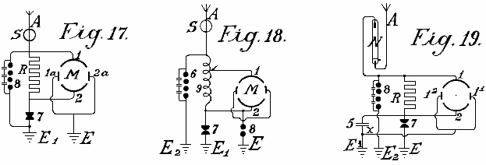

The circuits shown in Fig.17, Fig.18 and Fig.19 may be used with resonance and particularly with induction capacitor motors; between the large stator induction capacitor surfaces, small reversing pole capacitors are connected which are lead together to earth. Such reversing poles have the advantage that, with large quantities of electrical energy, the spark formation between the separate oscillation circuits ceases.

Fig.19 shows another method which prevents high frequency electromagnetic oscillations formed in the oscillation circuit, feeding back to the aerial. It is based on the well known principle that a mercury lamp, one electrode of which is formed of mercury, the other of solid metal such as steel, allows an electric charge to pass in only one direction: from the mercury to the steel and not vice versa. The mercury electrode of the vacuum tube N is therefore connected with the aerial conductor and the steel electrode with the oscillation circuit. Charges can then only pass from the aerial through the vacuum tube to the oscillation circuit and no flow occurs in the opposite direction. In practice, these vacuum tubes must be connected behind an electromagnet as the latter alone provides no protection against the danger of lightning.

As regards the use of spark gaps, all arrangements as used for wireless telegraphy may be used. Of course, the spark gaps in large machines must have a sufficiently large surface. In very large stations they are cooled in liquid carbonic acid or better still, in liquid nitrogen or hydrogen; in most cases the cooling may also take place by means of liquefied low homologues of the metal series or by means of hydrocarbons, the freezing point of which lies between -90ºC and -40⁰C. The spark gap casing must also be insulated and be of sufficient strength to be able to resist any pressure which may arise. Any undesirable excess super-pressure which may be formed must be let off automatically. I have employed with very good results, mercury electrodes which were frozen in liquid carbonic acid, the cooling being maintained during the operation from the outside, through the walls.

Fig.20 shows one of the most simple forms of construction of an aerial network in combination with collectors, transformers and the like. E is the earth wire, 8 the safety spark gap, 7 the working spark gap, 1 and 2 the stator surfaces of the motor, 5 a capacitor battery, S the protective magnet which is connected with the coil in the aerial conductor, A¹ to A¹⁰ aerial antennae with collecting balloons, N horizontal collecting or connecting wires, from which, a number of connections run to the centre.

The actual collectors consist of metal sheaths, preferably made of an aluminium magnesium alloy, and are filled with hydrogen or helium, and are attached to copper-plated steel wires. The size of the balloon is selected so that the actual weight of the balloon and its conducting wire is supported by it. Aluminium spikes, made and gilded as described below, are arranged on top of the balloons in order to produce a conductor action. Small quantities of radium preparations, more particularly, polonium-ionium or mesothorium preparations, considerably increase the ionisation, and the performance of these collectors.

In addition to metal balloons, fabric balloons which are sprayed with a metallic coating according to Schoop’s metal-spraying process may also be used. A metallic surface may also be produced by lacquering with metallic bronzes, preferably according to Schoop’s spraying process, or lacquering with metallic bronze powders in two electrical series of widely different metals, because this produces a considerably increased collecting effect.

Instead of the ordinary round balloons, elongated cigar-shaped ones may be employed. In order also to utilise the frictional energy of the wind, patches or strips of non-conducting substances which produce electricity by friction, may be attached to the metallised balloon surfaces. The wind will impart a portion of its energy in the form of frictional electricity, to the balloon casing, thus substantially increasing the collection effect.

In practice however, very high towers of up to 300 metres may be employed as antennae. In these towers, copper tubes rise freely further above the top of the tower. A gas lamp secured against the wind is then lit at the point of the copper tube and a netting is secured to the copper tube over the flame of this lamp to form a collector. The gas is conveyed through the interior of the tube, up to the summit. The copper tube must be absolutely protected from moisture at the place where it enters the tower, and rain must be prevented from running down the walls of the tower, which might lead to a bad catastrophe. This is done by bell-shaped enlargements which expand downwards, being arranged in the tower in the form of high voltage insulators of Siamese pagodas.

Special attention must be devoted to the foundations of such towers. They must be well insulated from the ground, which may be achieved by first embedding a layer of concrete in a box form to a sufficient depth in the ground, and inserting in this, an asphalt lining and then glass bricks cast about 1 or 2 metres in thickness. Over this in turn, there is a ferro-concrete layer in which alone the metal foot of the tube is secured. This concrete block must be at least 2 metres from the ground and at the sides, be fully protected from moisture by a wooden covering. In the lower part of the tower, a wood or glass housing should be constructed to protect the capacitors and/or motors. In order to ensure that the ground lead connects to the water-table, a well insulated pit lined with vitreous bricks must be provided. Several such towers are erected at equal distances apart and connected with a horizontal conductor. The horizontal connecting wires may either run directly from tower to tower or be carried on bell-shaped insulators similar to those in use for high voltage electricity transmission lines. The width of the aerial tower network may be of any suitable size and the connection of the motors can take place at any convenient location.

In order to collect large quantities of electricity with few aerials, it is as well to provide the aerial conductor with sets of capacitors as shown in the two methods of construction illustrated in Fig.21 and Fig.22. In Fig.21 the set of capacitors 5 is connected between the aerials Z via lead A and an annular conductor from which horizontal run to the connecting points C to which the earth wire is connected. Fig.22 shows a similar arrangement.

Should two such series of antenna rings be shown by a voltmeter to have a large voltage difference (for example, one in the mountains and one on the plain) or even of a different polarity, these differences may be compensated for by connecting sufficiently large capacitor sets (5, 5a, 5b) by means of Maji star conductors D and D¹. Fig.23, shows a connection of three such rings of collectors are positioned in a triangle with a central set of capacitors.

The capacitor sets of such large installations must be embedded in liquefied gasses or in liquids freezing at very low temperatures. In such cases, a portion of the atmospheric energy must be employed for liquefying these gasses. It is also preferable to employ pressure. By this means, the capacitor surfaces may be reduced in area and still allow the storage of large quantities of energy to be stored, secure against breakdown. For the smaller installations, the immersing of the capacitors in well insulated oil or the like, is sufficient. Solid substances, on the other hand, cannot be employed as insulators.

The arrangement in the diagrams shown earlier has always shown both poles of the capacitors connected to the aerial conductors. An improved method of connection has been found to be very advantageous. In this method, only one pole of each capacitor is connected to the collecting network. Such a method of connection is very important, as by means of it, a constant current and an increase in the normal working voltage is obtained. If, for example, a collecting balloon aerial which is allowed to rise to a height of 300 metres, shows 40,000 volts above earth voltage, in practice it has been found that the working voltage (with a withdrawal of the power as described earlier by means of oscillating spark gaps and the like) is only about 400 volts. If however, the capacity of the capacitor surfaces be increased, which capacity in the above mentioned case was equal to that of the collecting surface of the balloon aerials, to double the amount, by connecting the capacitors with only one pole, the voltage rises under an equal withdrawal of current up to and beyond 500 volts. This can only be ascribed to the favourable action of the connecting method.

In addition to this substantial improvement it has also been found preferable to insert double inductances with electromagnets and to place the capacitors preferably between two such electromagnets. It has also been found that the useful action of such capacitors can be further increased if an induction coil is connected as an inductive resistance to the unconnected pole of the capacitor, or still better if the capacitor itself be made as an induction capacitor. Such a capacitor may be compared to a spring, which when compressed, carries in itself accumulated force, which it gives off again when released. In charging, a charge with reversed sign is formed at the other free capacitor pole, and if a short circuit occurs through the spark gap, the accumulated energy is again given back since now new quantities of energy are induced at the capacitor pole connected to the conductor network, which in fact, charges with opposite sign to that at the free capacitor pole. The new induced charges have of course, the same sign as the collector network. The whole voltage energy in the aerial is thereby increased. In the same time interval, larger quantities of energy are accumulated than is the case without such capacitor sets being inserted.

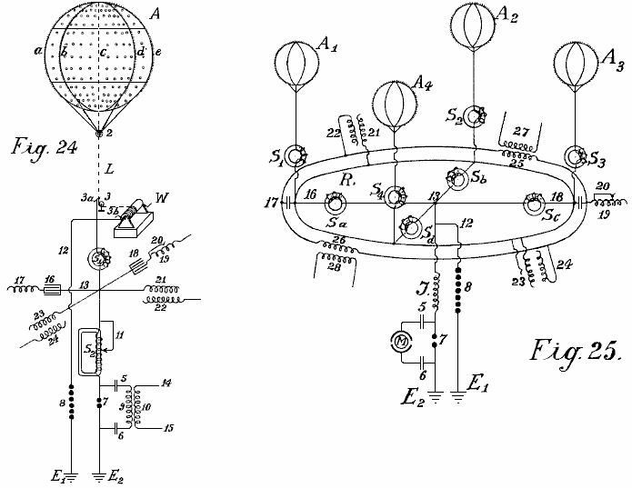

In Fig.24 and Fig.25, two different connection diagrams are illustrated in more detail. Fig.24 shows a collecting balloon along with its earth connections. Fig.25 shows four collecting balloons and the parallel connection of their capacitor sets.

A is the collecting balloon made of an aluminium magnesium alloy (electron metal magnalium) of a specific gravity of 1.8 and a plate thickness of 0.1 mm to 0.2 mm. Inside, there are eight strong vertical ribs of T-shaped section of about 10 mm to 20 mm in height and about 3 mm in thickness, with the projecting part directed inwards (indicated by a, b, c, d and so forth). They are riveted together to form a firm skeleton and are stiffened in a horizontal direction by two cross ribs. The ribs are further connected to one another internally and transversely by means of thin steel wires, whereby the balloon obtains great strength and elasticity. Rolled plates of 0.1 mm to 0.2 mm in thickness made of magnalium alloy are then either soldered or riveted on to this skeleton so that a fully metallic casing with a smooth external surface is created. Well silvered or coppered aluminium plated steel wires run from each rib to the fastening ring 2. Further, the coppered steel hawser L, preferably twisted out of separate thin wires (shown as dotted lines in Fig.24) and which must be long enough to allow the balloon to rise to the desired height, leads to a metal roller or pulley 3 and on to a winch W, which must be well insulated from the earth. By means of this winch, the balloon which is filled with hydrogen or helium, can be allowed to rise to a suitable height of 300 to 5,000 metres, and brought to the ground for recharging or repairs.

The actual current is taken directly through a friction contact from the metal roller 3 or from the wire or even from the winch, or simultaneously from all three by means of brushes (3, 3a and 3b). Beyond the brushes, the conductor is divided, the paths being:- firstly, over 12 to the safety spark gap 8, on to the earth conductor E¹, and secondly over electromagnet S¹, point 13, to a second loose electromagnet having an adjustable coil S², then to the spark gap 7 and to the second earth conductor E². The actual working circuit is formed through the spark gap 7, capacitors 5 and 6, and through the primary coil 9; here the static electricity formed by oscillatory discharges is accumulated and converted into high frequency electromagnetic oscillations. Between the electromagnets S¹ and S² at the crossing point 13, four capacitor sets are introduced which are only indicated diagramatically in the drawings by a single capacitor. Two of these sets of capacitors (16 and 18) are made as plate capacitors and prolonged by regulating induction coils or spirals 17 and 19 while the two others (21 and 23) are induction capacitors. As may be seen from the drawings, each of the four capacitor sets, 16, 18, 21 and 23 is connected by only one pole to either the aerial or to the collector conductor. The second poles 17, 19, 22 and 24 are open. In the case of plate capacitors having no inductive resistance, an induction coil is inserted. The object of such a spiral or coil is the displacement of phase of the induction current by ¹/₄ periods, whilst the charging current of the capacitor poles which lie free in the air, works back to the collector aerial. The consequence of this is that in discharges in the collector aerial, the back-inductive action of the free poles allows a higher voltage to be maintained in the aerial collecting conductor than would otherwise be the case. It has also been found that such a back action has an extremely favourable effect on the wear of the contacts. Of course, the inductive effect may be regulated at will within the limits of the size of the induction coil, the length of the coil in action being adjustable by means of wire connection without induction (see Fig.24 No. 20).

S¹ and S² may also be provided with such regulating devices, in the case of S² illustrated by 11. If excess voltage be formed, it is conducted to earth through wire 12 and spark gap 8, or through any other suitable apparatus, since this voltage would be dangerous for the other components. The action of these capacitor sets has already been described.

The small circles on the collector balloon indicate places where small patches of extremely thin layers (0.01 to 0.05 mm thick) of zinc amalgam, gold amalgam or other photoelectric acting metals, are applied to the balloon casing of light metal. Such metallic patches may also be applied to the entire balloon as well as in greater thickness to the conducting network. The capacity of the collector is thereby considerably strengthened at the surface. The greatest possible effect in collecting may be obtained by polonium amalgams and the like. On the surface of the collector balloon, metal points or spikes are also fixed along the ribs. These spikes enhance the charge collection operation. Since it is well known that the sharper the spikes, the less the resistance of the spikes, it is therefore extremely important to use spikes which are as sharp as possible. Experiments have shown that the formation of the body of the spike or point also play a large part, for example, spikes made of bars or rollers with smooth surfaces, have point resistance many times greater than those with rough surfaces. Various kinds of spike bodies have been experimented with for the collector balloons and the best results were given with spikes which were made in the following way: Fine points made of steel, copper, nickel or copper and nickel alloys, were fastened together in bundles and then placed as anode with the points placed in a suitable electrolyte (preferably in hydrochloric acid or muriate of iron solutions) and so treated with weak current driven by 2 to 3 volts. After 2 to 3 hours, according to the thickness of the spikes, the points become extremely sharp and the bodies of the spikes have a rough surface. The bundle can then be removed and the acid washed off with water. The spikes are then placed as cathode in a bath containing a solution of gold, platinum, iridium, palladium or wolfram salts or their compounds, and coated at the cathode galvanically with a thin layer of precious metal, which mush however be sufficiently firm to protect them from atmospheric oxidation.

Such spikes act at a 20 fold lower voltage almost as well as the best and finest points made by mechanical means. Still better results are obtained if polonium or radium salts are added to the galvanic bath when forming the protective layer or coating. Such pins have low resistance at their points and have excellent collector action even at one volt or lower.

In Fig.24, the three unconnected poles are not connected with one another in parallel. That is quite possible in practice without altering the principle of the free pole. It is also preferable to interconnect a series of collecting aerials in parallel to a common collector network. Fig.25 shows such an arrangement. A¹, A², A³, A⁴ are four metal collector balloons with gold or platinum coated spikes which are electrolytically mad in the presence of polonium emanations or radium salts, the spikes being connected over four electromagnets S¹, S², S³, S⁴, through an annular conductor R. From this annular conductor, four wires run over four further electromagnets Sª, S^{b}, S^{c}, S^{d}, to the connecting point 13. There, the conductor is divided, one branch passing over 12 and the safety spark gap 7 to the earth at E¹, the other over inductive resistance J and working spark gap 7 to the earth at E². The working circuit, consisting of the capacitors 5 and 6 and a resonance motor or a capacitor motor M, such as already described, is connected in proximity around the sparking gap section 7. Of course, instead of connecting the capacitor motor directly, the primary circuit for high frequency oscillatory current may also be inserted.

The capacitor sets are connected by one pole to the annular conductor R and can be either inductionless (16 and 18) or made as induction capacitors as shown by 21 and 23. The free poles of the inductionless capacitors are indicated by 17 and 19, and those of the induction capacitors by 22 and 24. As may be seen from the drawings, all of these poles 17, 22, 19 and 24 may be interconnected in parallel through a second annular conductor without any fear that thereby the principle of the free pole connection will be lost. In addition to the advantages already mentioned, the parallel connection also allows an equalisation of the working voltage in the entire collector network. Suitably calculated and constructed induction coils 25 and 26 may also be inserted in the annular conductor of the free poles, by means of which, a circuit may be formed in the secondary coils 27 and 28 which allows current produced in this annular conductor by fluctuations of the charges, to be measured or otherwise utilised.

According to what has already been stated, separate collector balloons may be connected at equidistant stations distributed over the whole country, either connected directly with one another metallically or by means of intermediate suitably connected capacitor sets through high voltage conductors insulated from earth. The static electricity is converted through a spark gap, into high frequency dynamic electricity which may be utilised as a source of energy by means of a suitable connection method, various precautions being observed, and with special regulations. The wires leading from the collector balloons, have up to now been connected through an annular conductor without this endless connection, which can be regarded as an endless induction coil, being able to exert any action on the whole conductor system.

It has now been found that if the network conductor connecting the aerial collector balloons with one another, is not made as a simple annular conductor, but preferably short-circuited in the form of coils over a capacitor set or spark gap or through thermionic valves, then the total collecting network exhibits quite new properties. The collection of atmospheric electricity is thereby not only increased but an alternating field may easily be produced in the collector network. Further, the atmospheric electrical forces showing themselves in the higher regions, may also be obtained directly by induction. In Fig.26 and Fig.28, a form of construction is shown, on the basis of which, the further foundations of the method will be explained in more detail.

In Fig.26, 1,2,3 and 4 are metallic collector balloons, with 5, 6, 7 and 8 their metallic aerial conductors and I the actual collector network. This consists of five coils and is mounted on high voltage insulators in the air, on high voltage masts (or with a suitable construction of cable, embedded in the earth). One coil has a diameter of 1 to 100 km. or more. S and S¹ are two protective electromagnets, F is the second safety section against excess voltage, E its earth conductor and E¹ the earth conductor of the working section. When an absorption of static atmospheric electricity is effected through the four balloon collectors, in order to reach the earth connection E¹, the current must flow spirally through the collector network, over the electromagnet S, primary induction coil 9, conductor 14, anode A of the audion tube, incandescent cathode K, as the way over the electromagnet and safety spark gap F offers considerably greater resistance. Owing to the fact that the accumulated current flows in one direction, an electromagnetic alternating field is produced in the interior of the collector network coil, whereby all of the free electrons are directed more or less into the interior of the coil. An increased ionisation of the atmosphere is therefore produced. Consequently, the points mounted on the collector balloon, show a considerably reduced resistance and therefore increased static charges are produced between the points on the balloon and the surrounding atmosphere. This results in a considerably increased collector effect.

A second effect, which could not be achieved in any other way, is obtained by the alternating electromagnetic field running parallel to the earth’s surface, which acts more or less with a diminishing or increasing effect on the earth’s magnetic field, whereby in the case of fluctuations in the current, a return induction current of reversed sign is always produced in the collector coil by earth magnetism. Now if a constantly pulsating, continuous alternating field is produced as stated in the collector network I, an alternating current of the same frequency is also produced in the collecting network coil. As the same alternating field is further transmitted to the aerial balloon, the resistance of its points is thereby considerably reduced, while the collector action is considerably increased. A further advantage is that positive charges which collect on the metal surfaces during the conversion into dynamic current, produce a so-called voltage drop in the collector area. As an alternating field is present, when discharge of the collector surfaces takes place, the negative ions surrounding the collector surfaces produce, by the law of induction, an induction of reversed sign on the collector surface - that is, a positive charge. In addition to the advantages already stated, the construction of connecting conductors in coil form, when of sufficiently large diameter, allows a utilisation of energy arising in higher regions, also in the most simple way. As is well known, electric discharges frequently take place at very great elevations which may be observed, such as ‘St. Elmo’s fires’ or ‘northern lights’. These energy quantities have not been able to have been utilised before now. By this invention, all of these kinds of energy, as they are of electromagnetic nature and since the axis of the collector coils is at right angles to the earth’s surface, can be absorbed in the same way as a radio absorbs distant radio signals. With a large diameter of the spiral, it is possible to connect large surfaces and thereby take up large quantities of energy.

It is well known that in the summer months and in the tropics, large radio stations are very frequently unable to receive signals due to interruptions caused by atmospheric electricity, and this takes place with vertical coils of only 40 to 100 metres in diameter. If, on the contrary, horizontal coils of 1 to 100 kilometres in diameter are used, very strong currents may be obtained through discharges which are constantly taking place in the atmosphere. Particularly in the tropics, or still better in the polar regions where the northern lights are constantly present, large quantities of energy may probably be obtained in this way. A coil with several windings should perform the best. In a similar manner, any alteration of the earth’s magnetic field should act inductively on such a coil.

It is not at all unlikely that earthquakes and sunspots will also produce an induction in collector coils of that size. In similar manner, this collector conductor will react to earth currents more particularly when they are near the surface of the earth or even embedded in the earth. By combining the previous kind of current collectors, so far as they are adapted for the improved system with the improved possibilities of obtaining current, the quantities of free natural energy which are to be obtained in the form of electricity are considerably increased.

In order to produce uniform undamped current oscillations in the improved collector coil, so-called audion high vacuum or thermionic valves are used instead of the previous described spark gaps (Fig.26, 9-18). The main aerial current flows through electromagnet S (which in the case of a high number of alternations is not connected here but in the earth conductor E¹) and may be conveyed over the primary coils in the induction winding through wire 14 to the anode A of the high vacuum grid valve. Parallel with the induction resistance 9, a regulating capacity of suitable size, such as capacitor 11, is inserted. In the lower part of the vacuum grid valve is the incandescent filament cathode K which is fed through a battery B. From the battery, two branches run, one to the earth conductor E¹ and the other through battery B¹ and secondary coil 10 to the grid anode g of the vacuum tube. By the method of connections shown in dotted lines, a desired voltage may also be produced at the grid electrode g through wire 17 which is branched off from the main current conductor through switches 16 and some small capacitors (a, b, c, d) connected in series, and conductor 18, without the battery B¹ being required. The action of the whole system is somewhat as follows:-

On the connecting conductor of the aerial collector network being short-circuited to earth, the capacitor pole 11 is charged, and slightly dampened oscillations are formed in the short-circuited oscillation circuit formed by capacitor 11 and self inductance 9. Because of the coupling through coil 10, voltage fluctuations of the same frequency take place in the grid circuit 15 and in turn, these fluctuations influence the strength of the electrode current passing through the high vacuum amplifying valve and thus produce current fluctuations of the same frequency in the anode circuit. A permanent supply of energy. Consequently, a permanent supply of energy is supplied to the oscillation circuits 9 and 10 takes place, until a balance is achieved where the oscillation energy consumed exactly matches the energy absorbed. This produces constant undamped oscillations in the oscillation circuits 9 - 11.

For regular working of such oscillation producers, high vacuum strengthening tubes are necessary and it is also necessary that the grid and anode voltages shall have a phase difference of 180⁰ so that if the grid is negatively charged, then the anode is positively charged and vice versa. This necessary difference of phase may be obtained by most varied connections, for example, by placing the oscillating circuit in the grid circuit or by separating the oscillation circuit and inductive coupling from the anodes and the grid circuit, and so forth.

A second important factor is that care must be taken that the grid and anode voltages have a certain relation to one another; the latter may be obtained by altering the coupling and a suitable selection of the self induction in the grid circuit, or as shown by the dotted lines 18, 17, 16 by means of a larger or smaller number of capacitors of suitable size connected in series; in this case, the battery B¹ may be omitted. With a suitable selection of the grid potential, a glow discharge takes place between the grid g and the anode A, and accordingly at the grid there is a cathode drop and a dark space is formed. The size of this cathode drop is influenced by the ions which are emitted in the lower space in consequence of shock ionisation of the incandescent cathodes K and pass through the grid in the upper space. On the other hand, the number of the ions passing through the grid is dependent on the voltage between the grid and the cathode. Thus, if the grid voltage undergoes periodic fluctuations (as in the present case), the amount of the cathode drop at the grid fluctuates, and consequently, the internal resistance of the valve fluctuates correspondingly, so that when a back-coupling of the feed circuit with the grid circuit takes place, the necessary means are in place for producing undamped oscillations and of taking current as required, from the collecting conductor.

With a suitably loose coupling, the frequency of the undamped oscillations produced is equal to the self-frequency of the oscillation circuits 9 and 10. By selecting a suitable self-induction for coil 9 and capacitor 11, it is possible to extend operation from frequencies which produce electromagnetic oscillations with a wavelength of only a few metres, down to the lowest practical alternating current frequency. For large installations, a suitable number of frequency producing tubes in the form of the well known high vacuum transmission tubes of 0.5 kW to 2 kW in size may be connected in parallel so that in this respect, no difficulty exists.

The use of such tubes for producing undamped oscillations, and the construction and method of inserting such transmission tubes in an accumulator or dynamo circuit is known, also, such oscillation producing tubes only work well at voltages of 1,000 volts up to 4,000 volts, so that on the contrary, their use at lower voltages is considerably more difficult. By the use of high voltage static electricity, this method of producing undamped oscillations as compared with that through spark gaps, must be regarded as an ideal solution, particularly for small installations with outputs from 1 kW to 100 kW.

By the application of safety spark gaps, with interpolation of electromagnets, not only is short-circuiting avoided but also the taking up of current is regulated. Oscillation producers inserted in the above way, form a constantly acting alternating electromagnetic field in the collector coil, whereby, as already stated, a considerable accumulating effect takes place. The withdrawal or ‘working’ wire is connected at 12 and 13, but current may be taken by means of a secondary coil which is firmly or moveably mounted in any suitable way inside the large collector coil, i.e. in its alternating electromagnetic field, so long as the direction of its axis is parallel to that of the main current collecting coil.

In producing undamped oscillations of a high frequency (50 KHz and more) in the oscillation circuits 9 and 11, electromagnets S and S¹ must be inserted if the high frequency oscillations are not to penetrate the collector coil, between the oscillation producers and the collector coil. In all other cases they are connected shortly before the earthing (as in Fig.27 and Fig.28).

In Fig.27 a second method of construction of the connecting conductor of the balloon aerials is illustrated in the form of a coil. The main difference is that in addition to the connecting conductor I another annular conductor II is inserted parallel to the former on the high voltage masts in the air (or embedded as a cable in the earth) but both in the form of a coil. The connecting wire of the balloon aerials is both a primary conductor and a current producing network while the coil is the consumption network and is not in unipolar connection with the current producing network.

In Fig.27 the current producing network I is shown with three balloon collectors 1, 2, 3 and aerial conductors 4, 5, 6; it is short-circuited through capacitor 19 and inductor 9. The oscillation forming circuit consists of spark gap f, inductor 10 and capacitor 11. The earth wire E is connected to earth through electromagnet S¹. F_{I} is the safety spark gap which is also connected to earth through a second electromagnet S_{II} at E_{II}. On connecting up the capacitor circuit 11 it is charged over the spark gap f and an oscillatory discharge is formed. This discharging current acts through inductor 10 on the inductively coupled secondary 9, which causes a change in the producing network, by modifying the voltage on capacitor 19. This causes oscillations in the coil-shaped producer network. These oscillations induce a current in the secondary circuit II, which has a smaller number of windings and lower resistance, consequently, this produces a lower voltage and higher current in it.

In order to convert the current thus obtained, into current of an undamped character, and to tune its wavelengths, a sufficiently large regulatable capacitor 20 is inserted between the ends 12 and 13 of the secondary conductor II. Here also, current may be taken without an earth conductor, but it is advisable to insert a safety spark gap E¹ and to connect this with the earth via electromagnet S². The producer network may be connected with the working network II over an inductionless capacitor 21 or over an induction capacitor 22, 23. In this case, the secondary conductor is unipolarly connected with the energy conductor.

In Fig.28, the connecting conductor between the separate collecting balloons is carried out according to the autotransformer principle. The collecting coil connects four aerial balloons 1, 2, 3, 4, the windings of which are not made side-by-side but one above the other. In Fig.28, the collector coil I is shown with a thin line and the metallically connected prolongation coils II with a thick line. Between the ends I¹ and II¹ of the energy network I, a regulating capacitor 19 is inserted. The wire I¹ is connected with the output wire and with the spark gap F.

As transformer of the atmospheric electricity, an arrangement is employed which consists of using rotary pairs of capacitors in which the stator surface B is connected with the main current, while the other A is connected to the earth pole. These pairs of short-circuited capacitors are caused to rotate and the converted current can be taken from them via two collector rings and brushes. This current is alternating current with a frequency dependent on the number of balloons and the rate of revolutions of the rotor. As the alternating current formed in the rotor can act through coils 10 on the inductor 9, an increase or decrease of the feed current in I can be obtained according to the direction of the current by back-induction. Current oscillations of uniform rhythm are produced in the coil-shaped windings of the producer network.

As the ends of this conductor are short-circuited through the regulatable capacitor 19, these rhythms produce short-circuited undamped oscillations in the energy conductor. The frequency of these oscillations can be altered at will by adjusting the capacitance of capacitor 19. These currents may also be used as working current via the conductors II¹ and III. By inserting capacitor 20, a connection between these conductors may also be made, whereby harmonic oscillations of desired wavelength are formed. By this means, quite new effects as regards current distribution are obtained. The withdrawal of current can even take place without direct wire connection if, at a suitable point in the interior of the producing network (quite immaterially whether this has a diameter of 1 or 100 km) a coil tuned to these wavelength and of the desired capacity, is firmly or moveably mounted in the aerial conductor in such a way that its axis is parallel with the axis of the collector coil. In this case, a current is induced in the producing network, the size of which is dependent on the total capacity and resistance and on the frequency selected. A future possibility is taking energy from the producer network by radio signals as in addition to atmospheric electricity, magnetic earth currents and energy from the upper atmosphere may be tapped.

Of course, vacuum tubes may be used to produce undamped oscillations anywhere spark gaps are shown in the circuits. The separate large-diameter coils of the producer network may be connected to one another through separate conductors all in parallel or all in series or in groups in series. By regulating the number of oscillations and the magnitude of the voltage, more or fewer large collector coils of this kind may be used. The coils may also be divided spirally over the entire section. The coils may be carried out in annular form or in triangular, quadrangular, hexagonal or octagonal form.

Of course, wires which form guides for the current waves, may be carried from a suitable place to the centre or also laterally. This is necessary when the currents have to be conducted over mountains and valleys and so forth. In all these cases, the current must be converted into a current of suitable frequency.

As already mentioned, separate collecting balloons may be directly metallically interconnected a equidistant stations distributed over the entire country, or may be connected by interpolation of suitable capacitor sets by means of high voltage conductors. The static electricity is converted through a spark gap into dynamic energy of high frequency and could then in that form be used as an energy source after special regulation.

According to this invention, in order to increase the collecting effect of the balloon in the aerial collector conductor or in the earth wire, radiating collectors are used. These consist of either incandescent metal or oxide electrodes in the form of vacuum grid valves, or electric arcs (mercury or similar electrodes), Nernst lamps, or flames of various kinds maybe simply connected with the respective conductor.

It is well known that energy can be drawn off from a cathode consisting of an incandescent body opposite an anode charged with positive electricity (vacuum grid tube). Hitherto however, a cathode was always first directly placed opposite an anode, and secondly, the system always consisted of a closed circuit.

Now if we dispense with the ordinary ideas in forming light or flame arcs in which a cathode must always stand directly opposite an anode charged to a high voltage or another body freely floating in the air, or consider the incandescent cathode to be only a source of unipolar discharge, (which represents group and point discharges in electro-static machines similar to unipolar discharges), it may be ascertained that incandescent cathodes and less perfectly, all incandescent radiators, flames and the like, have relatively large current densities and allow large quantities of electric energy to radiate into open space in the form of electron streams as transmitters.

The object of this invention is as described below, if such incandescent oxide electrodes or other incandescent radiators or flames are not freely suspended in space but instead are connected metallically with the earth so that they can be charged with negative terrestrial electricity, these radiators possess the property of absorbing the free positive electrical charges contained in the air space surrounding them (that is to say, of collecting them and conducting them to earth). They can therefore serve as collectors and have in comparison to the action of the spikes, a very large radius of action R; the effective capacity of these collectors is much greater than the geometrical capacity (R₀) calculated in an electro-static sense.

As is well known, our earth is surrounded with an electro-static field and the difference of potential dV/dh of the earth field according to the latest investigations, is in summer about 60 to 100 volts, and in winter, 300 to 500 volts per metre difference in height, a simple calculation gives the result that when such a radiation collector or flame collector is arranged, for example, on the ground, and a second one is mounted vertically over it at a distance of 2,000 metres and both are connected by a conducting cable, there is a voltage difference in summer of about 2,000,000 volts and in winter 6,000,000 volts or more.

According to Stefan Boltzmann’s law of radiation, the quantity of energy which an incandescent surface (temperature T) of 1 sq. cm. radiates in a unit of time into the open air (temperature T₀) is expressed by the following formula:

S = R (T⁴ -T₀⁴) watts per square centimetre

and the universal radiation constant R, according to the latest researches of Ferry, is equal to 6.30 x 10⁻¹² watts per square centimetre.

Now, if an incandescent surface of 1 sq. cm., as compared to the surrounding space, shows a periodic fall of potential dV, it radiates (independent of the direction of the current) in accordance with the above formula, for example at a temperature of 3715⁰ C. an energy of 1.6 kW per square centimetre. As for the radiation, the same value can be calculated for the collection of energy, but reversed. Now, as carbon electrodes at the temperature of the electric arc, support a current density up to 60 to 65 amps per sq. cm., no difficulties will result in this direction in employing radiating collectors as accumulators.

If the earth be regarded as a cosmically insulated capacitor in the sense of geometrical electro-statics x, according to Chwolson, there results from the geometric capacity of the earth:

For negative charging 1.3 x 10⁶ Coulomb For negative potential V = 10 x 10⁸ volts.

It follows from this that EJT is approximately equal to 24.7 x 10²⁴ watts/sec. Now if it is desired to make a theoretical short circuit through an earthed flame collector, this would represent an electrical total work of about 79,500 x 10¹⁰ kilowatt years. As the earth must be regarded as a rotating mechanism which is thermo-dynamically, electromagnetically and kinematically coupled with the sun and star system by cosmic radiation and gravitation, a reduction in the electric energy of the earth field is not to be feared. The energies which the incandescent collectors could withdraw from the earth field can only cause a lowering of the earth temperature. This is however, not the case as the earth does not represent a cosmically entirely insulated system. On the contrary, there is conveyed from the sun to the earth an energy of 18,500 x 10¹⁰ kilowatts. Accordingly, any lowering of the earth temperature without a simultaneous lowering of the sun’s temperature would contradict Stefan Boltzmann’s law of radiation.

From this it must be concluded that if the earth temperature sinks, the total radiation absorbed by the earth increases, and further, the rate of cooling of the earth is directly dependent on that of the sun and the other radiators cosmically coupled with the sun.

The incandescent radiation collectors may, according to this invention, be used for collecting atmospheric electricity if they (1) are charged with the negative earth electricity (that is to say, when they are directly connected to the earth by means of a metallic conductor) and (2) if large capacities (metal surfaces) charged with electricity are mounted opposite them as positive poles in the air. This is regarded as the main feature of the present invention as without these inventive ideas it would not be possible to collect with an incandescent collector, sufficiently large quantities of the electrical charges contained in the atmosphere as technology requires; the radius of action of the flame collectors would also be too small, especially if it be considered that the very small surface density does not allow of large quantities of charge being absorbed from the atmosphere.

It has already been proposed to employ flame collectors for collecting atmospheric electricity and it is known that their collecting effect is substantially greater opposite the points. It is however, not known that the quantities of current which hitherto be obtained are too small for technical purposes. According to my experiments, the reason for this is to be found in the inadequate capacities of the collector conductor poles. If such flame or radiating collectors have no or only small positive surfaces, their radius of action for large technical purposes is too small. If the incandescent collectors be constantly kept in movement in the air, they may collect more according to the speed of the movement, but this is again not capable of being carried out in practice.

By this invention, the collector effect is considerably increased by a body charged with a positive potential and of the best possible capacity, being also held floating (without direct earth connection) opposite such an incandescent collector which is held floating in the air at a desired height. If, for example, a collecting balloon of sheet metal or metallised fabric, be caused to mount to 300 to 3,000 metres in the air, and as a positive pole it is brought opposite such a radiating collector connected by a conductor to earth, quite different results are obtained.

The metallic balloon shell which has a large surface area is charged to a high potential by atmospheric electricity. This potential is greater the higher the collecting balloon is above the incandescent collector. The positive electricity acts concentratedly on the anode floating in the air as it is attracted through the radiation shock ionisation, proceeding from the incandescent cathode. The consequence of this is that the radius of action of the incandescent cathode collector is considerably increased and so is the collecting effect of the balloon surface. Further, the large capacity of the anode floating in the air, plays therefore an important part because it allows the collection of large charges resulting in a more uniform current even when there is substantial current withdrawal - this cannot be the case with small surfaces.

In the present case, the metallic collecting balloon is a positive anode floating in the air and the end of the earth conductor of this balloon serves as positive pole surface opposite the surface of the radiating incandescent cathode, which in turn is charged with negative earth electricity as it is connected to the earth by a conductor. The process may be carried out by two such contacts (negative incandescent cathode and anode end of a capacity floating in the air) a capacitor and an inductive resistance being switched on in parallel, whereby simultaneously undamped oscillations may be formed.

In very large installations it is advisable to connect two such radiating collectors in series. Thus an arc light incandescent cathode may be placed below on the open ground and an incandescent cathode which is heated by special electro-magnetic currents, be located high in the air. Of course for this, the special vacuum Liebig tubes with or without grids may also be used. An ordinary arc lamp with oxide electrodes may be introduced on the ground and the positive pole is not directly connected with the collecting balloon, but through the upper incandescent cathode or over a capacitor. The method of connecting the incandescent cathode floating in the air may be seen in Figs.29-33.

B is the air balloon, K a Cardan ring (connection with the hawser) C the balloon, L a good conducting cable, P a positive pole, N negative incandescent cathode and E the earth conductor.

Fig.29 represents the simplest form of construction. If electric oscillations are produced below on the ground by means of a carbon arc lamp or in any other suitable way, a considerably greater electric resistance is opposed to that in the direct way by inserting an electrical inductive resistance 9. Consequently, between P and N, a voltage is formed, and as, over N and P only an inductionless ohmic resistance is present, a spark will spring over so long as the separate induction coefficients and the like are correctly calculated. The consequence of this is that the oxide electrode (carbon or the like) is rendered incandescent and then shows as incandescent cathode, an increased collecting effect. The positive poles must be substantially larger than the negative in order that they may not also become incandescent. As they are further connected with the large balloon area which has a large capacity and is charged at high voltage, an incandescent body which is held floating in the air and a positive pole which can collect large capacities is thereby obtained in the simplest way. The incandescent cathode is first caused to become incandescent by means of separate energy produced on the earth, and then maintained by the energy collected from the atmosphere.

Fig.30 only shows the difference that instead of a round balloon, a cigar-shaped one may be used, also, a capacitor 5 is inserted between the incandescent cathode and the earth conductor so that a short-circuited oscillation circuit over P N 5 and 9 is obtained. This has the advantage that quite small quantities of electricity cause the cathode to become incandescent and much larger cathode bodies may be made incandescent.

In this form of construction, both the incandescent cathode and the positive electrode may be enclosed in a vacuum chamber as shown in Fig.32. A cable L is carried well insulated through the cover of a vessel and ends in a capacitor disc 5. The cover is arched in order to keep the rain off. The vessel is entirely or partially made of magnetic metal and well insulated inside and outside. Opposite disc 5 another disc 6 and on this again a metallic positive pole of the vacuum tube g with the incandescent cathode (oxide electrode) N is arranged. The negative electrode is on the one hand connected to the earth conductor E, and on the other hand with the inductive resistance 9 which is also connected with the cable L with the positive pole and wound around the vessel in coils. The action is exactly the same as that in Fig.29 only instead of an open incandescent cathode, one enclosed in vacuo is used. As in such collectors, only small bodies be brought to incandescence, in large installations a plurality of such vacuum tubes must be inserted in proximity to one another. According to the previous constructions Fig.31 and Fig.33 are quite self evident without further explanations.

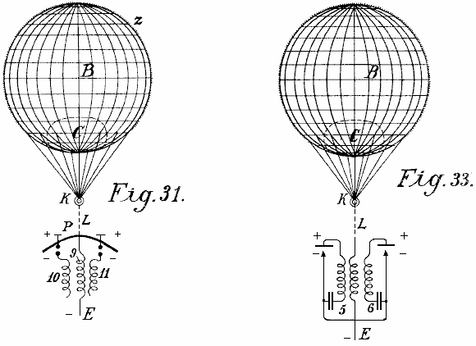

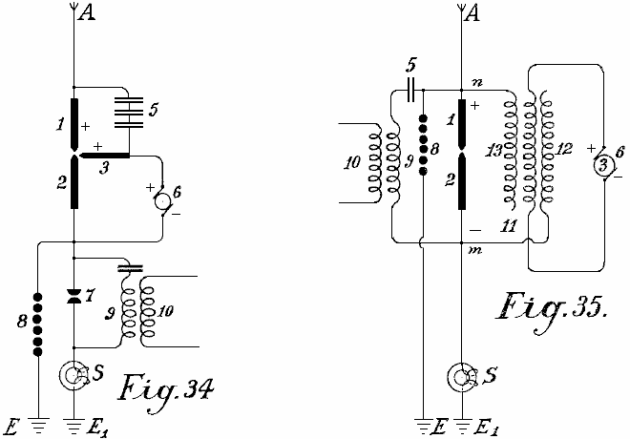

Figs.34-37 represent further diagrams of connections over radiating and flame collectors, and in fact, how they are to be arranged on the ground. Fig.34 shows an arc light collector with oxide electrodes for direct current and its connection. Fig.35 shows a similar one for alternating current. Fig.36 an incandescent collector with a Nernst lamp and Fig.37 a similar one with a gas flame.
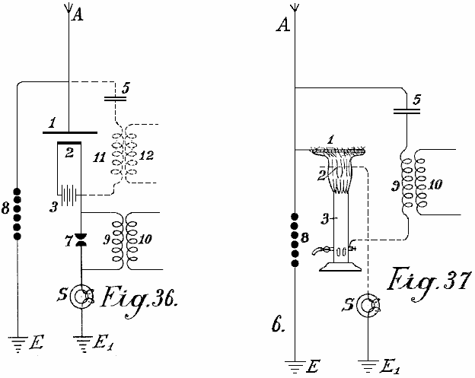

The positive pole 1 of the radiating collectors is always directly connected to the aerial collecting conductor A. In Fig.34, this is further connected over the capacitor set 5 with a second positive electrode 3. The direct current dynamo b produces current which flows over between the electrodes 3 and 2 as an arc light. On the formation of an arc, the negative incandescent electrode 2 absorbs electricity from the positive poles standing opposite it and highly charged with atmospheric electricity which it conveys to the working circuit. The spark gap 7, inductive resistance 9 and induction coil 10 are like the ones previously described. The protective electromagnet S protects the installation from earth circuiting and the safety spark gap 8 from excess voltage or overcharging.

In Fig.35, the connection is so far altered that the alternating current dynamo feeds the excitation coil 11 of the induction capacitor. 12 is its negative and 13 its positive pole. If the coil 3 on the magnet core of the dynamo is correctly calculated and the frequency of the alternating current sufficiently high, then an arc light can be formed between poles 1 and 2. As the cathode 2 is connected to the negatively charged earth, and therefore always acts as a negative pole, a form of rectification of the alternating current produced by the dynamo 3 is obtained, since the second half of the period is always suppressed. The working circuit may be carried out in the same way as in Fig.34; the working spark gap 7 may however be dispensed with, and instead of it, between the points n and m, a capacitor 5 and an induction resistance 9 may be inserted, from which, a current is taken inductively.

Fig.36 represents a form of construction similar to that shown in Fig.34 except that here instead of an arc lamp, a Nernst incandescent body is used. The Nernst lamp is fed through the battery 3. The working section is connected with the negative pole, the safety spark gap with the positive poles. The working spark gap 7 may also be dispensed with and the current for it taken at 12 over the oscillation circuit 5, 11 (shown in dotted lines).

Flame collectors (Fig.37) may also be employed according to this invention. The wire network 1 is connected with the aerial collector conductor A and the burner with the earth. At the upper end of the burner, long points are provided which project into the flame. The positive electrode is connected with the negative over a capacitor 5 and the induction coil 9 with the earth.

The novelty in this invention is:

(1) The use of incandescent cathodes opposite positive poles which are connected to large metallic capacities as automatic collecting surfaces.
(2) The connection of the incandescent cathodes to the earth whereby, in addition to the electricity conveyed to them from the battery of machine which causes the incandescing, also the negative charge of the earth potential is conveyed, and
(3) The connection of the positive and negative poles of the radiating collectors over a capacitor circuit alone or with the introduction of a suitable inductive resistance, whereby simultaneously an oscillatory oscillation circuit may be obtained. The collecting effect is by these methods quite considerably increased.
ROY MEYERS

Patent GB1913,01098 14th January 1914 Inventor: Roy J. Meyers

APPARATUS FOR PRODUCING ELECTRICITY

ABSTRACT
A rectifier for use with apparatus for producing electricity from the earth consists of mercury- vapour lamps constructed and arranged as shown in Fig.4. Each lamp comprises two wires 6<1>, 7<1> wound around a steel tube 15 surrounding a mercury tube 11 preferably of copper. The coil 6<1> is connected between the electrode 14 and the terminal 18, and the coil 7<1> between the terminals 19, 5. The coils 6<1>, 7<1> are preferably composed of soft iron.

DESCRIPTION
This invention relates to improvements in apparatus for the production of electrical currents, and the primary object in view is the production of a commercially serviceable electrical current without the employment of mechanical or chemical action. To this end the invention comprises means for producing what I believe to be dynamic electricity from the earth and its ambient elements.

I am, of course aware that it has been proposed to obtain static charges from upper strata of the atmosphere, but such charges are recognised as of widely variant potential and have thus far proved of no practical commercial value, and the present invention is distinguished from all such apparatus as has heretofore been employed for attracting static charges by the fact that this improved apparatus is not designed or employed to produce or generate irregular, fluctuating or other electrical charges which lack constancy, but on the other hand I have by actual test been able to produce from a very small apparatus at comparatively low elevation, say about 50 or 60 feet above the earth’s surface, a substantially constant current at a commercially usable voltage and amperage.

This current I ascertained by repeated tests is capable of being readily increased by additions of the unit elements in the apparatus described below, and I am convinced from the constancy of the current obtained and its comparatively low potential that the current is dynamic and not static, although, of course, it is not impossible that certain static discharges occur and, in fact, I have found occasion to provide against the damage which might result from such discharge by the provision of lightning arresters and cut-out apparatus which assist in rendering the obtained current stable by eliminating sudden fluctuations which sometimes occur during conditions of high humidity from what I consider static discharges.

The nature of my invention is obviously such that I have been unable to establish authoritatively all of the principles involved, and some of the theories herein expressed may possibly prove erroneous, but I do know and am able to demonstrate that the apparatus which I have discovered does produce, generate, or otherwise acquire a difference of potential representing a current amperage as stated above.

The invention comprises the means for producing electrical currents of serviceable potential substantially without the employment of mechanical or chemical action, and in this connection I have been able to observe no chemical action whatever on the parts utilised although deterioration may possibly occur in some of the parts, but so far as I am able to determine such deterioration does not add to the current supply but is merely incidental to the effect of climatic action.

The invention more specifically comprises the employment of a magnet or magnets and a co-operating element, such as zinc positioned adjacent to the magnet or magnets and connected in such manner and arranged relative to the earth so as to produce current, my observation being that current is produced only when such magnets have their poles facing substantially to the north and south and the zincs are disposed substantially along the magnets.

The invention also comprehends other details of construction, combinations and arrangements of parts as will be fully set forth.

DESCRIPTION OF THE DRAWINGS

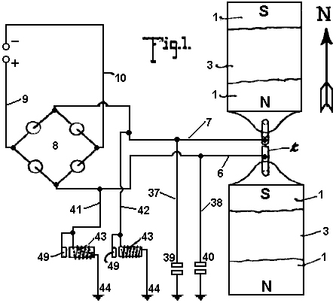

Fig.1 is a plan view of an apparatus embodying the features of the present invention, the arrow accompanying the figure indicating substantially the geographical north, parts of this figure are diagrammatic.

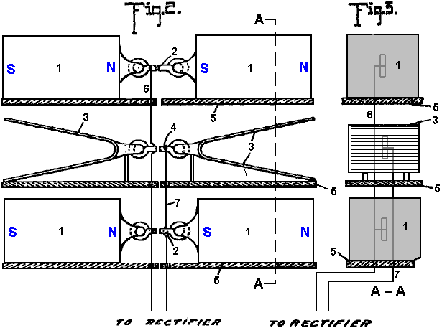
Fig.2 is a view is side elevation of the parts seen in plan in Fig.1
Fig.3 is a vertical section taken on the plane indicated by the line A--A of Fig.2.

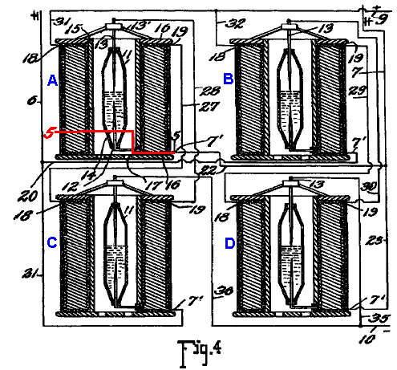
Fig.4 is a detail view, partly in elevation and partly in section, showing the connections of the converter and intensifier.

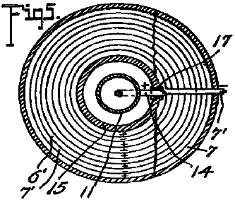

Fig.5 is a transverse section taken on the planes indicated by line 5-5 of Fig.4, looking downwards.
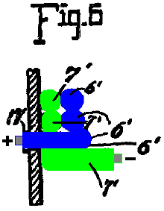

Fig.6 is an enlarged detail fragmentary section illustrating the parts at the junction of the conductors and one of the intensifiers.

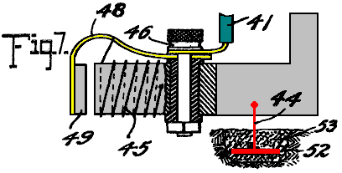
Fig.7 is an enlarged detail view partly in elevation and partly in section of one of the automatic cut-outs
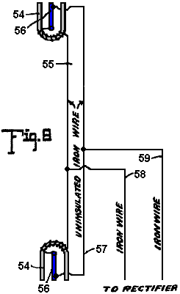

Fig.8 is a diagrammatic view of one of the simplest forms of embodiment of the invention.

Referring to the drawing by numerals, 1,1 indicates magnets connected by a magnetic substance 2, preferably an iron wire. The magnets 1 are arranged in pairs, one pair being spaced beneath the other, and interposed between the magnets are zinc plates 3,3 connected by an iron wire conductor 4. Suitable insulating supports 5 are arranged for sustaining the respective magnets 1 and plates 3,3. Each plate 3 is preferably bent substantially into V form, as clearly seen in Fig.1, and the V of one of the plates opens or faces toward the North and the V of the other plate to the South. I have determined by experimentation that it is essential that the plates 3 be disposed substantially North and South with their flat faces approximately parallel to the adjacent faces of the co-operating magnets, although by experience I have not discovered any material difference in the current obtained when the plates are disposed slightly to one side of North and South, as for instance when the plates are disposed slightly to one side of North and South, as for instance when disposed in the line of the magnetic polarity of the earth. The same is true with respect to the magnets 1, the said magnets being disposed substantially North and South for operative purposes, although I find that it is immaterial whether the North pole of one of the magnets is disposed to the North and the South pole to the South, or vice versa, and it is my conviction from experience that it is essential to have the magnets of each pair connected by magnetic material so that the magnets substantially become one with a pole exposed to the North and a pole exposed to the South.

In Fig.1, I have indicated in full lines by the letters 8 and N the respective polarities of the magnets 1, and have indicated in dotted lines the other pole of those magnets when the connection 2 is severed. I have found that the magnets and zinc plates operate to produce, (whether by collection or generation I am not certain), electrical currents when disposed substantially North and South, but when disposed substantially East and West, no such currents are produced. I also find that the question of elevation is by no means vital, but it is true that more efficient results are obtained by placing the zincs and magnets on elevated supports. I furthermore find from tests, that it is possible to obtain currents from the apparatus with the zincs and magnets disposed in a building or otherwise enclosed, although more efficient results are obtained by having them located in the open.

While in Figures 1, 2, and 3, I have shown the magnets and the zinc plates as superimposed, it will be apparent, as described in detail below, that these elements may be repositioned in horizontal planes, and substantially the same results will be secured. Furthermore, the magnets 1 with the interposed zincs 3, as shown in Figures 1, 2 and 3 merely represent a unit which may be repeated either horizontally or vertically for increasing the current supply, and when the unit is repeated the zinc plates are arranged alternating with the magnets throughout the entire series as indicated below.

A conductor 6 is connected in multiple with the conductors 2 and a conductor 7 is connected with conductor 4, the conductor 6 extending to one terminal of a rectifier which I have indicated by the general reference character 8, and the conductor 7 extending to the other terminal of the rectifier. The rectifier as seen in the diagram Fig.1 may assume any of several well known embodiments of the electrical valve type and may consist of four asymmetric cells or Cooper-Hewitt mercury vapour lamps connected as indicated in Fig.1 for permitting communication of the positive impulses from the conductor 6 only to the line conductor 9 and the negative impulses from conductor 6 on only to the line conductor 10. The current from this rectifier may be delivered through the conductors 9 and 10 to any suitable source for consumption.

While the said rectifier 8 may consist of any of the known types, as above outlined, it preferably consists of a specially constructed rectifier which also has the capacity of intensifying the current and comprises specifically the elements shown in detail in Figures 4, 5, and 6 wherein I have disclosed the detail wiring of the rectifier when composed of four of the rectifying and intensify in elements instead of asymmetric cells or simple mercury vapour valves. As each of these structures is an exact embodiment of all the others, one only will be described, and the description will apply to all. The rectifying element of each construction consists of a mercury tube 11 which is preferably formed of glass or other suitable material, and comprises a cylinder having its end portions tapered and each terminating in an insulating plug or stopper 12. Through the upper stopper 12 is extended the electrode 13 which extends well into the tube and preferably about one-half its length, to a point adjacent the inner end of an opposing electrode 14 which latter electrode extends from there down through the insulation 12 at the lower end of the tube. The tube 11 is supplied with mercury and is adapted to operate on the principle of the mercury vapour lamp, serving to rectify current by checking back impulses of one sign and permitting passage of impulses of the other.

To avoid the necessity for utilising a starter, as is common with the lamp type of electrical valve, the supply of mercury within the tube may be sufficient to contact with the lower end of the electrode 13 when current is not being supplied, so that as soon as current is passed from one electrode to the other sufficiently for volatilising that portion of the mercury immediately adjacent the lower end of electrode 13, the structure begins its operation as a rectifier. The tube 11 is surrounded by a tube 15 which is preferably spaced from tube 11 sufficiently for allowing atmospheric or other cooling circulation to pass the tube 11. In some instances, it may be desirable to cool the tube 11 by a surrounding body of liquid, as mentioned below. The tube 15 may be of insulating material but I find efficient results attained by the employment of a steel tube, and fixed to the ends of the of the tube are insulating disks 16, 16 forming a spool on which are wound twin wires 6’ and 7’, the wire 6’ being connected at the inner helix of the coil with the outer end of the electrode 14, the lower portion of said electrode being extended to one side of the tube 11 and passed through an insulating sleeve 17 extending through the tube 15, and at its outer end merging into the adjacent end of the wire 6’. The wire 7’ extends directly from the outer portion of the spool through the several helices to a point adjacent to the junction of the electrode 14 with wire 6’ and thence continues parallel to the wire throughout the coil, the wire 6’ ending in a terminal 18 and the wire 7’ ending in a terminal 19.

For the sake of convenience of description and of tracing the circuits, each of the apparatus just above described and herein known as an intensifier and rectifier will be mentioned as A, B, C and D, respectively. Conductor 6 is formed with branches 20 and 21 and conductor 7 is formed with similar branches 22 and 23. Branch 20 from conductor 6 connects with conductor 7’ of intensifier B and branch 21 of conductor 6 connects with the conductor 7’ of intensifier C, while branch 22 of conductor 7 of intensifier C, while branch 22 of conductor 7 connects with conductor 7’ of intensifier D. A conductor 27 is connected to terminal 19 of intensifier A and extends to and is connected with the terminal 18 of intensifier C, and a conductor 7 connects with conductor 7’ of intensifier D. A conductor 27 is connected to terminal 19 of intensifier A, and extends to and is connected to terminal 18 of intensifier C, and a conductor 28 is connected to the terminal 19 of intensifier C and extends from the terminal 19 of intensifier B to the terminal 18 of intensifier D to electrode 13 of intensifier B. Each electrode 13 is supported on a spider 13’ resting on the upper disk 16 of the respective intensifier. Conductors 31 and 32 are connected to the terminals 18 of intensifiers A and B and are united to form the positive line wire 9 which co-operates with the negative line wire 10 and extends to any suitable point of consumption. The line wire 10 is provided with branches 35 and 36 extending to the electrodes 13 of intensifiers C and D to complete the negative side of the circuit.

Thus it will be seen that alternating currents produced in the wires 6 and 7 will be rectified and delivered in the form of a direct current through the line wires 9 and 10, and I find by experiment that the wires 6 and 7 should be of iron, preferably soft, and may of course be insulated, the other wiring not specified as iron being of copper or other suitable material.

In carrying out the operation as stated, the circuits may be traced as follows: A positive impulse starting at the zincs 3 is directed along conductor 7 to branch 23 to conductor 7’ and the winding of the rectifier of intensifier B through the rectifier to the conductor 6’, through its winding to the contact 18, conductor 32 and to the line wire 9. The next, or negative, impulse directed along conductor 7 cannot find its way along branch 23 and the circuit just above traced because it cannot pass across the rectifier of intensifier B but instead the negative impulse passes along conductor 22 to conductor 7 of intensifier A and its winding to the contact 19 and to conductor 27 to contact 18 of intensifier C, to the winding of the wire 6’ thereof to the electrode 14 through the rectifier to the of the electrode 13 and conductor of intensifier A, electrode 14 thereof and conductor 6’ to contact 18 and wire 31 to line wire 9.

Obviously the positive impulse cannot pass along the wire 20 because of its inverse approach to the rectifier of intensifier B. The next impulse or negative impulse delivered to conductor 6 cannot pass along conductor 21 because of its connection with electrode 13 of the rectifier of intensifier A, but instead passes along conductor 20 to the wire 7’ and its winding forming part of intensifier B to the contact 19 and conductor 29 to contact 18 and the winding of wire 6’ of intensifier D to the electrode 14 and through the rectifier to the electrode 13 and conductor 35 to line wire 10. Thus the current is rectified and all positive impulses directed along one line and all negative impulses along the other lie s that the potential difference between the two lines will be maximum for the given current of the alternating circuit. It is, of course, apparent that a less number of intensifiers with their accompanying rectifier elements may be employed with a sacrifice of the impulses which are checked back from a lack of ability to pass the respective rectifier elements, and in fact I have secured efficient results by the use of a single intensifier with its rectifier elements, as shown below.

Grounding conductors 37 and 38 are connected respectively with the conductors 6 and 7 and are provided with the ordinary lightning arresters 39 and 40 respectively for protecting the circuit against high tension static charges.

Conductors 41 and 42 are connected respectively with the conductors 6 and 7 and each connects with an automatic cut-out 43 which is grounded as at 4. Each of the automatic cut-outs is exactly like the other and one of the these is shown in detail in Fig.7 and comprises the inductive resistance 45 provided with an insulated binding post 46 with which the respective conductor 6 or 7 is connected, the post also supporting a spring 48 which sustains an armature 49 adjacent to the core of the resistance 45. The helix of resistance 45 is connected preferably through the spring to the binding post at one end and at the other end is grounded on the core of the resistance, the core being grounded by ground conductor 44 which extends to the metallic plate 52 embedded in moist carbon or other inductive material buried in the earth. Each of the conductors 41, 42 and 44 is of iron, and in this connection I wish it understood that where I state the specific substance I am able to verify the accuracy of the statement by the results of tests which I have made, but of course I wish to include along with such substances all equivalents, as for instance, where iron is mentioned its by-products, such as steel, and its equivalents such as nickel and other magnetic substances are intended to be understood.

The cut-out apparatus seen in detail in Fig.7 is employed particularly for insuring against high voltage currents, it being obvious from the structure shown that when potential rises beyond the limit established by the tension of the spring sustaining the armature 40, the armature will be moved to a position contacting with the core of the cut-out device and thereby directly close the ground connection for line wire 41 with conductor 44, eliminating the resistance of winding 45 and allowing the high voltage current to be discharged to the ground. Immediately upon such discharge the winding 45 losing its current will allow the core to become demagnetised and release the armature 49 whereby the ground connection is substantially broken leaving only the connection through the winding 45 the resistance of which is sufficient for insuring against loss of low voltage current.

In Fig.8 I have illustrated an apparatus which though apparently primitive in construction and arrangement shows the first successful embodiment which I produced in the course of discovery of the present invention, and it will be observed that the essential features of the invention are shown there. The structure shown in the figure consists of horseshoe magnets 54, 55, one facing North and the other South, that is, each opening in the respective directions indicated and the two being connected by an iron wire 55 which is uninsulated and wrapped about the respective magnets each end portion of the wire 55 being extended from the respective magnets to and connected with, as by being soldered to, a zinc plate 56, there being a plate 56 for each magnet and each plate being arranged longitudinally substantially parallel with the legs of the magnet and with the faces of the plate exposed toward the respective legs of the magnet, the plate being thus arranged endwise toward the North and South. An iron wire 57 connects the plates 56, the ends of the wire being preferably connected adjacent the outer ends of the plates but from experiment I find that the wire may be connected at practically any point to the plate. Wires 58 and 59 are connected respectively with the wires 55 and 57 and supply an alternating current at a comparatively low voltage, and to control such current the wires 58 and 59 may be extended to a rectifier or combined rectifier and intensifier, as discussed above.

The tests which I have found successful with the apparatus seen in Fig.8 were carried out by the employment first of horseshoe magnets approximately 4 inches in length, the bar comprising the horseshoe being about one inch square, the zincs being dimensioned proportionately and from this apparatus with the employment of a single intensifier and rectifier, as above stated, I was able to obtain a constant output of 8 volts.

It should be obvious that the magnets forming one of the electrodes of this apparatus may be permanent or may be electromagnets, or a combination of the two.

While the magnets mentioned throughout the above may be formed of any magnetic substance, I find the best results obtained by the employment of the nickel chrome steel.

While the successful operation of the various devices which I have constructed embodying the present invention have not enabled me to arrive definitely and positively at fixed conclusion relative to the principles and theories of operation and the source from which current is supplied, I wish it to be understood that I consider myself as the first inventor of the general type described above, capable of producing commercially serviceable electricity, for which reason my claims hereinafter appended contemplate that I may utilise a wide range of equivalents so far as concerns details of construction suggested as preferably employed.

The current which I am able to obtain is dynamic in the sense that it is not static and its production is accomplished without chemical or mechanical action either incident to the actual chemical or mechanical motion or incident to changing caloric conditions so that the elimination of necessity for the use of chemical or mechanical action is to be considered as including the elimination of the necessity for the use of heat or varying degrees thereof.

PAULO and ALEXANDRA CORREA

Pat. Application US 2006/0082,334 20th April 2006 Inventors: Paulo & Alexandra Correa

ENERGY CONVERSION SYSTEMS

This patent application shows the details of devices which can produce ordinary electricity from Tesla longitudinal waves. If these claims are correct (and there does not appear to be the slightest reason for believing that they are not), then implementations of this patent application are capable of producing free electrical power and the importance of this information is enormous.

ABSTRACT
This invention relates to apparatus for the conversion of mass-free energy into electrical or kinetic energy, which uses in its preferred form a transmitter and a receiver both incorporating Tesla coils, the distal ends of whose secondary windings are co-resonant and connected to plates of a chamber, preferably evacuated or filled with water, such that energy radiated by the transmitter may be picked up by the receiver, the receiver preferably further including a pulsed plasma reactor driven by the receiver coil and a split phase motor driven by the reactor. Preferably the reactor operates in pulsed abnormal gas discharge mode, and the motor is an inertially dampened drag motor. The invention also extends to apparatus in which an otherwise driven plasma reactor operating in pulsed abnormal gas discharge mode in turn used to drive an inertially dampened drag motor.

DESCRIPTION
This is a continuation of application Ser. No. 09/907,823, filed Jul. 19, 2001.

FIELD OF THE INVENTION
This invention relates to systems for the conversion of energy, inter alia in the form of what we will refer to for convenience as Tesla waves (see below), to conventional electrical energy.

BACKGROUND OF THE INVENTION
Energy converters that are fed by local or environmental energy are usually explained by taking recourse to the notion that they convert zero point electromagnetic radiation (ZPE) to electric energy. The ZPE theories have gained a life of their own, as T. Kuhn has pointed out (in his "Black Body Theory and the Quantum"), after emerging from Planck's second theory, specifically from the term in the new formula for oscillator energy. In 1913, Einstein and Stern suggested that motional frequencies contributing to specific heat fell into two categories--those that were independent of temperature and those that were not (e.g. rotational energy), leading them to conclude that zero-point energy on the order of was most likely. In the second part of their paper, however, they provided a derivation of Planck's Law without taking recourse to discontinuity, by assuming that the value of the ZPE was simply ha. It is worth noting that Einstein had already in 1905 ("Erzeugung und Verwandlung des Lichtes betreffenden heuristichen Gesichtspunkt",Ann. d. Phys, 17, 132) framed the problem of discontinuity, even if only heuristically, as one of placing limits upon the infinite energy of the vacuum state raised by the Rayleigh-Jeans dispersion law. According to Einstein, the Rayleigh-Jeans law would result in an impossibility, the existence of infinite energy in the radiation field, and this was precisely incompatible with Planck's discovery - which suggested instead, that at high frequencies the entropy of waves was replaced by the entropy of particles. Einstein, therefore, could only hope for a stochastic validation of Maxwell's equations at high frequencies "by supposing that electromagnetic theory yields correct time-average values of field quantities", and went on to assert that the vibration-energy of high frequency resonators is exclusively discontinuous (integral multiples of ).

Since then, ZPE theories have gone on a course independent from Planck's second theory. The more recent root of modern ZPE theories stems from the work of H. Casimir who, in 1948, apparently showed the existence of a force acting between two uncharged parallel plates. Fundamentally the Casimir effect is predicated upon the existence of a background field of energy permeating even the “vacuum”, which exerts a radiation pressure, homogeneously and from all directions in space, on every body bathed in it. Given two bodies or particles in proximity, they shield one another from this background radiation spectrum along the axis (i.e. the shortest distance) of their coupling, such that the radiation pressure on the facing surfaces of the two objects would be less than the radiation pressure experienced by all other surfaces and coming from all other directions in space. Under these conditions, the two objects are effectively pushed towards one another as if by an attractive force. As the distance separating the two objects diminishes, the force pushing them together increases until they collapse one on to the other. In this sense, the Casimir effect would be the macroscopic analogy of the microscopic van der Waals forces of attraction responsible for such dipole-dipole interactions as hydrogen bonding. However, it is worth noting that the van der Waals force is said to tend to establish its normal radius, or the optimal distance between dipoles, as the distance where the greatest attractive force is exerted, beyond which the van der Waals forces of nuclear and electronic repulsion overtake the attraction force.

Subsequently, another Dutch physicist, M. Sparnaay, demonstrated that the Casimir force did not arise from thermal radiation and, in 1958, went on to attribute this force to the differential of radiation pressure between the ZPE radiation from the vacuum state surrounding the plates and the ZPE radiation present in the space between them. Sparnaay's proposal is that a classical, non-quantal, isotropic and ubiquitous electromagnetic zero-point energy exists in the vacuum, and even at a temperature of absolute zero. It is further assumed that since the ZPE radiation is invariant with respect to the Lorentz transformations, it obeys the rule that the intensity of its radiation is proportional to the cube of the frequency, resulting in an infinite energy density for its radiation spectrum.

What appeared to be the virtue of this reformulated theory was the notion that the vacuum no longer figured as pure space empty of energy, but rather as a space exposed to constantly fluctuating “fields of electromagnetic energy”.

Puthoff has utilised the isomorphism between van der Waals and Casimir forces to put forth the zero-point (ZP) energy theory of gravity, based on the interpretation that the virtual electromagnetic ZP field spectrum predicted by quantum electrodynamics (QED) is functionally equivalent to an actual vacuum state defined as a background of classical or Maxwellian electromagnetic radiation of random phases, and thus can be treated by stochastic electrodynamics (SED). Whereas in QED, the quanta are taken as virtual entities and the infinite energy of the vacuum has no physical reality, for SED, the ZPE spectrum results from the distortion of a real physical field and does not require particle creation. Gravity then, could be seen as only the macroscopic manifestation of the Casimir force.

We do not dispute the fact that even in space-absent matter, there is radiant energy present which is not of a thermal nature. But we claim that this energy is not electromagnetic, nor is its energy spectrum-infinite. That this is so, stems not just from our opinion that it is high time that Einstein's heuristic hypothesis should be taken as literally factual - in the dual sense that all electromagnetic energy is photon energy and all photons are local productions, but above all from the fact that it is apparent, from the experiments of Wang and his colleagues (Wang, Li, Kuzmich, A & Dogariu, A. "Gain-assisted superluminal light propagation", Nature 406; #6793; 277), that the photon stimulus can propagate at supraluminal speeds and lies therefore well outside of any scope of electromagnetic theory, be this Maxwell's classical approach taken up by ZPE theories, or Einstein's special relativistic phenomenology of Maxwell's theory. The fact is, that if the light stimulus can propagate at speeds greater than those of light, then what propagates is not light at all, and thus not energy configured electromagnetically. Light is solely a local production of photons in response to the propagation of a stimulus that itself is not electromagnetic.

It is critical to understand that the implication from this, that - aside from local electromagnetic radiation and from thermal radiation associated with the motions of molecules (thermo-mechanical energy), there is at least one other form of energy radiation which is everywhere present, even in space-absent matter. Undoubtedly, it is that energy which prevents any attainment of absolute zero, for any possible local outpumping of heat is matched by an immediate local conversion of some of this energy into a minimum thermal radiation required by the manifolds of Space and Time. Undoubtedly also, this radiation is ubiquitous and not subject to relativistic transformations (i.e. it is Lorentz invariant). What it is not, is electromagnetic radiation consisting of randomistic phases of transverse waves.

To understand this properly, one must summarise the differences from existing ZPE theories - and all these differences come down to the fact that this energy, which is neither electromagnetic nor thermal per se, (and is certainly not merely thermo-mechanical), has nevertheless identifiable characteristics both distributed across sub-types or variants and also common to all of them.

Essentially, the first sub-type or variant consists of longitudinal mass-free waves which deploy electric energy. They could well be called Tesla waves, since Tesla-type transformers can indeed be shown experimentally to radiate mass-free electric energy, in the form of longitudinal magnetic and electric waves having properties not reducible to photon energy nor to “electromagnetic waves”, and having speeds of displacement which can be much greater than the limit c for all strictly electromagnetic interactions.

One may well denote the second sub-type by the designation of mass-free thermal radiation, since it contributes to temperature changes - and, as obviously indicated by the impossibility of reaching an absolute zero of temperature, this contribution occurs independently of the presence of matter, or mass-energy, in Space. In other words, not all thermal radiation can be reduced to vibration, rotation and translation (drift motion) of molecules, i.e. to thermomechanical energy, because the properties of pressure and volume which determine temperature and affect matter, appear indeed to a great extent to be independent from matter, a fact which itself is responsible for the observed catastrophic and unexpected phase changes of matter and has required to this day the insufficient explanation offered semi-empirically by the Van der Waals Force Law.

Finally, the third sub-type may be designated latent mass-free energy radiation - since it deploys neither charge, nor thermal or baroscopic effects, and yet it is responsible for “true latent heat” or for the “intrinsic potential energy” of a molecule. It is also responsible for the kineto-regenerative phenomenon whereby an electroscope performs a variable charge-mediated work against the local gravitational field.

The common characteristic of all three sub-types of mass-free energy radiation is that they share the same non-classical fine structure, written as follows for any energy unit, where c is any speed of light wave function, and the wavelength and wave function W are interconnected as a function of the physical quality of the energy field under consideration:

In the instance of longitudinal electric radiation, this takes on the directly quantifiable form:
where:
W_{v} is the voltage-equivalent wave function corresponding to V,
P_{e} constitutes the linear momentum corresponding to the conventional q or e,
h is the Planck constant,
is the Duane-Hunt constant expressed as a wavelength,
is a wavelength constant; and the sign
signifies exact equality between an expression in the conventional dimensions of length, mass and time, and an expression in length and time dimensions alone.

In the instance of mass-free thermal radiation (contributing to temperature changes), the transformation obeys Boltzmann's rule (k is now Boltzmann's constant and T is Kelvin-scale temperature):

and in the third instance - of latent mass-free radiation, the transformation obeys the rule:

where and are frequency functions, being a specific gravitational frequency term, and being defined as equal to and has the value of

If the electric variant of mass-free radiation has a direct quantum equivalence, via the Duane-Hunt Law, none of the three primary aether energy variants possess either the classic form of electromagnetic energy which requires square superimposition of speed of light wave functions c, as c², or the quantum form of energy, requiring E = . The critical first step in the right direction may well be attributed to Dr. W. Reich, as it regards the fact that mass-free energy couples two unequal wave functions, only one of which is electromagnetic and abides by the limit c. We then unravelled the threefold structure described above, and further showed that, in the case of longitudinal electric waves, the postulated equivalence is merely phenomenological, as these waves are not restricted by the function c in their conveying of electric charge across space. It can further be demonstrated that all black-body photons are bound by an upper frequency limit (64 x 10¹⁴ Hz), above which only ionising photons are produced, and that all black-body photons arise precisely from the interaction of mass-free electric radiation with molecules of matter (including light leptons), whereby the energy of that radiation is locally converted into photon or electromagnetic radiation. In other words, all non-ionising electromagnetic energy appears to be secondary energy which results locally from the interaction of matter with mass-free electric energy. It cannot therefore consist of the primary energy that is present in the vacuum, an energy that is neither virtual nor electromagnetic, but actual and concrete in its electric, thermal and antigravitic manifestations. Lastly, gravitational energy, being either the potential or the kinetic energy responsible for the force of attraction between units of matter, is a manifestation that also requires, much as electromagnetic radiation does, coupling of mass-free energy to matter or to mass-energy.

The Tesla coil is a generator of a mass-free electric energy flux which it transmits both by conduction through the atmosphere and by conduction through the ground. Tesla thought it did just that, but it has been since regarded instead (because of Maxwell, Hertz and Marconi) as a transmitter of electromagnetic energy. The transmitter operates by a consumption of mass-bound electric power in the primary, and by induction it generates in the coupled secondary two electric fluxes, one mass-bound in the coil conductor, and the other mass-free in the body of the solenoid. Tesla also proposed and demonstrated a receiver for the mass-free energy flux in the form of a second Tesla coil resonant with the first. The receiver coil must be identical and tuned to the transmitter coil; the capacitance of the antenna plate must match that of the transmitter plate; both transmitter and receiver coils must be grounded; and the receiver coil input and output must be unipolar, as if the coil were wired in series.

The generators of mass-free energy with which we are concerned, provide current pulses associated with a dampened wave (DW) oscillation of much higher frequency than the pulse repetition frequency. A particular problem in recovering the mass-free energy content of such pulses is provided by the dampened wave oscillations. Although in our U.S. Pat. No. 5,416,391 we describe arrangements incorporating split phase motors to recover such energy, their efficiency is a great deal less than what should theoretically be attainable. Other workers such as Tesla and Reich, have encountered the same problem to an even greater degree.

In nineteenth century motor engineering terminology, dynamos capable of producing direct current by continuous homopolar induction were known as “unipolar” generators. The term “unipolar induction” appears to have originated with W. Weber, to designate homopolar machines where the conductor moves continuously to cut the magnetic lines of one kind of magnetic pole only, and thus require sliding contacts to collect the generated current. Faraday's rotating copper disc apparatus was, in this sense, a homopolar generator when the disc was driven manually, or a homopolar motor when the current was provided to it. Where the rotating conductor continuously cuts the magnetic field of alternatingly opposite magnetic poles, the operation of a machine, whether a generator or a motor, is said to be “heteropolar”. Unipolar machines went on to have a life of their own in the form of low voltage and high current DC generators - from Faraday, through Plucker, Varley, Siemens, Ferraris, Hummel, to Lord Kelvin, Pancinoti, Tesla and others - almost exclusively in the form of disc dynamos, but some having wound rotors.

In Mordey's alternator, and in so-called “inductor alternators”, however, homopolar generators were employed to obtain alternating currents, with the use of rotors wound back and forth across the field. Use of smooth, unwound rotors in AC induction motors (as opposed to AC synchronous motors, such as hysteresis motors) was a later development than homopolar dynamos. By 1888, Tesla and Ferraris amongst still others, had independently produced rotating magnetic fields in a motor, by employing two separate alternate currents with the same frequency but different phase. Single phase alternate current motors were developed later, and split-phase motors were developed last. Ferraris (Ferraris, G (1888) "Rotazioni elettrodynamiche", Turin Acad, March issue.) proposed the elementary theory of the 2-phase motor, where the current induced in the rotor is proportional to the slip (the difference between-the angular velocity of the magnetic field and that of the rotating cylinder), and the power of the motor is proportional to both the slip and the velocity of the rotor.

If an iron rotor is placed within the rotating magnetic field of a 2-phase stator, it will be set in rotation, but not synchronously, given that it is always attracted to the moving magnetic poles with a lag. But if an aluminium or copper rotor is used instead, it gets “dragged” around by the rotating stator field because of the eddy currents induced in it. If the aluminium or copper rotor were to rotate synchronously with the stator magnetic field, there would be no induced eddy currents and thus no motor action would result. The motor action depends, in this instance, upon the presence of asynchronous slip, since the function of the latter is to sustain the induction of those currents in the rotor that are responsible for the motor action of the dragged rotor. This then is the origin of the term “AC drag motors”. Once the drag rotor evolved from a cylinder to a hollow cup, they earned the epithet of “drag-cup motors”. Later, already in the 20th century, the cups were fitted over a central stator member, and the sleeve rotor 2-phase servo motor was born.

Tesla knew that impulse currents as well as CW (constant wave) sinusoidal currents could be used to drive AC motors. Regarding his invention of a hysteresis motor (which he called a “magnetic lag motor”), he stated: " . . . pulsatory as well as an alternating current might be used to drive these motors . . . " (Martin, T C (1894) "The inventions, researches and writings of Nikola Tesla", Chapter XII, p. 68). In his search for efficient utilisation of the high frequency DW (dampened wave) impulse currents of his induction coils, Tesla began by employing an AC disc induction motor as shown in Fig.17 of his famous 1892 address (Tesla, N (1892) "Experiments with alternate currents of high potential and high frequency", in "Nikola Tesla Lectures", 1956, Beograd, pp. L-70-71). This consisted of a copper or aluminium disc mounted vertically along the longitudinal axis of an iron core on which was wound a single motor coil which was series wired to the distal terminal of an induction coil at one end, and to a large suspended and insulated metal plate at the other. What was new about this was the implementation of an AC disc induction motor drive, where the exciting current travelled directly through the winding with just a unipolar connection to the coil secondary (under certain conditions, even the series connection to the plate could be removed, or replaced with a direct connection to the experimenter's body): "What I wish to show you is that this motor rotates with one single connection between it and the generator" (Tesla, N. (1892), op. cit., L-70, Tesla's emphasis). Indeed, he had just made a critical discovery that, unlike in the case of mass-bound charge where current flow requires depolarisation of a bipolar tension, mass-free charge engages current flow unipolarly as a mere matter of proper phase synchronisation:

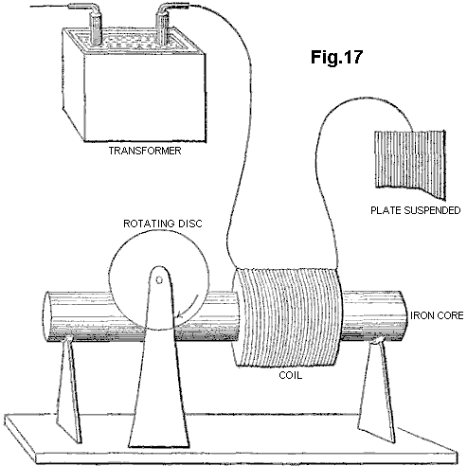

Tesla thought that his motor was particularly adequate to respond to windings which had “high-self-induction”, such as a single coil wound on an iron core. The basis of this self-induction is the magnetic reaction of a circuit, or an element of a circuit - an inductor - whereby it chokes, dims or dampens the amplitude of electric waves and retards their phase.

For the motor to respond to still higher frequencies, one needed to wind over the primary motor winding, a partial overlap secondary, closed through a capacitor, since "it is not at all easy to obtain rotation with excessive frequencies, as the secondary cuts off almost completely the lines of the primary" (Idem, L-71.).

Tesla stated that "an additional feature of interest about this motor" was that one could run it with a single connection to the earth ground, although in fact one end of the motor primary coil had to remain connected to the large, suspended metal plate, placed so as to receive or be bathed by "an alternating electrostatic field", while the other end was taken to ground. Thus Tesla had an ordinary induction coil that transmitted this "alternating electrostatic field", an untuned Tesla antenna receiving this "field", and a receiver circuit comprising his iron-core wound motor primary, a closely coupled, capacitatively closed secondary, and the coupled non-ferromagnetic disc rotor. Eventually, in his power transmission system, he would replace this transmitter with a Tesla coil, and place an identical receiving coil at the receiving end, to tune both systems and bring them into resonance. But his motor remained undeveloped, and so did the entire receiver system.

Tesla returned to this subject a year later, saying "on a former occasion I have described a simple form of motor comprising a single exciting coil, an iron core and disc" (Tesla, N (1893) "On light and other high frequency phenomena", in "Nikola Tesla Lectures", 1956, Beograd, pp. L-130, and L-131 with respect to Fig.16-II). He describes how he developed a variety of ways to operate such AC motors unipolarly from an induction transformer, and as well other arrangements for "operating a certain class of alternating motors founded on the action of currents of differing phase". Here, the connection to the induction transformer is altered so that the motor primary is driven from the coarse secondary of a transformer, whose finer primary is coupled, at one end, directly and with a single wire to the Tesla secondary, and at the other left unconnected. On this occasion, Tesla mentions that such a motor has been called a “magnetic lag motor”, but that this expression (which, incidentally, he had himself applied to his own invention of magnetic hysteresis motors) is objected to by "those who attribute the rotation of the disc to eddy currents when the core is finally subdivided" (Tesla, N (1893), op. cit., p. L-130).

In none of the other motor solutions, 2-phase or split-phase, that he suggests as unipolar couplings to the secondary of an induction coil, does the non-ferromagnetic disc rotor motor again figure. But he returns to it a page later, and indirectly so, by first addressing the disadvantages of ferromagnetic rotors: "Very high frequencies are of course not practicable with motors on account of the necessity of employing iron cores. But one may use sudden discharges of low frequency and thus obtain certain advantages of high-frequency currents-without rendering the iron core entirely incapable of following the changes and without entailing a very great expenditure of energy in the core. I have found it quite practicable to operate, with such low frequency disruptive discharges of condensers, alternating-current motors."

In other words--whereas his experiments with constant wave (CW) alternating currents, and as well with high-voltage dampened wave (DW) impulses from induction coils, indicated the existence of an upper frequency limit to iron core motor performance, one might employ instead high-current, DW impulses - of high DW frequencies but low impulse rates - to move these motors quite efficiently. Then he adds "A certain class of [AC] motors which I advanced a few years ago, that contain closed secondary circuits, will rotate quite vigorously when the discharges are directed through the exciting coils. One reason that such a motor operates so well with these discharges is that the difference of phase between the primary and secondary currents is 90 degrees, which is generally not the case with harmonically rising and falling currents of low frequency. It might not be without interest to show an experiment with a simple motor of this kind, inasmuch as it is commonly thought that disruptive discharges are unsuitable for such purposes."

What he proposes next, forms the basis of modern residential and industrial AC electric power meters, the AC copper disc motor whose rotor turns on the window of these meters, propelled forward by the supply frequency. But instead of employing any such Constant Wave input, Tesla uses the disruptive discharges of capacitors, incipiently operating as current rectifiers. With the proper conditions, e.g. correct voltage from the generator, adequate current from the capacitor, optimum capacitance for the firing rate, and tuned spark-gap, to mention a few, Tesla found that the non-ferromagnetic disc rotor turned but with considerable effort. But this hardly compared to the results obtained with a high-frequency CW alternator, which could drive the disc "with a much smaller effort". In summary then, Tesla went as far as being the first to devise a motor driven by Tesla waves, that employed a non-ferromagnetic rotor, and whose arrangement encompassed both transmitter and receiver circuits. For this purpose, he employed a single-phase method in which the signal is fed unipolarly to the winding, placed in series with a plate capacitance.

Tesla also later proposed driving a similar single-phase non-ferromagnetic disc motor from bipolar capacitative discharges through an atmospheric spark-gap now placed in parallel with the main motor winding, and again simulating a split-phase by a closely-wound secondary which was closed by a capacitance.

As Tesla admits, the results of all his AC eddy current motor solutions were meagre and limited by current and frequency problems. Likewise, the two-phase arrangements proposed by Reich for his OR motor, involving a superimposition of the Dampened Waves of a first phase on a fixed Continuous Wave second phase, require an external power source and a pulse amplifier circuit, and failed to meet Reich's own requirements.

We have previously proposed the use of squirrel cage motors with capacitative splitting of phase to convert the Dampened Wave output of plasma pulsers, but once a Squirrel Cage is introduced, the dampening effect which the non-ferromagnetic copper cage exerts in being dragged by the revolving stator field, is counteracted by the ferromagnetic cylinder of laminated iron, in which the copper cage is embedded, working to diminish the slip and bring the rotor to near synchronism. This is, in all likelihood, what limits Squirrel Cage motors responding to the DC component of the Dampened Wave impulse, and thus be limited to respond to fluxes of mass-bound charges. Historically, as we shall see, the obvious advantage of the Squirrel Cage servo motors lay in the fact that, in particular for 2-phase applications, they were far more efficient at performing work without evolution of heat. Indeed, if the eddy currents in the non-ferromagnetic rotor are permitted to circulate in non-ordered form, the rotor material and stator will heat up rapidly and consume much power in that heating. This is in fact considered to be a weakness of AC non-ferromagnetic-rotor induction motors.

SUMMARY OF THE INVENTION
The present invention is concerned with conversion to conventional electrical energy of the variants of mass-free energy radiation considered above, referred to for convenience as Tesla waves, mass-free thermal radiation and latent mass-free radiation. The first variant of such radiation was recognised, generated and at least partially disclosed by Tesla about a hundred years ago, although his work has been widely misinterpreted and also confused with his work on the transmission of radio or electromagnetic waves. The Tesla coil is a convenient generator of such radiation, and is used as such in many of the embodiments of our invention described below, but it should be clearly understood that our invention in its broadest sense is not restricted to the use of such a coil as a source of mass-free radiation and any natural or artificial source may be utilised. For example, the sun is a natural source of such radiation, although interaction with the atmosphere means that it is largely unavailable at the earth's surface, limiting applications to locations outside of the earth's atmosphere.

According to the invention, a device for the conversion of mass-free radiation into electrical or mechanical energy comprises a transmitter of mass-free electrical radiation having a dampened wave component, a receiver of such radiation tuned to resonance with the dampened wave frequency of the transmitter, a co-resonant output circuit coupled into and extracting electrical or kinetic energy from the receiver, and at least one structure defining a transmission cavity between the transmitter and the receiver, a full-wave rectifier in the co-resonant output circuit, and an oscillatory pulsed plasma discharge device incorporated in the co-resonant output circuit. The output circuit preferably comprises a full-wave rectifier presenting a capacitance to the receiver, or an electric motor, preferably a split-phase motor, presenting inductance to the receiver. The transmitter and receiver each preferably comprise a Tesla coil and/or an autogenous pulsed abnormal glow discharge device. The transmission cavity is preferably at least partially evacuated, and comprises spaced plates connected respectively to the farthest out poles of the secondaries of Tesla coils incorporated in the transmitter and receiver respectively, the plates being parallel or concentric. The structure defining the cavity may be immersed in ion-containing water. The split-phase motor is preferably an inertially-dampened AC drag motor.

The invention, and experiments demonstrating its basis, are described further below with reference to the accompanying drawings.

SHORT DESCRIPTION OF THE DRAWINGS
Fig.1 is a schematic view of a Tesla coil connected to a full-wave rectifier to form an energy conversion device:
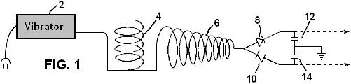

Fig.2 is a schematic view of a Tesla coil connected to a gold leaf electrometer:

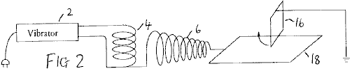

Fig.3 to Fig.6 show alternative electrometer configurations:

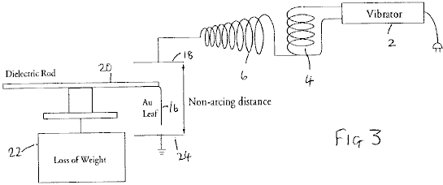

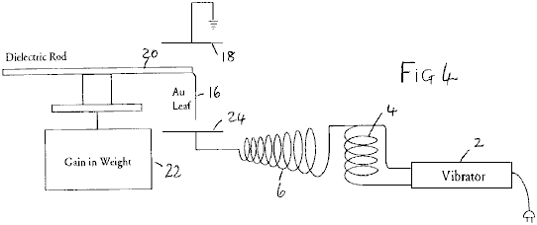

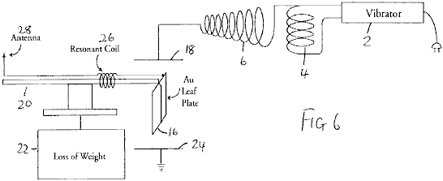

Fig.7 to Fig.11 show modifications of the circuit of Fig.1:

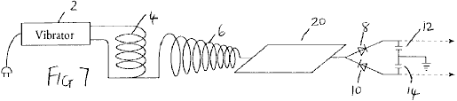

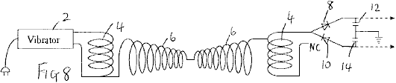

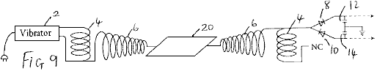

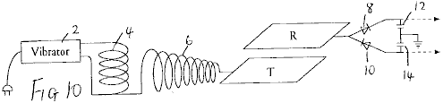

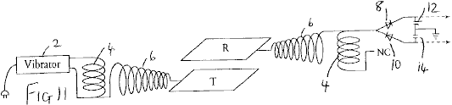

Fig.12 shows apparatus for investigating aspects of the experimental results obtained with the foregoing devices;

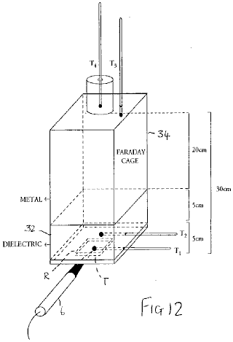

Fig.13 is a graph illustrating results obtained from the apparatus of Fig.12:

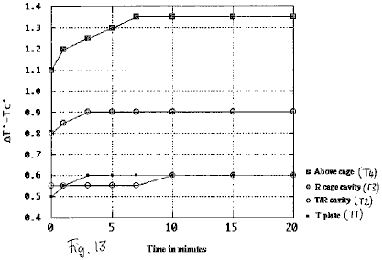

Fig.14 to Fig.17 show schematic diagrams of embodiments of energy conversion devices:

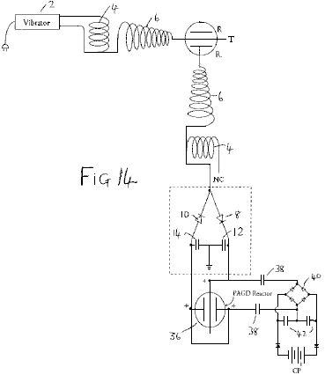

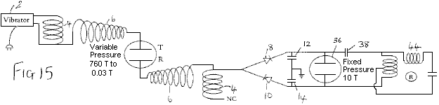

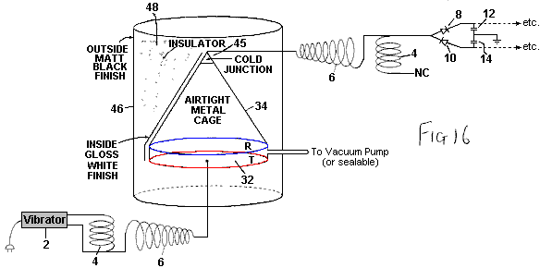

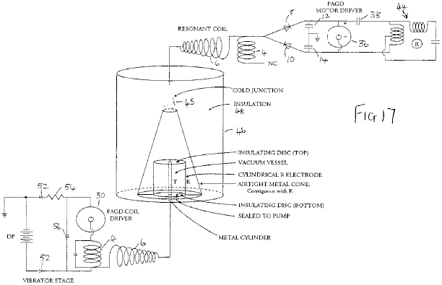

Fig.18 is a diagrammatic cross-section of an inertially dampened drag cup motor:

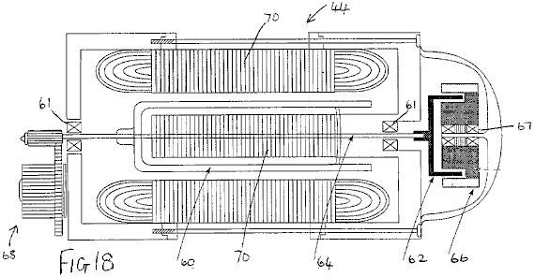

Fig.19 is a schematic diagram of a further embodiment of an energy conversion device incorporating such a motor:

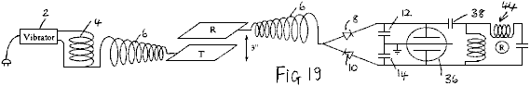

DESCRIPTION OF THE PREFERRED EMBODIMENTS
Based upon observations of weight loss in metallic matter as induced by exposure to high frequency alternating electric fields, we developed an experimental method to optimise this-weight loss, and from this a device that treats the forces causing weight loss as manifestations of intrinsic potential energy (or true "latent heat") of the molecules of matter, and converts both "true latent heat" energy present in the neighbourhood of a receiver, and "sensible" heat induced within that receiver, into electric energy which can be used to drive a motor, flywheel or charge batteries.

It is commonly believed that the output of the Tesla coil is ionising electromagnetic radiation. We have demonstrated that it is not, i.e. that it is neither electromagnetic radiation, nor ionising electromagnetic radiation. The output of an air-cored, sequentially-wound secondary, consists exclusively of electric energy: upon contact with the coil, a mass-bound AC current can be extracted at the resonant frequency, whilst across a non-sparking gap, mass-free AC-like electric wave radiation having the characteristics of longitudinal waves, can be intercepted anywhere in adjacent space. Accordingly, the radiation output from such coils is different to electromagnetic radiation.

The basic demonstration that the output of a Tesla coil does not consist of ionising radiation, is that it does not accelerate the spontaneous discharge rate of electroscopes, whether positively or negatively charged. In fact, in its immediate periphery, the coil only accelerates the spontaneous discharge rate of the negatively charged electroscope (i.e. the charge leakage rate), whereas it arrests the discharge of the positively charged electroscope (i.e. the charge seepage rate falls to zero). But this dual effect is not due to any emission of positive ions from the secondary, even if it can positively charge a discharged electroscope brought to its proximity. This charging effect is in fact an artifact, in that metals but not dielectrics are ready to lose their conduction and outer valence band electrons when exposed to the mass-free electric radiation of the coil.

This is simply demonstrated by the apparatus of Fig.1, in which the outer terminal of the secondary winding 6 of a Tesla coil having a primary winding 4 driven by a vibrator 2 is connected to the input of a full-wave voltage wave divider formed by diodes 8 and 10 and reservoir capacitors 12 and 14 (the same reference numerals are used for similar parts in subsequent diagrams). If the rectifiers employed are non-doped, then the coil appears to only charge the divider at the positive capacitance 10, but if doped rectifiers are employed, the coil will be observed to charge both capacitances equally. Whereas positive ionises can charge either doped or un-doped dividers positively, no positive ionise can charge a doped divider negatively, clearly demonstrating that the Tesla coil does not emit positive ions.

The basic demonstration that the output of a Tesla coil is not non-ionising electromagnetic radiation of high frequency, such as optical radiation, or of lower frequency, such as thermal photons, is also a simple one. Placement of a sensitive wide spectrum photoelectric cell (capable of detecting radiation to the limits of vacuum UV), wired in the traditional closed circuit manner from a battery supply, at any distance short of sparking from the outer terminal of the coil will show in the dark that the light output from the coil is negligible. This rules out optical radiation at high frequency. The demonstration that the sensible heat output from the Tesla coil is also negligible will be addressed below.

Our theory proposed the existence of physical processes whereby mass-free electric radiation can be converted into electromagnetic radiation. Such a process is at work whenever mass-free electric wave radiation interacts with electrons, such as those that remain in the valence bands of atoms. This mass-free electric energy interacts with charge carriers, such as electrons, to confer on them an electrokinetic energy which they shed in the form of light whenever that electrokinetic energy is dissociated from those carriers (e.g. by deceleration, collision or friction processes). Such a process is at work to a negligible extent in the coil itself and its usual terminal capacitance, hence the faint glow that can be seen to issue from it, but it can also be greatly amplified in the form of a corona discharge by connecting a large area plate to the output of the secondary, as Tesla himself did in his own experiments, and thus by increasing the capacitance of the coil system.

Now, what is interesting in this process is that, in the absence of virtually any I²R losses at the plate, and if the plate thus introduced is bent at the edges so that it has no pointed edges, or if it is in the form of a bowl, or in any other manner that precludes sparking at edges and specially corners, and thus enhances the corona discharge, any electroscope, whether negatively or positively charged, now brought close to the plate will show a tendency to arrest its spontaneous discharge rate. One might say that this is simply the result obtained in a Faraday cage which disperses charge on its outside and electrically insulates its interior, and indeed if an electroscope is placed inside a Faraday cage no amount of Tesla radiation on the outside of that cage, save direct sparking, adversely affects the leakage or seepage rate of the electroscope. In fact, since the effect of such a cage can be shown to be that of, by itself, inducing arrest of either spontaneous electroscopic discharge, this effect simply remains or is magnified when the cage is bathed by Tesla radiation. However, a cage constitutes an electrically isolated environment, whereas a plate with or without curved or bent edges does not. Furthermore, the change observed in the properties of the output radiation from a Tesla coil when certain metal plates or surfaces are directly connected to the outer terminal of the secondary, takes place whilst the capacitance of the coil is increased by the connected plate, and thus the plate is an electrically active element of the circuit - and hence the opposite of an electrically isolated element.

For a long time, we believed that the anomalous cathode reaction forces observed in autoelectronic discharges (atmospheric sparks, autogenous PAGD (pulsed abnormal glow discharge) and vacuum arc discharges) were exclusive to an autoelectronic emission mechanism prompted by a direct potential between discharging electrodes. Sparking driven by AC potentials could sustain the same forces, but their mutual cancellation over time would not deploy a net force. In this sense, when a large gold leaf connected directly to the ground (via a water pipe or any other suitable connection) or to another large area plate suspended at some height above the ground, is vertically placed at a sparking distance above the surface of another plate connected to the secondary of a Tesla coil, one would not expect the AC spark to sustain any net force across the gap between the gold leaf and the plate. In terms of cathode reaction forces, one would expect their cancellation to be simply brought about by the high frequency of the current alternation in the coil, as both leaf and plate would alternate between being the emitting cathode or the receiving anode. However, this is not what is observed - instead, the gold leaf 16 lifts away from the plate 18 (Fig.2). If instead, the suspended gold leaf is connected to the coil terminal, and the bottom plate is connected to the ground in the same manner as described above, this also yields the same result.

Even more curious is the finding that this anomalous reaction force deployed by an alternate current of mass-bound charges in the arc, remains present when the sparking is prevented and instead the corona effect is enhanced (by employing a large plate connected to the outer pole of the secondary, and by employing a distance at which sparking ceases), as if the lift itself were the property of the corona underlying the spark channels and not the property per se of the autoelectronic emission mechanism.

By mounting the suspended leaf 16 (41 mg of hammered 99.9996% pure gold) directly at the end of a long dielectric rod 20 balanced at the centre and placed on a light stand over an electronic balance 22, we sought to determine the observed lift of the leaf as weight lost. Surprisingly, and despite the most apparent lifting motion of the leaf, the balance registered a substantial weight gain, indicating the addition of 1 to 5 mg weight (with the same 14W input to the vibrator stage), independently of whether the leaf was connected to the terminal of the coil or instead to the earth ground via a water pipe. This suggested to us that, whether formed as a DC or AC spark channel, or whether in the form of a corona discharge, the electric gap develops an expansion force (exactly opposite to a Casimir force) on both electrodes, independently of their polarity, which force is responsible for the observed repulsion. Yet, this expansion goes hand in hand with an increase in their weight such that some other process is at work in that electric gap.

To examine this problem further, we assembled a different experiment where the gold leaf 16 was suspended between two large metal plates 18 and 24 placed 20 cm apart, and the leaf was not electrically connected to them or to any other circuit, while attached to the dielectric rod employed to suspend it over the electronic balance. Given that the leaf is suitably and equally spaced from both plates, there is no arcing between it and either plate. The obvious expectation is that, since the electric field bathing the leaf alternates at high frequency (measured in hundreds of kilohertz), and the corona from both electrodes should equalise and balance any electric wind, no lift should be observed. In fact, no lift is apparent, but a most curious observation is made: depending upon which orientation is employed for the plates, the gold leaf either gains or loses 4-6% of its weight. This gain or loss is registered for as long as the coil is on. If the top plate is grounded and the bottom one connected to the different terminal of the secondary, a gain in weight is observed (Fig.3). If the connections are reversed, an equal weight loss is registered (Fig.4).

Furthermore, in this last instance, if the grounded plate 24 is entirely removed (Fig.5), and only the top plate remains connected to the outer terminal of the secondary, the observed loss of weight continues to occur such that in effect, this reaction can be obtained with unipolar electric fields of high frequency, and it provides a unidirectional force which, once exerted upon metallic objects bathed by its field, can be made to oppose or augment gravity.

Now, these effects can be greatly magnified, in the order of 10-fold, if the same gold leaf is made part of a simple series floating electric circuit where the leaf functions as a large area plate, and is wired in series with a coil 26 which, for best results, should be wound so as to be of a length resonant with the secondary of the Tesla-type coil employed; and this coil is connected in turn to a point antenna 28 upwardly oriented (Fig.6). The entire floating circuit is mounted on the rod 20 and this in turn, is mounted over the sensitive balance. If both plates are kept as in Fig.3 and Fig.4, the observed weight loss and weight gain both vary between 30% and 95% of the total weight of the leaf. Again, the gain or loss of weight is registered for as long as the coil is on.

These anomalous findings suggested that, whatever is the nature of the energy responsible for the force observed in that high frequency alternating current gap, any metallic object placed in that gap will experience a force repelling it from the electric ground. This force will be maximised if the gap frequency is tuned to the elementary or molecular structure of the metallic object. If the electric ground is placed opposite the actual plane of the earth ground, that force will act in the direction of gravity. If, instead, the electric ground and the earth ground are made to coincide on the same plane, that force will act opposite the direction of gravity, i.e. will repel the metallic object from the ground.

No such weight alteration was observed with solid dielectrics, for instance with polyethylene and other thermoplastic sheets.

These facts rule out the possibility of a hidden electrostatic attraction force, acting between the plate connected to the different terminal of the secondary and the gold leaf. Firstly, such an attraction would be able to lift the gold leaf entirely, as is easily observed with the unipole of any electrostatic generator operating with a few milliwatts output with either negative or positive polarity; secondly, the same attraction, if it existed and were the product of an electric force, would surely be manifested independently from whether the experimental leaf was metallic or a dielectric (as again is observed with electrostatic generators).

The results suggest therefore, that whenever a large plate is connected to a Tesla-type coil, it induces in surrounding matter that is not part of its own circuit, a directional thrust which is oriented in a direction which is opposite to the electric ground and, if the electrical ground is on the same side as the surface of the Earth, then a thrust is produced which opposes gravity.

When this thrust is made to oppose gravity, we believe that its effect upon the gold leaf can be compared to the lifting power imparted to the water molecule when it transits from the liquid to the vapour state and which is associated with the increase in internal (or intrinsic) potential “thermal” energy (See Halliday D & ResnickR (1978) "Physics", Vol. 1, section 22-8, p. 489). The "specific latent heat" of water (m*L) contains indeed both an expression for the sensible radiant thermal work involving volume and pressure relations:
W = P(V_{V}-V_{L}) where P = a pressure of 1 atmosphere, and V_{V} and V_{L} are the molar volumes in the vapour and liquid phases respectively, and an expression for a quantity of "latent" energy () which is associated with the molecule in the more rarefied state. Hence, the relation for the latter with respect to water vapour is: = mL - P(V_{V}-V_{L})

We propose that likewise, if a very small portion of the energy of the mass-free electric waves is indirectly transformed by mass-bound charge carriers on that plate into blackbody photons (once those charge carriers shed their electrokinetic energy), the greater portion of those waves are directly transformed in the space adjacent to that plate into the latent energy equivalent to for the atoms of the surrounding air, and so on, until this process itself is also occurring for the atoms of that gold leaf, thus inducing their non-electrical weight loss and suggesting the existence of a non-thermal "antigravitokinetic" energy term previously unknown to mankind other than as "latent heat" or "internal potential energy".

From this viewpoint, the energy released by any Tesla-type coil to its surroundings, would be tantamount to a radiative injection of "internal potential energy" which would confer on local gas molecules a weight cancellation (a cancellation of gravitational mass occurring in the absence of any cancellation of inertial mass - a process which the inventors theorise is explained by the neutralisation of elementary gravitons), and the same process would be equally at work for metallic solids but not dielectric solids.

Gold vapour also deploys a substantial intrinsic potential energy. With an enthalpy of vaporisation on the order of H_{V} = 324 kJ mol⁻¹, the molar volumetric work performed by gold vapour at atmospheric pressure at the temperature of vaporisation T_{v} (2,856⁰C., i.e. 3,129 degrees Kelvin) is:

W = PV_{V-L} = 23.58 kJ mol.⁻¹ where V_{V-L} = 0.2327m³. The intrinsic potential energy of gold vapour is then given by:

= H_{v} - W = 300.4 kJ mol.⁻¹ i.e. 12.74 times greater than the volumetric work performed during the phase transition.

It is our contention that this intrinsic potential energy, associated with molecules as their "latent heat", has fine structure that in turn is altered if this energy is released from these molecules and fails to gain a "sensible" thermal form. What is suggested is that the fine structure of "latent heat" is not electromagnetic and obeys instead the molecular function:

/ N_{A} = _{n2}²c _{n2} where N_{A} is Avogadro's number, the wavelength denoted as _{n2} is the wavelength-equivalent of the mass of the molecule to which the "latent heat" is associated, obtained by a conversion method proposed in these inventors' theory, and the frequency term is a non-electromagnetic frequency term, specifically in this case a gravitational frequency function.

Employing the conversion of Joules into m³ sec⁻² proposed by these inventors as being exactly:

1J = 10 N_{A} m³ sec⁻², and putting the wavelength _{n2} down as the wavelength-equivalent of the mass of the gold atom, _{Au}, at 1.9698 m, that frequency term _{n2} can be obtained as being equal to 2.6 x 10⁻³ sec⁻¹.

According to the present inventors' theory, the wave function c constitutive of the fine structure of "latent heat" associated with molecules of matter, carries the same wavelength _{Au} and its frequency is given in the usual manner by c/_{Au} = 1.52 x 103 sec⁻¹. The resultant frequency for the non-Planckian unit quantum of "latent energy" associated with each gold atom at the vaporisation temperature is then obtained by the geometric mean of the two synchronous frequency terms: [(c/_{Au}) _{n2}]^{0.5} = 624 Hz. However, this is the signature of that intrinsic potential energy when associated with that gold atom at its vaporisation temperature. It is not the signature of the energy quantum itself if it is released from that molecule, nor prior to being absorbed (i.e. in transit), at that same temperature.

The fine structure of the same non-Planckian "latent" energy quantum varies to encompass different determinations of the constituent wavelength and frequency functions. The basic relation for the determination of the wavelength of a "latent thermal" energy quantum not associated with matter, but corresponding to one that is, is:

_{n1} = [ ( / N_{A}) / c]^{0.666} meters^{-0.333} seconds^{0.666}

which gives 0.046478 m for the unbound equivalent of the "latent heat" unit quantum of vaporisation associated with the gold atom at a pressure of one atmosphere. The fine structure of the free quantum is still parallel, as given by:

/ N_{A} = _{n1}²c_{n1}

but now notice how the frequency terms have changed value, with the _{n1} function having the value 4.65 sec⁻¹ and c / _{n1} yielding 6.48 x 10⁹ sec⁻¹. The geometric mean of the superimposition of the two frequencies is then:

[(c / _{n1}²)_{n1}]^{0.5} = 173.7 KHz

We contend that it is at this frequency that the atoms of gold vapour absorb "latent heat".

However, this is just the overall scenario of what happens at the temperature of vaporisation of gold. But at room temperature (e.g. 293 degrees Kelvin), and with respect to processes where there is no sublimation of the atoms of that gold leaf under way (and indeed, once the coil is turned off, the leaf returns to its normal weight), one must infer to a different phase of matter what portion of "latent heat" energy, if any, do the atoms of gold hold in the solid phase lattice. Assuming the same proportionality between the "sensible" and "latent" thermal energy terms for atoms of gold at room temperature, where the unit thermal energy is N_{A}kT = 2.436 kJ mol⁻¹, we speculate that the gold atom could absorb up to 12.74 times the value of this "sensible" thermal energy, and thus hold N_{A}kT = 31.053 kJ more energy in its own micro-atmosphere.

If this speculation is correct, and employing the above novel methodology, then the mean geometric frequency of the maximal "latent heat" energy quantum of a gold atom at room temperature would be 538 KHz (versus 174 KHz at the vaporisation temperature), and once absorbed its mean frequency mode would reduce to 201.5 Hz (versus 630 Hz once the atom has vaporised).

To test this hypothesis, we employed two different Tesla-type coils having output frequencies of 200 KHz and 394 KHz. The circuit tested was that shown in Fig.6, and both coils were operated at 50 KV outputs. Whereas the former coil, closer to the 174 KHz marker, could only systematically produce 10mg to 11 mg of weight cancellation in the gold leaf of the floating circuit, the second coil, closer to the speculated 538 KHz marker, could produce 15mg to 35 mg of weight cancellation in the same gold leaf. The empirical results appear therefore to suggest that our speculation may well be a valid one.

The above-mentioned full wave divider (see Fig.1) can be easily coupled to our autogenous Pulsed Abnormal Glow Discharge technology as described in our U.S. Pat. No. 5,416,391 to form an alternative source of direct current, ultimately powered by Tesla waves, and such a drive can equally be applied to any other vacuum device that can sustain endogenous oscillatory discharges, whether in the PAGD regime or any other pulsatory regime. For the purposes of experimental and visual determination of power outputs from the divider in question, we have utilised either 2 Torr vacuum tubes operating in the high-current PAGD regime, or 20-100 Torr spark tubes requiring high voltages (2 to 10 KV) for their spark breakdown. As taught in the above US Patent, the output from the full wave voltage divider can be assessed by the energy spent in driving the tube and the motor, whose rotary speed is proportional, within the limits chosen, to the power input.

Two separate sets of experiments presented in Table 1 below, showed that direct connection of the wave divider to the outer terminal of the coil (set constantly at 6 clicks on the vibrator stage in Fig.1) or to the same terminal but across a large (2 or 3 square feet) plate 30 that increased the capacitance of the secondary (Fig.7), presented the same power output in either case (the effect of the plate is to lower the voltage of the output proportional to the increase in current). A substantial increase in power output through the divider is observed only when an identically wound Tesla coil is connected in reverse (Fig.8) with the non-common end of its winding 4 not connected, in order to obtain a condition of resonance, and this observed increase is further augmented by now interposing either of the metal plates 18, 24 between the two chirally connected and identical coils (Fig.9). The increase in plate area appears to have the effect of increasing the output for as long as the plate is isolated between the two chiral image coils. Throughout these experiments, the input power to the vibrator was fixed at 14W (60 Hz AC). [Note: ‘Chirality’, or ‘handedness’, is a property of objects which are not symmetrical. Chiral objects have a unique three-dimensional shape and as a result a chiral object and its mirror image are not completely identical - PJK ].

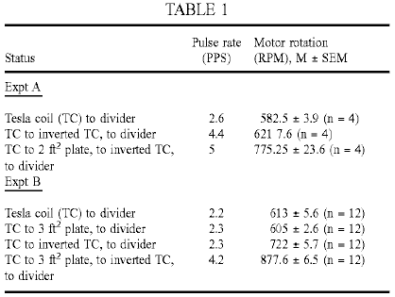

In our loss of weight experiments described above, we noted that the phenomenon of weight loss by a metallic body placed in proximity of the coil output continued to be observed when only the plate connected to the distal pole of the secondary was retained. The leaf, although not part of the circuit of the secondary, could however be seen as part of a circuit for the capture of ambient radiant energy, specifically that generated by the coil and, as well, that also possibly picked up, in the process, from other ambient sources. To determine whether the last consideration is a possibility at all, or whether the energy picked up by an analogue of our metallic body or gold leaf in the experiments described above, is entirely a by-product of the energy transmitted by the plate connected to the outer pole of the secondary, we next determined what would happen if the pick-up for the full-wave divider were placed, not at the output from the secondary coil, but from an, in all respects identical, plate (the Receiver plate R, as opposed to the Transmitter plate T) placed a distance away from, and above, the first one. In other words, the gold leaf is replaced by a receiver plate, and this carries an attached test circuit identical to the test circuit employed to directly assess the coil output.

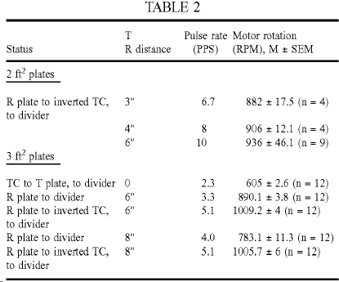

As shown in Table 2 above, the results of the experiment show that there is no loss of energy picked up at the R plate (Fig.10) when compared to the most favourable situation involving the plate 30 (Fig.9) interposed between the chirally connected coils. This observation is however not always the case. For best results one should employ iron, gold or silver plates placed parallel to the horizon, with the T plate underneath the R plate. In fact, if one employs instead aluminium plates and suspends these vertically, one can consistently register a loss of output at the divider when changing the divider input from the T to the R plates.

If however the plate R is connected in turn to a second identical coil, also wired in reverse, and this second coil in turn serves as input to the full-wave divider (Fig.11), then a most curious occurrence takes place - the power output increases considerably (see Table 2), as if the divider circuit had undergone an energy injection not present at the source. Note that the circuits are in fact resonant, but the energy injection contributing nearly 60-66% (for both plate areas in the previous experiment) of the input that we refer to, is not caused by inductive resonance, since the effect of resonance can be ascribed to the set-up described in Fig.9. The distance between the plates, as well as their orientation with respect to the local horizon system of the observer also appear to matter, best results being achieved at optimal distances (e.g. for 2 square feet plates the best gap, at 43% RH and room temperature, was at least 6 inches).

We tested the possibility that environmental heat produced by operation of the coil might be the source of the injected energy, the plate of the second system acting possibly as collector for the heat present in the gap. As it turned out, experiments showed repeatedly that in the gap between the T and R plates there was no significant thermal radiation propagating between one and the other. The more illustrative experiments are those in which we identified where the sensible thermal energy appears, and which involved coupling two cavities: the Transmitter-Receiver gap between plates T and R, and a Faraday cage enclosure 34 (see Fig.12). The first cavity appears to be much like that of a capacitor: the two identical parallel plates are surrounded by a thick dielectric insulator 32, and a thermometer T2 is inserted half-way through it. A thermometer T1 is also fixed to the T plate, to measure it’s temperature. The second cavity is a simple insulated metal cage with a thermometer T3 inserted 2 cm into its top. Some 2-4 cm above the top of the cage there is placed a fourth thermometer T4, inside an insulated cylinder.

If the Tesla Coil is a source of thermal energy (e.g. IR radiation, microwaves, etc.) we would expect the T plate to be the hottest element from which, by radiation, thermal energy would reach the middle of the first cavity making the next thermometer T2 second hottest, and that the third thermometer T3 inside the second cavity, even if it might initially be slightly warmer than the other two, would, over time, become comparatively cooler than either one of the other two thermometers, despite the fact that the rising heat would still be seen to warm it up over time. One would expect a similar outcome for the fourth thermometer T4, above the cage. As shown by Fig.13, where only the temperature differences (T⁰ - T_{C}⁰) between the experimental thermometers and the control thermometer reading the air temperature T_{C}⁰ of the laboratory are shown, the surface of the T plate warms up by 0.1⁰C. at 3 minutes after initiation of the run (closed squares), whereas in the space of the T/R gap a diminutive warming, by 0.05⁰C., is registered after 10 minutes (open circles). Conversely, the temperature inside the cage, at the top (shaded circles) rises by 0.1⁰C. also by the third minute, and the temperature above the cage itself (shaded squares) rises by a much greater difference of 0.35⁰C., which remains stable after the eighth minute.

These results show that it is not sensible heat that radiates from the T plate. Instead, some other form of radiation traverses these cavities to generate sensible heat at their metallic boundaries, such that more heat is generated above the R plate (inside the cage) and again above the third plate, i.e. above the top of the cage, than is generated in the T/R gap, i.e. near the T plate. This clearly shows that the Tesla coil is not a significant source of thermal radiation, and that sensible heat can be detected inside and on top of the Faraday cage only as a further transformation of the radiant energy transmitted across the T/R cavity.

The same experiment also illustrates that, whatever is the nature of the additional environmental energy being injected at the surface of R plate (as shown by Table 2 results above), it is most likely not thermal radiation, at least not energy in the form of sensible heat. And whatever is the nature of this ambient radiant energy being mobilised by the electric radiant energy transmitted from the T plate, it can produce significant heat inside an enclosure adjacent to plate R.

Since we also know experimentally, that this observation of an ambient energy injection at the R plate or R cage depends upon relative humidity, being most easily observable when the latter is low (<50% Relative Humidity), and being virtually impossible to observe when air is saturated with water vapour, we can infer that water vapour is a good absorber of the electric mass-free radiant energy emitted from the T plate. This strongly suggests that this absorption process is tantamount to increasing the potential intrinsic energy of the water vapour molecules adjacent to the T plate. In the absence of significant quantities of water vapour, when the atmosphere is dry, one may speculate that this absorption process is replaced by what one presumes is a parallel process involving the various gaseous molecules of air. However, either because the air molecules involve molecular species that readily give off this potential energy, as one might speculate is the case with molecular oxygen, hydrogen and nitrogen, or because the air molecules absorb far less "latent" energy (as appears to be the case with inert gases), and therefore there is more of it in the molecularly unbound state (as we explicitly propose as a possibility) and thus available for absorption by the appropriately tuned receiver, the increased of air molecules conferred by the absorption of the mass-free electric radiation in the T/R gap is transferred to the R conductor together with the latent energy which those molecules already possessed before entering that gap. Hence the energy injection and its dependency upon the partial pressure of water vapour, which absconds instead with this "latent" energy and succeeds in withholding it from transmission to the R plate.

If the T/R gap can mobilise ambient energy which is neither electromagnetic nor thermal in nature, but which "latent" energy becomes injected into the divider circuit in electric form, the heat (i.e. sensible thermal energy) produced inside and on top of the cage, can also be mobilised electrically as input into the divider circuit. The obvious place to look for the positioning of the cool junction which could convert sensible heat into electrokinetic energy of mass-bound charges is at the top of the cage, where it is warmest (See top curve of Fig.13 in shaded squares). This is clearly observed from the results shown in Table 3 below, where the initial temperature difference between the top of the box and the T plate surface was 0.5⁰C., and the top of the box temperature rose by 0.2⁰C. after 2.5 minutes when the divider was connected at the junction, versus 0.35⁰C. when it was not (and the transmitter coil was on).

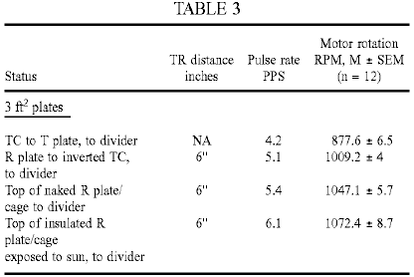

For the run performed with the naked R cage, the temperature directly above the top of the cage was 24.3⁰C., at the outset, versus the control room temperature of 23.9⁰C. For the run performed with the insulated R cage exposed directly to the sun at midday, on a cool and clear August day, the temperature directly above the top of the cage was 33⁰C., versus the control air temperature of 18.4⁰C. The temperature of the cool junction at the top of the cage was 31.9⁰C. while the run was performed.

It is apparent from the data of Table 3, how a second injection of energy has occurred in the apparatus. If, within the T/R gap, the energy injected appears to be on the order of absorption of "latent heat", at the top of the cage cavity, at the cool junction, the injection is one of radiant "sensible" heat. Moreover, this secondary energy addition could be further enhanced by placing strong insulation around the whole apparatus or the cage itself, and further so, by exposing the whole apparatus to solar radiation.

We next turned our attention to the T/R gap cavity with the intention of determining whether atmospheric conditions or vacua yield the same or different results. We could not, of course, test the same large area plates as have been employed for the studies undertaken at atmospheric pressures. For the present purpose we employed instead large area electrodes (ca 0.2 ft²) made of high grade stainless steel or even aluminium. Preliminary results showed that these T/R gap tubes, when coupled to the divider circuit, yielded faster pulse rates in the secondary circuit when evacuated than at atmospheric pressure. The strength of the corona discharge also intensified, as it eventually became replaced by a normal glow discharge. For purposes of improved spatial capture of (1) the electric mass-free energy radiated from the T electrode and (2) the non-radiant latent thermal energy mobilised by it to be collected electrically at the R plate, an axial cylindrical T electrode was inserted inside a larger concentric cylinder or between two common plates of large surface area (e.g. >100 cm²) functioning as the R electrode(s), in a dielectric container suitable for evacuation (glass, polycarbonate), at a typical distance of at least 3 cm between electrodes, and the entire device was tested at different pressures.

The secondary circuit connected downstream from the full-wave divider was as shown in Fig.14 (employing an autogenous pulsed abnormal glow discharge, or PAGD, converter circuit), with the PAGD reactor 36 set at 10 Torr (in light of the high-voltage input, which varied between 1,500V and 3,200V) and gave the results presented in Table 4 below. We should remark also that these pulses charged the charge pack CP through the coupling capacitors 38, bridge rectifier 40 and reservoir capacitors 42, and blocking diodes 44, as expected from the prior art represented by our patents related to PAGD devices.

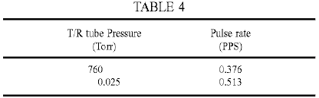

The effect of the vacuum in the T/R gap tube seems to be dual. By transforming the corona discharge into a normal glow discharge, it increases the local production of photons (probably associated to the formation and discharge of metastable states in the plasma), and at the same time, increases the pulse rate in the output circuit and thus, in all probability, the energy injected in the T/R gap cavity. But this did not yet permit us to confirm whether or not it is "latent heat" energy of the plasma molecules which is being tapped at the receiver plate, even if it be plausible in principle that plasmas may effect more efficient transfer of "latent heat" to tuned receivers than atmospheric gases.

The vacuum dependency of the pulse rate of the PAGD reactor employed as example in the secondary circuit downstream from the divider is also rather well marked, with the fastest pulse rates being registered at 1 Torr for the sample run shown in Table 5 below.

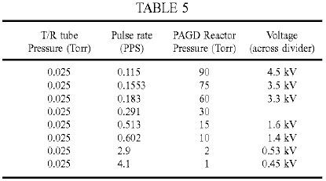

It is worth noting here that the illustrated polarity of the wiring of the PAGD reactor tube, as shown in Fig.14, is best for purposes of sustaining regular auto-electronic emission at high voltage. The reverse configuration, with the centre electrode negative and the plates positive favours instead heating of the cathode and a lapse into a normal glow discharge.

We tested a similar arrangement to that shown in Fig.14 above, but with a PAGD motor circuit (see our U.S. Pat. No. 5,416,391). A split-phase motor 44 replaces the rectifier and charge pack, and the PAGD reactor is operated at the same pressure of 15 Torr, as shown in Fig.15. The T/R gap tube tested had a longer plate distance (2''), with one plate now functioning as Transmitter and the other as Receiver. Note also the different wiring of the PAGD reactor. The results, as shown below in Table 6, present pulse per second (PPS) and motor revolutions per minute (RPM) curve trends that appear to be analogous and parallel to the well known Paschen curves for breakdown voltage in vacuum - such that the T/R gap performs better either in the atmospheric corona discharge mode, or in the high vacuum normal glow discharge (NGD) mode, than in the low breakdown voltage range of the curve where the discharge forms a narrow channel and takes on the appearance of an "aurora" transitional region discharge (TRD).

These results suggest that plasmas with high lateral dispersion, i.e. formed over large electrode areas (e.g. corona and NGD plasmas) and thus devoid of pinch, are more likely to mobilise electrically, the intrinsic potential energy of the molecular charges than pinch plasmas appear to be able to do (e.g. TRD plasmas). Apparently also, the greater the vacuum drawn from the T/R gap cavity, the more efficient does the transfer of this intrinsic potential energy become, i.e. the mass-bound latent heat, to the electrokinetic energy of the charges circulating in the receiver circuit. At about 0.06 Torr, this transfer in vacuo is comparable to that observed under atmospheric conditions and thus for a much greater density of molecules.

We investigated whether it Is possible to tap the latent heat energy of water molecules. It is possible that in the vapour phase they can effectively hold on to their latent energy - but could they give off some of it once closely packed in liquid phase? To test this hypothesis we immersed the T/R gap in a glass water tank. The motor employed for these tests was a high-speed 2-phase drag-cup motor (see Fig.18 and associated description), wired in split-phase with two identical phase windings capacitatively balanced, and the galvanised iron plates each had an area of one square foot. The results are shown in Table 7 below, and clearly indicate that it is possible to tap - within the T/R cavity - the `latent heat` of water in the liquid phase. As observed, immersion of the T/R cavity in water increased the motor output speed 22% (12,117 / 9,888) x 100). This corresponds to a 50% increase in power output, from 18W at 9,888 rpm to 27W at 12,117 rpm:

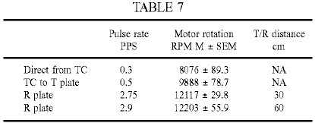

Thus the use of ion-containing water or other ion-containing aqueous liquid in the cavity promotes long distance propagation and a greater injection of latent and thermal energies in the receiver circuit. Such a result is not achieved if the cavity is filled with deionised water.

The preceding results lead therefore to the design of a presently preferred apparatus, based on these findings, for the conversion of mass-free electric energy, "latent heat" energy and "sensible" heat energy into conventional electric energy, as shown in Fig.16, which integrates all of the separate findings and improvements. The winding 6 of the Tesla coil at the bottom is driven in the usual manner employing a vibrator stage 2 to pulse the primary coil 4. The outer pole of the secondary 6 is then connected to a circular metal plate T which is one end of an evacuated cylindrical cavity, connected to a vacuum pump or sealed at a desired pressure, or which forms a still containing water or other aqueous solution or liquid. This cavity constitutes the transmitter/receiver gap, and is therefore bounded by a dielectric envelope and wall structure 32, with the circular receiver plate R as its top surface. In turn this plate R serves as the base of a conical Faraday cage 34, preferably air-tight and at atmospheric pressure, but which could also be subject to evacuation, which conical structure carries at its apex provisions for a cold junction 45 and any possible enhancement of the same junction by surface application of different metallic conductors that may optimise the Peltier-Seebeck effect. The output from the cold junction where sensible thermal energy is added to the electrokinetic energy of charge carriers, is also the input to the distal end of the winding 6 of the chiral coil arrangement that sustains resonant capture of all three energy flows ((1) mass-free electric waves of a longitudinal nature, (2) true "latent heat" or the intrinsic (thermal) potential energy, and (3) the thermokinetic energy of molecules, (i.e. "sensible" heat) and, placed in series with the input of the full wave divider 8, 10, feeds the circuit output from the series capacitors 12, 14 grounded at their common tap. In the T/R gap, the transmitted electric longitudinal wave energy is captured along with any intrinsic potential energy shed by molecules caught in the field. Within the R element, expanded into an enclosure that guides "sensible" radiant heat, the latter is generated and then recaptured at the cold junction.

The apparatus consisting of the cylindrical T/R gap cavity and the contiguous conical cage is then preferably finished in gloss white and cylindrically enveloped within a matt black container 46 by effective thermal insulation 48, the latter terminating at the height of the bottom disc T. Apparatus (not shown) may be provided to move the plate T vertically to adjust the T/R gap.

Another alternative embodiment of the apparatus is shown in Fig.17. Here the circuit driving the apparatus is as we have set forth in our prior patents, which employs an autogenous pulsed abnormal glow discharge tube 50 in the configuration shown, supplied by a battery pack DP through blocking diodes 52 and an RC circuit formed by resistor 54 and capacitor 56 to drive the primary 2 of a first Tesla coil to obtain at the distal pole of the secondary 6 the energy to be injected to plate T in the form of a central electrode of a coaxial vacuum chamber (sealed or not), of which the cylindrical metallic envelope forms the receiver plate R, the latter being placed centrally inside the conical cage 34 and contiguous with its walls and base. The top and bottom of the coaxial chamber carries suitable insulating discs, preferably with O-ring type fittings. Again, the apparatus is enclosed in insulation within a cylindrical container 46, and the input into the capture circuit driven from the full wave divider is taken from the cold junction 45 at the apex of the air-tight cage. The output circuit is similar to that of Fig.15.

We have found however that even when the component values in the motor driver and motor circuits are carefully selected so that these circuits are co-resonant with the dampened wave (DW) component of the motor driver pulses, the motor power output falls well short of that which should theoretically be attainable. In an endeavour to meet this problem, we replaced the squirrel-cage type induction motor 44 by a drag cup motor of type KS 8624 from Western Electric in the expectation that the low-inertia non-magnetic rotor would allow better response to the Dampened Wave component. This motor is similar to one of the types used by Reich in his experiments. Although results were much improved they still fell short of expectations. Replacement of this motor by an inertially dampened motor of type KS 9303, also from Western Electric, provided much better results as discussed below.

Fundamentally, the difficulties we encountered stemmed from the inability of motor couplings to respond efficiently and smoothly, and at the same time, to the pulse and wave components of Dampened Wave impulses: that is, simultaneously to the high-intensity peak current pulses (the front end event), the DC-like component, and to the dampened wave trains these cause, i.e. the pulse tails (or back end event)-or AC-like component. This difficulty is present even when we just seek to run induction motors from the DW impulses of a Tesla coil, the very difficulty that led Tesla to abandon his project of driving a non-ferromagnetic disc rotor mounted on an iron core bar stator with dampened waves.

We believe that the key to the capture of the mass-free energy flux output in electric form by Tesla transmitters, including any injected latent or thermal energy that have undergone conversion into electrical energy is to employ the tuned, unipolar, Y-fed, PAGD-plasma pulser driven split-phase motor drive we have invented (U.S. Pat. No. 5,416,391) in conjunction with an inertially dampened AC servomotor-generator (see Fig.18): this has a motor shaft 64 which couples a drag-cup motor rotor 60, preferably of aluminium, silver, gold or molybdenum, directly to a drag-cup generator rotor 62 that drives a permanent magnet (PM) flywheel 66, freely rotatable in bearings 67, that provides inertial damping. The shaft 64, journalled by bearings 61 in the casing of the motor 44, provides a power output through optional gearing 68. The phase windings of the motor 44 are wound on a stator core 70 having concentric elements between which the rotor or cup 60 rotates. This structure makes it ideal for the capture of the DW impulses, whether sourced in the transmitter, amplified in the T/R cavity or sourced in the plasma pulser, all in synchrony. Effectively the motor couples the damping action of the drag-cup sleeve motor rotor, which action, as we have already found for the KS-8624 motors, is quite effective at absorbing the front-end DC-like event, with the inertial damping of the PM flywheel upon the drag-cup sleeve generator rotor, that in turn is quite efficient at absorbing the back-end AC-like wavetrain event.

The KS-9154 motor used by Reich was not an inertial dampened AC drag-cup servomotor-generator. Had Reich succeeded in overcoming the limitations of his 2-phase OR Motor solution, as we have now shown it is possible to do (by applying the Function Y circuit to the PAGD split-phase motor drive which we invented), his motor would have suffered the same limitations which we encountered with the KS 8624 motor.

Any motor, by itself, has an internal or inherent damping whereby the acceleration only vanishes when the rotor is running at constant speed. For motors which operate on the basis of the drag principle, where the asynchronous slip is actually constitutive of the motor action, by inducing eddy currents in the rotor, the inherent damping is always more pronounced than for other induction motors. The damping or braking torque is produced when a constant current flows through a rotating drag disc or cup.

Aside from this inherent braking, dampers can also be applied to servo motors to further stabilise their rotation. They absorb energy, and the power output and torque of the motor is thereby reduced. Optimal operation of servo motors requires both rapid response on the part of the rotor to changes in the variable or control phase, and a stable response that is free from oscillation, cogging and overshooting. The rapid response is assured by employing low inertia rotors, such as drag-cups or cast alloy squirrel-cages, and the overshooting and oscillation are reduced to a minimum by damping or a retarding torque that increases with increasing motor speed. Typically, in a viscous-dampened servomotor, the damper is a drag-cup generator mounted rigidly on the shaft of the motor rotor, and the generator drag-cup rotates against the stator field of a static permanent magnet field. The generator develops a retarding torque directly proportional to speed, and the energy absorbed by the damper is proportional to speed squared. The damping can be adjusted and, as it increases, the same amount of input power yields lower torque and motor speeds. Inertial-dampened servo motors differ from viscous dampened motors in that the permanent magnet stator of the drag-cup generator is now mounted in its own bearings, either in the motor shaft or on a separate aligned shaft, forming a high-inertia flywheel.

This means that, whereas the motor rotor always experiences a viscous damping in viscous-dampened servo motors, in inertial-dampened servo motors the drag cup motor rotor only experiences a viscous damping while accelerating the flywheel, with the damping torque always opposing any change in rotor speed. Once the flywheel rotates synchronously with the rotor, all damping ceases. Note that this viscous damping is carried out via the coupling of the drag-cup generator rotor, rigidly affixed to the motor rotor, to the PM flywheel, so that their relative motion generates the viscous torque proportional to the relative velocity. Use of drag-cup sleeve rotors in inertially dampened servo motors was largely supplanted by squirrel-cage rotors once the latter became produced as cast alloy rotors. Since inertially dampened motors can be used in open and closed-loop servo applications, and present better stability - even in the presence of non-linearities - and higher velocity characteristics than other induction motors do (Diamond, A (1965) "Inertially dampened servo motors, performance analysis", Electro-Technology, 7:28-32.), they have been employed in antenna tracking systems, stable inertial-guidance platforms, analogue to digital converters, tachometers and torque tables.

The typical operation of an inertially dampened servomotor is as follows: with the reference phase fully excited, the motor rotor -fixedly linked to the generator rotor, as well as the flywheel - remain immobile; once power is applied to the control phase, the motor rotor immediately responds but the flywheel remains at rest. However, as the drag-cup generator 62 is forced to move through the permanent magnetic field of the flywheel, it creates a drag torque that slows down the attached motor rotor proportionally to the acceleration that it imparts to the flywheel that it now sets into motion, thus creating the viscous damper. As the flywheel accelerates, the relative speed of the motor with respect to the flywheel, as well as the damping torque, decrease until both motor and flywheel rotate synchronously and no damping torque is exercised - at which point the drag on the motor cup exerted by the generator cup is negligible.

The KS-9303 motor is an inertial dampened servomotor but is differentiated with respect to other inertially dampened motors, in that (1) it employs a drag-cup sleeve motor rotor made of aluminium, very much like that of the KS-8624, but with slightly altered dimensions and with a shaft extension for the drag-cup copper generator rotor, and (2) the moving flywheel structure was journalled on a separate, fixed shaft, as already described with reference to Fig.18. Now, in principle, even application of minimal damping decreases motor efficiency, resulting in diminished torque and speed. Whether the inertial-dampened motor has a drag-cup rotor, a sleeve rotor or a squirrel-cage rotor, the damping increases the rotor slip. Laithwaite considers drag-cup motors as being "dynamically inferior to their cage counterparts" (Laithwaite, E R (1957) "Induction machines for special purposes", London, England, p. 323). If we now add a viscous damping and retarding torque, we should not be able to get much more than a 55% efficiency in the best of conditions. On the other hand, the inertial damping arrangement described will only abstract or supply energy when the motor rotor is accelerating or decelerating relative to the flywheel.

These drag-cup motors, whether inertially dampened or not, develop a constant torque at constant rpm for a given supply frequency and a suitable phase shift capacitance. For each frequency the motors respond to, there is an optimum resonant split-phase capacitance, but other values nearby are still suited for operation, and for each value of capacitance, there is an optimum frequency to which the motors respond. For example the KS-8624 motor responds best at 450 Hz when a 1 microfarad capacitance is employed, responds best at 250 Hz when a capacitance of 10 microfarads is employed, and responds best at 60 Hz, when a capacitance of 100 microfarads is employed. As the capacitance increases, the resonant CW frequency of the motor is displaced to lower values. If we fix the capacitance at a value (e.g. 10 microfarads) suitable for testing the frequency response at a fixed voltage of 12 VAC, the observed result for both the KS-8624 and KS-9303 motors show a response distribution of the motor rotary velocity that has an identical peak at 250 Hz for both motors, with the response decreasing to zero smoothly on both sides of the peak.

These results indicate that, when wired as a split-phase motor, the motor rotary velocity varies not as a function of voltage or current, but as a function of frequency when the phase-splitting capacitance is fixed within a suitable range, there being an optimum frequency mode for each value of suitable capacitance, with lower values of capacitance favouring higher frequency modes. For a given frequency and capacitance, the motor rotary velocity remains essentially constant and independent from voltage and current input, and thus at a plateau. Torque, in the same circuit arrangement, follows exactly the same pattern as rotary velocity, as a function of input frequency at a fixed potential. Torque is linearly proportional to rpm in these motors when they are split-phase wired, and rpm linearly proportional to CW frequency, which makes them ideal for experimentation and determination of power output computations. Moreover, since these are drag machines, the slip itself determines the rotor currents and these are susceptible to tuning such that their retardation and relative position in the field can find resonant modes for varying CW frequency and capacitance.

In the circuit of Fig.17 when using the KS 9303 motor, the inertial damping of the flywheel coupling retards the motor rotor currents sufficiently to allow them to build up torque, with the entire motor assembly serving as the preferred sink for all of the energy, mass-free and mass-bound, captured by the receiving coil circuit with a drawing action established by the motor on the circuit, and providing satisfactory absorption by an inertial damper of the combined, synchronised, dampened wave impulses, those occurring at a low frequency as a result of the firing of the PAGD reactor, and those occurring at a higher superimposed frequency -sourced in the transmitter circuit and picked-up by the receiver plate and coil. The action of each DW impulse train itself generates two different events: the DC-like auto-electronic-like discontinuity which sets the motor in motion and initiates the rotor currents, and the AC-like dampened wavetrain which supports the consistency of those rotors. The concentration of current required to kick-start the motor is provided by the DW impulses of the PAGD reactor, whereas, once the motor is in motion, and particularly, once it is stabilised by the flywheel, the cumulative action of the higher frequency DW impulses makes itself felt by accelerating the rotor to an optimum rotary velocity.

For the next series of tests we employed the basic circuit diagram of the improved motor shown in Fig.19. The transmission station is the typical Tesla transmitter with a line-fed, 60 Hz vibrator stage. At the line input to the first stage, we place a calibrated AC wattmeter (Weston Model 432), and a Beckman 330B rms ammeter in series with the hot lead, we set the vibrator stage for 41 clicks, consuming between 28.5W and 35W, depending upon circumstances yet to be described. This consumption was confirmed by driving the coil from an inverter powered by a 12 volt battery. The inverter consumes 2.16 watts, and is 90% efficient. The total consumption from the battery was 42 watts (12V at 3.5A); once the 2.16 watts is deducted and the efficiency taken into account, we obtain the same 36W (vibrator stage at max., i.e. 47 clicks, in this experiment). The T/R gap is adjusted to 3'', and 2 square foot plates are used. Transmitter and receiver coils are tuned, and so are the plate capacitances, to 250 kHz, also the capacitances of the Function Y circuit connected at the output of the receiving coil.

The rectified voltage and current generated by the transmitter secondary and by the transmitter plate was ascertained with a coil-tuned wave-divider (Function Y) circuit by loading it with different resistive values. The results constitute a measure of the mass-bound electrical power output directly from the transmitter apparatus. The same method was employed to ascertain the voltage, current and power of the mass-bound charges circulating in the receiving plate and coil circuit. The results are shown in Table 8 below:

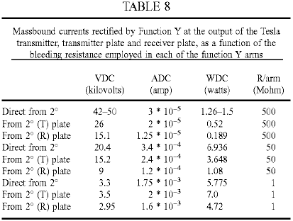

The results indicate that the highest mass-bound power assembled by the secondary transmitter circuit does not exceed 7 watts - and this is directly output from the secondary 26 when the load is 50 Megohm, or from the transmitter plate when the load is 1 Megohm. The mass-bound electric power emulated by the receiving circuit (plate, coil and Function Y without the plasma pulser circuitry) never exceeds the mass-bound electric power outputted directly by the transmitter, and peaks when the resistive load value (1 Megohm) approaches the pre-breakdown resistance range of the vacuum tube, at 4.72W. These findings then indicate that when the transmitter circuit is consuming a maximum of 35W, a typical output from the secondary of the transmitter is 7W, and at 3'' of distance within the proximal field of the latter, the pick-up by a tuned receiver will be of the order of 5W of mass-bound current duplicated within the receiving coil. The loss in the first stage is therefore on the order of sevenfold.

Continuing with the description of the circuit of Fig.19, a 128 cm² plate area, 6 cm gap PAGD reactor is used, connected as described in our prior art to a high-vacuum rotary pump (Correa, P & Correa, A (1995) "Energy conversion system", U.S. Pat. No. 5,449,989). Pressure readings were obtained with a thermocouple gauge during the operational runs. The KS-9303 motors to be tested are then connected to the PAGD reactor in the usual capacitatively-coupled, inverter fashion described in our prior art (Correa, P & Correa, A (1995) "Electromechanical transduction of plasma pulses", U.S. Pat. No 5,416.391). Their rpm is detected by a stroboscopic tachometer and fed to a Mac Performa 6400 running a motor algorithm program calculating the power output. Motor measurements were made at five minutes into each run for the unloaded motors, and at ten minutes for the inertially dampened motors.

All experiments were carried out in the same work session. The experimental determination of the continuous rotary power output as a function of the reactor pulse rate confirmed that the improved circuit develops maximum rotary capture of the mass-free energy in the receiver circuit at the lowest rates of pulsation, just as we have previously found for the conversion system of U.S. Pat. No. 5,449,989. Furthermore, the data showed that even motors of type KS-8624 are able to output power mechanically in excess of the mass-bound power output by the transmitter (7W) or captured by the receiver (5 to a max. of 7W), once the PAGD rate decreases to 1.5 PPS. Such an anomaly can only be explained by the system having become able to begin capturing the mass-free energy flux in the receiver circuit that we know already is output by the transmitter circuit. But this excess mechanical power is still less than the power input into the transmitter, and clearly so. It represents a power gain with respect to the secondary, but a loss with respect to the primary. The full breadth of the capture of the mass-free electric energy flux circulating in the receiver circuit is not seen until the motors are resonantly loaded because they are inertially dampened.

The KS-9303 motors, once inertially dampened, and thus loaded, are able to recover enough power from the mass-free energy field to develop a mechanical power, not just greatly in excess of the mass-bound power of the secondary, but also greatly in excess of the mass-bound power input to the vibrator stage and the primary, at 28 to 35W. Once the pulse rate approaches the same 1.5 PPS marker, mechanical power in excess of the mass-bound electric power input to the primary becomes evident, peaking at nearly three times that input. In fact, the highest output recorded was also obtained with the lowest input to the transmitter circuit, the highest exact coefficient observed in this experiment being 100.8W / 28W = 3.6. Furthermore, with respect to the secondary mass-bound output, the same mechanical rotary output represents a much greater overunity coefficient of performance, on the order of 14.4 times greater. This is at least partly the result of the receiver and motor capture of the mass-free electric energy output by the transmitter, and may be partly the result of mass-free energy engrafted by the PAGD regime in the PAGD reactor.

Reviewing the mechanical power output results as a function of increasing vacuum in the PAGD reactor and at different output power levels, any motor performance below the 5-7W limit of the traditional mass-bound output power of the secondary represents an output mechanical power loss with respect to both the mass-bound secondary output and the mass-bound primary input. All the results for pressures down to 0.03 Torr fall into this category, and thus represent a very inefficient coupling to the PAGD regime. Any motor performance between 7W and 28-35W represent a loss with respect to the electrical power input to the transmitter system, but a net gain of power with respect to the mass-bound secondary power output. None of the non-inertially dampened motors tested were able to perform outside of this area, under the test conditions. With more efficient primary to secondary couplings in the transmitter station, however, one could advantageously employ these motors alone to extract some of the mass-free power of the secondary or to operate them in enclosed vessels without conventional external electrical connections.

To reach satisfactory levels of recovery of mass-free energy, one must dampen the superimposed DW impulses. Hence, all results showing outputs in excess of 35W were obtained using the inertially dampened KS-9303 motors, and represent a net overunity power gain over both the power input to the primary and the mass-bound power output by the secondary, or the mass-bound power emulated by the receiver circuitry. This happens when the PAGD pulse rate falls to 2 PPS, with the rotary power output steeply increasing as the rate falls to 1 PPS.

One of the interesting features of the motor circuitry we have proposed is that it can operate with pulsed plasmas in both the TRD and the AGD regions, the least efficient response occurring in the NGD region near the Paschen minimum. One might think that the voltage depression would allow increased current intensity supplied to the motors, but in fact that is not observed, with the flashing of the NGD yielding erratic oscillations and low values of current. In keeping with the notion that the TRD plasma is mainly composed of lagging positive ions, whereas the PAGD plasma is mostly an electron plasma, the observed direction of rotation of the motors is opposite in the TRD region to that of the AGD region. The NGD region therefore marks the depression where the velocity vectors change direction. In the second or PAGD region, motor operation is very quiet, unlike what is observed in the TRD region.

Part and parcel of the tuning of the circuit components is the selection of the optimum capacitances employed to couple the PAGD reactor to the motor circuit and split the phase to feed the auxiliary winding of the motor. We have experimented with capacitances ranging from 0.5 to 100 microfarads, and found that best results (for the specific circuit in question - including the characteristics of the transmission), were such that the optimum value of the PAGD coupling capacitance lay near 4 microfarads, and the phase splitting capacitance, near 1 to 4 microfarads, depending upon weather conditions. In good weather days lower capacitance values can be used, while in bad weather days higher capacitances are needed. For ease of comparison in demonstrating the need to tune the circuit by employing optimum capacitances in those two couplings (reactor to motor, and motor phase coupling), we employed the same capacitances in both circuit locations.

A comparison of tests using 1 and 4 microfarad values shows the difference caused by changing those capacitances from their optimum value: across all discharge regions of the pressure range that was examined, the four motors tested, operated with greater motor speeds when the capacitances are set to 4 microfarads rather than to 1 microfarad. The less efficient performance obtained with 1 microfarad capacitance fits the inverse correlation of pulse power with increasing pulse frequency, such as we have found for the PAGD regime. This is made evident by a comparison of rpm versus pulse rate for the two capacitance values being considered. They demonstrate the higher pulse rates observed with the lower capacitance, that correlate with the lower motor speeds, and result in lower efficiency of the motor response. The results equally indicate that low capacitance values increase the pulse rate, but if this increase is out of tune with the rest of the circuit values, it results in power waste because it imposes a rate that is not optimum.

We have also determined experimentally that the efficiency of the system is affected by external weather conditions, higher efficiencies being noted on a fine bright day than under poor weather conditions even though the apparatus is not exposed to such conditions. This may reflect a diminution under poor weather conditions of latent mass-free energy that can be taken up by the system.

The observed high efficiency of circuits including inertially dampened motors indicates that the phenomenon does not reduce to a mere optimum capture of, DC-like pulses produced by the reactor in what is essentially an AC motor circuit. Effectively, the pulsed plasma discharge deploys a front-end, DC-like pulse, or discontinuity, but this is followed by an AC-like dampened wave of a characteristic frequency (having a half-cycle periodicity identical to that of the front-end pulse) to which the motor circuit also responds. Moreover, the mass-free electric radiation from the transmitter circuit itself induces, in the receiver antenna, coil and circuit, and in the reactor discharge itself, the train of finer dampened wave impulses responsible, after conversion through the wave-divider, for the mass-bound rectified current which is employed to charge the plasma reactor to begin with. Serving as trigger of the plasma discharges in the reactor are the DW impulses circulating in the receiver circuit, such that the two different lines of DW impulses, in the receiver circuit (for example 120 PPS for the pulses and 154 kHz for the waves) and from the reactor, are synchronised by interpolated coincidences, since their pulse and wave frequencies are different. Ideally, these two superimposed DW frequencies are harmonics or made identical. The receiver stage involves capture of the mass-free electric energy received from the transmitter, duplication of the mass-bound current in the receiver coil, and injection of latent and sensible thermal energy in the T/R gap cavity which augments the emulated mass-bound current.

The mass-bound current is employed to charge the wave-divider capacitance bridge and therefore the reactor. In turn, the plasma pulses from the reactor are superimposed with the DW impulses from the receiving coil, and together they are coupled to the split-phase motor drive. Hence the first receiver stage employs the totality of the energy captured in the T/R gap cavity - mass-free electric energy transmitted by the T plate, latent and sensible thermal energy injected at the surface of the R plate - and produces in the receiving coil a mass-bound current comparable to that assembled in the transmitter coil by the action of the primary. The mass-bound current is stored in the wave-divider bridge and used to drive the plasma reactor in the PAGD region. Subsequently, the autogenous disruptive discharge that employs a substantial electron plasma generates both a concentrated, intense flux of mass-bound charges in the output circuit, and a mass-free oscillation of its own. The dampened motor is therefore fed directly with (1) the intense mass-bound current output from the reactor; (2) the pulse and wave components of the mass-free electric energy captured by the receiver plate and coil (and matched by conduction through the earth), and which are gated through the wave-divider and the reactor for the duration of the PAGD channel; and (3) any mass-free latent energy taken up from the vacuum by the PAGD event. Once the motor is set into motion, and is resonantly loaded with an inertial damper, we believe that it will also respond to the much weaker DW impulses captured by the receiver, since these impulses encompass both a DC-like front end - further enhanced by analytic separation through the wave-divider - and a dampened wave at 154 kHz.

Essentially, the DW impulses that are ultimately sourced in the transmitter - and received unipolarly through the T/R gap - have sufficient DC-like potential (plus all the other requisite physical characteristics, such as frequency) to contribute directly to the motor response, once the motor has gained substantial speed (for they lack the current to set it into motion, one of the contributions from the plasma pulser). This is the case, provided that the motor itself is suited for absorption of both DC-like pulses and AC-like dampened waves, which is precisely the case with motors of the type shown in Fig.18 since the inertia of the flywheel is overcome through homopolar absorption of the dampened oscillations simultaneously in the motor drag-cup rotor and in the generator drag-cup rotor.

We also tested these inertially dampened motors in the traditional DC power supply-driven PAGD circuit we have taught in our previous patents, that is, circuits with an overt HV DC power source, and thus in the absence of any Function Y circuit or transmitter circuit. Here then, only the DW impulses generated by the PAGD reactor can account for the motor response. The tube employed (A31) had an area of 256 cm², and a gap distance of 4 cm. Coupling capacitances employed were 4 microfarads for the inverter coupling, and 1 microfarad for the split phase motor coupling. The DC power supply delivered up to 1 ampere of current between 150 and 1,000 VDC, and the ballast resistor was adjusted to 215 ohms. Having determined the basic physical characteristics of the reactor's behaviour in the circuit under consideration, we conducted our experiment in the PAGD region. We chose a pressure of 0.6 Torr, just off from the Paschen minimum, as we intended to benefit from the lower sustaining voltage which it affords.

The experiment basically consisted of increasing the sustaining voltage at this fixed pressure in the PAGD regime, and measuring the diverse physical parameters of the circuit and motor response in order to ultimately ascertain the difference between the input electric DC power and the output mechanical rotary power. We first looked at how the motor rpm response varied as a function of the sustaining voltage (V_{s}): the results illustrate the importance of starting close to the Paschen minimum in the pressure scale, since the KS-9303 motors reach plateau response (at 17,000 rpm) when the reactor output voltage nears 450V. Any further increase in potential is simply wasted. Likewise, the same happened when we measured motor speed as a function of increasing peak DC current, plateau response being reached at 0.1 ADC. Again, any further increase in current is wasted. Essentially then, the optimal power input to the reactor when the output of the latter is coupled to the motor, lies around 45 watts. This is a typical expenditure in driving a PAGD reactor. As for pulse rate we once again find a motor response that is frequency proportional in the low frequency range, between 10 and 40 PPS (all pulse rates now refer solely to PAGDs per sec), but once rates of >40 PPS are reached, the response of the motor also reaches a plateau.

The observed increment in speed from 40 to 60 PPS translates only into an increase of 1,000 RPM, from 16,000 to 17,000 RPM. So, we can place the optimal PAGD rate at ca 40 PPS. The DC electric power input to drive the PAGD reactor was next compared to the rotary mechanical power output by the inertially loaded motor, driven in turn by the reactor. This comparison was first carried out with respect to the PAGD rates. The motor response far exceeds the conventional input power, indicating that the whole system can be tuned to resonance such that optimal power capture inside the reactor takes place, the critical limit rate lying at around 60 PPS, when the motor response is firmly within the pulse response plateau. At this juncture, the break-even efficiency for the measured rates of energy flux over time reach 700% (overunity coefficient of 7), in keeping with the observations and the values we have made in the PAGD conversion system. In the proportional part of the curve, before the plateau is reached, even greater rates of break-even efficiency - up to >1,000% were registered.

These results constitute the first time we have been able to confirm the presence of output energy in excess of break-even over conventional mass-bound energy input in the PAGD inverter system, and the results are comparable to what we have observed and previously reported for the PAGD converter system. At pulse rates greater than 60 PPS a greater input power results in decreased efficiency, also translated into a noticeable heating of the reactor and motor. And this is all the more remarkable as experiments we have conducted with inductive tuning of PAGD reactors, or employing PAGD reactors as replacements for the primaries of Tesla coil assemblies, and still, more recently, with the PAGD inverter circuit driving motors, have all shown that it is possible to operate these reactors with minimal mirroring and heating, preserving essentially the cold-cathode conditions and yet focusing the plasma column so that deposition on the insulator is negligible. It appears that above a certain threshold of optimal efficiency, surplus input energy is just dissipated thermally by both the reactor and the motors.

It should be understood that the above described embodiments are merely exemplary of our invention, and are, with the exception of the embodiments of Figs. 16 to 19 designed primarily to verify aspects of the basis of the invention. It should also be understood that in each of these embodiments, the transmitter portion may be omitted if an external or natural source of Tesla waves is available, provided that the receiver is tuned to the mass-free radiation mode of the source. For example if solar radiation is available in which the mass-free component has not interacted with the earth's atmosphere (as in space applications), the receiver is tuned to the voltage wave of the mass-free radiation sourced in the sun, e.g. by using a Tesla coil in the receiver constructed to have an appropriate voltage wave close to the 51.1 kV characteristic of such radiation.

STANLEY MEYER

US Patent 4,936,961 June 26, 1990 Inventor: Stanley A. Meyer

METHOD FOR THE PRODUCTION OF A FUEL GAS

Please note that this is a re-worded excerpt from this patent. It describes one of the methods which Stan used to split water into hydrogen and oxygen using very low levels of input power.

OBJECTS OF THE INVENTION
It is an object of the invention to provide a fuel cell and a process in which molecules of water are broken down into hydrogen and oxygen gases, and other formerly dissolved within the water is produced. As used herein the term "fuel cell" refers to a single unit of the invention comprising a water capacitor cell, as hereinafter explained, that produces the fuel gas in accordance with the method of the invention.

BRIEF DESCRIPTION OF THE DRAWINGS:

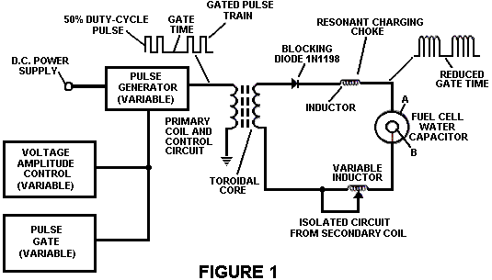

Fig.1 Illustrates a circuit useful in the process.

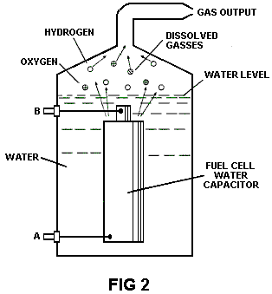
Fig.2 Shows a perspective of a "water capacitor" element used in the fuel cell circuit.

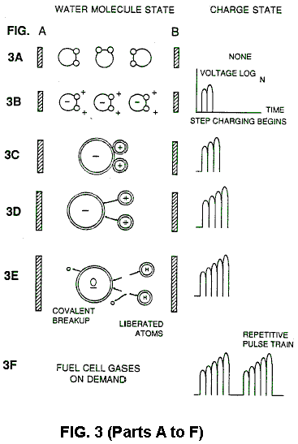

Figs. 3A through 3F are illustrations depicting the theoretical bases for the phenomena encountered during operation of the invention herein.

DESCRIPTION OF THE PREFERRED EMBODIEMENT
In brief, the invention is a method of obtaining the release of a gas mixture including hydrogen on oxygen and other dissolved gases formerly entrapped in water, from water consisting of:
(a) Providing a capacitor, in which the water is included as a dielectric liquid between capacitor plates, in a resonant charging choke circuit that includes an inductance in series with the capacitor;
(b) Subjecting the capacitor to a pulsating, unipolar electric voltage field in which the polarity does not pass beyond an arbitrary ground, whereby the water molecules within the capacitor are subjected to a charge of the same polarity and the water molecules are distended by their subjection to electrical polar forces;
(c) Further subjecting in said capacitor to said pulsating electric field to achieve a pulse frequency such that the pulsating electric field induces a resonance within the water molecule;
(d) Continuing the application of the pulsating frequency to the capacitor cell after resonance occurs so that the energy level within the molecule is increased in cascading incremental steps in proportion to the number of pulses;
(e) Maintaining the charge of said capacitor during the application of the pulsing field, whereby the co-valent electrical bonding of the hydrogen and oxygen atoms within said molecules is destabilised such that the force of the electrical field applied, as the force is effective within the molecule, exceeds the bonding force of the molecule, and hydrogen and oxygen atoms are liberated from the molecule as elemental gases; and
(f) Collecting said hydrogen and oxygen gases, and any other gases that were formerly dissolved within the water, and discharging the collected gases as a fuel gas mixture.

The process follows the sequence of steps shown in the following Table 1 in which water molecules are subjected to increasing electrical forces. In an ambient state, randomly oriented water molecules are aligned with respect to a molecule polar orientation.
They are next, themselves polarised and "elongated" by the application of an electrical potential to the extent that covalent bonding of the water molecule is so weakened that the atoms dissociate and the molecule breaks down into hydrogen and oxygen elemental components.
Engineering design parameters based on known theoretical principles of electrical circuits determine the incremental levels of electrical and wave energy input required to produce resonance in the system whereby the fuel gas comprised of a mixture of hydrogen, oxygen, and other gases such as air were formerly dissolved within the water, is produced.

TABLE 1
----------------------------------------------------------------------------------------------------------------------------
Process Steps:
The sequence of the relative state of the water molecule and/or hydrogen/oxygen/other atoms:
----------------------------------------------------------------------------------------------------------------------------
A. (ambient state) random
B. Alignment of polar fields
C. Polarisation of molecule
D. Molecular elongation
E. Atom liberation by breakdown of covalent bond
F. Release of gases
----------------------------------------------------------------------------------------------------------------------------

In the process, the point of optimum gas release is reached at a circuit resonance. Water in the fuel cell is subjected to a pulsating, polar electric field produced by the electrical circuit whereby the water molecules are distended by reason of their subjection to electrical polar forces of the capacitor plates. The polar pulsating frequency applied is such that the pulsating electric field induces a resonance in the molecule. A cascade effect occurs and the overall energy level of specific water molecules is increased in cascading, incremental steps. The hydrogen and oxygen atomic gases, and other gas components formerly entrapped as dissolved gases in water, are released when the resonant energy exceeds the covalent bonding force of the water molecule. A preferred construction material for the capacitor plates is T304-grade stainless steel which is
non-chemical reactive with water, hydrogen, or oxygen. An electrically conductive material which is inert in the fluid environment is a desirable material of construction for the electrical field plates of the "water capacitor" employed in the circuit.

Once triggered, the gas output is controllable by the attenuation of operational parameters. Thus, once the frequency of resonance is identified, by varying the applied pulse voltage to the water fuel cell assembly, gas output is varied. By varying the pulse shape and/or amplitude or pulse train sequence of the initial pulsing wave source, final gas output is varied. Attenuation of the voltage field frequency in the form of OFF and ON pulses likewise affects output.

The overall apparatus thus includes an electrical circuit in which a water capacitor having a known dielectric property is an element. The fuel gases are obtained from the water by the disassociation of the water molecule. The water molecules are split into component atomic elements (hydrogen and oxygen gases) by a voltage stimulation process called the electrical polarisation process which also releases dissolved gases entrapped in the water.

From the outline of physical phenomena associated with the process described in Table 1, the theoretical basis of the invention considers the respective states of molecules and gases and ions derived from liquid water. Before voltage stimulation, water molecules are randomly dispersed throughout water in a container. When a unipolar voltage pulse train such as shown in Figs.3B through 3F is applied to positive and negative capacitor plates, an increasing voltage potential is induced in the molecules in a linear, step like charging effect. The electrical field of the particles within a volume of water including the electrical field plates increases from a low energy state to a high energy state successively is a step manner following each pulse-train as illustrated figuratively in the depictions of Figs.3A through 3F. The increasing voltage potential is always positive in direct relationship to negative ground potential during each pulse. The voltage polarity on the plates which create the voltage fields remains constant although the voltage charge increases. Positive and negative voltage "zones" are thus formed simultaneously in the electrical field of the capacitor plates.

In the first stage of the process described in Table 1, because the water molecule naturally exhibits opposite electrical fields in a relatively polar configuration (the two hydrogen atoms are positively electrically charged relative to the negative electrically charged oxygen atom), the voltage pulse causes initially randomly oriented water molecules in the liquid state to spin and orient themselves with reference to positive and negative poles of the voltage fields applied. The positive electrically charged hydrogen atoms of said water molecule are attracted to a negative voltage field; while, at the same time, the negative electrically charged oxygen atoms of the same water molecule are attracted to a positive voltage field. Even a slight potential difference applied to inert, conductive plates of a containment chamber which forms a capacitor will initiate polar atomic orientation within the water molecule based on polarity differences.

When the potential difference applied causes the orientated water molecules to align themselves between the conductive plates, pulsing causes the voltage field intensity to be increased in accordance with Fig.3B. As further molecule alignment occurs, molecular movement is hindered. Because the positively charged hydrogen atoms of said aligned molecules are attracted in a direction opposite to the negatively charged oxygen atoms, a polar charge alignment or distribution occurs within the molecules between said voltage zones, as shown in Fig.3B. And as the energy level of the atoms subjected to resonant pulsing increases, the stationary water molecules become elongated as shown in Fig.3C and Fig.3D. Electrically charged nuclei and electrons are attracted toward opposite electrically charged equilibrium of the water molecule.

As the water molecule is further exposed to an increasing potential difference resulting from the step charging of the capacitor, the electrical force of attraction of the atoms within the molecule to the capacitor plates of the chamber also increase in strength. As a result, the covalent bonding between which form the molecule is weakened --- and ultimately terminated. The negatively charged electron is attracted toward the positively charged hydrogen atoms, while at the same time, the negatively charged oxygen atoms repel electrons.

In a more specific explanation of the "sub-atomic" action the occurs in the water fuel cell, it is known that natural water is a liquid which has a dielectric constant of 78.54 at 20 degrees C. and 1 atmosphere pressure. [Handbook of Chemistry & Physics, 68th ed., CRC Press(Boca Raton, Florida (1987-88)), Section E-50. H20(water)].

When a volume of water is isolated and electrically conductive plates, that are chemically inert in water and are separated by a distance, are immersed in water, a capacitor is formed, having a capacitance determined by the surface area of the plates, the distance of their separation and the dielectric constant of water.

When water molecules are exposed to voltage at a restricted current, water takes on an electrical charge. By the laws of electrical attraction, molecules align according to positive and negative polarity fields of the molecule and the alignment field. The plates of the capacitor constitute such as alignment field when a voltage is applied.

When a charge is applied to a capacitor, the electrical charge of the capacitor equals the applied voltage charge; in a water capacitor, the dielectric property of water resists the flow of amps in the circuit, and the water molecule itself, because it has polarity fields formed by the relationship of hydrogen and oxygen in the covalent bond, and intrinsic dielectric property, becomes part of the electrical circuit, analogous to a "microcapacitor" within the capacitor defined by the plates.

In the Example of a fuel cell circuit of Fig.1, a water capacitor is included. The step-up coil is formed on a conventional toroidal core formed of a compressed ferromagnetic powered material that will not itself become permanently magnetised, such as the trademarked "Ferramic 06# "Permag" powder as described in Siemens Ferrites Catalogue, CG-2000-002-121, (Cleveland, Ohio) No. F626-1205". The core is 1.50 inch in diameter and 0.25 inch in thickness. A primary coil of 200 turns of 24 gauge copper wire is provided and coil of 600 turns of 36 gauge wire comprises the secondary winding.

In the circuit of Fig.1, the diode is a 1N1198 diode which acts as a blocking diode and an electric switch that allows voltage flow in one direction only. Thus, the capacitor is never subjected to a pulse of reverse polarity.

The primary coil of the toroid is subject to a 50% duty cycle pulse. The toroidal pulsing coil provides a voltage step-up from the pulse generator in excess of five times, although the relative amount of step-up is determined by preselected criteria for a particular application. As the stepped-up pulse enters first inductor (formed from 100 turns of 24 gauge wire 1 inch in diameter), an electromagnetic field is formed around the inductor, voltage is switched off when the pulse ends, and the field collapses and produces another pulse of the same polarity i.e., another positive pulse is formed where the 50% duty cycle was terminated. Thus, a double pulse frequency is produced; however, in pulse train of unipolar pulses, there is a brief time when pulses are not present.

By being so subjected to electrical pulses in the circuit of Fig.1, water confined in the volume that includes the capacitor plates takes on an electrical charge that is increased by a step charging phenomenon occurring in the water capacitor. Voltage continually increases (to about 1000 volts and more) and the water molecules starts to elongate.

The pulse train is then switched off; the voltage across the water capacitor drops to the amount of the charge that the water molecules have taken on, i.e., voltage is maintained across the charged capacitor. The pulse train is the reapplied.

Because a voltage potential applied to a capacitor can perform work, the higher the voltage the higher the voltage potential, the more work is performed by a given capacitor. In an optimum capacitor that is wholly non-conductive, zero (0) current flow will occur across the capacitor. Thus, in view of an idealised capacitor circuit, the object of the water capacitor circuit is to prevent electron flow through the circuit, i.e. such as occurs by electron flow or leakage through a resistive element that produces heat. Electrical leakage in the water will occur, however, because of some residual conductivity and impurities or ions that may be otherwise present in the water. Thus, the water capacitor is preferably chemically inert. An electrolyte is not added to the water.

In the isolated water bath, the water molecule takes on charge, and the charge increases. The object of the process is to switch off the covalent bonding of the water molecule and interrupt the subatomic force, i.e. the electrical force or electromagnetic force, that binds the hydrogen and oxygen atoms to form a molecule so that the hydrogen and oxygen separate.

Because an electron will only occupy a certain electron shell (shells are well known) the voltage applied to the capacitor affects the electrical forces inherent in the covalent bond. As a result of the charge applied by the plates, the applied force becomes greater than the force of the covalent bonds between the atom of the water molecule; and the water molecule becomes elongated. When this happens, the time share ratio of the electron shells is modified.

In the process, electrons are extracted from the water bath; electrons are not consumed nor are electrons introduced into the water bath by the circuit as electrons are conventionally introduced in as electrolysis process. There may nevertheless occur a leakage current through the water. Those hydrogen atoms missing electrons become neutralised; atoms are liberated from the water. The charged atoms and electrons are attracted to the opposite polarity voltage zones created between the capacitor plates. The electrons formerly shared by atoms in the water covalent bond are reallocated such that neutral elemental gases are liberated.

In the process, the electrical resonance may be reached at all levels of voltage potential. The overall circuit is characterised as a "resonant charging choke" circuit which is an inductor in series with a capacitor that produces a resonant circuit. [SAMS Modern Dictionary of Electronics, Rudolf Garff, copyright 1984, Howard W. Sams & Co. (Indianapolis, Ind.), page 859.] Such a resonant charging choke is on each side of the capacitor. In the circuit, the diode acts as a switch that allows the magnetic field produced in the inductor to collapse, thereby doubling the pulse frequency and preventing the capacitor from discharging. In this manner a continuous voltage is produced across the capacitor plates in the water bath; and the capacitor does not discharge. The water molecules are thus subjected to a continuously charged field until the breakdown of the covalent bond occurs.

As noted initially, the capacitance depends on the dielectric properties of the water and the size and separation of the conductive elements forming the water capacitor.

EXAMPLE 1

In an example of the circuit of Fig.1 (in which other circuit element specifications are provided above), two concentric cylinders 4 inches long formed the water capacitor of the fuel cell in the volume of water. The outside cylinder was 0.75 inch in outside diameter; the inner cylinder was 0.5 inch in outside diameter. Spacing from the outside of the inner cylinder to the inner surface of the outside cylinder was 0.0625 inch. Resonance in the circuit was achieved at a 26 volt applied pulse to the primary coil of the toroid at 0 KHz (suspected mis-typing for 10KHz), and the water molecules disassociated into elemental hydrogen and oxygen and the gas released from the fuel cell comprised a mixture of hydrogen, oxygen from the water molecule, and gases formerly dissolved in the water such as the atmospheric gases or oxygen, nitrogen, and argon.

In achieving resonance in any circuit, as the pulse frequency is adjusted, the flow of amps is minimised and the voltage is maximised to a peak. Calculation of the resonance frequency of an overall circuit is determined by known means; different cavities have a different frequency of resonance dependant on parameters of the water dielectric, plate size, configuration and distance, circuit inductors, and the like. Control of the production of fuel gas is determined by variation of the period of time between a train of pulses, pulse amplitude and capacitor plate size and configuration, with corresponding value adjustments to other circuit components.

The wiper arm on the second conductor tunes the circuit and accommodates to contaminants in water so that the charge is always applied to the capacitor. The voltage applied determines the rate of breakdown of the molecule into its atomic components. As water in the cell is consumed, it is replaced by any appropriate means or control system.

Variations of the process and apparatus may be evident to those skilled in the art.

STANLEY MEYER

US Patent 4,389,981 28th June 1983 Inventor: Stanley A. Meyer

HYDROGEN GAS INJECTOR SYSTEM FOR INTERNAL COMBUSTION ENGINES

Please note that this is a re-worded excerpt from this patent. It describes one method for using hydrogen and oxygen gases to fuel a standard vehicle engine.

ABSTRACT
System and apparatus for the controlled intermixing of a volatile hydrogen gas with oxygen and other non-combustible gasses in a combustion system. In a preferred arrangement the source of volatile gas is a hydrogen source, and the non-combustible gasses are the exhaust gasses of the combustion system in a closed loop arrangement. Specific structure for the controlled mixing of the gasses, the fuel flow control, and safety are disclosed.

CROSS REFERENCES AND BACKGROUND
There is disclosed in my co-pending U.S. patent application Serial No. 802,807 filed Sept. 16, 1981 for a Hydrogen-Generator, a generating system converting water into hydrogen and oxygen gasses. In that system and method the hydrogen atoms are dissociated from a water molecule by the application of a non-regulated, non-filtered, low-power, direct current voltage electrical potential applied to two non-oxidising similar metal plates having water passing between them. The sub-atomic action is enhanced by pulsing this DC voltage. The apparatus comprises structural configurations in alternative embodiments for segregating the generated hydrogen gas from the oxygen gas.

In my co-pending patent application filed May 5, 1981, U.S. Serial No. 262,744 now abandoned for Hydrogen-Airdation Processor, non-volatile and non-combustible gasses are controlled in a mixing stage with a volatile gas. The hydrogen airdation processor system utilises a rotational mechanical gas displacement system to transfer, meter, mix, and pressurise the various gasses. In the gas transformation process, ambient air is passed through an open flame gas-burner system to eliminate gasses and other substances present. After that, the non-combustible gas-mixture is cooled, filtered to remove impurities, and mechanically mixed with a pre-determined amount of hydrogen gas. This results in a new synthetic gas.

This synthetic gas-formation stage also measures the volume and determines the proper gas-mixing ratio for establishing the desired burn-rate of hydrogen gas. The rotational mechanical gas displacement system in that process determines the volume of synthetic gas to be produced.

The above-noted hydrogen airdation processor, of my co-pending application, is a multi-stage system suited to special applications. Whereas the hydrogen generator system of my other mentioned co-pending application does disclose a very simple and unique hydrogen generator.

In my co-pending patent application Serial No. 315,945, filed Oct. 18, 1981 there is disclosed a combustion system incorporating a mechanical drive system. In one instance, this is designed to drive a piston in an automotive device. There is shown a hydrogen generator for developing hydrogen gas, and perhaps other non-volatile gasses such as oxygen and nitrogen. The hydrogen gas with the attendant non-volatile gasses is fed via a line to a controlled air intake system. The combined hydrogen, non-volatile gasses, and the air, after inter-mixing, are fed to a combustion chamber where they are ignited. The exhaust gasses of the combustion chamber are returned in a closed loop arrangement to the mixing chamber to be used again as the non-combustible gas component. Particular applications and structural embodiments of the system are disclosed.

SUMMARY OF THE INVENTION
The system of the present invention in its most preferred embodiment is for a combustion system utilising hydrogen gas; particularly to drive the pistons in an car engine. The system utilises a hydrogen generator for developing hydrogen gas. The hydrogen gas and other non-volatile gasses are then fed, along with oxygen, to a mixing chamber. The mixture is controlled in such a way as to lower the temperature of the combustion to bring it in line with that of the currently existing commercial fuels. The hydrogen gas feed line to the combustion chamber includes a fine linear control gas flow valve. An air intake is the source of oxygen and it also includes a variable valve. The exhaust gasses from the combustion chamber are utilised in a controlled manner as the non-combustible gasses.

The hydrogen generator is improved by the inclusion of a holding tank which provides a source of start-up fuel. Also, the hydrogen gas generator includes a pressure-controlled safety switch on the combustion chamber which disconnects the input power if the gas pressure rises above the required level. The simplified structure includes a series of one-way valves, safety valves, and quenching apparatus. The result is an apparatus which comprises the complete assembly for converting a standard car engine from petrol (or other fuels) to use a hydrogen/gas mixture.

OBJECTS
It is accordingly a principal object of the present invention to provide a combustion system of gasses combined from a source of hydrogen and non-combustible gasses.

Another object of the invention is to provide such a combustion system that intermixes the hydrogen and non-combustible gasses in a controlled manner and thereby control the combustion temperature.

A further object of the invention is to provide such a combustion system that controls the fuel flow to the combustion chamber in s system and apparatus particularly adapted to hydrogen gas.

Still other objects and features of the present invention will become apparent from the following detailed description when taken in conjunction with the drawings in which:

BRIEF DESCRIPTION OF THE DRAWINGS

Fig.1 is a mechanical schematic illustration partly in block form of the present invention in its most preferred embodiment.

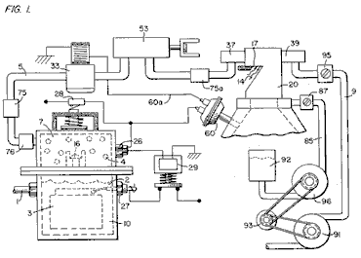

Fig.2 is a block schematic illustration of the preferred embodiment of the hydrogen injector system shown in Fig.1.

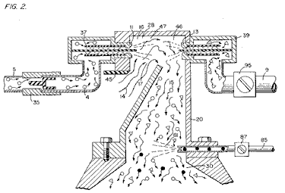

Fig.3 is the fine linear fuel flow control shown in Fig.1.

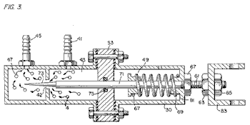

Fig.4 is cross-sectional illustration of the complete fuel injector system in an car utilising the concepts of the present invention.

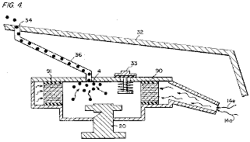

Fig.5 is a schematic drawing in a top view of the fuel injector system utilised in the preferred embodiment.
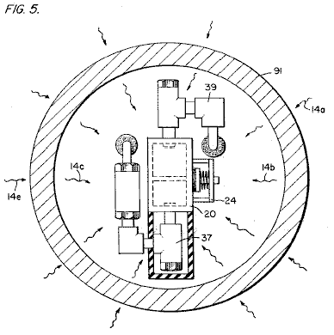

Fig.6 is a cross-sectional side view of the fuel injector system in the present invention.
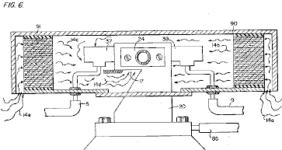

Fig.7 is a side view of the fuel mixing chamber.

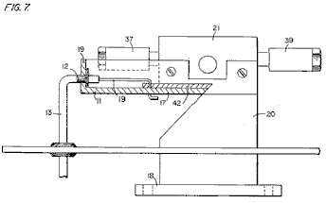
Fig.8 is a top view of the air intake valve to fuel mixing chamber.

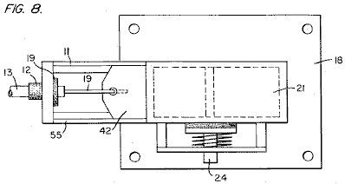

Fig.9 is a comparison of the burning velocity of hydrogen with respect to other fuels.

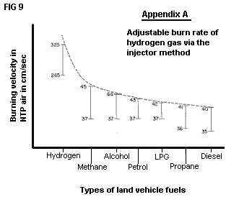

DETAILED DESCRIPTION OF INVENTION TAKEN WITH DRAWINGS:

Referring to Fig.1 the complete overall gas mixing and fuel flow system is illustrated together for utilisation in a combustion engine, particularly an engine in a car. With specific reference to Fig.1, the hydrogen source 10 is the hydrogen generator disclosed and described in my co-pending application, supra. The container 10 is an enclosure for a water bath 2. Immersed in the water 2 is an array of plates 3 as further described in my co-pending application, supra. Applied to plates 3 is a source of direct current potential via electrical inlet 27. The upper portion 7 of the container 10 is a hydrogen storage area maintaining a predetermined amount of pressure. In this way, there will be an immediate flow of hydrogen gas at start-up.

To replenish the expended water, the generator provides a continuous water source 1. Thereafter, the generator is operable as described in the aforesaid patent application. The safety valve 28 is designed to rupture should there be an excessive build-up of gas. Switch 26 is a gas-pressure switch included to maintain a predetermined gas pressure level about a regulated low-volume.

The generated hydrogen gas 4 is fed from the one-way check valve 16 via pipe 5 to a gas-mixing chamber 20, where the hydrogen gas is mixed with non-combustible gasses via pipe 9 from a source described later.

If the one-way valve 75 failed, there could be a return spark which could ignite the hydrogen gas 4 in the storage area 7 of the hydrogen generator 10. To prevent this, the quenching assembly 76 has been included to prevent just such an ignition.

With particular reference to Fig.2, the hydrogen gas (via pipe 5) and non-combustible gasses (via pipe 9), are fed to a carburettor (air-mixture) system 20 also having an air intake 14 for ambient air.

The hydrogen gas 4 is fed via line 5 through nozzle 11 in a spray 16 in to the trap area 46 of the mixing chamber 20. Nozzle 11 has an opening smaller than the plate openings in the quenching assembly 37, thereby preventing flash-back in the event of sparking. The non-volatile gasses are injected into mixing chamber 20 trap area 47 in a jet spray 17 via nozzle 13. Quenching assembly 39 is operable much in the same manner as quenching assembly 37.

In the preferred arrangement, the ambient air is the source of oxygen necessary for the combustion of the hydrogen gas. Further, as disclosed in the aforesaid co-pending application, the non-volatile gasses are in fact, the exhaust gasses passed back via a closed loop system. It is to be understood that the oxygen and/or the non-combustible gasses might also be provided from an independent source.

With continued reference to Fig.2 the gas trap area 47 is a predetermined size. As hydrogen is lighter than air, the hydrogen will rise and become trapped in area 47. Area 47 is large enough to contain enough hydrogen gas to allow instant ignition upon the subsequent start-up of the combustion engine.

It will be noted that the hydrogen gas is injected in the uppermost region of the trap area 47. Hydrogen rises at a much greater rate than oxygen or the non-combustible gasses; perhaps three times or greater. Therefore, if the hydrogen gas entered the trap area 47 (mixing area) at its lowermost region the hydrogen gas would rise so rapidly that the air could not mix with the oxygen. With the trap area 47 shown in Fig.2, the hydrogen is forced downwards into the air intake 15. That is, the hydrogen gas is forced downwards into the upwardly forced air and this causes adequate mixing of the gasses.

The ratio of the ambient air (oxygen) 14 and the non-combustible gas via line 9 is a controlled ratio which is tailored to the particular engine. Once the proper combustion rate has been determined by the adjustment of valve 95 (for varying the amount of the non-combustible gas) and the adjustment of valve 45 (for varying the amount of the ambient air), the ratio is maintained thereafter.

In a system where the non-combustible gasses are the exhaust gasses of the engine itself, passed back through a closed loop-arrangement, and where the air intake is controlled by the engine, the flow velocity and hence the air/non-combustible mixture, is maintained by the acceleration of the engine.

The mixture of air with non-combustible gasses becomes the carrier for the hydrogen gas. That is, the hydrogen gas is mixed with the air/non-combustible gas mixture. By varying the amount of hydrogen gas added to the air/non-combustible mixture, the engine speed is controlled.

Reference is made to Fig.3 which shows in a side view cross-section, the fine linear fuel flow control 53. The hydrogen gas 4 enters chamber 43 via gas inlet 41. The hydrogen gas passes from chamber 43 to chamber 47 via port or opening 42. The amount of gas passing form chamber 43 to chamber 47 is dictated by the setting of the port opening 42.

The port opening is controlled by inserting the linearly tapered pin 73 into it. The blunt end of pin 73 is fixed to rod 71. Rod 71 is passed, (via supporting O-ring 75), through opening 81 in housing 30, to the manual adjustment mechanism 83.

Spring 49 retains the rod 71 in a fixed position relative to pin 73 and opening 42. When mechanism 83 is operated, pin 73 moves back from the opening 42. As pin 73 is tapered, this backward movement increases the free area of opening 42, thereby increasing the amount of gas passing from chamber 43 to chamber 47.

The stops 67 and 69 maintain spring 49 in its stable position. The nuts 63 and 67 on threaded rod 61 are used to set the minimum open area of opening 42 by the correct positioning of pin 73. This minimum opening setting, controls the idle speed of the engine, so pin 73 is locked in its correct position by nuts 63 and 67. This adjustment controls the minimum rate of gas flow from chamber 43 to chamber 47 which will allow continuous operation of the combustion engine.

Referring now to Fig.8 which illustrates the air adjustment control for manipulating the amount of air passing into the mixing chamber 20. The closure 21 mounted on plate 18 has an opening 17 on end 11. A plate-control 42 is mounted so as to slide over opening 17. The position of this plate, relative to opening 17, is controlled by the position of the control rod 19 which passes through grommet 12 to control line 13. Release valve 24 is designed to rupture should any malfunction occur which causes the combustion of the gasses in mixing chamber 20.

With reference now to Fig.4, if hydrogen gas 4 were to accumulate in mixing chamber 20 and reach an excessive pressure, the escape tube 36 which is connected to port 34 (located on the car bonnet 32), permits the excess hydrogen gas to escape safely to the atmosphere. In the event of a malfunction which causes the combustion of the gasses in mixing chamber 20, the pressure relief valve 33 will rupture, expelling the hydrogen gas without combustion.

In the constructed arrangement of Fig.1, there is illustrated a gas control system which may be fitted to an existing car’s internal combustion engine without changing or modifying the car's design parameters or characteristics. The flow of the volatile hydrogen gas is, of course, critical; therefore, there is incorporated in line 5 a gas-flow valve 53, and this is used to adjust the hydrogen flow. This gas-flow valve is shown in detail in Fig.3.

The intake air 14 may be in a carburettor arrangement with an intake adjustment 55 which adjusts the plate 42 opening. This is shown more fully in Fig.8. To maintain constant pressure in hydrogen gas storage 7 in the on-off operation of the engine, the gas flow control valve is responsive to the electrical shut-off control 33. The constant pressure permits an abundant supply of gas on start-up and during certain periods of running time in re-supply.

The switch 33 is in turn responsive to the vacuum control switch 60. During running of the engine vacuum will be built up which in turn leaves switch 33 open by contact with vacuum switch 60 through lead 60a. When the engine is not running the vacuum will decrease to zero and through switch 60 will cause electrical switch 33 to shut off cutting off the flow of hydrogen gas to the control valve 53.

As low-voltage direct current is applied to safety valve 28, solenoid 29 is activated. The solenoid applies a control voltage to the hydrogen generator exciter 3 via terminal 27 through pressure switch 26. As the electrical power activates solenoid 29, hydrogen gas is caused to pass through flow adjustment valve 16 and then outlet pipe 5 for utilisation. The pressure differential hydrogen gas output to gas mixing chamber 20 is for example 30 lbs. to 15 lbs. Once hydrogen generator 10 reaches an optimum gas pressure level, pressure switch 26 shuts off the electrical power to the hydrogen excitors. If the chamber pressure exceeds a predetermined level, the safety release valve 28 is activated disconnecting the electrical current and thereby shutting down the entire system for safety inspection.

With particular reference now to Fig.6 which illustrates the fuel injector system in a side cross-sectional view and to Fig.5 the top view. The structural apparatus incorporated in the preferred embodiment comprises housing 90 which has air intakes 14a and 14e. The air passes through filter 91 around the components 14b and 14c and then to intake 14d of the mixing chamber 20. The hydrogen enters via line 5 via quenching plates 37 and into the mixing chamber 20. The non-volatile gasses pass via line 9 to the quenching plates 39 and into the mixing chamber 20.

Fig.7 illustrates the mechanical arrangement of the components which make up the overall structure of mixing chamber 20 (shown independently in the other figures).

Returning to Fig.1 there is illustrated the non-volatile gas line 9 passing through mixture pump 91 by engine pulley 93. Valve 95 controls the rate of flow. Also driven by pulley 93 is pump 96 having line 85 connected to an oil reservoir 92 and valve 87 and finally to mixing chamber 20. As a practical matter, such as in a non-oil lubricated engine, lubricating fluid such as oil 81 is sprayed in the chamber 20, via oil supply line 85 for lubrication.

There have been several publications in the past year or so, delving into the properties of Hydrogen gas, its potential use, generating systems, and safety. One such publication is "Selected Properties of Hydrogen" (Engineering Design Data) issued February 1981 by the National Bureau of Standards.

These publications are primarily concerned with the elaborate and costly processes for generating hydrogen. Equally so, they are concerned with the very limited use of hydrogen gas because of its extremely high burning velocities. This in turn reflects the danger in the practical use of hydrogen.

With reference to the graph of the Appendix A, it is seen that the burning velocities of alcohol, propane, methane, petrol, Liquid Petroleum Gas, and diesel oil are in the range of minimum 35 to maximum 45. Further, the graph illustrates that the burning velocity of hydrogen gas is in the range of 265 minimum to 325 maximum. In simple terms, the burning velocity of hydrogen is of the order of 7.5 times the burning velocity of ordinary commercial fuels.

Because of the unusually high burning velocity of hydrogen gas, it has been ruled out as a substitute fuel, by these prior investigators. Further, even if an engine could be designed to accommodate such high burning velocities, the danger of explosion would eliminate any thoughts of commercial use.

The present invention, as above described, has resolved the above-noted criteria for the use of hydrogen gas in a standard commercial engine. Primarily, the cost in the generation of hydrogen gas, as noted in the aforementioned co-pending patent applications, is minimal. Water with no chemicals or metals is used. Also, as noted in the aforementioned co-pending patent applications, the reduction in the hydrogen gas burn velocity has been achieved. These co-pending applications not only teach the reduction in velocity, but teach the control of the velocity of the hydrogen gas.

In the preferred embodiment, practical apparatus adapting the hydrogen generator to a combustion engine is described. The apparatus linearly controls the hydrogen gas flow to a mixing chamber mixing with a controlled amount of non-combustible gas oxygen, hence, the reduction in the hydrogen gas velocity. The reduction in the hydrogen gas velocity makes the use of hydrogen as safe as other fuels.

In more practical terms the ordinary internal combustion engine of any size or type of fuel, is retrofitted to be operable with only water as a fuel source. Hydrogen gas is generated from the water without the use of chemicals or metals and at a very low voltage. The burning velocity of the hydrogen gas has been reduced to that of conventional fuels. Finally, every component or step in the process has one or more safety valves or features thereby making the hydrogen gas system safer than that of conventional cars.

In the above description the terms ‘non-volatile’ and ‘non-combustible’ were used. It is to be understood they are intended to be the same; that is, simply, gas which will not burn.

Again, the term ‘storage’ has been used, primarily with respect to the hydrogen storage area 7. It is not intended that the term ‘storage’ be taken literally - in fact, it is not storage, but a temporary holding area. With respect to area 7, this area retains a sufficient amount of hydrogen for immediate start-up.

Other terms, features, apparatus, and the such have been described with reference to a preferred embodiment. It is to be understood modifications and alternatives can be had without departing from the spirit and scope of the invention.

STANLEY MEYER

US Patent 4,421,474 December 1983 Inventor: Stanley A. Meyer

HYDROGEN GAS BURNER

Please note that this is a re-worded excerpt from this patent. It describes how to burn the hydrogen and oxygen gas mix produced by electrolysis of water. Normally, the flame produced is too hot for practical use other than cutting metal or welding. This patent shows a method of reducing the flame temperature to levels suitable for general use in boilers, stoves, heaters, etc.

ABSTRACT
A hydrogen gas burner for the mixture of hydrogen gas with ambient air and non-combustible gasses. The mixture of gasses when ignited provides a flame of extremely high, but controlled intensity and temperature.

The structure comprises a housing and a hydrogen gas inlet directed to a combustion chamber positioned within the housing. Air intake ports are provided for adding ambient air to the combustion chamber for ignition of the hydrogen gas by an ignitor therein. At the other end of the housing there is positioned adjacent to the outlet of the burner (flame) a barrier/heating element. The heating element uniformly disperses the flame and in turn absorbs the heat. The opposite side to the flame, the heating element uniformly disperses the extremely hot air. A non-combustible gas trap adjacent to the heating element captures a small portion of the non-combustible gas (burned air). A return line from the trap returns the captured non-combustible gas in a controlled ratio to the burning chamber for mixture with the hydrogen gas and the ambient air.

CROSS REFERENCE
The hydrogen/oxygen generator utilised in the present invention is that disclosed and claimed in my co-pending patent application, Serial. No.: 302,807, filed: Sept. 16, 1981, for: HYDROGEN GENERATOR SYSTEM. In that process for separating hydrogen and oxygen atoms from water having impurities, the water is passed between two plates of similar non-oxidising metal. No electrolyte is added to the water. The one plate has placed thereon a positive potential and the other a negative potential from a very low amperage direct-current power source. The sub-atomic action of the direct current voltage on the non-electrolytic water causes the hydrogen and oxygen atoms to be separated--and similarly other gasses entrapped in the water such as nitrogen. The contaminants in the water that are not released are forced to disassociate themselves and may be collected or utilised and disposed of in a known manner.

The direct current acts as a static force on the water molecules; whereas the non-regulated rippling direct current acts as a dynamic force. Pulsating the direct current further enhances the release of the hydrogen and oxygen atoms from the water molecules.

In my co-pending patent application, Serial. No. 262,744, filed: May 11, 1981, for: HYDROGEN AERATION PROCESSOR, there is disclosed and claimed the utilisation of the hydrogen/oxygen gas generator. In that system, the burn rate of the hydrogen gas is controlled by the controlled addition of non-combustible gasses to the mixture of hydrogen and oxygen gasses.

SUMMARY OF INVENTION
The present invention is for a hydrogen gas burner and comprises a combustion chamber for the mixture of hydrogen gas, ambient air, and non-combustible gasses. The mixture of gasses is ignited and burns at a retarded velocity rate and temperature from that of hydrogen gas, but at a higher temperature rate than other gasses.

The extremely narrow hydrogen gas mixture flame of very high temperature is restricted from the utilisation means by a heat absorbing barrier. The flame strikes the barrier which in turn disperses the flame and absorbs the heat therefrom and thereafter radiates the heat as extremely hot air into the utilisation means.

Positioned on the opposite side of the heat radiator/barrier is a hot air trap. A small portion of the radiated heat is captured and returned to the combustion chamber as non-combustible gasses. Valve means in the return line regulates the return of the non-combustible gas in a controlled amount to control the mixture.

The present invention is principally intended for use with the hydrogen generator of my co-pending patent application, supra; but it is not to be so limited and may be utilised with any other source of hydrogen gas.

OBJECTS
It is accordingly a principal object of the present application to provide a hydrogen gas burner that has a temperature controlled flame and a heat radiator/barrier.

Another object of the present invention is to provide a hydrogen gas burner that is capable of utilising the heat from a confined high temperature flame.

Another object of the present invention is to provide a hydrogen gas burner that is retarded from that of hydrogen gas, but above that of other gasses.

Another object of the present invention is to provide a hydrogen gas burner that utilises the exhaust air as non-combustible gas for mixture with the hydrogen gas.

Another object of the present invention is to provide a hydrogen gas burner that is simple but rugged and most importantly safe for all intended purposes.

Other objects and features of the present invention will become apparent from the following detailed description when taken in conjunction with the drawings in which:

BRIEF DESCRIPTION OF THE DRAWINGS
Fig.1 is an overall cross-sectional view of the present invention in its most preferred embodiment.
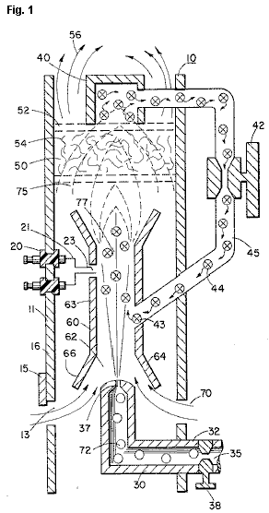

Fig.2 is a graphical illustration of the burning of various standard fuels with that of hydrogen velocities.
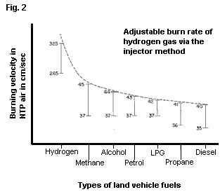

DETAILED DESCRIPTION OF INVENTION

With particular reference Fig.1 there is illustrated in a schematic cross-section the principals of the present invention. The structure of the preferred embodiment comprises a housing 10, having an igniter 20 extending through the wall 11 thereof. A combustion chamber 60 positioned within the housing 10 has a first open end 62. A hydrogen gas 72 inlet 30 directs hydrogen gas via port 37 from a source 35 to the inlet 62 of the combustion chamber 68. Also directed to the same inlet 62, and assisted by flanges 64 and 66, is ambient air 70 entering through ports 13 in the housing 10.

Adjacent the opposite end of the combustion chamber 60 the gas mixture 75 is ignited by the ignitor 20 to produce flame 77. The velocity of the flame 77 causes it to strike and penetrate the barrier/radiator 50. The barrier 50 is of a material, such as metallic mesh or ceramic material, to disperse therein the flame and in turn become saturated with heat. The flame 77 is of a size sufficient to be dispersed throughout the barrier 50, but yet, not penetrate through the barrier 50.

Radiated from the surface 52 of the barrier 50 is superheated air 56 (gasses) to be passed on to a utilisation device. Adjacent to surface 52 of barrier/radiator 50 is a hot air trap 40 with closed loop line 45 returning non-combustible gas 44 to the combustion chamber 60. Control valve 42 is intermediate the line 45.

In operation of the preferred embodiment hydrogen gas, 72, emitted from the nozzle 37 is directed to the combustion chamber 60. The flanges 64 and 66 on the open end of housing 63 of the combustion chamber 60 enlarges the open end of 62. In the enlargement ambient air from the opening 13 in the housing 10 is also directed to the combustion chamber 60.

The ambient air and hydrogen traverses the opening 43 and further mixes with the non-combustible gas 44 from the closed loop line 45 with the hot air trap 40. The mixture of hydrogen gas 72, ambient air 70, and non-combustible gas 44, is ignited by the ignitor 20 having electrical electrodes 21 and 23. Upon ignition flame 77 ensues. The mixture is controlled with each of three gasses. That is, the line 32 from the hydrogen source 35 has a valve 38 therein for controlling the amount of hydrogen 72 emitted from the nozzle 37. The opening 13 has a plate adjustment 15 for controlling the amount of ambient air 60 directed to the combustion chamber 60, and the closed-loop line has valve 42, as aforesaid, for controlling the amount of non-combustible gasses in the mixture.

It can be appreciated that the temperature of the flame 77 and the velocity of the flame 77 is a function of the percentage of the various gasses in the mixture. In a practical embodiment, the flame 70 temperature and velocity was substantially retarded from that of a hydrogen flame per se; but yet, much greater than the temperature and velocity of the flame from the gasses utilised in a conventional heating system.

To maintain a sufficient pressure for combustion of the hydrogen gas mixture with a minimum of pressure (for safety) and to limit blow-out, the nozzle 37 opening 39 is extremely small. As a consequence, if the hydrogen gas were burned directly from the nozzle 37, the flame would be finite in diameter. Further, its velocity would be so great it is questionable whether a flame could be sustained. The mixing of ambient air and non-combustible gas does enlarge the flame size and reduce its velocity. However, to maintain a flame higher in temperature and velocity than the conventional gasses, the size and temperature of the flame is controlled by the mixture mentioned earlier.

Therefore, to utilise the flame 77 in a present day utilisation means, the flame is barred by the barrier 50. The barrier 50 is of a material that can absorb safely the intense flame 77 and thereafter radiate heat from its entire surface 52. The material 54 can be a ceramic, metallic mesh or other heat absorbing material known in the art. The radiated heat 56 is directed to the utilisation means.

As stated earlier, the mixture of gasses which are burned include non-combustible gasses. As indicated in the above-noted co-pending patent applications, an excellent source of non-combustible gasses is exhaust gasses. In this embodiment, the trap 50 entraps the hot air 74 and returns the same, through valve 42, to the combustion chamber 60 as non-combustible gas.

With reference to Fig.2 there is illustrated the burning velocity of various standard fuels. It can be seen the common type of fuel burns at a velocity substantially less than hydrogen gas. The ratio of hydrogen with non-combustible oxygen gasses is varied to obtain optimum burning velocity and temperature for the particular utilisation. Once this is attained, the ratio, under normal conditions, will not be altered. Other uses having different fuel burn temperature and velocity will be adjusted in ratio of hydrogen/oxygen to non-combustible gasses in the same manner as exemplified above.

Further, perhaps due to the hydrogen gas velocity, there will occur unburned gas at the flame 77 output. The barrier 50, because of its material makeup will retard the movement and trap the unburned hydrogen gas. As the superheated air 77 is dispersed within the material 54, the unburned hydrogen gas is ignited and burns therein. In this way the barrier 50 performs somewhat in the nature of an after-burner.

STANLEY MEYER

US Patent 5,149,407 22nd September 1992 Inventor: Stanley Meyer

PROCESS AND APPARATUS FOR THE PRODUCTION OF FUEL GAS AND

THE ENHANCED RELEASE OF THERMAL ENERGY FROM SUCH GAS

Please note that this is a re-worded excerpt from this patent. It describes in considerable detail, one of Stan’s methods for splitting water into hydrogen and oxygen gasses and the subsequent methods for using those gasses.

ABSTRACT
Water molecules are broken down into hydrogen and oxygen gas atoms in a capacitive cell by a polarisation and resonance process dependent on the dielectric properties of water and water molecules. The gas atoms are then ionised or otherwise energised and thermally combusted to release a degree of energy greater than that of combustion of the gas in air.

OBJECTS OF THE INVENTION
A first object of the invention is to provide a fuel cell and a process in which molecules of water are broken down into hydrogen and oxygen gasses, and a fuel gas mixture comprised of hydrogen, oxygen and other gasses formerly dissolved in the water, is produced. A further object of the invention is to realise significant energy-yield from a fuel gas derived from water molecules. Molecules of water are broken down into hydrogen and oxygen gasses. Electrically charged hydrogen and oxygen ions of opposite electrical polarity are activated by electromagnetic wave energy and exposed to a high temperature thermal zone. Significant amounts of thermal energy with explosive force beyond the gas burning stage are released.

An explosive thermal energy under a controlled state is produced. The process and apparatus provide a heat energy source useful for power generation, aircraft rocket engines or space stations.

BRIEF DESCRIPTION OF THE DRAWINGS

Figs.1A through 1F are illustrations depicting the theoretical bases for phenomena encountered during operation of the fuel gas production stage of the invention.
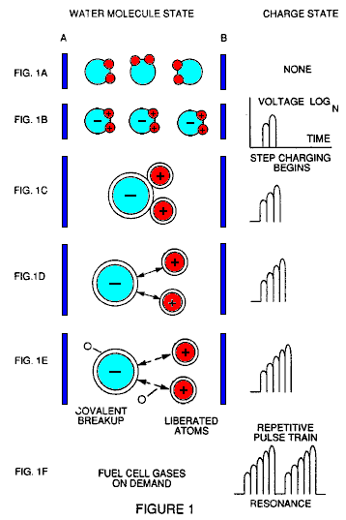

Fig.2 illustrates a circuit which is useful in the fuel gas generation process.

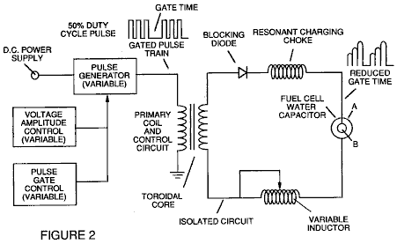

Fig.3 shows a perspective of a “water capacitor” element used in the fuel cell circuit.

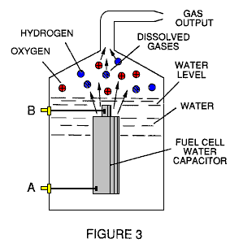

Fig.4 illustrates a staged arrangement of apparatus useful in the process, beginning with a water inlet and culminating in the production of thermal explosive energy.

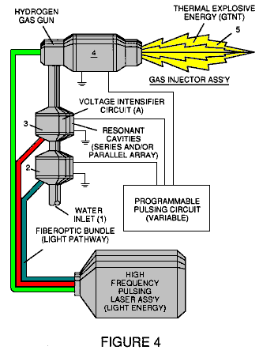

Fig.5A shows a cross-section of a circular gas resonant cavity used in the final stage assembly of Fig.4

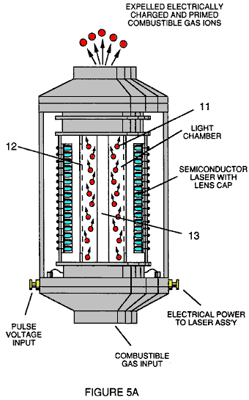

Fig.5B shows an alternative final stage injection system useful in the apparatus of Fig.4

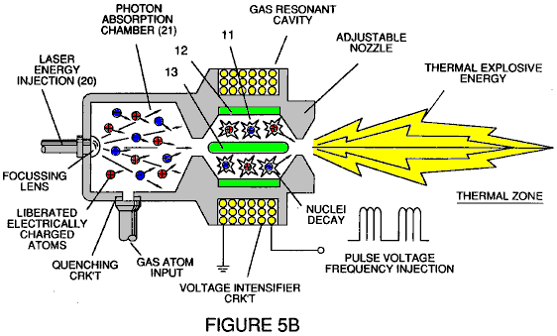

Fig.5C shows an optical thermal lens assembly for use with either final stage of Fig.5A or Fig.5B.

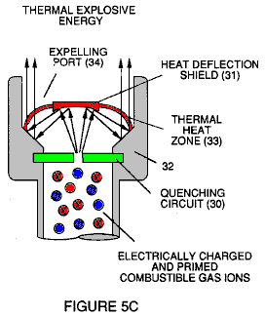

Figs.6A, 6B, 6C and 6D are illustrations depicting various theoretical bases for atomic phenomena expected to occur during operation of this invention.

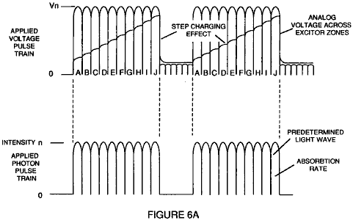

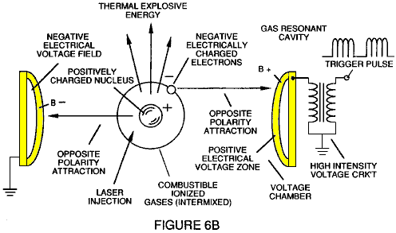

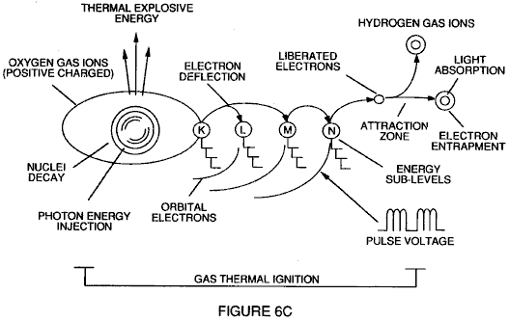

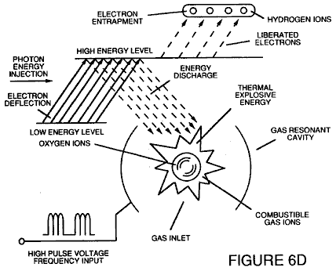

Fig.7 is an electrical schematic of the voltage source for the gas resonant cavity.

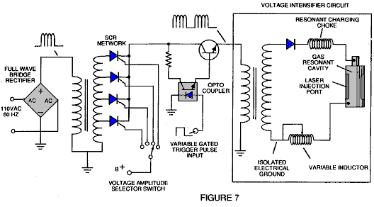

Figs.8A and 8B respectively, show (A) an electron extractor grid used in the injector assemblies of Fig.5A and Fig.5B, and (B) the electronic control circuit for the extractor grid.

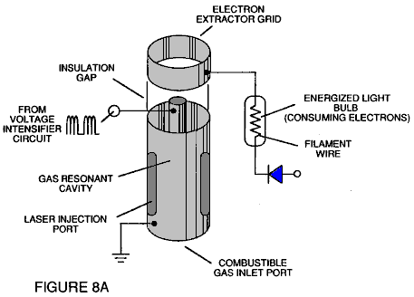

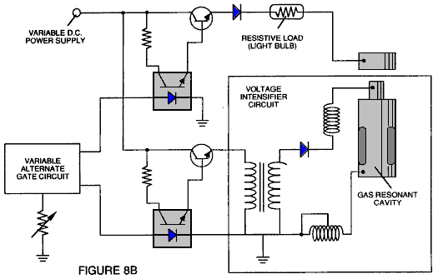

Fig.9 shows an alternative electrical circuit useful in providing a pulsating waveform to the apparatus.

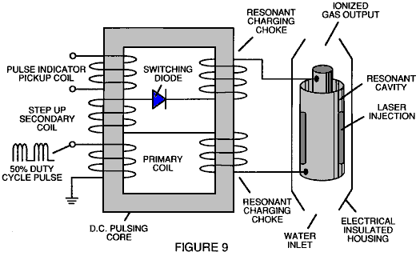

TABLE 1: PROCESS STEPS LEADING TO IGNITION

Relative State of Water Molecule and/or Hydrogen/Oxygen/Other Atoms | Stage
Random (ambient state) alignment of polar fields, polarisation of molecules. Molecular elongation. Atom liberation by breakdown of covalent bond | 1st Stage: Water to Gas
Release of gasses, Liquid to gas ionisation, Electrical charging effect, Particle Impact | 2nd Stage: Gas Ionisation
Electromagnetic Wave, Laser or photon injection, Electron extraction, Atomic destabilisation | 3rd Stage: Priming
Thermal Ignition | Final Stage: Ignition

DESCRIPTION OF THE PREFERRED EMBODIMENT
A fuel gas is produced by a hydrogen fracturing process which follows the sequence of steps shown in Table 1. Beginning with water molecules, the molecule is subjected to successively increasing electrical wave energy and thermal forces. In the succession of forces, randomly orientated water molecules are aligned with respect to molecular polar orientation and themselves polarised and “elongated” by the application of an electric potential, to the extent that the co-valent bonding of the water molecules is so weakened that the atoms disassociate and the molecule breaks down into hydrogen and oxygen elemental components. Next, the released atomic gasses are ionised and electrically charged in a vessel while being subjected to a further energy source which promotes inter-particle impact in the gas at an increased overall energy level. Finally, the atomic particles in the excited gas, having achieved successively higher energy levels, are subjected to a laser or electromagnetic wave energy source which produces atomic destabilisation and the final release of thermal explosive energy.

Engineering design parameters based on known theoretical principles of atomic physics, determine the incremental levels of electrical and wave energy input required to produce resonance in each stage of the system. Instead of a dampening effect, a resonant energisation of the molecule, atom or ion provides a compounding energy interaction resulting in the final energy release.

In brief, in the first stage, a gas mixture including hydrogen, oxygen and other gasses formerly dissolved in the water, is obtained from water. In general, the method used in the first stage consists of:
(A) Providing a capacitor, in which the water is included as a dielectric liquid between capacitor plates, in a resonant charging choke circuit, which includes an inductor in series with the capacitor.
(B) Subjecting the capacitor to a pulsating, unipolar electric voltage field in which the polarity does not pass beyond an arbitrary ground, whereby the water molecules within the capacitor are subjected to a charge of the same polarity, and the water molecules are distended by the electrical polar forces.
(C) Further subjecting the water in the capacitor to the pulsating electric field to achieve a pulse frequency which induces a resonance within the water molecule.
(D) Continuing the application of the pulsing frequency to the capacitor cell after resonance occurs so that the energy level within the molecule is increased in cascading incremental steps in proportion to the number of pulses.
(E) Maintaining the charge of the capacitor during the application of the pulsating field, whereby the co-valent electrical bonding of the hydrogen and oxygen atoms within the water molecules is destabilised to such a degree that the force of the electrical field within the molecule exceeds the bonding force of the molecule, causing the molecule to break apart into the elemental gasses of hydrogen and oxygen.
(F) Collecting the hydrogen and oxygen gasses, along with any other gasses formerly dissolved in the water, and discharging the collected gasses as a fuel gas mixture.

The water molecules are subjected to increasing electrical forces. In an ambient state, randomly orientated water molecules are aligned with respect to a molecular polar orientation. Next, they themselves are polarised and “elongated” by the application of an electrical potential to the extent that co-valent bonding of the water molecules is so weakened that the atoms disassociate and the molecule breaks down into hydrogen and oxygen elemental components. In this process, the point of optimum gas release is reached when the circuit is at resonant frequency. Water in the cell is subjected to a pulsating, polar electric field produced by the electrical circuit, whereby the water molecules are distended by the electrical force on the plates of the capacitor. The polar pulsating frequency applied is such that the pulsating electric field induces a resonance in the molecules. A cascade effect occurs, and the overall energy of specific water molecules is increased in cascading incremental steps. The hydrogen and oxygen are released when the resonant energy exceeds the co-valent bonding force of the water molecules.

A preferred construction material for the capacitor plates is stainless steel T-304 which does not react chemically with water, hydrogen or oxygen. An electrically conductive material which is inert in the fluid environment, is a desirable material of construction for the electric field plates of the “water capacitor” employed in the circuit.

Once triggered, the gas output is controllable by the attenuation of operational parameters. Thus, once the frequency of resonance is identified, by varying the applied pulse voltage to the water fuel cell assembly, gas output is varied. By varying the pulse shape, pulse amplitude or pulse train sequence, the gas output can be varied. Attenuation of the voltage field’s mark/space ratio of OFF/ON periods also affects the rate of gas production.

The overall apparatus thus includes and electrical circuit in which a water capacitor is an element. The water capacitor has a known dielectric property. The fuel gasses are obtained from the water by the disassociation of the water molecules. The water molecules are split into component atomic elements by a voltage stimulation process called the ‘electrical Polarisation process’ which also releases dissolved gasses trapped in the water.

From the outline of physical phenomena associated with the first stage of the process described in Table 1, the theoretical basis of the invention considers the respective states of molecules, gasses and ions derived from liquid water. Before voltage stimulation, water molecules are randomly dispersed throughout water in a container. When a unipolar voltage pulse train such as that shown in Figs.1B through 1F is applied to positive and negative capacitor plates, and increasing voltage potential is induced in the molecules in a linear, step-like charging effect. The electrical field of the particles within a volume of water including the electrical field plates, increases from a low energy state to a high energy state in a step manner following each pulse train as illustrated figuratively in Figs.1A through 1F. The increasing voltage potential is always positive in direct relationship to negative ground potential during each pulse. The voltage polarity on the plates which create the voltage fields remains constant although the voltage charge increases. Positive and negative voltage “zones” are thus formed simultaneously in the electrical field of the capacitor plates.

In the first stage of the process described in Table 1, because the water molecule naturally exhibits opposite electrical fields in a relatively polar configuration (the two hydrogen atoms have a positive charge while the oxygen atom has a negative charge), the voltage pulse causes the water molecules which were initially orientated in random directions, to spin and align themselves with the electrical field applied to the cell. The positively charged hydrogen atoms are attracted to the negative field while the negatively charged oxygen atoms, of the same water molecule, are attracted to the positive voltage field. Even a slight potential difference between the plates of a containment chamber capacitor will initiate the alignment of each water molecule within the cell.

When the voltage applied to the plates causes the water molecules to align themselves, then the pulsing causes the voltage field intensity to be increased in accordance with Fig.1B. As further molecular alignment occurs, molecular movement is hindered. Because the positively charged hydrogen atoms of the aligned molecules are attracted in a direction opposite to the negatively charged oxygen atoms, a polar charge alignment or distribution occurs within the molecules between the voltage zones as shown in Fig.1B, and as the energy level of the atoms, subjected to resonant pulsing, increases, the stationary water molecules become elongated as shown in Figs.1C and 1D. Electrically charged nuceli and electrons are attracted towards opposite electrically charged voltage zones - disrupting the mass and charge equilibrium of the water molecule.

As the water molecule is further exposed to an increasing potential difference resulting from the step charging of the capacitor, the electrical force of attraction of the atoms within the molecule to the capacitor plates of the chamber also increases in strength. As a result, the co-valent bonding between the atoms of the molecule is weakened and ultimately, terminated. The negatively charged electron is attracted toward the positively charged hydrogen atoms, while at the same time, the negatively charged oxygen atoms repel electrons.

In a more specific explanation of the “sub-atomic action which occurs in the water cell, it is known that natural water is a liquid which has a dielectric constant of 78.54 at 20 degrees Centigrade and 1 atmosphere of pressure [Handbook of Chemistry and Physics, Section E-50].

When a volume of water is isolated and electrically conductive plates that are chemically inert in water and which are separated by a distance, are immersed in the water, a capacitor is formed, having a capacitance determined by the surface area of the plates, the distance of their separation and the dielectric constant of the water.

When water molecules are exposed to voltage at a restricted current, water takes on an electrical charge. By the laws of electrical attraction, molecules align according to positive and negative polarity fields of the molecule and the alignment field. The plates of a capacitor constitute such an alignment field when a voltage is applied across them.

When a charge is applied to a capacitor, the electrical charge of the capacitor equals the applied voltage charge. In a water capacitor, the dielectric property of water resists the flow of current in the circuit, and the water molecule itself, because it has polarity fields formed by the relationship of hydrogen and oxygen in the co-valent bond, and an intrinsic dielectric property, becomes part of the electrical circuit, analogous to a “microcapacitor” within the capacitor defined by the plates.

In the Example of a fuel cell circuit of Fig.2, a water capacitor is included. The step-up coil is formed on a conventional torroidal core formed of a compressed ferromagnetic powered material that will not itself become permanently magnetised, such as the trademarked “Ferramic 06# ‘Permag’” powder as described in Siemens Ferrites Catalogue, CG-2000-002-121, (Cleveland, Ohio) No. F626-1205. The core is 1.50 inch in diameter and 0.25 inch in thickness. A primary coil of 200 turns of 24 AWG gauge copper wire is provided and a coil of 600 turns of 36 AWG gauge wire comprises the secondary winding. Other primary/secondary coil winding ratios may be conveniently determined.

An alternate coil arrangement using a conventional M27 iron transformer core is shown in Fig.9. The coil wrap is always in one direction only.

In the circuit of Fig.2, the diode is a 1N1198 diode which acts as a blocking diode and an electric switch which allows current flow in one direction only. Thus, the capacitor is never subjected to a pulse of reverse polarity.

The primary coil of the torroid is subject to a 50% duty-cycle pulse. The torroidal pulsing coil provides a voltage step-up from the pulse generator in excess of five times, although the relative amount of step-up is determined by pre-selected criteria for a particular application. As the stepped-up pulse enters the first inductor (formed of 100 turns of 24 gauge wire, 1 inch in diameter), an electromagnetic field is formed around the inductor. Voltage is switched off when the pulse ends, and the field collapses and produces another pulse of the same polarity; i.e. another positive pulse is formed where the 50% duty-cycle was terminated. Thus, a double pulse frequency is produced; however, in a pulse train of unipolar pulses, there is a brief time when pulses are not present.

By being so subjected to electrical pulses in the circuit of Fig.2, the water between the capacitor plates
takes on an electrical charge which is increased by a step-charging phenomenon occurring in the water capacitor.. Voltage continually increases (to about 1000 volts and more) and the water molecules start to elongate.

The pulse train is then switched off; the voltage across the water capacitor drops to the amount of charge that the water molecules have taken on, i.e. voltage is maintained across the charged capacitor. The pulse train is then applied again.

Because a voltage potential applied to a capacitor can perform work, the higher the voltage potential, the more work is performed by a given capacitor. In an optimum capacitor which is wholly non-conductive, zero current flow will occur across the capacitor. Thus, in view of an idealised capacitor circuit, the object of the water capacitor circuit is to prevent electron flow through the circuit, i.e. such as occurs by electron flow or leakage through a resistive element that produces heat. Electrical leakage in water will occur, however, because of some residual conductivity and impurities, or ions that may otherwise be present in the water. thus, the water capacitor is preferably chemically inert. An electrolyte is not added to the water.

In the isolated water bath, the water molecule takes on charge, and the charge increases. The object of the process is to switch off the co-valent bonding of the water molecule and interrupt the sub-atomic force that binds the hydrogen and oxygen atoms together to form a molecule, thus causing the hydrogen and oxygen to separate.

Because an electron will only occupy a certain electron shell, the voltage applied to the capacitor affects the electrical forces inherent in the co-valent bond. As a result of the charge applied by the plates, the applied force becomes greater than the force of the co-valent bonds between the atoms of the water molecule, and the water molecule becomes elongated. When this happens, the time share ratio of the electrons between the atoms and the electron shells, is modified.

In the process, electrons are extracted from the water bath; electrons are not consumed nor are electrons introduced into the water bath by the circuit, as electrons would be during conventional electrolysis. Nevertheless, a leakage current through the water may occur. Those hydrogen atoms missing electrons become neutralised and atoms are liberated from the water. The charged atoms and electrons are attracted to opposite polarity voltage zones created between the capacitor plates. The electrons formerly shared by atoms in the water co-valent bond are re-allocated so that neutral elemental gasses are liberated.

In the process, the electrical resonance may be reached at all levels of voltage potential. The overall circuit is characterised as a “resonant charging choke” circuit which is an inductor in series with a capacitor [SAMS Modern Dictionary of Electronics, 1984 p.859]. Such a resonant charging choke is on each side of the capacitor. In the circuit, the diode acts as a switch which allows the magnetic field produced in the inductor to collapse, thereby doubling the pulse frequency and preventing the capacitor from discharging. In this manner, a continuous voltage is produced across the capacitor plates in the water bath and the capacitor does not discharge. The water molecules are thus subjected to a continuously charged field until the breakdown of the co-valent bond occurs.

As noted initially, the capacitance depends on the dielectric properties of the water and the size and separation of the conductive elements forming the water capacitor.

Example 1
In an example of the circuit of Fig.2 (in which other circuit element specifications are provided above), two concentric cylinders 4 inches long, formed the water capacitor of the fuel cell in the volume of water. The outside cylinder was o.75 in outside diameter; the inner cylinder was 0.5 inch in outside diameter. Spacing between the inside cylinder and the outside cylinder was 0.0625 inch (1.59 mm). Resonance in the circuit was achieved at a 26 volt pulse applied to the primary coil of the torroid at 10khz and a gas mixture of hydrogen, oxygen and dissolved gasses was given off. The additional gasses included nitrogen and argon from air dissolved in the water.

In achieving resonance in any circuit, as the pulse frequency is adjusted, the current flow is minimised and the voltage on the capacitor plates is maximised. Calculation of the resonant frequency of an overall circuit is determined by known means; different cavities have a different resonant frequency. The gas production rate is varied by the period of time between trains of pulses, pulse amplitude, capacitor plate size and plate separation.

The wiper arm on the second inductor tunes the circuit and allows for contaminants in the water so that the charge is always applied to the capacitor. The voltage applied , determines the rate of breakdown of the molecule into its atomic components. As water in the cell is consumed, it is replaced by any appropriate means or control system.

Thus, in the first stage, which is of itself independently useful, a fuel gas mixture is produced having, in general, the components of elemental hydrogen and oxygen and some additional atmospheric gasses. The fuel gas is itself combustible in a conventional manner.

After the first stage, the gas atoms become elongated during electron removal as the atoms are ionised. Laser or light wave energy of a predetermined frequency is injected into a containment vessel in a gas ionisation process. The light energy absorbed by voltage-stimulated gas nuclei, causes destabilisation of gas ions still further. The absorbed laser energy causes the gas nuclei to increase in energy state, which in turn, causes electron deflection to a higher orbital shell.

The electrically charged and laser-primed combustible gas ions from a gas resonant cavity, may be directed into a an optical thermal lens assembly for triggering. Before entry into the optimal thermal lens, electrons are stripped from the ions and the atom is destabilised. The destabilised gas ions which are electrically and mass unbalanced atoms having highly energised nuclei, are pressurised during spark ignition. The unbalanced, destabilised atomic components interact thermally; the energised and unstable hydrogen gas nuclei collide with highly energised and unstable oxygen gas nuclei, causing and producing thermal explosive energy beyond the gas burning stage. The ambient air gas components in the initial mixture aid the thermal explosive process under a controlled state.

In the process, the point of optimum energy yield is reached when the electron-deficient oxygen atoms (having less than a normal number of electrons) lock on to an capture a hydrogen atom electron, prior to, or during, thermal combustion of the hydrogen/oxygen mixture. Atomic decay results in the release of energy.

After the first stage, the gas mixture is subjected to a pulsating, polar electric field which causes the orbits of the electrons of the gas atoms to become distended . The pulsating electrical field is applied at a frequency which resonates with the electrons of the gas atoms. This results in the energy levels of the electrons increasing in cascading incremental steps.

Next, the gas atoms are ionised and subjected to electromagnetic wave energy of the correct frequency to induce further electron resonance in the ion, whereby the energy level of the electron is successively increased. Electrons are extracted from the resonating ions while they are in this increased energy state, and this destabilises the nuclear electron configuration of the ions. This gas mixture of destabilised ions is thermally ignited.

In the apparatus shown in Fig.4, water is introduced at inlet 1 into a first stage water fracturing module 2, such as the water fuel cell described above, in which water molecules are broken down into hydrogen, oxygen and released gasses which were trapped in the water. These gasses may be introduced to a successive stage 3 or other number of like resonant cavities, which are arranged in either a series or parallel combined array. The successive energisation of the gas atoms, provides a cascading effect, successively increasing the voltage stimulation level of the released gasses as they pass sequentially through cavities 2, 3, etc. In a final stage, and injector system 4, of a configuration of the type shown in Fig.5A or Fig.5B, receives energised atomic and gas particles where the particles are subjected to further energy input, electrical excitation and thermal stimulation, which produces thermal explosive energy 5, which may be directed through a lens assembly of the type shown in Fig.5C to provide a controlled thermal energy output.

A single cell, or battery of cells such as shown in Fig.3, provides a fuel gas source for the stages following the first stage. The fuel gas is activated by electromagnetic waves, and electrically charged gas ions of hydrogen and oxygen (of opposite polarity) are expelled from the cascaded cells 2, 3, etc. shown in Fig.4. The circuit of Fig.9 may be utilised as a source of ionising energy for the gasses. The effect of cascading, successively increases the voltage stimulation level of the released gasses, which are then directed to the final injector assembly 4. In the injector assembly, gas ions are stimulated to an even greater energy level. The gasses are continually exposed to a pulsating laser or other electromagnetic wave energy source together with a high-intensity oscillating voltage field which occurs within the cell between electrodes or conductive plates of opposite electrical polarity. A preferred construction material for the plates is a stainless steel T-304 which is non-chemically reactive with water, hydrogen or oxygen. An electrically conductive material inserted in the fluid environment, is a desirable material of construction for the electrical field producing plates, through which field, the stream of activated gas particles passes.

Gas ions of opposite electrical charges reach and maintain a critical energy level state. The gas ions have opposite electrical charges and are subjected to oscillating voltage fields of opposite polarity. They are also subjected to a pulsating electromagnetic wave energy source. Immediately after reaching critical energy, the excited gas ions are exposed to a high temperature thermal zone in the injection cell 4, which causes the excited gas ions to undergo gas combustion. The gas ignition triggers atomic decay and releases thermal energy 5, with explosive force.

Once triggered, the explosive thermal energy output is controllable by the attenuation of operational parameters. With reference to Fig.6A, for example, once the frequency of resonance is identified, by varying applied pulse voltage to the initial water fuel cell assemblies 2, 3, the ultimate explosive energy output is likewise varied. By varying the pulse shape and/or amplitude, or pulse train sequence of the electromagnetic wave energy source, final output is varied. Attenuation of the voltage field frequency in the form of OFF and ON pulses, likewise affects the output of the staged apparatus. Each control mechanism can be used separately, grouped in sections, or systematically arranged in a sequential manner.

A complete system in accordance with the present application thus includes:

1. A water fuel cell for providing a first fuel gas mixture consisting of at least a portion of hydrogen and oxygen gas.
2. An electrical circuit of the type shown in Fig.7 providing a pulsating, polar electric field to the gas mixture as illustrated in Fig.6A, whereby electron orbits of the gas atoms are distended by being subjected to electrical polar forces, changing from the state shown conceptually in Fig.6B to that of Fig.6C, at a frequency such that the pulsating electric field induces a resonance with respect to electrons of the gas atoms. The energy level of the resonant electrons is thereby increased in cascading incremental steps.
3. A further electric field to ionise the gas atoms and
4. An electromagnetic wave energy source for subjecting the ionised gas atoms to wave energy of a predetermined frequency to induce further electron resonance in the ions, whereby the energy level of the electron is successively increased, as shown in Fig.6D.
5. An electron sink, which may be in the form of the grid element shown in Fig.8A, extracts further electrons from the resonating ions while such ions are in an increased energy state and destabilises the nuclear electron configuration of the ions. The “extraction” of electrons by the sink is co-ordinated with the pulsating electrical field of the resonant cavity produced by the circuit of Fig.7, by means of
6. An interconnected synchronisation circuit, such as shown in Fig.8B.
7. A nozzle, 10 in Fig.5B, or thermal lens assembly, Fig.5C, provides the means to direct the destabilised ions, and in which they are finally thermally ignited.

As previously noted, to reach and trigger the ultimate atomic decay of the fuel cell gasses at the final stage, sequential steps are taken. First, water molecules are slit into hydrogen and oxygen gasses by a voltage stimulation process. In the injector assembly, a laser produced coherent light wave is absorbed by the gasses. At this point, as shown in Fig.6B, the individual atoms are subjected to an electric field to begin an ionisation process. The laser energy is absorbed and causes gas atoms to lose electrons and form positively charged gas ions. The energised, positively charged hydrogen atoms now accept electrons liberated from the heavier gasses and attract other negatively charged gas ions as conceptually illustrated in Fig.6C. Positively and negatively charged gas ions are re-exposed to further pulsating energy sources to maintain random distribution of ionised gas particles.

The gas ions within the wave energy chamber are subjected to an oscillating high-intensity voltage field in a chamber 11 in Fig.5A and Fig.5B formed within electrodes 12 and 13 in Fig.5A and Fig.5B of opposite electrical polarity, to produce a resonant cavity. The gas ions reach a critical energy state at the point of resonance.

At this point, within the chamber, additional electrons are attracted to the positive electrode; while positively charged ions or atomic nuclei are attracted to the negative electrode. The positive and negative attraction forces are co-ordinated and act on the gas ions simultaneously; the attraction forces are non-reversible. The gas ions experience atomic component deflection approaching the point of electron separation. At this point electrons are extracted from the chamber by a grid system such as shown in Fig.5A. The extracted electrons are consumed and prevented from re-entering the chamber by a circuit such as shown in Fig.8B. The elongated gas ions are subjected to a thermal heat zone to cause gas ignition, releasing thermal energy with explosive force. During ionic gas combustion, highly energised and stimulated atoms and atom nuclei collide and explode during thermal excitation. The hydrogen fracturing process occurring, sustains and maintains a thermal zone, at a temperature in excess of normal oxygen/hydrogen combustion temperature, that is, in excess of 2,500 degrees Fahrenheit. To cause and maintain the atomic elongation depicted in Fig.6C before gas ignition, a voltage intensifier circuit such as shown in Fig.7 is utilised as a current-restricting voltage source to provide the excitation voltage applied to the resonant cavity. At the same time, the interconnected electron extractor circuit shown in Fig.8B, prevents the reintroduction of electrons back into the system. depending on calculated design parameters, a predetermined voltage and frequency range may be designed for any particular application or physical configuration of the apparatus.

In the operation of the assembly, the pulse train source for the gas resonant cavity shown at 2 and 3 in Fig.4 may be derived from a circuit such as shown in Figs. 2, 7 or 9, and such cavity circuits may be in sequence to provide a cascading energy input. It is necessary in the final electron extraction, that the frequency with which electrons are removed from the system be sequenced and synchronised with the pulsing of the gas resonant cavity. In the circuit of Fig.8B, the co-ordination of synchronisation of the circuit with the circuit of Fig.7 may be achieved by interconnecting point “A” of the gate circuit of Fig.8B to point “A” of the pulsing circuit of Fig.7.

The circuit shown in Fig.9 enhances the voltage potential across the resonant charging choke coils during pulsing operations and restricts current flow by allowing an external electromagnetic pulsing field F, derived from the primary coil A being energised to traverse the coil windings D and E being energised by the incoming pulse train Ha xxx Hn, through switching diode G. The external pulse field F, and the incoming pulse train Ha xxx Hn, are sequentially the same, allowing resonant action to occur, restricting current flow while allowing voltage intensity to increase to stimulated the electrical polarisation process, the gas ionisation process and the electron extraction process. The voltage intensifier circuit of Fig.9 prevents electrons from entering into those processes.

Together, the hydrogen injector assembly 4, and the resonant cavity 2 and 3, form a gas injector fuel cell which is compact, low in weight and whose design can be varied. For example, the hydrogen injector system is suited for cars and jet engines. Industrial applications require larger systems. For rocket engine applications, the hydrogen gas injector system is positioned at the top of each resonant cavity arranged in a parallel cluster array. If resonant cavities are sequentially combined in a parallel/series array, the hydrogen injection assembly is positioned after the exits of the resonant cavities have been combined.

From the outline of the physical phenomena associated with the process described in Table 1, the theoretical basis of the invention considers the respective states of molecules, gasses and ions derived from liquid water. Before voltage stimulation, water molecules are randomly dispersed throughout water within a container. When a unipolar voltage pulse train such as shown in Fig.6A (53a xxx 53n) is applied, an increasing voltage potential is induced in the molecules, gasses and/or ions in a linear, step-like charging effect. The electrical field of the particles within a chamber including the electrical field plates increases from a low-energy state (A) to a high-energy state (J) in a step manner, following each pulse train as illustrated in Fig.6A. The increasing voltage potential is always positive in direct relationship to negative ground potential during each pulse. The voltage polarity on the plates which create the voltage fields, remains constant. Positive and negative voltage “zones” are thus formed simultaneously.

In the first stage of the process described in Table 1, because the water molecule naturally exhibits opposite electric fields in a relatively polar configuration (the two hydrogen atoms are positively electrically charged relative to the negatively electrically charged oxygen atom), the voltage pulse causes initially randomly orientated water molecules in the liquid state to spin and orientate themselves with reference to the voltage fields applied.

When the potential difference applied causes the oriented water molecules to align themselves between the conductive plates, pulsing causes the voltage field intensity to be increased in accordance with Fig.6A. As further molecular alignment occurs, molecular movement is hindered. Because the positively charged hydrogen atoms are attracted in the opposite direction to the negatively charged oxygen atoms, a polar charge alignment or distribution occurs as shown in Fig.6B. As the energy level of the atoms subjected to resonant pulsing increases, the stationary water molecules become elongated as shown in Fig.6C. Electrically charged nuceli and electrons are attracted towards opposite voltage zones, disrupting the mass equilibrium of the water molecule.

In the first stage, as the water molecule is further exposed to a potential difference, the electrical force of attraction of the atoms to the chamber electrodes also increases in intensity. As a result, the co-valent bonding between the atoms is weakened and ultimately, terminated. The negatively charged electron is attracted towards the positively charged hydrogen atoms, while at the same time, the negatively charged oxygen atoms repel electrons.

Once the applied resonant energy caused by pulsation of the electrical field in the cavities reaches a threshold level, the disassociated water molecules, now in the form of liberated hydrogen, oxygen and ambient air gasses, begin to ionise and lose or gain electrons during the final stage in the injector assembly. Atom destabilisation occurs and the electrical and mass equilibrium of the atoms is disrupted. Again, the positive field produced within the chamber or cavity that the encompasses the gas stream, attracts negatively charged ions while the positively charged ions are attracted to the negative field. Atom stabilisation does not occur because the pulsing voltage applied is repetitive without polarity change. A potential of approximately several thousand volts, triggers the ionisation state.

As the ionised particles accumulate within the chamber, the electrical charging effect is again an incremental stepping effect that produces an accumulative increased potential, while, at the same time, resonance occurs. The components of the atom begin to “vibrate” at a resonant frequency such that an atomic instability is created. As shown in Fig.6D, a high energy level is achieved, which then collapses, resulting in the release of thermal explosive energy. Particle impact occurs when liberated ions in a gas are subjected to further voltage. A longitudinal cross-section of a gas resonant cavity is shown in Fig.5A. To promote gas ionisation, electromagnetic wave energy such as a laser or photon energy source of a predetermined wavelength and pulse intensity is directed to, and absorbed by, the ions of the gas. In the device of Fig.5A, semiconductor optical lasers 20a - 20p, 20xxx surround the gas flow path. In the device of Fig.5B, photo energy 20 is injected into a separate absorption chamber 21. The incremental stimulation of nuclei to a more highly energised state by electromagnetic wave energy causes electron deflection to a higher orbital state. The pulse rate as well as intensity of the electromagnetic wave source is varied to match the absorption rate of ionised particles to produce the stepped incremental increase in energy. A single laser coupled by means of fibre optic light guides is an alternative to the plurality of lasers shown in Fig.5B. Continued exposure of the gas ions to different forms of wave energy during voltage stimulation, maintain individual atoms in a destabilised state and prevents atomic stabilisation.

The highly energised gas ions are thermally ignited when they pass from injector 4 and enter into and pass through a nozzle 10 in Fig.5B, or an optical thermal lens assembly as shown in Fig.5C. In Fig.5C, the combustible gas ions are expelled through and beyond a quenching circuit 30, and reflected by lenses 31 and 32, back and forth through a thermal heat zone 33, prior to atomic breakdown and then exiting through a final port 34. A quenching circuit is a restricted orifice through which the particle stream passes, such that flashback does not occur. The deflection shield or lens 31, superheats beyond 3000 degrees Fahrenheit and the combustible gas ions passing through the exiting ports are regulated to allow a gas pressure to form inside the thermal zone. The energy yield is controlled by varying the applied voltage or pulse-train since the thermal-lens assembly is self-adjusting to the flow rate of the ionised and primed gasses. The combustible ionic gas mixture is composed of hydrogen, oxygen and ambient air gasses. The hydrogen gas provides the thermal explosive force, the oxygen atoms aid the gas thermal ignition, and the ambient air gasses retard the gas thermal ignition process to a controllable state.

As the combustible gas mixture is exposed to a voltage pulse train, the stepped increasing voltage potential causes the moving gas atoms to become ionised (losing or gaining electrons) and changes the electrical and mass equilibrium of the atoms. Gasses which do not undergo the gas ionisation process may accept the liberated electrons (electron entrapment) when exposed to light or photon stimulation. The electron extractor grid circuit shown in Fig.8A and Fig.8B, is applied to the assembly of Fig.5A or Fig.5B, and restricts electron replacement. The extractor grid 56, is applied adjacent to electric field producing components 44 and 45, within the resonant cavity. The gas ions incrementally reach a critical state which occurs after a high energy resonant state. At this point, the atoms no longer tolerate the missing electrons, the unbalanced electrical field and the energy stored in the nucleus. Immediate collapse of the system occurs and energy is released as the atoms decay into thermal explosive energy.

The repetitive application of a voltage pulse train (A through J of Fig.6A) incrementally achieves the critical state of the gas ions. As the gas atoms or ions (1a xxx 1n) shown in Fig.6C, become elongated during electron removal, electromagnetic wave energy of a predetermined frequency and intensity is injected. The wave energy absorbed by the stimulated gas nuclei and electrons, causes further destabilisation of the ionic gas. The absorbed energy from all sources, causes the gas nuclei to increase in energy state and induces the ejection of electrons from the nuclei.

To further stimulate the electron entrapment process beyond the atomic level (capturing the liberated electrons during the hydrogen fracturing process), the electron extractor grid (as shown in Fig.8A) is placed in spaced relationship to the gas resonant cavity structure shown in Fig.5A. The electron extractor grid is attached to an electrical circuit (such as that shown in Fig.8B) which allows electrons to flow to an electrical load 55, when a positive electrical potential is placed on the opposite side of the electrical load. The electrical load may be a typical power-consuming device such as a light bulb or resistive heat-producing device. As the positive electrical potential is switched on, or pulse-applied, the negatively charged electrons liberated in the gas resonant cavity, are drawn away and enter into the resistive load where they are released as heat or light energy. The consuming electrical circuit may be connected directly to the gas resonant cavity positive electrical voltage zone. The incoming positive wave form applied to the resonant cavity voltage zone through a blocking diode, is synchronised with the pulse train applied to the gas resonant cavity by the circuit of Fig.7 via an alternate gate circuit. As one pulse train is gated “ON”, the other pulse train is switched “OFF”. A blocking diode directs the electron flow to the electrical load, while resistive wire prevents voltage leakage during the pulse train “ON” time.

The electron extraction process is maintained during gas-flow change by varying the trigger pulse rate in relationship to the applied voltage. The electron extraction process also prevents spark-ignition of the combustible gasses travelling through the gas resonant cavity because electron build-up and potential sparking is prevented.

In an optical thermal lens assembly or thrust-nozzle, such as shown in Fig.5C, destabilised gas ions (electrically and mass unbalanced gas atoms having highly energised nuclei) can be pressurised during spark ignition. During thermal interaction, the highly energised and unstable hydrogen gas nuclei collide with the highly energised and unstable oxygen gas nuclei and produce thermal explosive energy beyond the gas-burning stage. Other ambient air gasses and ions not otherwise consumed, limit the thermal explosive process.

STANLEY MEYER

Canadian Patent 2,067,735 16th May 1991 Inventor: Stanley Meyer

WATER FUEL INJECTION SYSTEM

ABSTRACT
An injector system comprising an improved method and apparatus useful in the production of a hydrogen containing fuel gas from water in a process in which the dielectric property of water and/or a mixture of water and other components determines a resonant condition that produces a breakdown of the atomic bonding of atoms in the water molecule. The injector delivers a mixture of water mist, ionised gases and non-combustible gas to a zone within which the breakdown process leading to the release of elemental hydrogen from the water molecules occurs.

DESCRIPTION
This invention relates to a method and apparatus useful in producing thermal combustive energy from the hydrogen component of water.

In my patent no. 4,936,961 “Method for the Production of a Fuel Gas”, I describe a water fuel cell which produces a gas energy source by a method which utilises water as a dielectric component of a resonant electrical circuit.

In my patent no. 4,826,581 “Controlled Process for the Production of Thermal Energy From Gasses and Apparatus Useful Therefore”, I describe a method and apparatus for obtaining the enhanced release of thermal energy from a gas mixture including hydrogen and oxygen in which the gas is subjected to various electrical, ionising and electromagnetic fields.

In my co-pending application serial no. 07/460,859 “Process and Apparatus for the Production of Fuel Gas and the Enhanced Release of Thermal Energy from Fuel Gas”, I describe various means and methods for obtaining the release of thermal/combustive energy from the hydrogen (H) component of a fuel gas obtained from the disassociation of a water (H₂O) molecule by a process which utilises the dielectric properties of water in a resonant circuit; and in that application I more thoroughly describe the physical dynamics and chemical aspects of the water-to-fuel conversion process.

The invention of this present application represents generational improvement in methods and apparatus useful in the utilisation of water as a fuel source. In brief, the present invention is a microminiaturised water fuel cell which permits the direct injection of water, and its simultaneous transformation into a hydrogen-containing fuel, in a combustion zone, such as a cylinder in an internal combustion engine, a jet engine or a furnace. Alternatively, the injection system of the present invention may be utilised in any non-engine application in which a concentrated flame or heat source is desired, for example: welding.

The present injection system eliminates the need for an enclosed gas pressure vessel in a hydrogen fuel system and thereby reduces a potential physical hazard heretofore associated with the use of hydrogen-based fuels. The system produces fuel-on-demand in real-time operation and sets up an integrated environment of optimum parameters so that a water-to-fuel conversion process works at high efficiency.

The preferred embodiment of the invention is more fully explained below with reference to the drawings in which:

Fig.1 figuratively illustrates the sections and operating zones included in a single injector of the invention.

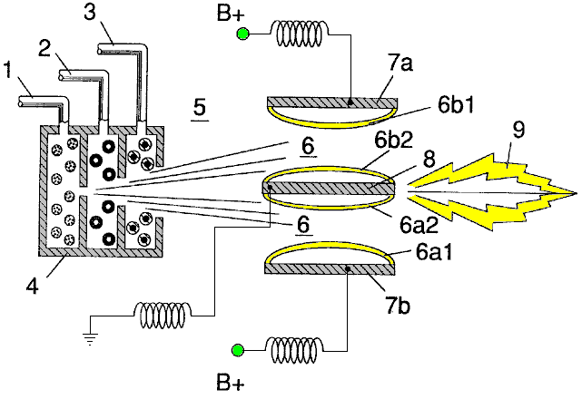

Fig.2A is a side cross-sectional view.

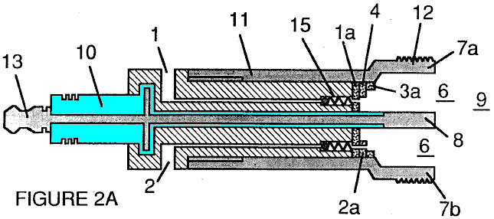

Fig.2B is a frontal view from the operative end.

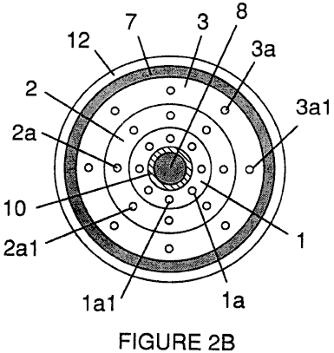

Fig.2C is an exploded view of an individual injector.

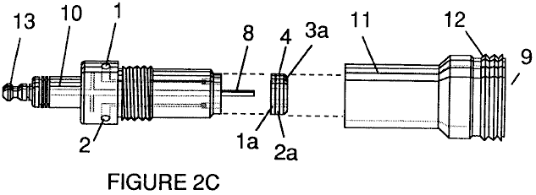

Fig.3 and Fig.3A show the side and frontal cross-sectional views of an alternatively configured injector.

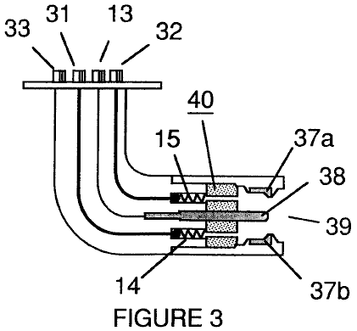

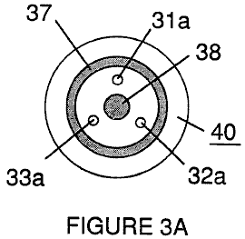

Fig.4 shows a disk array of injectors.

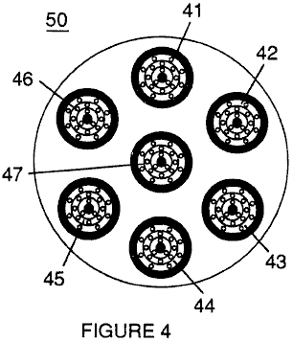

Fig.5 shows the resonance electrical circuit including the injector.

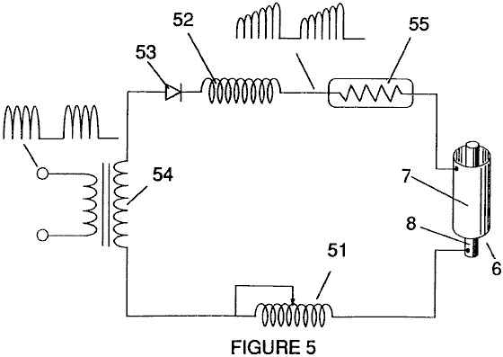

Fig.6 depicts the inter-relationship of the electrical and fuel distribution components of an injector system.

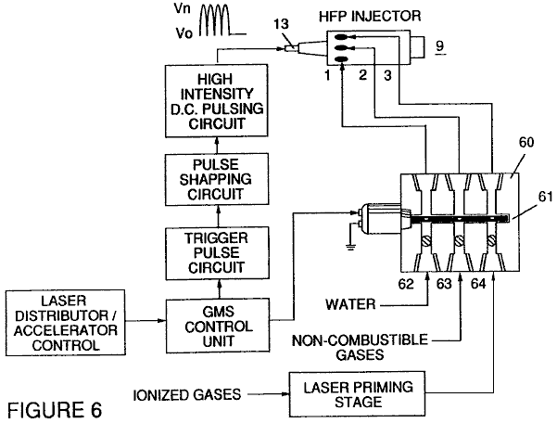

Although I refer to an “injector” in this document, the invention relates not only to the physical configuration of an injector apparatus, but also to the overall process and system parameters determined in the apparatus to achieve the release of thermal energy. In a basic outline, an injector regulates the introduction of process constituents into a combustion zone and sets up a fuel mixture condition permitting combustion. That combustion condition is triggered simultaneously with injector operation in real-time correspondence with control parameters for the process constituents.

In the fuel mixture condition which is created by the injector, water (H₂0) is atomised into a fine spray and mixed with 1 ionised ambient air gasses and 2 other non-combustible gasses such as nitrogen, argon and other rare gasses, and water vapour. (Exhaust gas produced by the combustion of hydrogen with oxygen is a non-combustible water vapour. This water vapour and other inert gasses resulting from combustion may be recycled from an exhaust outlet in the injector system, back into the input mixture of non-combustible gasses.) The fuel mix is introduced at a consistent flow rate maintained under a predetermined pressure. In the triggering of the condition created by the injector, the conversion process described in my patent no. 4,936,961 and co-pending application serial no. 07/460,859 is set off spontaneously on a “micro” level in a predetermined reaction zone. The injector creates a mixture, under pressure in a defined zone of water, ionised gasses and non-combustible gasses. Pressure is an important factor in the maintenance of the reaction condition and causes the water/gas mixture to become intimately mixed, compressed and destabilised to produce combustion when activated under resonance conditions of ignition. In accordance with the earlier mentioned conversion process of my patent and application, when water is subjected to a resonance condition water molecules expand and distend; electrons are ejected from the water molecule and absorbed by ionised gasses and the water molecule, thus destabilised, breaks down into its elemental components of hydrogen (H₂) and oxygen (O) in the combustion zone. The hydrogen atoms released from the molecule provide the fuel source in the mixture for combustion with oxygen. The present invention is an application of that process and is outlined in Table 1:

Table 1

Injector Mixture + Process conditions = Thermal Energy

(1) Water Mist (1) Release Under (1) Heat
pressure into
and Combustion Zone or

and (2) Internal
Combustion
(2) Ionised Gas (2) Resonance utilising Engine
the dielectric (Explosive
property of water force)
as a capacitor
and or

and (3) Jet Engine

(3) Non-combustible (3) Unipolar pulsing or
Gas at high voltage
(4) Other application

The process occurs as water mist and gasses under pressure are injected into, and intimately mixed in the combustion zone and an electrically polarised zone. In the electrically polarised zone, the water mixture is subjected to a unipolar pulsed direct current voltage which is tuned to achieve resonance in accordance with the electrical, mass and other characteristics of the mixture as a dielectric in the environment of the combustion zone. The resonant frequency will vary according to the injector configuration and depends upon the physical characteristics, such as the mass and volume of the water and gasses in the zone. As my prior patents and application point out, the resonant condition in the capacitative circuit is determined by the dielectric properties of water: (1) as the dielectric in a capacitor formed by adjacent conductive surfaces, and (2) as the water molecule itself is a polar dielectric material. At resonance, current flow in the resonant electrical circuit will be minimised and voltage will peak.

The injector system provides a pressurised fuel mixture for subjection to the resonant environment of the voltage combustion zone as the mixture is injected into the zone. In a preferred embodiment, the injector includes concentrically nested serial orifices, one for each of the three constituent elements of the fuel mixture. (It may be feasible to combine and process non-combustible and ionised gasses in advance of the injector. In this event, only two orifices are required, one for the water and the other for the combined gasses.) The orifices disperse the water mist and gasses under pressure into a conically shaped activation and combustion zone.

Fig1A shows a transverse cross-section of an injector, in which, supply lines for water 1, ionised gas 2, and non-combustible gas 3, feed into a distribution disk assembly 4 which has concentrically nested orifices. The fuel mixture passes through a mixing zone 5, and a voltage zone 6, created by electrodes 7a and 7b (positive) and 8 (negative or ground). Electrical field lines are shown as 6a1 and 6a2 and 6b1 and 6b2. Combustion (i.e. the oxidation of hydrogen) occurs in the zone 9. Ignition of the hydrogen can be primed by a spark or may occur spontaneously as a result of the exceptionally high volatility of hydrogen and its presence in a high-voltage field.

Although the mixing zone, the voltage zone and the combustion zone are mentioned separately in this explanation, they are not in fact physically separated, as can be seen from Fig.1. In the zone(s), there is produced an “excited” mixture of vaporised water mist, ionised gasses and other non-combustible gasses, all of which have been instantaneously released from under high pressure. Simultaneously, the released mixture in the zone, is exposed to a pulsed voltage at a frequency corresponding to electrical resonance. Under these conditions, outer-shell electrons of atoms in the water molecule are de-stabilised and molecular time-share is interrupted. Thus, the gas mixture in the injector zone is subjected to physical, electrical and chemical interactive forces which cause a breakdown of the atomic bonding forces of the water molecule.

Process parameters are determined, based on the size of a particular injector. In an injector sized appropriately for use to provide a fuel mixture to a conventional cylinder in a passenger vehicle car engine, the injector may resemble a conventional spark plug. In such an injector, the water orifice is 0.1 to 0.15 inch in diameter; the ionised gas orifice is 0.15 to 0.2 inch in diameter, and the non-combustible gas orifice is 0.2 to 0.25 inch in diameter. In such a configuration, the serial orifices increase in size from the innermost orifice, as appropriate in a concentric configuration. As noted above, it is desirable to maintain the introduction of the fuel components at a constant rate. Maintaining a back-pressure of about 125 pounds per square inch for each of the three fuel gas constituents appears to be satisfactory for a “spark-plug” injector. In the pressurised environment of the injector, spring-loaded one-way check valves in each supply line, such as 14 and 15, maintain pressure during pulse off times.

Voltage zone 6 surrounds the pressurised fuel mixture and provides an electrically charged environment of pulsed direct current in the range from about 500 to 20,000 volts and more, at a frequency tuned into the resonant characteristic of the mixture. this frequency will typically lie within the range from about 20 KHz to about 50 KHz, dependent, as noted above, on the mass flow of the mixture from the injector and the dielectric property of the mixture. In a spark-plug sized injector, the voltage zone will typically extend longitudinally about 0.25 to 1.0 inch to permit sufficient dwell time of the water mist and gas mixture between the conductive surfaces 7 and 8 which form a capacitor so that resonance occurs at a high-voltage pulsed frequency, and combustion is triggered. In the zone, an energy wave which is related to the resonant pulse frequency, is formed. The wave continues to pulse through the flame in the combustion zone. The thermal energy produced is released as heat energy. In a confined zone such as a piston/cylinder engine, gas detonation under resonant conditions, produces explosive physical power.

In the voltage zone, the time-share ratio of the hydrogen and oxygen atoms comprising the individual water molecules in the water mist, is upset in accordance with the process explained in my patent no. 4,936,961 and application serial no. 07/460,859. Namely, the water molecule, which is itself a polar structure, is distended or distorted in shape by being subjected to the polar electric field in the voltage zone. The resonant condition induced in the molecule by the unipolar pulses, upsets the molecular bonding of shell electrons such that the water molecule, at resonance, breaks apart into its constituent atoms. In the voltage zone, the water molecules are excited into an ionised state, and the pre-ionised gas component of the fuel mixture, captures the electrons released from the water molecule. In this manner, at the resonant condition, the water molecule is destabilised and the constituent atomic elements of the molecule 2H and O, are released and the released hydrogen atoms are available for combustion. the non-combustible gasses in the fuel mixture, reduce the burn rate of hydrogen to that of a hydrocarbon fuel such as gasoline (petrol) or kerosene (paraffin), from its normal burn rate which is about 2.5 times that of gasoline. Hence the presence of non-combustible gasses in the fuel mixture, moderates the energy release and the rate at which the free hydrogen and oxygen molecules combine in the combustion process.

The combustion process does not occur spontaneously so the conditions in the zone must be fine-tuned carefully to achieve an optimum input flow rate for water and the gasses corresponding to the maintenance of a resonant condition. The input water mist and gasses may likewise be injected into the zone in a physically pulsed (on/off) manner corresponding to the resonance achieved. In an internal combustion engine, the resonance of the electrical circuit and the physical pulsing of the input mixture may be required to be related to the combustion cycle of the reciprocating engine. In this regard, one or two conventional spark plugs may require a spark cycle tuned in correspondence to the conversion cycle resonance, so that combustion of the mixture will occur. Thus, the input flow, conversion rate and combustion rate are interrelated and optimally, each should be tuned in accordance with the circuit resonance at which conversion occurs.

The injection system of the present invention is suited to retrofit applications in conventionally fuelled gasoline and diesel internal combustion engines and conventionally fuelled jet aircraft engines.

Example 1

Figs 2A, 2B and 2C illustrate a type of injector useful, among other things, as a fuel source for a conventional internal combustion engine. In the cross-section of Fig.2A, reference numerals corresponding to the identifying numerals used in Fig.1 show a supply line for water 1, leading to first distribution disc 1a and supply line for ionised gas 2, leading to second distribution disc 2a. In the cross-section, the supply line for non-combustible gas 3 leading to distribution disc 3a, is not illustrated, however, its location as a third line should be self evident. The three discs comprise distribution disc assembly 4. The supply lines are formed in an electrically insulating body 10, surrounded by electrically conductive sheath/housing 11 having a threaded end segment 12.

A central electrode 8, extends the length of the injector. Conductive elements 7a and 7b (7a and 7b depict opposite sides of the diameter in the cross-section of a circular body), adjacent threaded section 12 and electrode 8, form the electrical polarisation zone 6 adjacent to combustion zone 9. An electrical connector 13 may be provided at the other end of the injector. (In this document, the term “electrode” refers to the conductive surface of an element forming one side of a capacitor.) In the frontal view of Fig.2B, it is seen that each disc making up the distribution disc assembly 9, includes a plurality of micro-nozzles 1a1, 2a1, 3a1, etc. for the injection of the water and gasses into the polarisation/voltage and combustion zones. The exploded view of Fig.2C shows another view of the injector and additionally depicts two supply line inlets 1 and 2, the third not being shown because of the inability of representing the uniform 120⁰ separation of three lines in a two-dimensional drawing.

In the injector, water mist (forming droplets in the range, for example, of from 10 to 250 microns and above, with size being related to voltage intensity) is injected into the fuel-mixing and polarising zone by way of water spray nozzles 1a1. The tendency of water to form a “bead” or droplet is a parameter related to droplet mist size and voltage intensity. ionised air gasses and non-combustible gasses, introduced through nozzles 2a1 and 3a1, are intermixed with the expelling water mist to form a fuel-mixture which enters into voltage zone 6 where the mixture is exposed to a pulsating, unipolar, high-intensity voltage field (typically 20,000 volts at 50 Hz or above, at the resonant condition in which current flow in the circuit (amps) is reduced to a minimum) created between electrodes 7 and 8.

Laser energy prevents discharge of the ionised gasses and provides additional energy input into the molecular destabilisation process which occurs at resonance. It is preferable that the ionised gasses be subjected to laser (photonic energy) activation prior to their introduction into the zone(s); although, for example, a fibre optic conduit may be useful to channel photonic energy directly into the zone. However, heat generated in the zone may affect the operability of such an alternate configuration. The electrical polarisation of the water molecule and a resonant condition occurs to destabilise the molecular bonding of the hydrogen and oxygen atoms. Combustion energy is then released by spark ignition.

To ensure proper flame projection and subsequent flame stability, pumps for the ambient air, non-combustible gas and water, introduce these components to the injector under static pressure up to and beyond 125 pounds per square inch.

Flame temperature is regulated by controlling the volume flow-rate of each fluid-media in direct relationship to applied voltage intensity. To elevate flame temperature, fluid displacement is increased while the volume flow rate of non-combustible gasses is maintained or reduced and the applied voltage amplitude is increased. To lower flame temperature, the fluid flow rate of non-combustible gasses is increased and pulse voltage amplitude is lowered. To establish a predetermined flame temperature, the fluid media and applied voltage are adjusted independently. The flame-pattern is further maintained as the ignited, compressed, and moving gasses are projected under pressure from the nozzle ports in distribution disc assembly 4 and the gas expands in the zone and is ignited.

In the voltage zone, several functions occur simultaneously to initiate and trigger thermal energy yield. Water mist droplets are exposed to high intensity pulsating voltage fields in accordance with an electrical polarisation process which separates the atoms of the water molecule and causes the atoms to experience electron ejection. The polar nature of the water molecule which facilitates the formation of minute droplets in the mist, appears to cause a relationship between the droplet size and the voltage required to effect the process, i.e. the greater the droplet size, the higher the voltage required. The liberated atoms of the water molecule interact with laser-primed ionised ambient air gasses to cause a highly energised and destabilised mass of combustible gas atoms to ignite thermally. Incoming ambient air gasses are laser primed and ionised when passing through a gas processor, and an electron extraction circuit (Fig.5) captures and consumes in sink 55, ejected electrons, and prevents electron flow into the resonant circuit.

In terms of performance, reliability and safety, ionised air gasses and water fuel liquid do not become volatile until the fuel mixture reaches the voltage and combustion zones. Injected non-combustible gasses retard and control the combustion rate of hydrogen during gas ignition.

In alternate applications, laser-primed ionised liquid oxygen and laser-primed liquid hydrogen stored in separate fuel tanks, can be used in place of the fuel mixture, or liquefied ambient air gasses alone with water can be substituted as a fuel source.

The injector assembly is design variable and is retro-fittable to fossil fuel injector ports conventionally used in jet/rocket engines, grain dryers, blast furnaces, heating systems, internal combustion engines and the like.

Example 2

A flange-mounted injector is shown in cross-section in Fig.3 which shows the fuel mixture inlets and illustrates an alternative three-nozzle configuration leading to the polarisation (voltage) and combustion zones in which one nozzle 31a, 32a and 33a is provided for each of the three gas mixtures, and connected to supply lines 31 and 32 (33 is not shown). Electrical polarisation zone 36 is formed between electrode 38 and surrounding conductive shell 37. The capacitative element of the resonant circuit is formed when the fuel mixture, acting as a dielectric, is introduced between the conductive surfaces of 37 and 38. Fig.3A is a frontal view of the operative end of the injector.

Example 3

Multiple injectors may be arranged in a gang as shown in Fig.4 in which injectors 40, 41, 42, 43, 44, 45, 46, 47, 48 and 49 are arranged concentrically in an assembly 50. Such a ganged array is useful in applications having intensive energy requirements such as jet aircraft engines and blast furnaces.

Example 4

The basic electrical system utilised in the invention is depicted in Fig.5 showing the electrical polarisation zone 6 which receives and processes the water and gas mixture as a capacitive circuit element in a resonant charging circuit formed by inductors 51 and 52 connected in series with diode 53, pulsed voltage source 54, electron sink 55 and zone 6 formed from conductive elements 7 and 8. In this manner, electrodes 7 and 8 in the injector, form a capacitor which has electrical characteristics dependent on the dielectric media (e.g. the water mist, ionised gasses and non-combustible gasses) introduced between the conductive elements. Within the macro-dielectric media, however, the water molecules themselves, because of their polar nature, can be considered micro-capacitors.

Example 5

Fuel distribution and management systems useful with the injector of this application are described in my co-pending applications for patent; PCT/US90/6513 and PCT/US90/6407.

A distribution block for the assembly is shown in Fig.6. In Fig.6 the distribution block pulses and synchronises the input of the fuel components in sequence with the electrical pulsing circuit. The fuel components are injected into the injector ports in synchronisation with the resonant frequency, to enhance the energy wave pulse extending from the voltage zone through the flame. In the configuration of Fig.6, the electrical system is interrelated to distribution block 60, gate valve 61 and separate passageways 62, 63 and 64 for fuel components. The distributor produces a trigger pulse which activates a pulse-shaping circuit that forms a pulse having a width and amplitude determined by resonance of the mixture and establishes a dwell time for the mixture in the zone to produce combustion..

As in my referenced application regarding control and management and distribution systems for a hydrogen-containing fuel gas produced from water, the production of hydrogen gas is related to pulse frequency on/off time. In the system shown in Fig.6, the distributor block pulses the fluid media introduced to the injector in relationship to the resonant pulse frequency of the circuit and to the operational on/off gate pulse frequency. In this manner, the rate of water conversion (i.e. the rate of fuel produced by the injector) can be regulated and the pattern of resonance in the flame controlled.

STANLEY MEYER

Patent WO 92/07861 2nd November 1990 Inventor: Stanley A. Meyer

CONTROL AND DRIVER CIRCUITS FOR A HYDROGEN GAS FUEL PRODUCING CELL

The major difficulty in using Stan’s low-current Water Fuel Cell (recently reproduced by Dave Lawton and shown in Chapter 10) is the issue of keeping the cell continuously at the resonant frequency point. This patent application shows the Stan’s circuitry for doing exactly that, and consequently, it is of major importance.

ABSTRACT
A control circuit for a capacitive resonant cavity water capacitor cell (7) for the production of a hydrogen containing fuel has a resonant scanning circuit co-operating with a resonance detector and PLL circuit to produce pulses. The pulses are fed into the primary transformer (TX1). The secondary transformer (TX2) is connected to the resonant cavity water capacitor cell (7) via a diode and resonant charging chokes (TX4, TX5).

This invention relates to electrical circuit systems useful in the operation of a Water Fuel Cell including a water capacitor/resonant cavity for the production of a hydrogen containing fuel gas, such as that described in my United States Letter Patent No. 4,936,961 “Method for the Production of a Fuel Gas” issued on 26th June 1990.

In my Letters Patent for a “Method for the Production of a Fuel Gas”, voltage pulses applied to the plates of a water capacitor tune into the dielectric properties of the water and attenuate the electrical forces between the hydrogen and oxygen atoms of the molecule. The attenuation of the electrical forces results in a change in the molecular electrical field and the covalent atomic bonding forces of the hydrogen and oxygen atoms. When resonance is achieved, the atomic bond of the molecule is broken, and the atoms of the molecule disassociate. At resonance, the current (amp) draw from a power source to the water capacitor is minimised and voltage across the water capacitor increases. Electron flow is not permitted (except at the minimum, corresponding to leakage resulting from the residual conductive properties of water). For the process to continue, however, a resonant condition must be maintained.

Because of the electrical polarity of the water molecule, the fields produced in the water capacitor respectively attract and repel the opposite and like charges in the molecule, and the forces eventually achieved at resonance are such that the strength of the covalent bonding force in the water molecule (which are normally in an electron-sharing mode) disassociate. Upon disassociation, the formerly shared bonding electrons migrate to the hydrogen nuclei, and both the hydrogen and oxygen revert to net zero electrical charge. The atoms are released from the water as a gas mixture.

In the invention herein, a control circuit for a resonant cavity water capacitor cell utilised for the production of a hydrogen-containing fuel gas is provided.

The circuit includes an isolation means such as a transformer having a ferromagnetic, ceramic or other electromagnetic material core and having one side of a secondary coil connected in series with a high speed switching diode to one plate of the water capacitor of the resonant cavity and the other side of the secondary coil connected to the other plate of the water capacitor to form a closed loop electronic circuit utilising the dielectric properties of water as part of the electronic resonant circuit. The primary coil of the isolation transformer is connected to a pulse generation means. The secondary coil of the transformer may include segments which form resonant charging choke circuits in series with the water capacitor plates.

In the pulse generation means, an adjustable resonant frequency generator and a gated pulse frequency generator are provided. A gate pulse controls the number of the pulses produced by the resonant frequency generator sent to the primary coil during a period determined by the gate frequency of the second pulse generator.

The invention also includes a means for sensing the occurrence of a resonant condition in the water capacitor / resonant cavity, which when a ferromagnetic or electromagnetic core is used, may be a pickup coil on the transformer core. The sensing means is interconnected to a scanning circuit and a phase lock loop circuit, whereby the pulsing frequency to the primary coil of the transformer is maintained at a sensed frequency corresponding to a resonant condition in the water capacitor.

Control means are provided in the circuit for adjusting the amplitude of a pulsing cycle sent to the primary coil and for maintaining the frequency of the pulsing cycle at a constant frequency regardless of pulse amplitude. In addition, the gated pulse frequency generator may be connected to a sensor which monitors the rate of gas production in the cell and controls the number of pulses from the resonant frequency generator sent to the cell in a gated frequency in correspondence with the rate of gas production. The sensor may be a gas pressure sensor in an enclosed water capacitor resonant cavity which also includes a gas outlet. The gas pressure sensor is connected to the circuit to determine the rate of gas production with respect to ambient gas pressure in the water capacitor enclosure.

Thus, a comprehensive control circuit and it’s individual components for maintaining and controlling the resonance and other aspects of the release of gas from a resonant cavity water cell is described here and illustrated in the drawings which depict the following:

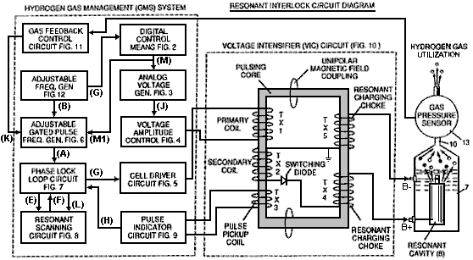

Fig.1 is a block diagram of an overall control circuit showing the interrelationship of sub-circuits, the pulsing core / resonant circuit and the water capacitor resonant cavity.
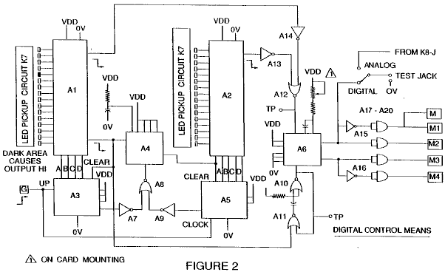

Fig.2 shows a type of digital control circuit for regulating the ultimate rate of gas production as determined by an external input. (Such a control circuit would correspond, for example, to the accelerator in a car, or the thermostat control in a building).

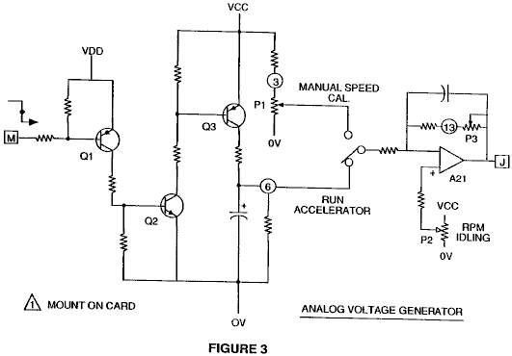

Fig.3 shows an analog voltage generator.

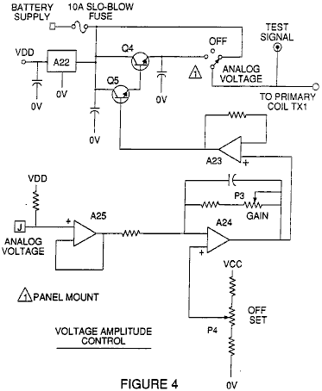

Fig.4 is a voltage amplitude control circuit interconnected with the voltage generator and one side of the primary coil of the pulsing core.

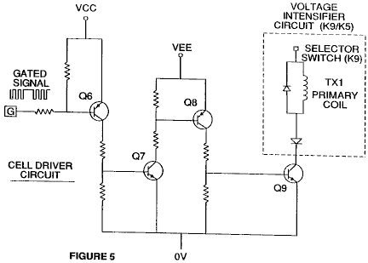

Fig.5 is the cell driver circuit that is connected with the opposite side of the primary coil of the pulsing core. Figures 6 to 9 form the pulsing control circuitry:

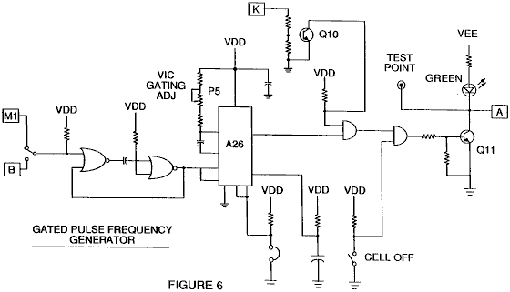

Fig.6 is a gated pulse frequency generator.

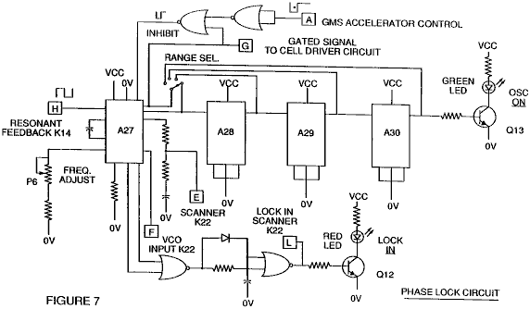

Fig.7 is a phase lock circuit.

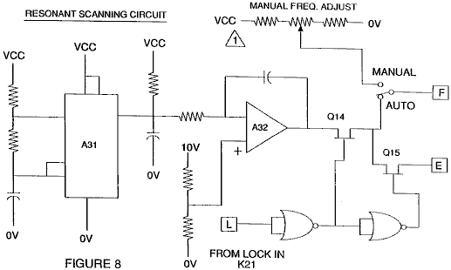

Fig.8 is a resonant scanning circuit

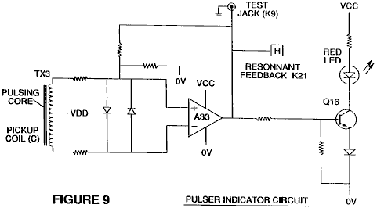

Fig.9 is the pulse indicator circuit.

These four circuits control the pulses transmitted to the resonant-cavity / Water Fuel Cell capacitor.

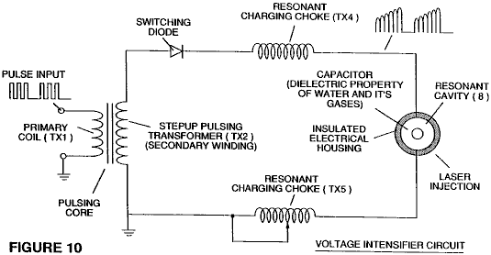

Fig.10 shows the pulsing core and the voltage intensifier circuit which forms the interface between the control circuit and the resonant cavity.

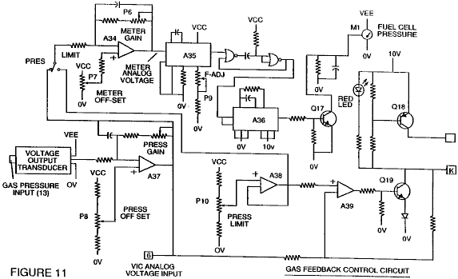

Fig.11 is a gas feedback control circuit

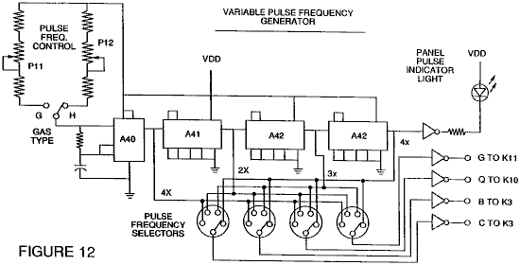

Fig.12 is an adjustable frequency generator circuit.

The circuits are interconnected as shown in Fig.1 and to the pulsing core voltage intensifier circuit of Fig.10, which, among other things, isolates the water capacitor electrically so that it becomes an electrically isolated cavity for the processing of water in accordance with it’s dielectric resonance properties. By reason of this isolation, power consumption in the control and driving circuits is minimised when resonance occurs, and current demand is minimised as voltage is maximised in the gas production mode of the water capacitor / Fuel Cell.

The reference letters “A” through “M” and “M1” show, with respect to each separate circuit shown, the point at which a connection in that circuit is made to another of the circuits shown.

In the invention, the water capacitor is subjected to a duty pulse which builds up in the resonant charging choke coil and then collapses. This occurrence allows a unipolar pulse to be applied to the Fuel Cell capacitor. When a resonant condition of the circuit is locked-in by the circuit, current leakage is held to a minimum as the voltage which creates the dielectric field tends to infinity. Thus, when high voltage is detected upon resonance, the phase-lock-loop circuit, which controls the cell driver circuit, maintains the resonance at the detected (or sensed) frequency.

The resonance of the water capacitor cell is affected by the volume of water in the cell. The resonance of any given volume of water contained in the water capacitor cell is also affected by “contaminants” in the water which act as a damper. For example, with a potential difference of 2,000 to 5,000 volts applied to the cell, a current spike or surge may be caused by inconsistencies in the water characteristics which cause an out-of-resonance condition which is remedied instantaneously by the control circuits.

In the invention, the adjustable frequency generator, shown in Fig.12, tunes in to the resonant condition of the circuit which includes the water cell and the water inside it. The generator has a frequency capability of 0 to 10 KHz and tunes into resonance typically at a frequency of 5 KHz in a typical 3-inch long water capacitor formed from a 0.5 inch rod inside a 0.75 inch inside-diameter cylinder. At start up, in this example, current draw through the water cell will measure about 25 milliamps; however, when the circuit finds a tuned resonant condition, the current drops down to a 1 to 2 milliamp leakage condition.

The voltage to the capacitor water cell increases according to the turns of the winding and the size of the coils, as in a typical transformer circuit. For example, if 12 volts is sent to the primary coil of the pulsing core and the secondary coil resonant charging choke ratio is 30 to 1, then 360 volts is sent to the capacitor water cell. The number of turns is a design variable which controls the voltage of the unipolar pulses sent to the capacitor.

The high-speed switching diode, shown in Fig.10, prevents charge leaking from the charged water in the water capacitor cavity, and the water capacitor as an overall capacitor circuit element, i.e. the pulse and charge status of the water/capacitor never pass through an arbitrary ground. the pulse to the water capacitor is always unipolar. The water capacitor is electrically isolated from the control, input and driver circuits by the electromagnetic coupling through the core. The switching diode in the Voltage Intensifier Circuit (Fig.10) performs several functions in the pulsing. The diode is an electronic switch which determines the generation and collapse of an electromagnetic field to permit the resonant charging choke(s) to double the applied frequency and it also allows the pulse to be sent to the resonant cavity without discharging the “capacitor” therein. The diode is, of course, selected in accordance with the maximum voltage encountered in the pulsing circuit. A 600 PIV (“Peak Inverse Volts”) fast switching diode, such as an NVR 1550, has been found to be useful in this circuit.

The Voltage Intensifier Circuit of Fig.10 also includes a ferromagnetic or ceramic ferromagnetic pulsing core capable of producing electromagnetic flux lines in response to an electrical pulse input. The flux lines affect both the secondary coil and the resonant charging choke windings equally. Preferably, the core is of a closed loop construction. The effect of the core is to isolate the water capacitor and to prevent the pulsing signal from going below an arbitrary ground and to maintain the charge of the already charged water and water capacitor.

In the pulsing core, the coils are preferably wound in the same direction to maximise the additive effect of the electromagnetic field in them. The magnetic field of the pulsing core is synchronised with the pulse input to the primary coil. The potential from the secondary coil is introduced to the resonant charging choke(s) series circuit elements which are subjected to the same synchronous applied electromagnetic field, simultaneously with the primary pulse.

When resonance occurs, control of the gas output is achieved by varying the time of duty gate cycle. The transformer core is a pulse frequency doubler. In a figurative explanation of the workings of the fuel gas generator water capacitor cell, when a water molecule is “hit” by a pulse, electron time-share is effected and the molecule is charged. When the time of the duty cycle is changed, the number of pulses that “hit” the molecules in the fuel cell is modified correspondingly. More “hits” result in a greater rate of molecular disassociation.

With reference to the overall circuit of Fig.1, Fig.3 receives a digital input signal, and Fig.4 shows the control circuit which applies 0 to 12 volts across the primary coil of the pulsing core. Depending on design parameters of primary coil voltage and other factors relevant to core design, the secondary coil of the pulsing core can be set up for a predetermined maximum, such as 2,000 volts.

The cell driver circuit shown in Fig.5, allows a gated pulse to be varied in direct relation to voltage amplitude. As noted above, the circuit of Fig.6 produces a gate pulse frequency. The gate pulse is superimposed on the resonant frequency pulse, to create a duty cycle that determines the number of discrete pulses sent to the primary coil. For example, assuming a resonant pulse of 5 KHz, a 0.5 KHz gating pulse with a 50% duty cycle, will allow 2,500 discrete pulses to be sent to the primary coil, followed by an equal time interval in which no pulses are passed through. The relationship of resonant pulse to the gate pulse is determined by conventional signal addition/subtraction techniques.

The phase lock loop circuit shown in Fig.7 allows the pulse frequency to be maintained at a predetermined resonant condition sensed by the circuit. Together, the circuits of Fig.7 and Fig.8, determine an output signal to the pulsing core until the peak voltage signal sensed at resonance is achieved.

A resonant condition occurs when the pulse frequency and the voltage input attenuates the covalent bonding forces of the hydrogen and oxygen atoms of the water molecule. When this occurs, current leakage through the water capacitor is minimised. The tendency of voltage to maximise at resonance, increases the force of the electric potential applied to the water molecules, which ultimately disassociate into atoms.

Because resonances of different waters, water volumes and capacitor cells vary, the resonant scanning circuit of Fig.8 scans frequency from high to low and back to high, until a signal lock is achieved. The ferromagnetic core of the voltage intensifier circuit transformer, suppresses electron surge in an out-of-resonance condition of the fuel cell. In an example, the circuit scans at frequencies from 0 Hz to 10 KHz and back to 0 Hz. In water having contaminants in the range of 1 part per million to 20 parts per million, a 20% variation in resonant frequency is encountered. depending on water flow rate into the fuel cell, the normal variation range is about 8% to 10%. For example, iron in well water affects the status of molecular disassociation. Also, at a resonant condition, harmonic effects occur. In a typical operation of the cell with a representative water capacitor described below, at a frequency of about 5 KHz, with unipolar pulses from 0 to 650 volts, at a sensed resonant condition in the resonant cavity, on average, the conversion into gas occurs at a rate of about 5 US gallons (19 litres) of water per hour. To increase the rate, multiple resonant cavities can be used and/or the surfaces of the water capacitor can be increased, however, the water capacitor cell is preferably small in size. A typical water capacitor may be formed from a 0.5 inch diameter stainless steel rod and a 0.75 inch inside-diameter cylinder which extends over the rod for a length of 3 inches.

The shape and size of the resonant cavity may vary. Larger resonant cavities and higher rates of consumption of water in the conversion process require higher frequencies up to 50 KHz and above. The pulsing rate, to sustain such high rates of conversion, must be increased correspondingly.

From the above description of the preferred embodiment, other variations and modifications of the system disclosed will be evident to those skilled in the art.
STEPHEN MEYER

Patent application US 2005/0246059 3rd November 2005 Inventor: Stephen F. Meyer

MLS-HYDROXYL FILLING STATION

This is a patent application from Stephen Meyer, brother of the late Stan Meyer. While this application mentions filling stations, it is clear that the design is aimed at use in vehicles with internal combustion engines. I believe that the impedance-matching interface between the alternator and the cell electrodes is particularly important. The water-splitter cell uses sets of three pipes in a concentric array which results in small gaps between the innermost, middle and outer pipe. Stephen refers to these three electrode pipes as a “wave-guide”, so please bear that in mind when reading this patent application. Stephen uses the word “hydroxyl” to refer to the mixture of hydrogen and oxygen gases produced by electrolysis of water. Other people use the word “hydroxy” to describe this mixture, so they should be considered interchangeable.

The operation of this system as described here, calls for the generating power to be removed when the gas pressure in the generating chambers reaches 5 psi. The gas is then pumped into a pressure chamber where the pressure ranges from 40 psi to 80 psi, at which point the compressor is powered down and the excess gas vented to some external storage or using device. It is not until this is completed that the power is applied again to the generating chambers. May I remark that, in my opinion, there is no need to remove the power from at generating chambers at any time when this system is in operation, since all that that does is to lower the generating capacity, unless of course, the production rate is so high that it exceeds the level of demand.

ABSTRACT
The usefullness of this system, it’s configuration, design and operation, are the keystone of a new type of automation: the production of hydroxyl gases from renewable sources.

BACKGROUND OF THE INVENTION
Fuel Cell and auto industries have been looking for methods and apparatus that can supply a source of hydrogen and oxygen for its new hybrid industry. This invention is such a device.

SUMMARY OF THE INVENTION
The invention is a computerised, automatic, on-site/mobile hydroxyl gas producing filling station which allows the products being produced to be used, either by the hydrogen fuel cells installed in automobiles, trucks, buses, boats and land-based generating applications, or in any internal combustion engine.

BRIEF DESCRIPTION OF THE DRAWINGS
Fig.1 shows the configuration of the components which go to make up the MLS-hydroxyl Filling Station.

Fig.2 shows the software display which the operator uses to monitor and control the production of hydroxy gases and heat.

Fig.3 shows the methods, configuration, and apparatus used in the hydroxyl producing cell system 120.

Fig.4 shows the electronic impedance-matching circuits 102, connected between the dual three-phase synchronised generators (110A and 110B in Fig.3) and each of the electrodes or “waveguide” arrays 132 in cell 120 of Fig.3. Note that only generator A is depicted in Fig.4 as being connected to arrays A, B and C using PC cards 1 to 3. generator B is connected to arrays D, E and F using cards 4 to 6.

Fig.5 Shows the signals emitted by each of the impedance-matching circuits (102 in Fig.4 mounted on cards 1 to 6) which are applied to each of the cylinder arrays (132 in Fig.3) installed in hydroxyl cell 120. These sets of signals with their offset phase relationship, frequencies and amplitudes, are the driving forces producing the hydroxy gases in cell 120 of Fig.3.

Fig.6 shows the high-frequency ringing signal which is produced between points T1 and T2 in the impedance-matching circuit 102 in Fig.4. It is this ringing which enhances the production of the hydroxyl gas in cell 120 of Fig.3.

DETAILED DESCRIPTION OF THE DRAWINGS

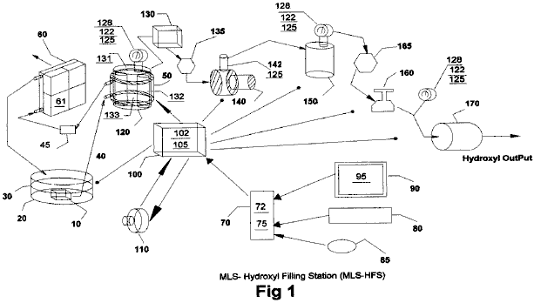

The heat-removing section in Fig.1 consists of a liquid bath 30 and its container 20, a liquid circulating pump 10, conveying-conduits 40, cooling chamber 50 attached to hydroxyl generating cell 120, filter 45, radiator 60 and cooling fans 61 attached to it.

The automatic-control section in Fig.1 consists of a computer 70, software program 75, video monitor 90 and it’s graphic operator display 95 (Fig.2), pointer 85, keyboard 80, interface card 72, and Input/Output controller 100 with it’s driver electronics cards 102 and 105.

Dual three-phase power sources 110 and impedance-matching circuits 102, provide the power needed to drive the hydroxyl cell 120.

The remaining apparatus is used to convey the gases from cells 120, through liquid trap 130, through gas flow restriction valve 135, elevate its gas pressures through compressor 140, transfer them to storage tank 150, then deliver the gases through safety cut off 165, regulators 160 and through flash-back arrestor 170 for external delivery.

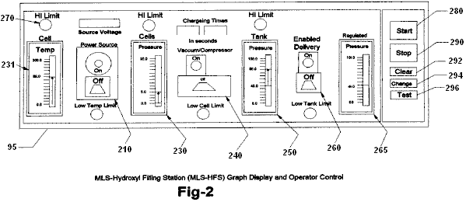

Fig.2 shows the layout and functions of the operator control display 95 of program 75 in Fig.1. It consists of cell temperature indicator 230, vacuum controller 240, high-pressure tank indicator 250, delivery controller 260, delivery regulated-pressure indicator 265 and related alarm/status indicators 270. Also, software control buttons are provided to start 280, stop 290, clear data 292, change setting 294 and the testing of equipment and their sequences 296.

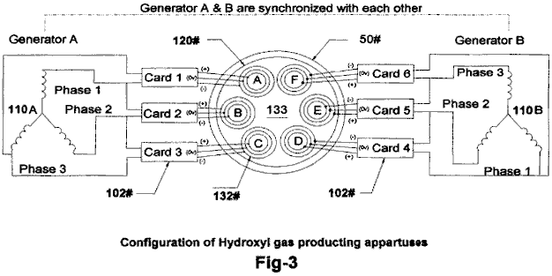

Fig.3 shows the configuration of our proprietary hydroxyl-producing apparatus 120 consisting of dual three-phase power source 110, impedance matching electronic circuits 102 and gas converter devices 132 submerged in a bath of water 133 in cell 120. The drawing also shows the water jacket 50 surrounding the cell 120 that helps lower its temperature and allows more production of the hydroxyl gases at higher voltage signals as shown in Fig.5.

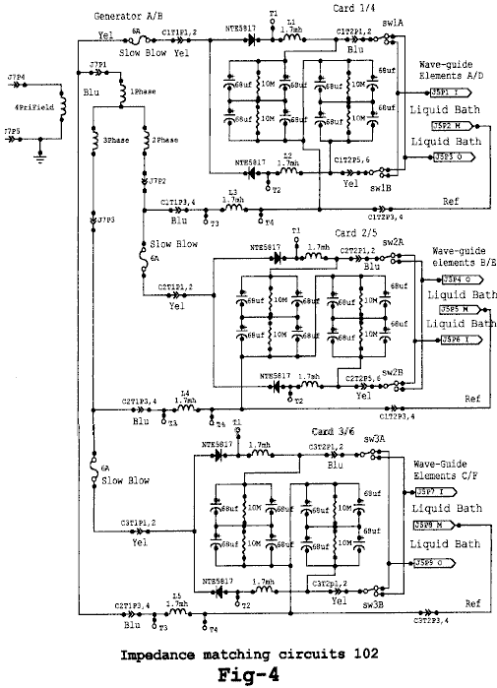

Fig.4 shows the electrical circuits 102, used to drive the gas converting arrays (132 in Fig.3) submerged in a bath of water 133 in cell 120. Fig.4 shows three identical circuits connected to each of the three-phase signals from one half of the dual three-phase generator 110A in Fig.3. The circuits 102, convert the AC signal from each phase of 110 into a modulated signal as depicted by Fig.5. These signals are then coupled to the triple array elements 132, (Inside, Middle and Outside) by alternating the connection between the Inside and Outside elements of the arrays (132 in Fig.3).

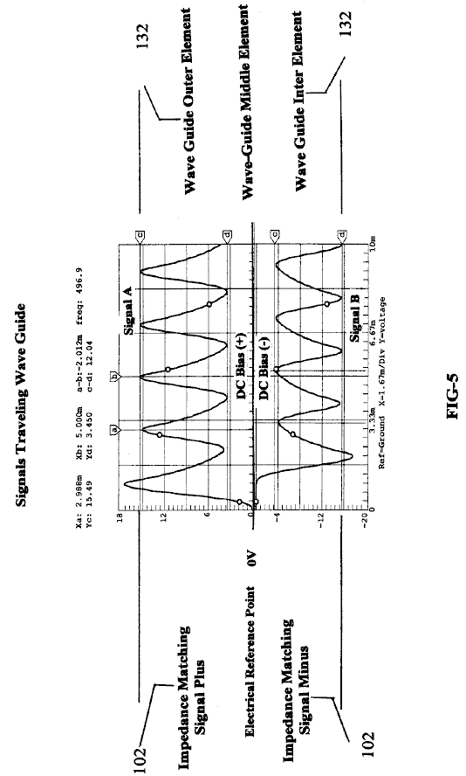

Fig.5 shows the composite signals applied to each of the arrays (132 in Fig.3) submerged in the water bath 133 in cell 120, and indicates the differential voltages used in the hydroxyl producing process. Note that the Middle wave-guide element is used as the electrical reference point for both the Outside and Inside elements of array 132. It is this composite signal applied to the surface of the stainless steel elements in array 132 submerged in water bath 133, heat allows the ions from the elements in array 132 to cross its water surface barriers 133 and contribute to the hy-droxyl production. Note the DC bias voltage +,- on either side of the centre electrical reference point 0V. It is this bias voltage being modulated by multi-polarity differential signals from 102, that contributes to the wave-guide action of arrays 132. Also, the frequency of the waveform shown in Fig.5 is adjusted to match the electrical wavelength of the arrays 132 of Fig.3 and the impedance of water bath 133.

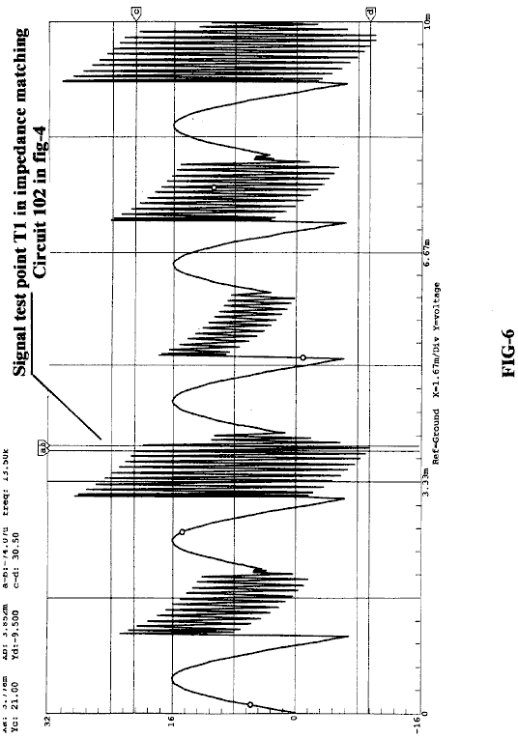

Fig.6 shows the high-frequency ringing signals which contribute to the operation of the hydroxyl production. just as a tuning fork rings when struck by a hammer, so do the wave-guide elements in array 132 immersed in the hydroxyl-generating liquid 133 when struck by the electrical signals shown in Fig.5 and Fig.6, coming from the impedance-matching circuits 102 shown in Fig.4.

Brief Description of Sequences
This invention is a computerised Hydroxyl Gas producing filling station “MLS-HFS” designed to provide automatic control of its on-site gas production and delivery.

The MLS-HFS shown in Fig.1, is a hydroxyl gas and heat generating system which uses a renewable source of liquid supply 30 such as water. It uses a computer control program 75 with display interface 95, for the monitoring, adjusting and controlling of the electronic and hardware apparatus and process logic. The electronic circuits 102 mounted in driver 100, control the production of the gases and heating while circuit 105 controls the process and routeing of the hydroxyl gas.

The system consists of a low-pressure hydrolyser cell 120 in Fig.1, a liquid trap 130, an adjustable flow-restriction valve 135, high-pressure vacuum pump 140, and check valve 142 installed in 140. It also contains a high-pressure storage tank 150, an alarm/low-pressure cut-off valve 165, gas regulator 160, flashback arrestor 170, over-pressure safety release valves 125, pressure gauges 128, analogue pressure-sending units 122 installed on cell 120, and tank 150 at the regulating side of regulator 160. Also, 125 is installed on Compressor 140 high-pressure output. The computer controller 70, monitor 90, keyboard 80, interface I/O card 72 and software position pointer 85, are used to control the production process, using electronic driver 100 through it’s PC boards 105 and their attached control devices. The power to the cell-driving circuits 102, installed in driver 100, is supplied from a dual three-phase isolated power source 110. The amplitude, signal phases and frequency from this power source is controlled by signal adjustments coming from the computer 70.

Detailed Description

Sequence of Operation
The system shown in Fig.1 is monitored and controlled by the software program 75, computer 70, monitor 90, keyboard 80, pointer 85, and display interface 95 in Fig.2.

The software program has five main functions, namely: to purge the system of ambient air, check and test for any equipment malfunctions, prepare the system for production, monitor and control the current activities of the production process, and the safety shutdown of the system if alarms are detected.

During the initial installation, and again after any repairs, the total system is purged using the vacuum pump 140, using manual procedures to ensure that all ambient air has been removed from the system. Before the system is put into service, the operator can test the operation of the system by using the graphic display. The main functions of the testing is to ensure that the temperature electronics 131 attached to the hydroxyl cells 120, transferring compressor 140 and analogue pressure sensors 122 mounted on cells 120, high-pressure tank 150 and the discharge side of regulator 160 used for control and monitoring, are working properly. the operator can then activate the Run Sequence of the program 75 via the start software button 280 in Fig.2 on graphic display 95.

During the initial startup phase of the system, the computer program will configure the system for the purge sequence. this sequence allows the vacuum pump 140 to draw down the hydroxyl cells 120 liquid trap 130 coupled to flow-restriction valve 135, to remove all ambient air from them. Once the program has done this and detected no leaks in the system, it then prepares the system for gas production by switching the gas flow from cells 120 to high-pressure tank 150 and on to the output flashback protector 170.

The program starts it’s production sequence by turning on the cooling system pump 10 which is submerged in the liquid bath 30, contained in vessel 20. The cooling liquid is pumped through the cooling jacket 50 which is attached to the outside of cells 120, through filter 45 and then through an air-cooled radiator 60. Fans attached to the radiator are turned on for cooling.

Next, the computer turns on the dual three-phase power source 110, which supplies operating power to the frequency, phase-shifting, signal amplitude and impedance-matching circuits coupled to the hydroxyl generating cells.

The result of this is just like the operation of a radio transmitter matching it’s signal to the air via the antenna impedance. Fig.3 shows the relationship of this configuration to arrays 132, water bath 133 and Signals (Fig.5 and Fig.6).

While the power source 110 is operating, the computer 70 is monitoring the pressure 122 and temperature 131 of hydroxyl cells 120. When the cell pressure reaches a typical level of 5 pounds per square inch, the power source is turned off and compressor 140 is turned on the pump the gas into pressure tank 150. When the pressure in the hydroxyl cells 120 is drawn down to near zero, the compressor is turned off and the power to the gas generating cells is turned back on again, to repeat the cycle.

The production cycle is repeated until tank 150 reaches a pressure of, typically, 80 psi, at which time the computer enables the output pressure regulator 160 which is typically set to operate at 40 psi, for the delivery of the hydroxyl gas to some external storage system or device. During this operation, the computer program handles all switching and displays the current status and any alerts or warning messages for the operator on the graphical display 95.

Impedance-Matching Circuit 102:

The impedance-matching circuits 102 in Fig.4, convert the sinewave signals coming from the three-phase power source (110 in Fig.3) into multi-polarity differential signals (Fig.5) which are applied to the triple wave-guide cluster arrays 132 A, 132B, 132C, 132D, 132E and 132F installed in cell 120.

It is this converted signal, along with the phase relationship of the power source 110 and the triple wave-guide elements in cluster 132 submerged in water bath 133, which produce the hydroxyl gases. It is important to note that not only is the gas produced between the elements in the array, but also between each array installed in the cell - see the phase relationship of array A-B-C shown in Fig.3. Also note that the array elements themselves are supplying many of the ions needed for the production of the gases.

Sequence of Hydroxyl Gas Generation:

Once the hydroxyl-generating cell 120 has been purged of ambient air and the production routing completed (Fig.1), the dual three-phase power source 110 is activated, supplying frequency, amplitude and phase signals to the impedance-matching circuitry 102. The converted signals from 102 are then applied to cell array 132 for processing. It is the combination of the impedance-matching circuits signal transformations (as shown in Fig.5 and Fig.6), the cell configuration and materials used in arrays 132, and the rotational phase relationship between arrays AD, BE and CF and the submersion of these arrays in a bath of water 133, that allows this system to produce large amounts of hydroxyl gases. The computer program 75 and it’s graphic display 95, is used by the operator to adjust the rate of gas production and set the upper limit to which the low-pressure cell 120 will charge.

After the cell 120 has reached its upper pressure cut-off limit (typically 5 psi), the power source 110 is turned off, enabling the compressor 140 to start its draw-down and transfer of the gases to the high-pressure tank 150. When the pressure in the cell 120 reaches a low-level limit (near zero psi), 140 stops its charging cycle of 150. Check valve 142 which is installed in 140, prevents any back flow of gases to 120 from high-pressure tank 150. The power source 110 is then turned back on to repeat the cycle. These charging cycles continue until the high-pressure tank 150 reaches it’s upper pressure limit (typically 80 psi), at which point the hydroxyl production is stopped. As the gases in the high-pressure tank are being used or transferred to some external storage system, the pressure in 150 is monitored at the output of pressure-regulator 160, until the low-pressure limit for this tank is reached (typically 40 psi). When this pressure level is reached, the hydroxyl gas production is started again.

During the operation of cell 120, it’s temperature is monitored to ensure that it does not exceed the “out of limits” conditions set by control 231 and monitored via the graphics display 95. If the temperature exceed the limit set, then the gas production is stopped and the computer program alerts the operator, indicating the problem. The cooling system 30 which uses water jacket 50 surrounding cell 120, helps to reduce the temperature and allows higher rates of gas production.

After extended running times, the water in cell 120 is replenished from bath 30 and filtered by 45, to help control the operating impedance of the cell.

Dr HENRY PUHARICH

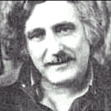

Dr Andrija Puharich (who later changed his name to Henry Puharich) reportedly drove his motor home for hundreds of thousands of miles around North America in the 1970s using only water as fuel. At a mountain pass in Mexico, he collected snow for water. Here is an article which he wrote:

Cutting The Gordian Knot of the Great Energy Bind
by Andrija Puharich

Introduction
It is hardly necessary to weigh the value of the World Energy bank account for any sophisticated person, these days. It is grim. The oil reserves will dwindle away in a score of years or so, and the coal reserves will be gone in some twelve score years. This is not to say that the outlook is hopeless. There is an abundance of alternative energy sources, but the economics of development and exploitation present an enormous short-term strain on the world political and banking resources.

Visionary scientists tell us that the ideal fuel in the future will be as cheap as water, that it will be non-toxic both in its short-term, and in its long-term, effects, that it will be renewable in that it can be used over and over again, that it will be safe to handle, and present minimal storage and transportation problems and costs. And finally that it will be universally available anywhere on earth. What is this magical fuel, and why is it not being used? The fuel is water. It can be used in its fresh water form. It can be used in its salt water form. It can be used in its brackish form. It can be used in its snow and ice form. When such water is decomposed by electrolytic fission into hydrogen and oxygen gases, it becomes a high energy fuel with three times the energy output which is available from an equivalent weight of high grade gasoline.

Then why is water not being used as a fuel? The answer is simple - it costs too much with existing technology to convert water into hydrogen and oxygen gases. The basic cycle of using water for fuel is described in the following two equations, familiar to every high school student of Chemistry:

H₂O Electrolysis + 249.68 BTU ΔG → H₂ + (1/2)O₂ per mole of water..............(1)

(1 mole = 18 gm). This means that it requires 249.688 BTU of energy (from electricity) to break water by electrolysis into the gases hydrogen and oxygen.

H₂ + (1/2)O₂ + catalyst → H₂O - ΔH 302.375 BTU per mole of water..............(2)

This means that 302.375 BTU of energy (heat or electricity) will be released when the gases, hydrogen and oxygen, combine. The end product (the exhaust) from this reaction is water. Note that more energy (under ideal conditions) is released from combining the gases than is used to free them from water. It is know that under ideal conditions it is possible to get some 20% more energy out of reaction (2) above, then it takes to produce the gases of reaction (1) above. Therefore, if reaction (1) could be carried out at 100% efficiency, the release of energy from reaction (2) in an optimally efficient engine (such as a low temperature fuel cell), there would be a net energy profit which would make the use of water as a fuel an economically feasible source of energy .

The cost of producing hydrogen is directly related to the cost of producing electricity. Hydrogen as produced today is generally a by-product of off-peak-hour electrical production in either nuclear or hydroelectric plants. The electricity thus produced is the cheapest way of making hydrogen. We can compare the cost of production of electricity and the cost of producing hydrogen. The following table is adapted from Penner whose data source is based on Federal Power Commission, and American Gas Association Figures of 1970 and on a 1973 price evaluation (just before the OPEC oil price escalation.)

Table 1: Relative Prices in Dollars per 106 BTU
Cost Component | Electricity | Electrolytically-Produced H
Production | 2.67 (b) | 2.95 to 3.23 (b)
Transmission | 0.61 | 0.52 (c)
Distribution | 1.61 | 0.34
Total Cost | $4.89 | $3.81 to $4.09

If we compare only the unit cost of production of electricity vs Hydrogen from the above table:

106 BTU H₂ / 106 BTU El = $3.23 / $2.67, or 20.9% higher cost, H₂

It must also be noted that the price of natural gas is much cheaper than either electricity or hydrogen, but because of the price fluctuations due to recent deregulation of gas it is not possible to present a realistic figure. In the opinion of Penner, if the hydrogen production cost component of its total cost could be reduced three fold, it would become a viable alternate energy source. In order to achieve such a three-fold reduction in production costs, several major breakthroughs would have to occur.

1. Endergonic Reaction A technological breakthrough which permits 100% conversion efficiency of water by electrolysis fission into the two gases, Hydrogen as fuel and Oxygen as oxidant.

2. Hydrogen Production in Situ A technological breakthrough which eliminates the need and cost of hydrogen liquefaction and storage, transmission, and distribution, by producing the fuel in situ, when and where needed.

3. Exergonic Reaction A technological breakthrough which yields a 100% efficient energy release from the combination of hydrogen and oxygen into water in an engine that can utilize the heat, steam, or electricity thus produced.

4. Engine Efficiency By a combination of the breakthroughs outlined above, 1, 2, and 3 utilized in a highly efficient engine to do work, it is theoretically possible to achieve a 15% to 20% surplus of energy return over energy input.

It is of interest to record that a new invention is now being developed to realise the above outlined goal of cheap, clean renewable and high grade energy. A Thermodynamic Device has been invented which produces hydrogen as fuel, and oxygen as oxidant, from ordinary water or from sea water, eliminating the cost and hazard of liquefaction, storage, transmission, and distribution. The saving of this aspect of the invention alone reduces the total cost of hydrogen by about 25%.

This Thermodynamic Device is based on a new discovery - the efficient electrolytic fission of water into hydrogen gas and oxygen gas by the use of low frequency alternating currents as opposed to the conventional use of direct current, or ultra-high frequency current today. Such gas production from water by electrolytic fission approaches 100% efficiency under laboratory conditions and measurements. No laws of physics are violated in this process.

This Thermodynamic Device has already been tested at ambient pressures and temperatures from sea level to an altitude of 10,000 feet above sea level without any loss of its peak efficiency. The device produces two types of gas bubbles; one type of bubble contains hydrogen gas; the other type contains oxygen gas. The two gases are thereafter easily separable by passive membrane filters to yield pure hydrogen gas, and pure oxygen gas.

The separate gases are now ready to be combined in a chemical fusion with a small activation energy such as that from a catalyst or an electrical spark, and yield energy in the form of heat, or steam, or electricity as needed. When the energy is released by the chemical fusion of hydrogen and oxygen, the exhaust product is clean water. The water exhaust can be released into nature and then renewed in its energy content by natural processes of evaporation, solar irradiation in cloud form, an subsequent precipitation as rain on land or sea, and then collected again as a fuel source. Or, the exhaust water can have its energy content pumped up by artificial processes such as through solar energy acting through photocells. Hence, the exhaust product is both clean and renewable. The fuel hydrogen, and the oxidant oxygen, can be used in any form of heat engine as an energy source if economy is not an important factor. But the practical considerations of maximum efficiency, dictate that a low temperature fuel cell with its direct chemical fusion conversion from gases to electricity offers the greatest economy and efficiency from small power plants of less than 5 kilowatts.

For large power plants, steam and gas turbines are the ideal heat engines for economy and efficiency. With the proper engineering effort, automobiles could be converted rather easily to use water as the main fuel source.

The Thermodynamic Device (“TD”) is made up of three principal components:
Component 1: An electrical function generator which energizes a water cell.
Component 2: The Thermodynamic Device
Component 3: A weak electrolyte.

Component 1: The Electrical Function Generator:

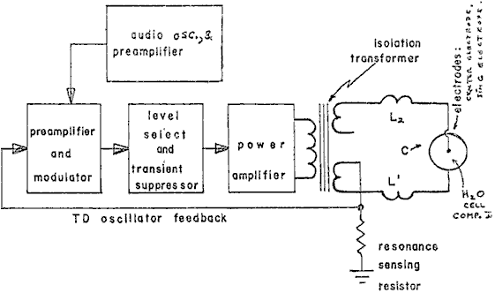
Figure 1: Signal Generator Component Block

This electronic device has a complex alternating current output consisting of an audio frequency (range 20 to 200 Hz) amplitude modulation of a carrier wave (range: 200 to 100,000 Hz). The output is connected by two wires to Component II at the center electrode, and at the ring electrode. See Fig.1. The impedance of this output signal is continuously being matched to the load which is the water solution in Component II.

Component 2: The Thermodynamic Device:

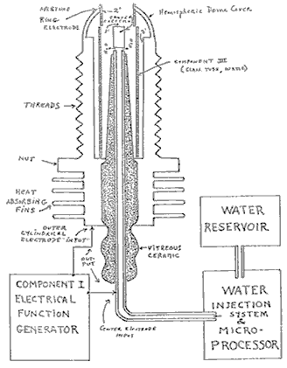
Figure 2: Thermodynamic Device

The TD is fabricated of metals and ceramic in the geometric form of a coaxial cylinder made up of a centered hollow tubular electrode which is surrounded by a larger tubular steel cylinder. These two electrodes comprise the coaxial electrode system energised by Component I. The space between the two electrodes is, properly speaking, Component III which contains the water solution to be electrolysed. The center hollow tubular electrode carries water into the cell, and is further separated from the outer cylindrical electrode by a porous ceramic vitreous material. The space between the two electrodes contains two lengths of tubular Pyrex glass, shown in Figures 2 and 3. The metal electrode surface in contact with the water solution are coated with a nickel alloy.

Component 3: The weak electrolyte water solution:

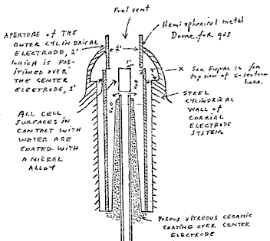
Figure 3: The Water Cell Section of Component 2

This consists of the water solution, the two glass tubes, and the geometry of the containing wall of Component 2. It is the true load for Component 1, and its electrode of Component 2.

The Component 3 water solution is more properly speaking, ideally a 0.1540 M Sodium Chloride solution, and as such, it is a weak electrolyte. In Figure 4 we show the hypothetical tetrahedral structure of water molecule, probably in the form in which the complex electromagnetic waves of Component 1 to see it. The center of mass of this tetrahedral form is the oxygen atom. The geometric arrangement of the p electrons of oxygen probably determine the vectors i (L1) and i (L2) and i (H1) and i (H2) which in turn probably determine the tetrahedral architecture of the water molecule. The p electron configuration of oxygen is shown in Figure 5. Reference to Figure 4, shows that the diagonal of the right side of the cube has at its corner terminations, the positive charge hydrogen (H+) atoms; and that the left side of the cube diagonal has at its corners, the lone pair electrons, (e-). It is to be further noted that this diagonal pair has an orthonormal relationship.

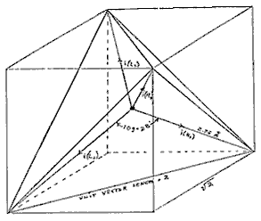

Figure 4: The Water Molecule in Tetrahedral Form:

Hydrogen bonding occurs only along the four vectors pointing to the four vertices of a regular tetrahedron, and in the above drawing we show the four unit vectors along these directions originating from the oxygen atoms at the center. i(H1) and i(H2) are the vectors of the hydrogen bonds formed by the molecule i as a donor molecule. These are assigned to the lone pair electrons. Molecules i are the neighboring oxygen atoms at each vertex of the tetrahedron.

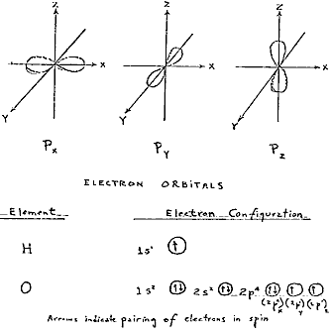

Figure 5: Electron Orbitals

3. Electrothermodynamics

We will now portray the complex electromagnetic wave as the tetrahedral water molecule sees it. The first effect felt by the water molecule is in the protons of the vectors, i (H1) and i (H2). These protons feel the 3-second cycling of the amplitude of the carrier frequency and its associated side bands as generated by Component 1. This sets up a rotation moment of the proton magnetic moment which one can clearly see on the XY plot of an oscilloscope, as an hysteresis loop figure. However, it is noted that this hysteresis loop does not appear in the liquid water sample until all the parameters of the three components have been adjusted to the configuration which is the novel basis of this device. The hysteresis loop gives us a vivid portrayal of the nuclear magnetic relaxation cycle of the proton in water.

The next effect felt by the water molecule is the Component 1 carrier resonant frequency, Fo. At the peak efficiency for electrolysis the value of Fo is 600 Hz +/- 5 Hz.

This resonance however is achieved through control of two other factors. The first is the molal concentration of salt in the water. This is controlled by measuring the conductivity of the water through the built-in current meter of Component 1. There is maintained an idea ratio of current to voltage where I/E = 0.01870 which is an index to the optimum salt concentration of 0.1540 Molal.

The second factor which helps to hold the resonant which helps to hold the resonant frequency at 600 Hz is the gap distance of Y, between the centre electrode, and the ring electrode of Component 2.

This gap distance will vary depending on the size scale of Component 2, but again, the current flow I, is used to set it to the optimal distance when the voltage reads between 2.30 (rms) volts, at resonance Fo, and at molal concentration, 0.1540. The molal concentration of the water is thus seen to represent the electric term of the water molecule and hence its conductivity.

The amplitude modulation of the carrier gives rise to side bands in the power spectrum of the carrier frequency distribution. It is these side bands which give rise to an acoustic vibration of the liquid water, and it is believed, also to the tetrahedral water molecule. The importance of the phonon effect - the acoustic vibration of water in electrolysis - was discovered in a roundabout way. Research work with Component 1 had earlier established that it could be used for the electro-stimulation of hearing in humans. When the output of Component 1 is comprised of flat circular metal plates applied to the head of normal hearing humans, it was found that they could hear pure tones and speech. Simultaneously, acoustic vibration could also be heard by an outside observer with a stethoscope placed near one of the electrodes on the skin. It was observed that the absolute threshold of hearing could be obtained at 0.16 mW (rms), and by calculation that there was an amplitude of displacement of the eardrum of the order of 10⁻¹¹ meter and a corresponding amplitude of the cochlear basilar membrane of 10⁻¹³ meter. Corollary to this finding, I was able to achieve the absolute reversible threshold of electrolysis at a power level of 0.16 mW (rms). By carrying out new calculations, I was able to show that the water was being vibrated with a displacement of the order of 1 Angstrom unit ( = 10⁻¹⁰ meters). This displacement is of the order of the diameter of the hydrogen atom. Thus it is possible that the acoustic phonons generated by audio side bands of the carrier are able to vibrate particle structures within the unit water tetrahedron.

We now turn to the measurement problem with respect to efficiency of electrolysis. There are four means which can be used to measure the reactant product of water electrolysis. For simple volume measurements, one can use a precision nitrometer such as the Pregl type. For both volume and quantitative analysis one can use the gas chromatography with thermal conductivity detector. For a continuous flow analysis of both volume and gas species the mass spectrometer is very useful. For pure thermodynamic measurements the calorimeter is useful. In our measurements, all four methods were examined, and it was found that the mass spectrometer gave the most flexibility and the greatest precision. In the next section we will describe our measurement using the mass spectrometer.

Protocol
4. Methodology for the Evaluation of the Efficiency of Water Decomposition by Means of Alternating Current Electrolysis

Introduction

All systems used today for the electrolysis of water into hydrogen as fuel, and oxygen as oxidant apply direct current to a strong electrolyte solution. These systems range in efficiency from 50% to 71%. The calculation of energy efficiency in electrolysis is defined as follows:

"The energy efficiency is the ratio of the energy released from the electrolysis products formed (when they are subsequently used) to the energy required to effect electrolysis."

The energy released by the exergonic process under standard conditions is

H₂(g) + (1/2) O₂(g) → H₂O = 3 02.375 BTU

which is 68.315 Kcal/mol. or, 286,021 Joules/mol, and is numerically equal to the enthalphy charge (ΔH) for the indicated process. On the other hand, the minimum energy (or useful work input) required at constant temperature and pressure for electrolysis equals the Gibbs free energy change (ΔG).

Penner shows that there is a basic relation derivable from the first and second laws of thermodynamics for isothermal changes which shows that

ΔG = ΔH - T ΔS .......... (2)

where ΔS represents the entropy change for the chemical reaction and T is the absolute temperature.

The Gibbs free energy change (ΔG) is also related to the voltage (e) required to implement electrolysis by Faraday's equation:

e = (ΔG / 23.06 n ) volts .......... (3)

where ΔG is in Kcal/mol, and n is the number of electrons (or equivalents) per mole of water electrolysed and has the numerical value 2 in the equation (endergonic process),

H₂O → H₂ (g) + (1/2)O₂ (g) + 56.620 kcal or + 249.68 BTU .......... (4)

Therefore, according to equation (2) at atmospheric pressure, and 300^{O}K:
ΔH = 68.315 kcal/mol of H₂O, and
ΔG = 56.620 kcal / mol of H₂O = 236,954 J/mol H₂O for the electrolysis of liquid water.

In view of these thermodynamic parameters for the electrolysis of water into gases, hydrogen and oxygen, we can establish by Eq.(2) numeric values where,

ΔG = 236.954 J/mol H₂O under standard conditions. Thus

n = ΔG (J/mol) / ΔGe (J/mol) = <1 .......... (5)

where ΔGe is the electrical energy input to H₂O (1) in Joules, and ΔG is the Gibbs free energy of H₂O. The conversion between the two quantities is one Watt second (Ws) = one Joule.

Or, in terms of gas volume, as hydrogen, produced and measured,

n = Measured H₂ (cc) / Ideal H₂ (cc) = <1 .......... (6)

In accordance with these general principles we present the methodology followed in evaluating the electrolytic of alternating current on H₂O in producing the gases, hydrogen and oxygen. No attempt has been made to utilize these gases according to the process of Eq.(1). It is to be noted that the process

H₂ (g) + (1/2)O₂ (g) → H₂O (g) .......... (7)

yields only 57.796 kcal /mol. Eq.(7) shows that per mole of gases water formed at 300^{O}K, the heat released is reduced from the 68.315 kcal/mol at Eq. (1) by the molar heat of evaporation of water at 300^{O}K (10.5 kcal) and the overall heat release is 57.796 kcal/mol if H₂O (g) is formed at 300^{O}K.

In the following sections we describe the new method of electrolysis by means of alternating current, and the exact method and means used to measure the endergonic process of Eq.(4) and the governing Eq.(2) and Eq.(5).

5. Thermodynamic Measurement
In order to properly couple Component 2 to a mass spectrometer, one requires a special housing around Component 2 which will capture the gases produced, and permit these to be drawn under low vacuum into the mass spectrometer. Therefore a stainless steel and glass chamber was built to contain Component 2, and provision made to couple it directly through a CO₂ water-trap to the mass spectrometer with the appropriate stainless steel tubing. This chamber is designated as Component 4. Both the mass spectrometer and Component 4 were purged with helium and evacuated for a two hour period before any gas samples were drawn. In this way, contamination was minimized. The definitive measurement were done at Gollob Analytical Services in Berkeley Heights, New Jersey.

We now describe the use of Component 1 and how its energy output to Component 2 is measured. The energy output of Component 1 is an amplitude-modulated alternating current looking into a highly non-linear load, i.e., the water solution. Component 1 is so designed that at peak load it is in resonance across the system (Components 1, 2, and 3) and the vector diagrams show that the capacitive reactance, and the inductance reactance are almost exactly 180^{O} out of phase with each other, and so the net power output is reactive (the dissipative power is very small). This design ensures minimum power losses across the entire output system. In the experiments to be described, the entire emphasis is placed on achieving the maximum gas yield (credit) in exchange for the minimum applied electrical energy.

The most precise way to measure the applied energy from Component 1 to Component 2 and Component 3, is to measure the power, P, in watts, W. Ideally this should be done with a precision wattmeter, but since we were interested in following the voltage and current separately, it was decided not to use the watt meter. Separate meters were used to continuously monitor the current and the volts.

This is done by precision measurement of the volts across Component 3 as root mean square (rms) volts; and the current flowing in the system as rms amperes. Precisely calibrated instruments were used to take these two measurements. A typical set of experiments using water in the form of 0.9% saline solution 0.1540 molar to obtain high efficiency hydrolysis gave the following results:

rms Current = I = 25mA to 38 mA (0.025 A to 0.038 A.)

rms Volts = E = 4.0 Volts to 2.6 Volts

The resultant ration between current and voltage is dependent on many factors such as the gap distance between the center and ring electrodes, dielectric properties of the water, conductivity properties of the water, equilibrium states, isothermal conditions, materials used, and even the pressure of clathrates. The above current and voltage values reflect the net effect of various combinations of such parameters. When one takes the product of rms current, and rms volts, one has a measure of the power, P in watts.

P = I x E = 25 mA x 4.0 volts =100 mW (0.1 W)

and P = I x E =38 mA x 2.6 volts = 98.8 mW (0.0988 W)

At these power levels (with load), the resonant frequency of the system is 600 Hz (plus or minus 5 Hz) as measured on a precision frequency counter. The waveform was monitored for harmonic content on an oscilloscope, and the nuclear magnetic relaxation cycle was monitored on an XY plotting oscilloscope in order to maintain the proper hysteresis loop figure. All experiments were run so that the power in watts, applied through Components 1, 2, and 3 ranged between 98.8 mW to 100 mW.

Since by the International System of Units 1971 (ST), one Watt-second (Ws) is exactly equal to one Joule (J), our measurements of efficiency used these two yardsticks (1 Ws = 1J) from the debit side of the measurement.

The energy output of the system is, of course, the two gases, Hydrogen (H₂) and Oxygen, (1/2)O₂, and this credit side was measured in two laboratories, on two kinds of calibrated instruments, namely gas chromatography machine, and mass spectrometer machine.

The volume of gases H₂ and (1/2)O₂ was measured as produced under standard conditions of temperature and pressure in unit time, i.e., in cubic centimeters per minute (cc/min), as well as the possibility contaminating gases, such as air oxygen, nitrogen and argon, carbon monoxide, carbon dioxide, water vapor, etc.

The electrical and gas measurements were reduced to the common denominator of Joules of energy so that the efficiency accounting could all be handled in one currency. We now present the averaged results from many experiments. The standard error between different samples, machines, and locations is at +/- 10%, and we only use the mean for all the following calculations.

2. Thermodynamic Efficiency for the Endergonic Decomposition of Liquid Water (Salininized) to Gases Under Standard Atmosphere ( 754 to 750 mm. Hg) and Standard Isothermal Conditions @ 25^{O}C = 77^{O}F = 298.16^{O}K, According to the Following Reaction:

H₂0 (1) → H₂(g) + (1/2)O₂(1) + ΔG = 56.620 Kcal /mole .......... (10)

As already described, ΔG is the Gibbs function. We convert Kcal to our common currency of Joules by the formula, One Calorie = 4.1868 Joules

ΔG = 56.620 Kcal x 4.1868 J = 236,954/J/mol of H₂O where 1 mole = 18 gr. .......... (11)

ΔGe = the electrical energy required to yield an equivalent amount of energy from H₂O in the form of gases H₂ and (1/2)O₂.

To simplify our calculation we wish to find out how much energy is required to produce the 1.0 cc of H₂O as the gases H₂ and (1/2)O₂. There are (under standard conditions) 22,400 cc = V of gas in one mole of H₂O. Therefore

ΔG / V = 236,954 J / 22,400 cc = 10.5783 J/cc. .......... (12)

We now calculate how much electrical energy is required to liberate 1.0 cc of the H₂O gases (where H₂ = 0.666 parts, and (1/2)O₂ = 0.333 parts by volume) from liquid water. Since P = 1 Ws = 1 Joule , and V = 1.0 cc of gas = 10.5783 Joules, then

PV = 1 Js x 10.5783 J = 10.5783 Js, or, = 10.5783 Ws .......... (13)

Since our experiments were run at 100 mW ( 0.1 W) applied to the water sample in Component II, III, for 30 minutes, we wish to calculate the ideal (100% efficient) gas production at this total applied power level. This is,

0.1 Ws x 60 sec x 30 min = 180,00 Joules (for 30 min.). The total gas production at ideal 100% efficiency is 180 J/10.5783 J/cc = 17.01 cc H₂O (g)

We further wish to calculate how much hydrogen is present in the 17.01 cc H₂O (g).

17.01 cc H₂O (g) x 0.666 H₂ (g) = 11.329 cc H₂ (g) .......... (14)

17.01 cc H₂O (g) x 0.333 (1/2)O₂ (g) = 5.681 cc (1/2)O₂ (g)

Against this ideal standard of efficiency of expected gas production, we must measure the actual amount of gas produced under: (1) Standard conditions as defined above, and (2) 0.1 Ws power applied over 30 minutes. In our experiments, the mean amount of H₂ and (1/2)O₂ produced, as measured on precision calibrated GC, and MS machines in two different laboratories, where SE is +/- 10%, is,

Measured Mean = 10.80 cc H₂ (g)
Measured Mean = 5.40 cc (1/2) cc (1/2)O₂ (g)
Total Mean = 16.20 cc H₂O (g)

The ratio, n, between the ideal yield, and measured yield,

Measured H₂ (g) / Ideal H₂ (g) = 10.80 cc / 11.33 cc = 91.30%

6. Alternative Method for Calculating Efficiency Based on the Faraday Law of Electrochemistry

This method is based on the number of electrons that must be removed, or added to decompose, or form one mole of, a substance of valence one. In water (H₂O), one mole has the following weight:

H = 1.008 gr /mol
H = 1.008 gr /mol
O = 15.999 gr/mol
Thus, 1 mol H₂O = 18.015 gr/mol

For a univalent substance, one gram/mole contains 6.022 x 10-23 electrons = N = Avogadro's Number. If the substance is divalent, trivalent, etc., N is multiplied by the number of the valence. Water is generally considered to be of valence two.

At standard temperature and pressure (“STP”) one mole of a substance contains 22.414 cc, where Standard temperature is 273.15^{O}K = 0^{O}C = T . Standard Pressure (one atmosphere) = 760 mm Hg = P.

One Faraday (“F”) is 96,485 Coulombs per mole (univalent).

One Coulomb (“C”) is defined as:

1 N / 1 F = 6.122 x 10²³ Electrons / 96,485 C = one C

The flow of one C/second = one Ampere.
One C x one volt = one Joule second (Js).
One Ampere per second @ one volt = one Watt = one Joule.

In alternating current, when amps (I) and Volts (E) are expressed in root mean squares (rms), their product is Power in watts.

P = IE watts (Watts = Amps x Volts).

With these basic definitions we can now calculate efficiency of electrolysis of water by the method of Faraday’s electrochemistry.

The two-electron model of water requires 2 moles of electrons for electrolysis (2 x 6.022 x 10²³), or two Faraday quantities (2 x 96,485 = 192,970 Coulombs).

The amount of gas produced will be:

H₂ = 22,414 cc /mol at STP
(1/2)O₂ = 11,207 cc / mol at STP
Gases = 33.621 cc / mol H₂O (g)

The number of coulombs required to produce one cc of gases by electrolysis of water:

193,970 C / 33621 C = 5.739567 C per cc gases.

Then, 5,739 C /cc /sec = 5.739 amp/sec/cc. How many cc of total gases will be produced by 1 A/sec?

0.1742291709 cc.

How many cc of total gases will be produced by 1 A/min ?

10.45375 cc/min

What does this represent as the gases H₂ and O₂ ?

(1/2)O₂ = 3.136438721 cc/Amp/min.
H₂ = 6.2728 cc/Amp /min.

We can now develop a Table for values of current used in some of our experiments, and disregarding the voltage as is done conventionally.

1. Calculations for 100 mA per minute:
Total Gases = 1.04537 cc/min
H₂ = 0.6968 cc/min
(1/2)O₂ = 0.3484 cc/min
30 min. H₂ = 20.9054 cc/ 30 minutes

2. Calculations for 38 mA per minute:
Total Gases = 0.3972 cc/ 30 minutes
H₂ = 0.2645 cc/min
(1/2)O₂ = 0.1323 cc/min
30 min. H₂ = 7.9369 cc/min

3. Calculations for 25mA per minute:
30 min. H₂ = 5.2263 cc/ minute

7. Conclusion
Fig.6 and Fig.7 [not available] show two of the many energy production systems that may be configured to include renewable sources and the present electrolysis technique. Figure 6 shows a proposed photovoltaic powered system using a fuel cell as the primary battery. Assuming optimum operating conditions using 0.25 watt seconds of energy from the photovoltaic array would enable 0.15 watt-seconds to be load.

Figure 7 depicts several renewable sources operating in conjunction with the electrolysis device to provide motive power for an automobile.

********************

US Patent 4,394,230 DATE 19th July 1983 INVENTOR: HENRY K. PUHARICH

METHOD AND APPARATUS FOR SPLITTING WATER MOLECULES

This is a re-worded extract from the United States Patent number 4,394,230. It describes how Henry Puharich was able to split water into hydrogen and oxygen gasses by a process which used very little input power.

ABSTRACT
Disclosed herein is a new and improved thermodynamic device to produce hydrogen gas and oxygen gas from ordinary water molecules or from seawater at normal temperatures and pressure. Also disclosed is a new and improved method for electrically treating water molecules to decompose them into hydrogen gas and oxygen gas at efficiency levels ranging between approximately 80-100%. The evolved hydrogen gas may be used as a fuel; and the evolved oxygen gas may be used as an oxidant.
Inventors: Puharich; Henry K. (Rte. 1, Box 97, Delaplane, VA 22025)

BACKGROUND OF THE INVENTION
The scientific community has long realised that water is an enormous natural energy resource, indeed an inexhaustible source, since there are over 300 million cubic miles of water on the earth's surface, all of it a potential source of hydrogen for use as fuel. In fact, more than 100 years ago Jules Verne prophesied that water eventually would be employed as a fuel and that the hydrogen and oxygen which constitute it would furnish an inexhaustible source of heat and light.

Water has been split into its constituent elements of hydrogen and oxygen by electrolytic methods, which have been extremely inefficient, by thermochemical extraction processes called thermochemical water-splitting, which have likewise been inefficient and have also been inordinately expensive, and by other processes including some employing solar energy. In addition, artificial chloroplasts imitating the natural process of photosynthesis have been used to separate hydrogen from water utilising complicated membranes and sophisticated artificial catalysts. However, these artificial chloroplasts have yet to produce hydrogen at an efficient and economical rate.

These and other proposed water splitting techniques are all part of a massive effort by the scientific community to find a plentiful, clean, and inexpensive source of fuel. While none of the methods have yet proved to be commercially feasible, they all share in common the known acceptability of hydrogen gas as a clean fuel, one that can be transmitted easily and economically over long distances and one which when burned forms water.

SUMMARY OF THE PRESENT INVENTION
In classical quantum physical chemistry, the water molecule has two basic bond angles, one angle being 104°, and the other angle being 109°28'. The present invention involves a method by which a water molecule can be energised by electrical means so as to shift the bond angle from the 104° degree. configuration to the 109° degree 28' tetrahedral geometrical configuration.

An electrical function generator (Component 1) is used to produce complex electrical wave form frequencies which are applied to, and match the complex resonant frequencies of the tetrahedral geometrical form of water. It is this complex electrical wave form applied to water which is contained in a special thermodynamic device (Component II) which shatters the water molecule by resonance into its component molecules --- hydrogen and oxygen.

The hydrogen, in gas form, may then be used as fuel; and oxygen, in gas form is used as oxidant. For example, the thermodynamic device of the present invention may be used as a hydrogen fuel source for any existing heat engine --- such as, internal combustion engines of all types, turbines, fuel cell, space heaters, water heaters, heat exchange systems, and other such devices. It can also be used for the desalination of sea water, and other water purification purposes. It can also be applied to the development of new closed cycle heat engines where water goes in as fuel, and water comes out as a clean exhaust.

For a more complete understanding of the present invention and for a greater appreciation of its attendant advantages, reference should be made to the following detailed description taken in conjunction with the accompanying drawings.

DESCRIPTION OF THE DRAWINGS:

Fig.1 is a schematic block diagram illustrating the electrical function generator, Component I, employed in the practice of the present invention:

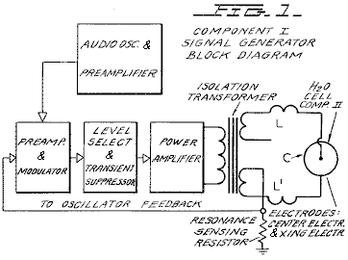

Fig.2 is a schematic illustration of the apparatus of the present invention, including a cross sectional representation of the thermodynamic device, Component II:

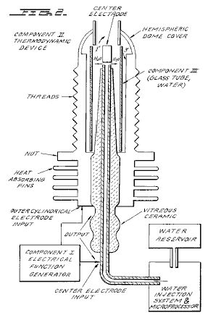

Fig.3 is a cross-sectional view of Component III of the present invention, the water cell section of Component II:

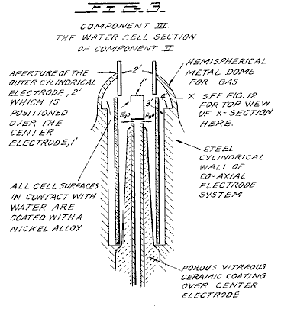

Fig.4 is an illustration of the hydrogen covalent bond:

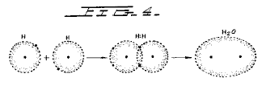

Fig.4A is an illustration of the hydrogen bond angle:

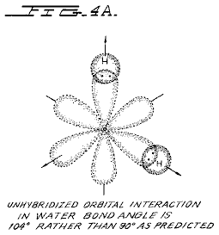

Fig.4B is an illustration of hybridised and un-hybridised orbitals:

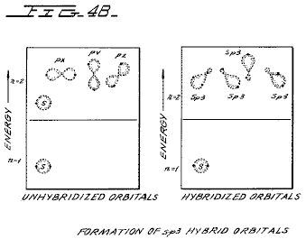

Fig.4C is an illustration of the geometry of methane ammonia and water molecules:

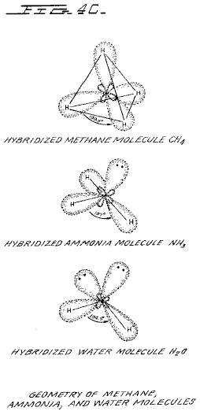

Fig.5 is an illustration of an amplitude modulated carrier wave:

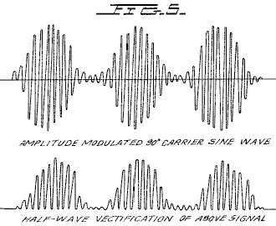

Fig.6 is an illustration of a ripple square wave:

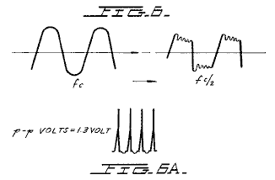

Fig.6A is an illustration of unipolar pulses.

Fig.7 is a diagram showing ion distribution at the negative electrode:

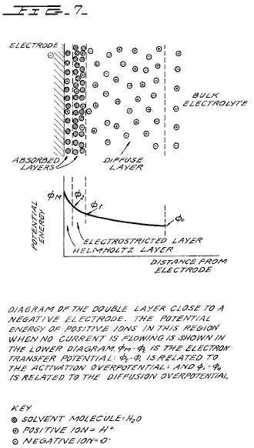

Fig.8 is an illustration of tetrahedral bonding orbitals:

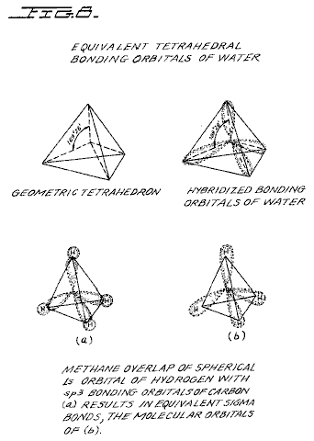

Fig.9 is an illustration of water molecules:

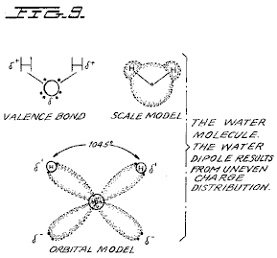

Fig.10 is an illustration of productive and non-productive collisions of hydrogen with iodine:

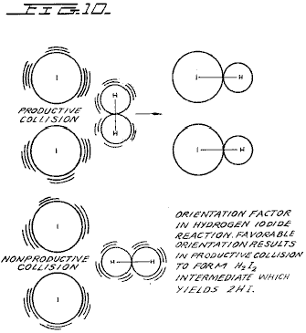

Fig.11 is a wave form found to be the prime characteristic for optimum efficiency:

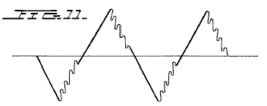

Fig.12 is an illustration of pearl chain formation:

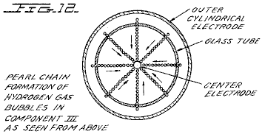

Fig.13 is a plot of the course of the onset of the barrier effect and the unblocking of the barrier effect:

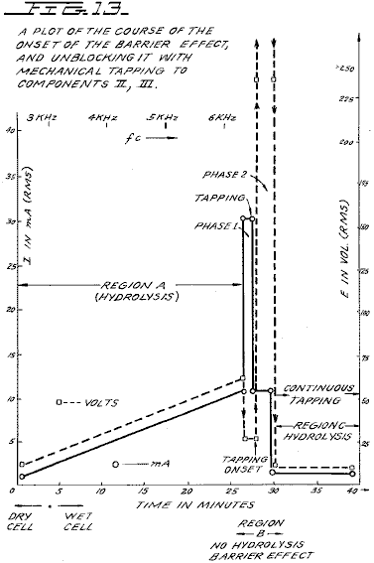

Figs.14A, B, and C are energy diagrams for exergonic reactions:

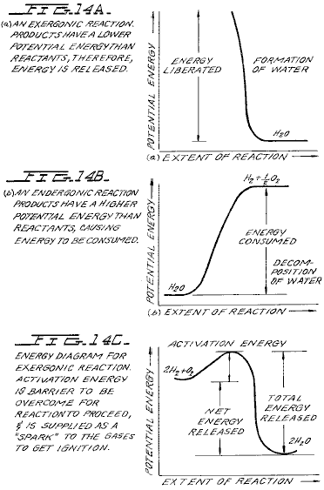

DETAILED DESCRIPTION OF INVENTION:

Section 1:
Apparatus of Invention;
The apparatus of the invention consists of three components, the Electrical Function Generator, the Thermodynamic Device, and the Water Cell.

Component I: The Electrical Function Generator;
This device has an output consisting of an audio frequency (range 20 to 200 Hz) amplitude modulation of a carrier wave (range 200 Hz to 100,000 Hz). The impedance of this output signal is continuously being matched to the load which is the second component, the thermodynamic device. The electrical function generator represents a novel application of circuitry disclosed in my earlier U.S. Pat. Nos. 3,629,521; 3,563,246; and 3,726,762, which are incorporated by reference herein. See Fig.1 for the block diagram of Component I.

Component II: The Thermodynamic Device;
The thermodynamic device is fabricated of metals and ceramic in the geometric form of coaxial cylinder made up of a central hollow tubular electrode which is surrounded by a larger tubular steel cylinder, said two electrodes comprising the coaxial electrode system which forms the load of the output of the electrical function generator, Component I. Said central hollow tubular electrode carries water, and is separated from the outer cylindrical electrode by a porous ceramic vitreous material. Between the outer surface of the insulating ceramic vitreous material, and the inner surface of the outer cylindrical electrode exists a space to contain the water to be electrolysed. This water cell space comprises the third component (Component III) of the invention. It contains two lengths of tubular Pyrex glass, shown in Fig.2 and Fig.3. The metal electrode surfaces of the two electrodes which are in contact with the water are coated with a nickel alloy.

The coaxial electrode system is specifically designed in materials and geometry to energise the water molecule to the end that it might be electrolysed. The central electrode is a hollow tube and also serves as a conductor of water to the Component III cell. The central tubular electrode is coated with a nickel alloy, and surrounded with a porous vitreous ceramic and a glass tube with the exception of the tip that faces the second electrode. The outer cylindrical electrode is made of a heat conducting steel alloy with fins on the outside, and coated on the inside with a nickel alloy. The central electrode, and the cylindrical electrode are electrically connected by an arching dome extension of the outer electrode which brings the two electrodes at one point to a critical gap distance which is determined by the known quenching distance for hydrogen. See Fig.2 for an illustration of Component II.

Component III: The Water Cell;
The water cell is a part of the upper end of Component II, and has been described. An enlarged schematic illustration of the cell is presented in FIG. 3. The Component III consists of the water and glass tubes contained in the geometrical form of the walls of cell in Component II, the thermodynamic device. The elements of a practical device for the practice of the invention will include:
(A) Water reservoir; and salt reservoir; and/or salt

(B) Water injection system with microprocessor or other controls which sense and regulate (in accordance with the parameters set forth here:
a. Carrier frequency
b. Current
c. Voltage
d. RC relaxation time constant of water in the cell
e. Nuclear magnetic relaxation constant of water
f. Temperature of hydrogen combustion
g. Carrier wave form
h. RPM of an internal combustion engine (if used)
i. Ignition control system
j. Temperature of region to be heated;

(C) An electrical ignition system to ignite the evolved hydrogen gas fuel.
The important aspects of Component III are the tubular vitreous material, the geometry of the containing walls of the cell, and the geometrical forms of the water molecules that are contained in the cell. A further important aspect of the invention is the manipulation of the tetrahedral geometry of the water molecule by the novel methods and means which will be more fully described in the succeeding sections of this specification.

The different parts of a molecule are bound together by electrons. One of the electron configurations which can exist is the covalent bond which is achieved by the sharing of electrons. A molecule of hydrogen gas, H₂ is the smallest representative unit of covalent bonding, as can be seen in Fig.4. The molecule of hydrogen gas is formed by the overlap and pairing of 1s orbital electrons. A new molecular orbit is formed in which the shared electron pair orbits both nuclei as shown in Fig.4. The attraction of the nuclei for the shared electrons holds the atoms together in a covalent bond.

Covalent bonds have direction. The electronic orbitals of an uncombined atom can change shape and direction when that atom becomes part of a molecule. In a molecule in which two or more covalent bonds are present the molecular geometry is dictated by the bond angles about the central atom. The outermost lone pair (non-bonding) electrons profoundly affect the molecular geometry.

The geometry of water illustrates this concept. In the ground state, oxygen has the outer shell configuration:
1s² 2s² 2p²_{x} 2p¹_{y} 2p¹_{z}
In water the 1s electrons from two hydrogen atoms bond with the 2p_{y} and 2p_{z} electrons of oxygen. Since p orbitals lie at right angles to each other (see Fig.4A), a bond angle of 90° might be expected. However, the bond angle is found experimentally to be approximately 104°. Theoretically this is explained by the effect of lone pair electrons on hybridised orbitals.

Combined or hybrid orbitals are formed when the excitement of 2s electrons results in their promotion from the ground state to a state energetically equivalent to the 2p orbitals. The new hybrids are termed sp³ from the combination of one s and three p orbitals (See Fig.4B). Hybrid sp³ orbitals are directed in space from the centre of a regular tetrahedron toward the four corners. If the orbitals are equivalent the bond angle will be 109°28' (See Fig.15) consistent with the geometry of a tetrahedron. In the case of water two of the orbitals are occupied by non-bonding electrons (See Fig.4C). There is greater repulsion of these lone pair electrons which orbit only one nucleus, compared to the repulsion of electrons in bonding orbitals which orbit two nuclei. This tends to increase the angle between non-bonding orbitals so that it is greater than 109°, which pushes the bonding orbitals together, reducing the bond angle to 104°. In the case of ammonia, NH₃ where there is only one lone pair, the repulsion is not so great and the bond angle is 107°. Carbon forms typical tetrahedral forms and components the simplest being the gas methane, CH₄ (See Fig.4C and Fig.8). The repulsion of lone pair electrons affects charge distribution and contributes to the polarity of a covalent bond. (See Fig.16)

As demonstrated in succeeding sections of this patent specification, a significant and novel aspect of this invention is the manipulation, by electronic methods and means, of the energy level of the water molecule, and the transformation of the water molecule into, and out of, the geometrical form of the tetrahedron. This is made possible only by certain subtle dynamic interactions among the Components I, II, and III of the present invention.

Section 2:
Electrodynamics (Pure Water);
The electrodynamics of Components I, II, and III, will be described individually and in interaction during the progress of pure water reaction rate in time. The reactions of saline water will be described in Section 3. It is to be noted that the output of Component I automatically follows the seven stages (hereinafter Stages A-F) of the reaction rate by varying its parameters of resonant carrier frequency, wave form, current voltage and impedance. All the seven states of the reaction herein described are not necessary for the practical operation of the system, but are included in order to explicate the dynamics and novel aspects of the invention. The seven stages are applicable only to the electrolysis of pure water.

Stage A:
Dry Charging of Component II by Component I;
To make the new system operational, the Component I output electrodes are connected to component II, but no water is placed in the cell of Component III. When Component I output is across the load of Component II we observe the following electrical parameters are observed:

Range of current (I) output with (dry) load: 0 to 25 mA (milliamps) rms.
Range of voltage (E) output with (dry) load: 0 to 250 Volts (AC) rms.
There is no distortion of the amplitude modulated (AM), or of the sine wave carrier whose central frequency, f_{c}' ranges between 59,748 Hz to 66, 221 Hz, with f_{c} average = 62, 985 Hz

The carrier frequency varies with the power output in that f_{c} goes down with an increase in amperes (current). The AM wave form is shown in Fig.5. It is to be noted here that the electrical function generator, Component I, has an automatic amplitude modulation volume control which cycles the degree of Amplitude Modulation from 0% to 100%, and then from 100% to 0% every 3.0 seconds. This cycle rate of 3.0 seconds corresponds to the nuclear spin relaxation time, tau/sec, of the water in Component III. The meaning of this effect will be discussed in greater detail in a later section.

In summary, the principal effects to be noted during Stage A -dry charging of Component II are as follows:

a. Tests the integrity of Component I circuitry.
b. Tests the integrity of the coaxial electrodes, and the vitreous ceramic materials of Component II and Component III.
c. Electrostatic cleaning of electrode and ceramic surfaces.

Stage B:
Initial operation of Component I, Component II, and with Component III containing pure water. There is no significant electrolysis of water during Stage B. However, in Stage B the sine wave output of Component I is shaped to a rippled square wave by the changing RC constant of the water as it is treated;

There is an `Open Circuit` reversible threshold effect that occurs in Component III due to water polarisation effects that lead to half wave rectification and the appearance of positive unipolar pulses; and
There are electrode polarisation effects in Component II which are a prelude to true electrolysis of water as evidenced by oxygen and hydrogen gas bubble formation.

Appearance of Rippled Square Waves:
Phase 1: At the end of the Stage A dry charging, the output of Component I is lowered to typical values of: I = 1 ma. E = 24V AC. f_{c} .congruent.66,234 Hz.

Phase 2: Then water is added to the Component III water cell drop by drop until the top of the centre electrode, 1', in Fig.3 is covered, and when this water just makes contact with the inner surface of the top outer electrode at 2'. As this coupling of the two electrodes by water happens, the following series of events occur:

Phase 3: The f_{c} drops from 66,234 Hz, to a range from 1272 Hz to 1848 Hz. The current and voltage both drop, and begin to pulse in entrainment with the water nuclear spin relaxation constant, tau =3.0 sec. The presence of the nuclear spin relaxation oscillation is proven by a characteristic hysteresis loop on the X-Y axes of an oscilloscope.
I = 0 to 0.2 mA surging at .tau. cycle
E = 4.3 to 4.8V AC surging at .tau. cycle
The sine wave carrier converts to a rippled square wave pulse which reflects the RC time constant of water, and it is observed that the square wave contains higher order harmonics. See Fig.6:
With the appearance of the rippled square wave, the threshold of hydrolysis may be detected (just barely) as a vapour precipitation on a cover glass slip placed over the Component III cell and viewed under a low power microscope.

The ‘Open Circuit’ Reversible Threshold Effect:
Phase 4 A secondary effect of the change in the RC constant of water on the wave form shows up as a full half wave rectification of the carrier wave indicating a high level of polarisation of the water molecule in tetrahedral form at the outer electrode.

With the already noted appearance of the rippled square wave, and the signs of faint vapour precipitation which indicate the earliest stage of electrolysis, it is possible to test for the presence of a reversible hydrolysis threshold. This test is carried out by creating an open circuit between Components I and II, i.e., no current flows. This is done by lowering the water level between the two electrodes in the region --- 1' and 2' shown in Fig.3; or by interrupting the circuit between Component I and II, while the Component I signal generator is on and oscillating.

Immediately, with the creation of an `open circuit` condition, the following effects occur:
(a) The carrier frequency, f_{c}, shifts from Phase 4 valve 1272 Hz to 1848 Hz to 6128 Hz.
(b) The current and voltage drop to zero on the meters which record I and E, but the oscilloscope continues to show the presence of the peak-to-peak (p-p) voltage, and the waveform shows a remarkable effect. The rippled square wave has disappeared, and in its place there appear unipolar (positive) pulses as follows in Fig.6A.

The unipolar pulse frequency stabilises to ca. 5000 Hz. The unipolar pulses undergo a 0 to 1.3 volt pulsing amplitude modulation with .tau. at 3.0 seconds. Thus, there exists a pure open circuit reversible threshold for water electrolysis in which the water molecules are capacitor charging and discharging at their characteristic low frequency RC time constant of 0.0002 seconds. It is to be noted that pure water has a very high dielectric constant which makes such an effect possible.

The pulsing amplitude modulation of the voltage is determined by the Hydrogen Nuclear Spin Relaxation constant of 3.0 seconds. It is to be noted that the positive pulse spikes are followed by a negative after-potential. These pulse wave forms are identical to the classic nerve action potential spikes found in the nervous system of all of the living species which have a nervous system. The fact that these unipolar pulses were observed arising in water under the conditions of reversible threshold hydrolysis has a profound significance. These findings illuminate and confirm the Warren McCulloch Theory of water "crystal" dynamics as being the foundation of neural dynamics; and the converse theory of Linus Pauling which holds that water clathrate formation is the mechanism of neural anesthesia.

Phase 5: The effects associated with reversible threshold electrolysis are noted only in passing, since they reflect events which are occurring on the electrode surfaces of Component II, the Thermodynamic Device.

A principal effect which occurs in Stage B, Phase 3, in Component II, (the thermodynamic device), is that the two electrodes undergo stages of polarisation. It has been observed in extensive experiments with different kinds of fluids in the cell of Component II , i.e., distilled water, sea water, tap water, Ringers solution, dilute suspensions of animal and human blood cells, etc. that the inner surface of the outer ring electrode at 3' in Fig.3 (the electrode that is in contact with the fluid) becomes negatively charged. Referring to Fig.7, this corresponds to the left hand columnar area marked, “Electrode .crclbar.”.

Electrode Polarisation Effects at the Interface Between Components II and III:
Concurrently with the driver pulsing of Component I at the .tau. constant cycle which leads to electrode polarisation effects in Component II, there is an action on Component III which energises and entrains the water molecule to a higher energy level which shifts the bond angle from 104° to the tetrahedral form with angle 109°28' as shown in Fig.8 and Fig.15.

This electronic pumping action is most important, and represents a significant part of the novel method of this invention for several reasons. First, the shift to the tetrahedral form of water increases the structural stability of the water molecule, thereby making it more susceptible to breakage at the correct resonant frequency, or frequencies. Second, increasing the polarisation of the water molecule makes the lone pair electrons, S- connected with the oxygen molecule more electronegative; and the weakly positive hydrogen atoms, S+ more positive. See Fig.9 and Fig.22.

As the outer electrode becomes more electrically negative, the central electrode becomes more electrically positive as will be shown. As the polarity of the water molecule tetrahedron increases, a repulsive force occurs between the two S+ apices of the water tetrahedron and the negatively charged electrode surface within the region of the Helmholtz layer, as shown in Fig.7. This effect "orients" the water molecule in the field, and is the well-known "orientation factor" of electrochemistry which serves to catalyse the rate of oxygen dissociation from the water molecule, and thereby causes the reaction rate to proceed at the lowest energy levels. See Fig.10 for an example of how the orientation factor works. Near the end of Stage B, the conditions are established for the beginning of the next stage, the stage of high efficiency electrolysis of water.

Stage C:
Generation of the complex wave form frequencies from Component I to match the complex wave form resonant frequencies of the energised and highly polarised water molecule in tetrahedral form with angles, 109°28' are carried out in Stage C. In the operation of the invention active bubble electrolysis of water is initiated following Stage B, phase 3 by setting (automatically) the output of Component I to:
I = 1 mA., E = 22V AC-rms, causing the rippled square wave pulses to disappear with the appearance of a rippled sawtooth wave. The basic frequency of the carrier now becomes, f_{c} = 3980 Hz.

The wave form now automatically shifts to a form found to be the prime characteristic necessary for optimum efficiency in the electrolysis of water and illustrated in Fig.11. In the wave form of Fig.11, the fundamental carrier frequency, f_{c} = 3980 Hz., and a harmonic modulation of the carrier is as follows:

1st Order Harmonic Modulation (OHM) = 7960 Hz.
2nd Order Harmonic Modulation (II OHM) = 15,920 Hz.
3rd Order Harmonic Modulation (III OHM) = 31,840 Hz.
4th Order Harmonic Modulation (IV OHM) = 63,690 Hz.

What is believed to be happening in this IV OHM effect is that each of the four apices of the tetrahedron water molecule is resonant to one of the four harmonics observed. It is believed that the combination of negative repulsive forces at the outer electrode with the resonant frequencies just described work together to shatter the water molecule into its component hydrogen and oxygen atoms (as gases). This deduction is based on the following observations of the process through a low power microscope. The hydrogen bubbles were seen to originate at the electrode rim, 4', of Fig.3. The bubbles then moved in a very orderly `pearl chain` formation centripetally (like the spokes of a wheel) toward the central electrode, 1' of Fig.3, (Fig.12 shows a top view of this effect).

Thereafter, upon lowering the output of Component I, the threshold for electrolysis of water as evidenced by vapour deposition of water droplets on a glass cover plate over the cell of Component III, is:

I = 1 mA, E = 10V so, Power = 10 mW

with all other conditions and waveforms as described under Stage C, supra. Occasionally, this threshold can be lowered to:

I = 1 ma, E = 2.6V so, Power = 2.6 mW

This Stage C vapour hydrolysis threshold effect cannot be directly observed as taking place in the fluid because no bubbles are formed --- only invisible gas molecules which become visible when they strike a glass plate and combine into water molecules and form droplets which appear as vapour.

Stage D:
Production of hydrogen and oxygen gas at an efficient rate of water electrolysis is slowed in Stage D when a barrier potential is formed, which blocks electrolysis, irrespective of the amount of power applied to Components II and III.

A typical experiment will illustrate the problems of barrier potential formation. Components I, II, and III are set to operate with the following parameters:

I = 1 ma, E = 11.2V so, Power = 11.2 mW (at the start, rising to 100 mW later)

This input to Component III yields, by electrolysis of water, approximately 0.1 cm³ of hydrogen gas per minute at one atmosphere and 289^{O}K. It is observed that as a function of time the f_{c} crept up from 2978 Hz to 6474 Hz over 27 minutes. The current and the voltage also rose with time. At the 27th minute a barrier effect blocked the electrolysis of water, and one can best appreciate the cycle of events by reference to Fig.13.

Stage E:
The Anatomy of the Barrier Effect:
Region A: Shows active and efficient hydrolysis
Region B: The barrier region effect can be initiated with taps of the finger, or it can spontaneously occur as a function of time.
Phase a: The current rose from 1 mA to 30 mA. The voltage fell from 22 volts to 2.5 V.
Phase b: If component II is tapped mechanically during Phase a supra --- it can be reversed as follows: The current dropped from 30 mA to 10 mA. The voltage shot up from 5 volts to over 250 volts (off scale).

Throughout ‘Phase a’ and ‘Phase b’, all hydrolysis has ceased. It was observed under the microscope that the inner surface of the outer electrode was thickly covered with hydrogen gas bubbles. It was reasoned that the hydrogen gas bubbles had become trapped in the electrostricted layer, because the water molecule tetrahedrons had flipped so that the S+ hydrogen apices had entered the Helmholtz layer and were absorbed to the electronegative charge of the electrode. This left the S- lone pair apices facing the electrostricted layer. This process bound the newly forming H⁺ ions which blocked the reaction
H⁺ + H⁺ + 2e → H₂ (gas)

Stage F:
Region C: It was found that the barrier effect could be unblocked by some relatively simple procedures:
(a) Reversing the output electrodes from Component I to Component II, and/or:
(b) Mechanically tapping the Component III cell at a frequency T/2 = 1.5 seconds per tap.
These effects are shown in FIG. 12 and induce the drop in barrier potential from:

I = 10 mA to 1 ma, E = 250V to 4V so, Power fell from 2.5W to 4 mW

Upon unblocking of the barrier effect, electrolysis of water resumed with renewed bubble formation of hydrogen gas.

The barrier potential problem has been solved for practical application by lowering the high dielectric constant of pure water, by adding salts (NaCl, KOH, etc.) to the pure water thereby increasing its conductivity characteristics. For optimum efficiency the salt concentration need not exceed that of sea water (0.9% salinity) in Section 3, "Thermodynamics of the Invention", it is to be understood that all water solutions described are not "pure" water as in Section B, but refer only to saline water.

Section 3:
The Thermodynamics of the Invention (Saline Water);

Introduction: (water, hereinafter refers to saline water);
The thermodynamic considerations in the normal operations of Components I, II, and III in producing hydrogen as fuel, and oxygen as oxidant during the electrolysis of water, and the combustion of the hydrogen fuel to do work in various heat engines is discussed in this section.

In chemical reactions the participating atoms form new bonds resulting in compounds with different electronic configurations. Chemical reactions which release energy are said to be exergonic and result in products whose chemical bonds have a lower energy content than the reactants. The energy released most frequently appears as heat. Energy, like matter, can neither be created nor destroyed according to the Law of Conservation of Energy. The energy released in a chemical reaction, plus the lower energy state of the products, is equal to the original energy content of the reactants. The burning of hydrogen occurs rather violently to produce water as follows:

2H₂ + O₂ → 2H₂O - ΔH 68.315 Kcal/mol (this is the enthalpy, or heat of combustion at constant pressure) where 18 gms = 1 mol.

The chemical bonds of the water molecules have a lower energy content than the hydrogen and oxygen gases which serve at the reactants. Low energy molecules are characterised by their stability. High energy molecules are inherently unstable. These relations are summarised in the two graphs of Fig.14. It is to be noted that Fig.14B shows the endergonic reaction aspect of the invention when water is decomposed by electrolysis into hydrogen and oxygen.

Fig.14A shows the reaction when the hydrogen and oxygen gases combine, liberate energy, and re-form into water. Note that there is a difference in the potential energy of the two reactions. Fig.14C shows that there are two components to this potential energy. The net energy released, or the energy that yields net work is labelled in the diagram as “Net Energy Released”, and is more properly called the free energy change denoted by the Gibbs function, -.Δ.G.

The energy which must be supplied for a reaction to achieve (burning) spontaneity is called the “Activation Energy”. The sum of the two is the total energy released. A first thermodynamic subtlety of the thermodynamic device of the invention is noted in Angus McDougall's Fuel Cells, Energy Alternative Series, The MacMillan Press Ltd., London, 1976, where on page 15 it is stated:

"The Gibbs function is defined in terms of the enthalpy H, and the entropy S of the system:
G = H-T S (where .tau. is the thermodynamic temperature) . A particularly important result is that for an electrochemical cell working reversibly at constant temperature and pressure, the electrical work done is the net work and hence,
. Δ.G = -w_{e}
For this to be a reversible process, it is necessary for the cell to be on `open circuit`, that is, no current flows and the potential difference across the electrodes is the EMF, E. Thus,
. Δ.G = -zFE
(where F is the Faraday constant --- the product of the Avogadro Constant + N_{A} = 6.022045 x 10²³ mole⁻¹, and the charge on the electron, e = 1.602 189 x 10⁻¹⁹ C --- both in SI units; and z is the number of electrons transported.) when the cell reaction proceeds from left to right."

It is to be noted that the Activation Energy is directly related to the controlling reaction rate process, and thus is related to the Gibbs free energy changes. The other thermodynamic subtlety is described by S. S. Penner in his work: Penner, S. S. and L. Icerman, Energy, Vol, II, Non-Nuclear Energy Technologies. Addison-Wesley Publishing Company, Inc. Revised Edition, 1977. Reading, Mass. where on page 140 it is stated that:

"It should be possible to improve the efficiency achieved in practical electrolysis to about 100% because, under optimal operating conditions, the theoretically-attainable energy conversion by electrolysis is about 120% of the electrical energy input. The physical basis for this last statement will now be considered:

"A useful definition for energy efficiency in electrolysis is the following: the energy efficiency is the ratio of the energy released from the electrolysis products formed (when they are subsequently used) to the energy required to effect electrolysis. The energy released by the process
H₂ (gas) + (1/2)O₂ (gas) → H₂O (liquid)
under standard conditions (standard conditions in this example are: (1) atmospheric pressure = 760 mm Hg and (2) temperature = 298.16^{O}K. = 25^{O}C. = 77^{O}F.) is 68.315 Kcal and is numerically equal to the enthalph change (.Δ.H) for the indicated process. On the other hand, the minimum energy (or useful work input) required at constant temperature and pressure for electrolysis equals the Gibbs free energy change (.Δ.G). There is a basic relation derivable from the first and second laws of thermodynamics for isothermal changes, which shows that:
.Δ.G = . Δ.H - T. Δ.S
where .Δ.S represents the entropy change for the chemical reaction. The Gibbs free energy change (.Δ.G) is also related to the voltage (E) required to implement electrolysis by Faraday's equation, viz.
E = (.Δ.G/23.06n) volts
where . Δ.G is in Kcal/mol and n is the number of electrons (or equivalents) per mol of water electrolysed and has the numerical value 2.

At atmospheric pressure and 300^{O}K., .Δ.H = 68.315 Kcal/mol of H₂O (i) and .Δ.G = 56.62 Kcal/mole of H₂O (i) for the electrolysis of liquid water. Hence, the energy efficiency of electrolysis at 300^{O}K. is about 120%.

(When) H₂ (gas) and O₂ (gas) are generated by electrolysis, the electrolysis cell must absorb heat from the surroundings, in order to remain at constant temperature. It is this ability to produce gaseous electrolysis products with heat absorption from the surroundings that is ultimately responsible for energy-conversion efficiencies during electrolysis greater than unity.”

Using the criteria of these two authorities, it is possible to make a rough calculation of the efficiency of the present invention.

Section 4:
Thermodynamic Efficiency of the Invention;
Efficiency is deduced on the grounds of scientific accounting principles which are based on accurate measurements of total energy input to a system (debit), and accurate measurements of total energy (or work) obtained out of the system (credit). In principle, this is followed by drawing up a balance sheet of energy debits and credits, and expressing them as an efficiency ration, ε.

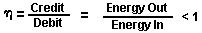

The energy output of Component I is an alternating current passing into a highly non-linear load, i.e., the water solution. This alternating current generator (Component I) is so designed that at peak load it is in resonance (Components I, II, III), and the vector diagrams show that the capacitive reactance, and the inductive reactance are almost exactly 180° out of phase, so that the net power output is reactive, and the dissipative power is very small. This design insures minimum power losses across the entire output system. In the experiments which are now to be described the entire emphasis was placed on achieving the maximum gas yield (credit) in exchange for the minimum applied energy (debit).

The most precise way to measure the applied energy to Components II and III is to measure the Power, P, in Watts, W. This was done by precision measurements of the volts across Component II as root mean square (rms) volts; and the current flowing in the system as rms amperes. Precisely calibrated instruments were used to take these two measurements. A typical set of experiments (using water in the form of 0.9% saline solution = 0.1540 molar concentration) to obtain high efficiency hydrolysis gave the following results:
ms Current = 25 mA to 38 mA (0.025 A to 0.038 A)
rms Volts = 4 Volts to 2.6 Volts
The resultant ratio between current and voltage is dependent on many factors, such as the gap distance between the central and ring electrodes, dielectric properties of the water, conductivity properties of the water, equilibrium states, isothermal conditions, materials used, and even the presence of clathrates. The above current and voltage values reflect the net effect of various combinations of such parameters. The product of rms current, and rms volts is a measure of the power, P in watts:
P = I x E = 25 mA x 4.0 volts = 100 mW (0.1 W)
P = I x E = 38 mA x 2.6 volts = 98.8 mW (0.0988 W)
At these power levels (with load), the resonant frequency of the system is 600 Hz (plus or minus 5 Hz) as measured on a precision frequency counter. The wave form was monitored for harmonic content on an oscilloscope, and the nuclear magnetic relaxation cycle was monitored on an X-Y plotting oscilloscope in order to maintain the proper hysteresis loop figure. All experiments were run so that the power in Watts, applied through Components I, II, and III ranged between 98.8 mW to 100 mW. Since, by the International System of Units --- 1971 (SI), One-Watt-second (Ws) is exactly equal to One Joule (J), the measurements of efficiency used these two yardsticks (1 Ws = 1 J) for the debit side of the measurement.

The energy output of the system is, of course, the two gases, hydrogen (H₂) and oxygen (1/2O₂), and this credit side was measured in two laboratories, on two kinds of calibrated instruments, namely, a Gas Chromatography Machine, and, a Mass Spectrometer Machine.

The volume of gases, H₂ and (1/2)O₂, was measured as produced under standard conditions of temperature and pressure in unit time, i.e., in ccs per minute (cc/min), as well as the possibly contaminating gases, such as air oxygen, nitrogen and argon; carbon monoxide, carbon dioxide, water vapour, etc.

The electrical, and gas, measurements were reduced to the common denominator of Joules of energy so that the efficiency accounting could all be handled in common units. The averaged results from many experiments follow. The Standard Error between different samples, machines, and locations is plus or minus 10%, and only the mean was used for all the following calculations.

Section 5:
Endergonic Decomposition of Liquid Water;
Thermodynamic efficiency for the endergonic decomposition of saline liquid water into gases under standard atmosphere (754 to 750 m.m. Hg), and standard isothermal conditions @ 25^{O}C. = 77^{O}F. = 298.16^{O}K., according to the following reaction:

H₂O(1) → H₂ (g) + (1/2)O₂ (g) + .Δ.G 56.620 KCal/mole

As already described, .Δ.G is the Gibbs function (Fig.14B). A conversion of Kcal to the common units, Joules, by the formula, One Calorie = 4.1868 Joules was made.

.Δ.G = 56.620 Kcal x 4.1868 J = 236,954 J/mol of H₂O (1) where, 1 mole is 18 gms.

.Δ.G = the free energy required to yield an equivalent amount of energy from H₂O in the form of the gases, H₂ and (1/2)O₂.

To simplify the calculations, the energy required to produce 1.0 cc of H₂O as the gases, H₂ and (1/2)O₂ was determined. There are (under standard conditions) 22,400 cc = V, of gas in one mole of H₂O. Therefore:
The electrical energy required to liberate 1.0 cc of the H₂O gases (where H₂ = 0.666 parts, and (1/2)O₂ = 0.333 parts, by volume) from liquid water is then determined. Since P = 1 Ws = 1 Joule, and V=1.0 cc of gas = 10.5783 Joules, then:

PV = 1 x 10.5783 J = 10.5783 Ws

Since the experiments were run at 100 mW (0.1 W) applied to the water sample in Component II, III, for 30 minutes, the ideal (100% efficient) gas production at this total applied power level was calculated.
0.1 Ws x 60 sec x 30 min = 180.00 Joules (for 30 min)
The total gas production at Ideal 100% efficiency is,
180.00 J / 10.5783 J/cc = 17.01 cc H₂O (g)
The amount of hydrogen present in the 17.01 cc H₂O (g) was then calculated.
17.01 cc H₂O (gas) x 0.666 H₂ (g) = 11.329 cc H₂ (g)
17.01 cc H₂O (g) x 0.333 (1/2)O₂ (g) = 5.681 cc (1/2)O₂ (g)
Against this ideal standard of efficiency of expected gas production, the actual amount of gas produced was measured under: (1) standard conditions as defined above (2) 0.1 Ws power applied over 30 minutes. In the experiments, the mean amount of H₂ and (1/2)O₂ produced, as measured on precision calibrated GC, and MS machines in two different laboratories, where the S.E. is +/-10%, was,
______________________________________
Measured Mean = 10.80 cc H₂ (g)
Measured Mean = 5.40 cc (1/2)O₂ (g)
Total Mean = 16.20 cc H₂O(g)
______________________________________

The ratio, ε, between the ideal yield, and measured yield is:

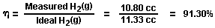

Section 6:
Energy Release;
The total energy release (as heat, or electricity) from an exergonic reaction of the gases, H₂ and O₂, is given by:

It is possible (Penner, Op. Cit., p.128) to get a total heat release, or total conversion to electricity in a fuel cell, in the above reaction when the reactants are initially near room temperature (298.16^{O}K.), and the reactant product (H₂O) is finally returned to room temperature. With this authoritative opinion in mind, it is desirable to determine the amount of energy released (ideal) from the exergonic experiment. The total energy of 1.0 cc of H₂O (1), as above is:

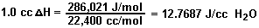

for H₂ = 12.7687 x 0.666 = 8.509 J/0.66 cc H₂ for O₂ = 12.7687 x 0.333 = 4.259 J/0.33 cc (1/2)O₂ The energy produced from the gases produced in the experiments in an exergonic reaction was:

16.20 cc H₂O (g) x 12.7687 J/cc H₂O = 206,8544 J.

The overall energy transaction can be written as:

In practical bookkeeping terms the balance of debits and credits, n = (-.Δ.H) - (+.Δ.G), so:

n = 206.8544 J - 180.0 = + 26.8544 J (surplus).

Since, in the invention, the gas is produced where and when needed, there is no additional cost accounting for liquefaction, storage, or transportation of the hydrogen fuel, and the oxygen oxidant. Therefore, the practical efficiency, is:

In practical applications, the energy output (exergonic) of the Component II System can be parsed between the electrical energy required to power the Component I System, as an isothermal closed loop; while the surplus of approximately 15% can be shunted to an engine (heat, electrical, battery, etc.) that has a work load. Although this energy cost accounting represents an ideal model, it is believed that there is enough return (approximately 15%) on the capital energy investment to yield a net energy profit that can be used to do useful work.

CONCLUSION:

From the foregoing disclosure it will be appreciated that the achievement of efficient water splitting through the application of complex electrical waveforms to energised water molecules, i.e. tetrahedral molecules having bonding angles of 109°28', in the special apparatus described and illustrated, will provide ample and economical production of hydrogen gas and oxygen gas from readily available sources of water. It is to be understood, that the specific forms of the invention disclosed and discussed herein are intended to be representative and by way of illustrative example only, since various changes may be made therein without departing from the clear and specific teachings of the disclosure. Accordingly, reference should be made to the following appended claims in determining the full scope of the method and apparatus of the present invention.
SHIGETA HASEBE

US Patent 4,105,528 8th August 1978 Inventor: Shigeta Hasebe

APPARATUS FOR DECOMPOSITION OF AQUEOUS LIQUID

Please note that this is a re-worded excerpt from this patent. This patent describes an electrolysis system which it is claimed has demonstrated ten times the efficiency that Faraday considered to be the maximum possible.

ABSTRACT
An apparatus for decomposition of liquid, in which spiral negative and positive electrodes are arranged close together but not touching. These two electrodes are supplied with power through external terminals and the electrolyte is caused to flow between the negative and positive electrodes for the electrolysis between two electrodes under the function of the potential magnetic field formed by the coil current which is generated by the electrodes with active movement of an electrolytic ion so that the electrolysis of water takes place smoothly under the spin functions of the atom and electron.

BACKGROUND AND SUMMARY OF THE INVENTION
This invention relates to an apparatus for decomposition of liquid where a flowing electrolyte is subjected to electrolysis for the production of gases.

As is well known, water is composed of hydrogen atoms and oxygen atoms. When water is sufficiently magnetised, each constitutive atom is also weakly magnetised to rotate the elementary particle in a regular direction. This rotation of the elementary particle is generally called "spin". That is, the spin function is caused by an electron, atomic nucleus, atom and even by the molecule. When a negative electrode is immersed in the electrolyte - Sodium Hydroxide (“lye”) solution - with a view to applying a voltage to it in order to cause the elementary particle to react with the electric field, the coupling state of the hydrogen with the oxygen is varied and the electrolysis is facilitated by the spin.

In the present invention, spiral negative and positive electrodes are arranged close together but not touching and these two electrodes are supplied with power through external terminals and the electrolyte is caused to flow between the negative and positive electrodes. Thus, the electrolyte is subjected to the electrolysis between two electrodes while within a magnetic field formed by the coil current which is generated by the electrodes with active movement of an electrolytic ion (Na⁺, OH⁻) so that the electrolysis of water takes place smoothly under the spin functions of the atom and electron.

It has been confirmed that the rate of the electrolysis of water using this invention is approximately 10 or more times (approximately 20 times when calculated) than that produced by conventional electrolysis.

The design of the electrolytic cell of this invention is such that the electrolyte flowing through the supply ports provided at the lower portion of the electrolytic cell is subjected to the magnetic field produced by a permanent magnet and the electrodes cause it to be further subjected to magnetic and electric fields which cause it to obtain a sufficient spin effect.

It is, therefore, a general object of the invention to provide a novel apparatus for decomposition of liquid in which an electrolyte (NaOH) solution is subjected to magnetic fields to cause electrolysis assisted by the spin of the water molecules which produces a great amount of gas with less consumption of electrical energy.

A principal object of the invention is to provide an apparatus for decomposition of liquid which has a liquid circulating system for the separation of gas and liquid in which positive and negative spiral electrodes are arranged across the flow path of the liquid and the opposite ends of the electrodes being provided with magnetic materials to augment the effect caused by the applied voltage across a liquid passing through a magnetic field caused by the positive and negative spiral electrodes, thereby to promote generation and separation of cat-ions and an-ions with a high efficiency in production of a large quantity of gases.

Other objects and advantages of the present invention will become apparent through the detailed description which follows.

BRIEF DESCRIPTION OF THE DRAWINGS
The invention will be described more in detail in the following with reference to the accompanying drawings, wherein:

Fig.1 is a partially cross-sectional schematic elevation of an apparatus in accordance with the invention;

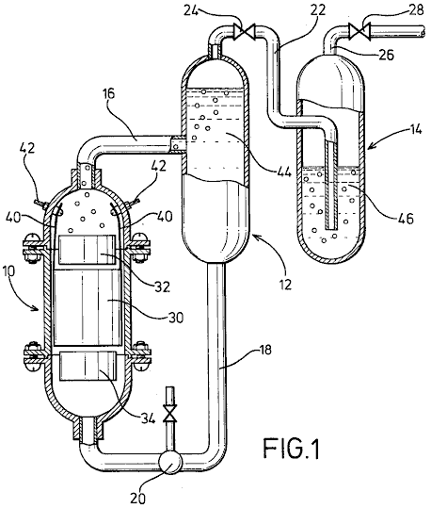

Fig.2 is a perspective view of electrodes arranged in accordance with the invention;

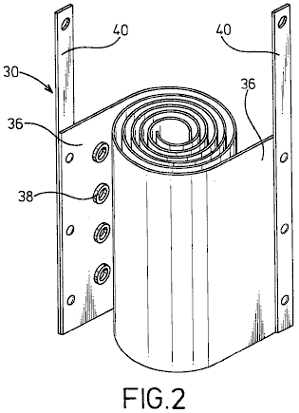

Fig.3 is a plan view of electrodes with magnetic materials.

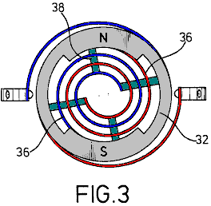

DESCRIPTION OF THE PREFERRED EMBODIMENT

In Fig.1, an electrolysis cell 10, a gas-liquid separation tank 12 and a gas-washing tank 14 are vertically arranged as shown with the electrolytic cell 10 being positioned a little lower than the tanks.

Cell 10 and tanks 12 and 14 are connected together by a delivery pipe 16 which connects the top of the electrolytic cell 10 with the middle of the gas-liquid separation tank 12. A feed-back pipe 18 containing a pump 20, is provided to connect the bottom of the gas-liquid separation tank 12, with the bottom of the electrolytic cell 10. Also provided is pipe 22, which runs from the top of the gas-liquid separation tank 12 through a valve 24 to the bottom of the gas-washing tank 14. A drain pipe 26, provided with a valve 28, is taken from the top of the gas-washing tank 14.

In the electrolytic cell 10, positive and negative spiral electrodes 30 of diameters suited to the internal diameter of the electrolytic cell 10 are arranged coaxially. At the upper and lower parts of the spiral electrodes 30 are arranged magnet rings 32 and 34 made from ferrite or similar material, positioned so that North and South poles are opposite one another to create a magnetic field which is at right angles to the axis of the electrolytic cell.

Electrodes 30 are composed of two metal strips 36 which are wound into spiral shapes with cylindrical insulating spacers 38 made of rubber or a similar material, placed between them and attached to the surface of the metal strips 36. From the metal strips 36, wires 40, are taken to the positive and negative power supply terminals, via connectors provided in the inner wall of the electrolytic cell.

The electrolytic cell 10 and the gas-liquid separation tank 12 are filled with a electrolyte 44 which is circulated by the pump 20, while the gas-washing tank 14 is filled with a washing liquid 46 to such a level that gases gushing out of the conduit 22 are thoroughly washed.

The apparatus of the present invention may be well be used for the electrolysis of flowing water for the production of hydrogen gas and oxygen gas at a high efficiency. That is to say, the electrolytic cell 10 and the gas-liquid separation tank 12 are filled with the electrolyte 44 which is caused by pump 20 to flow through a magnetic field in an vortex path in which positive and negative magnetic poles N, S of the magnets 32 and 34 face each other to produce a transverse field, and through the metal plates 36 of the vortical electrodes 30 to generate an orientation for the electrical migration of cat-ions and an-ions, causing an increased gas separation rate and enhancement of the electrolysis.

In particular, the flowing oxygen gas serves to facilitate an aeration of the electrolyte since it has varying magnetic effects as it passes through the magnetic field. The spiral electrodes 30 of this invention, create a remarkable increase in the rate of electrolysis. This is caused by the continuously decreasing space between the electrodes 30 which causes the flow velocity to increase as the flow progresses along its path. This causes turbulence which instantly removes bubbles of gas from the surface of the electrodes, allowing fresh ions full contact with the metal surfaces, thus raising the efficiency of the cell.

The spiral coiling of the electrodes also enables a very desirable reduction in the size of the cell, while increasing the electrode area and improving its contact with the electrolyte 44. There is also a relatively short migration distance of ions which also promotes rapid gas production. On the other hand, insulating spacers 38 interposed between the metal strips 36 serves to create the desired turbulence of the electrolyte passing through the cell.

The liquid circulating system for separation of gas and liquid requires no other driving unit except the circulation pump 20 to achieve separation of gas and liquid by utilising differences in water heads between cell 10 and tanks 12 and 14. In other words, a flow of gas-liquid mixture supplied from electrolytic cell 10 is fed into the gas-liquid separation tank 12 where, due to the difference in buoyancy of gases and liquid, the gas rises and is fed into the gas-washing tank 14 while the liquid moves down and is returned to the electrolytic cell 10. The washing tank 14 is filled with any convenient washing liquid 46 so that the gases gushing out of conduit 22 are thoroughly washed and fed into the drain pipe 26. Thus, the apparatus may be constructed at reduced cost and without any complexity.

As described earlier, the magnets 32 and 34 provide positive and negative magnetic poles N, S which are confronted in the annular wall for facilitating an alignment between the cross section of the flow-path of the liquid and the annular portion of the magnets 32 and 34 and a generation of a magnetic field in a direction perpendicular to that of the liquid flow, so that the liquid is forced to flow through the magnetic field.

Experimental data | Value
Room temperature | 20⁰ Centigrade
Atmospheric pressure | 1003 millibars
Electrolyte temperature | 25⁰ Centigrade
Humidity | 43%
Voltage | 2.8 Volts
Current | 30 Amps
Hydroxy gas production rate | 116 cc/sec.
Hydrogen production per Coulomb (1A x 1 sec.) | 2.6 cc.
Oxygen production per Coulomb | 1.3 cc.

The rate of generation shown by these figures is over 20 times that which could be obtained by standard Faraday electrolysis.

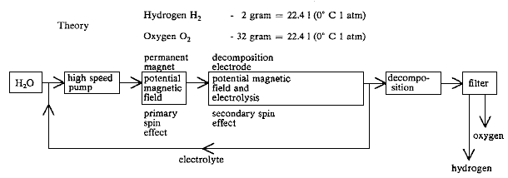

While a preferred embodiment of the invention has been illustrated by way of example in the drawings and particularly described, it will be understood that various modifications may be made in the construction and that the invention is no way limited to the embodiments shown.
STEPHEN CHAMBERS (Xogen Power Inc.)

US Patent 6,126,794 16th July 2002 Inventor: Stephen Chambers

AN APPARATUS FOR PRODUCING ORTHOHYDROGEN AND/OR PARAHYDROGEN

This patent describes an electrolyser system capable of running a small internal combustion engine directly from water alone.

ABSTRACT
An apparatus for producing orthohydrogen and/or parahydrogen. The apparatus includes a container holding water and at least one pair of closely-spaced electrodes arranged within the container and submerged in the water. A first power supply provides a particular first pulsed signal to the electrodes. A coil may also be arranged within the container and submerged in the water if the production of parahydrogen is also required. A second power supply provides a second pulsed signal to the coil through a switch to apply energy to the water. When the second power supply is disconnected from the coil by the switch and only the electrodes receive a pulsed signal, then orthohydrogen can be produced. When the second power supply is connected to the coil and both the electrodes and coil receive pulsed signals, then the first and second pulsed signals can be controlled to produce parahydrogen. The container is self-pressurised and the water within the container requires no chemical catalyst and yet can produce the orthohydrogen and/or parahydrogen efficiently. Heat is not generated, and bubbles do not form on the electrodes.

BACKGROUND OF THE INVENTION
Conventional electrolysis cells are capable of producing hydrogen and oxygen from water. These conventional cells generally include two electrodes arranged within the cell which apply energy to the water to thereby produce hydrogen and oxygen. The two electrodes are conventionally made of two different materials.

However, the hydrogen and oxygen generated in the conventional cells are generally produced in an inefficient manner. That is, a large amount of electrical power has to be applied to the electrodes in order to produce the hydrogen and oxygen. Moreover, a chemical catalyst such as sodium hydroxide or potassium hydroxide must be added to the water to separate hydrogen or oxygen bubbles from the electrodes. Also, the produced gas must often be transported to a pressurised container for storage, because conventional cells produce the gases slowly. Also, conventional cells tend to heat up, creating a variety of problems, including boiling of the water. In addition, conventional cells tend to form gas bubbles on the electrodes which act as electrical insulators and reduce the efficiency of the cell.

Accordingly, it is extremely desirable to produce a large amount of hydrogen and oxygen with only a modest amount of input power. Furthermore, it is desirable to produce the hydrogen and oxygen with "regular" tap water and without any additional chemical catalyst, and to operate the cell without the need for an additional pump to pressurise it. It is also desirable to construct both of the electrodes from the same material. It is also desirable to produce the gases quickly, and without heat, and without bubbles forming on the electrodes.

Orthohydrogen and parahydrogen are two different isomers of hydrogen. Orthohydrogen is that state of hydrogen molecules in which the spins of the two nuclei are parallel. Parahydrogen is that state of hydrogen molecules in which the spins of the two nuclei are antiparallel. The different characteristics of orthohydrogen and parahydrogen lead to different physical properties. For example, orthohydrogen is highly combustible whereas parahydrogen is a slower burning form of hydrogen. Thus, orthohydrogen and parahydrogen can be used for different applications. Conventional electrolytic cells make only orthohydrogen and parahydrogen. Parahydrogen is difficult and expensive to make by conventional means.

Accordingly, it is desirable to produce orthohydrogen and/or parahydrogen cheaply within a cell and to be able to control the amount of either produced by that cell. It is also desirable to direct the produced orthohydrogen or parahydrogen to a coupled machine in order to provide a source of energy for it.

SUMMARY OF THE INVENTION
It is therefore an object of the present invention to provide a cell having electrodes and containing water which produces a large amount of hydrogen and oxygen in a relatively small amount of time, and with a modest amount of input power, and without generating heat.

It is another object of the present invention for the cell to produce bubbles of hydrogen and oxygen which do not bunch around or on the electrodes.

It is also an object of the present invention for the cell to operate properly without a chemical catalyst. Thus, the cell can be run using ordinary tap water. This has the advantage of avoiding the additional costs required for producing the chemical catalyst.

It is another object of the present invention for the cell to be self-pressurising. Thus avoiding the need for an additional pump.

It is another object of the present invention to provide a cell having electrodes made of the same material. This material can, for example, be stainless steel. Thus, the construction of the cell can be simplified and construction costs reduced.

It is another object of the present invention to provide a cell which is capable of producing orthohydrogen, parahydrogen or a mixture thereof and can be set so as to produce any relative amount of orthohydrogen and parahydrogen desired by the user.

It is another object of the invention to couple the gaseous output of the cell to a device, such as an internal combustion engine, so that the device may be powered from the gas supplied to it.

These and other objects, features, and characteristics of the present invention will be more apparent upon consideration of the following detailed description and appended claims with reference to the accompanying drawings, wherein the same reference numbers have been used to indicate corresponding parts in the various figures.

Accordingly, the present invention includes a container for holding water. At least one pair of closely-spaced electrodes are positioned within the container and submerged under the water. A first power supply provides a particular pulsed signal to the electrodes. A coil is also arranged in the container and submerged under the water. A second power supply provides a particular pulsed signal through a switch to the electrodes.

When only the electrodes receive a pulsed signal, then orthohydrogen can be produced. When both the electrodes and coil receive pulsed signals, then parahydrogen or a mixture of parahydrogen and orthohydrogen can be produced. The container is self pressurised and the water within the container requires no chemical catalyst to produce the orthohydrogen and/or parahydrogen efficiently.
BRIEF DESCRIPTION OF THE DRAWINGS
Fig.1 is a side view of a cell for producing orthohydrogen including a pair of electrodes according to a first embodiment of the present invention;
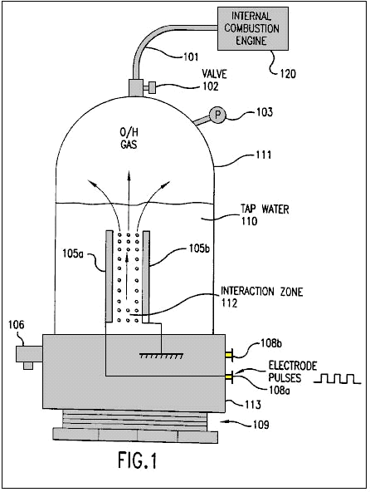
Fig.2 is a side view of a cell for producing orthohydrogen including two pairs of electrodes according to a second embodiment of the present invention;
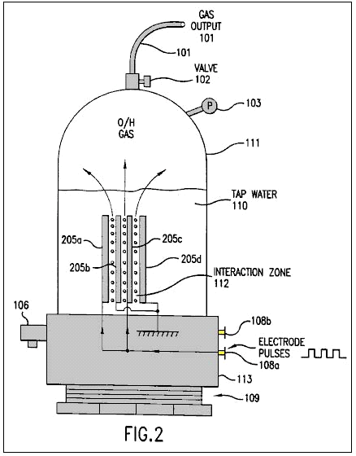
Fig.3 is a side view of a cell for producing orthohydrogen including a pair of cylindrical-shaped electrodes according to a third embodiment of the present invention;
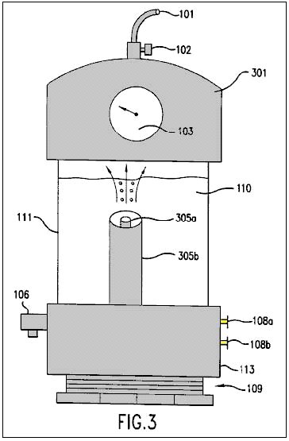
Fig.4a is a diagram illustrating a square wave pulsed signal which can be produced by the circuit of Fig.5 and applied to the electrodes of Fig.1 through Fig.3;

Fig.4b is a diagram illustrating a saw tooth wave pulsed signal which can be produced by the circuit of Fig.5 and applied to the electrodes of Fig.1 through Fig.3;

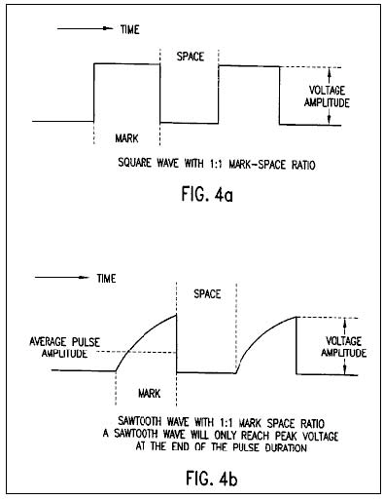

Fig.4c is a diagram illustrating a triangular wave pulsed signal which can be produced by the circuit of Fig.5 and applied to the electrodes of Fig.1 through Fig.3;
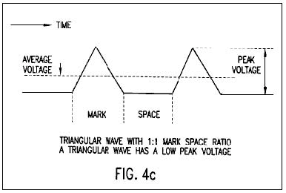
Fig.5 is an electronic circuit diagram illustrating a power supply which is connected to the electrodes of Fig.1 through Fig.3;

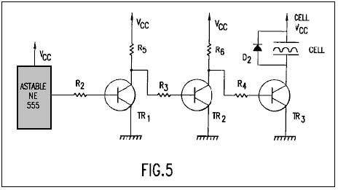

Fig.6 is a side view of a cell for producing at least parahydrogen including a coil and a pair of electrodes according to a fourth embodiment of the present invention;

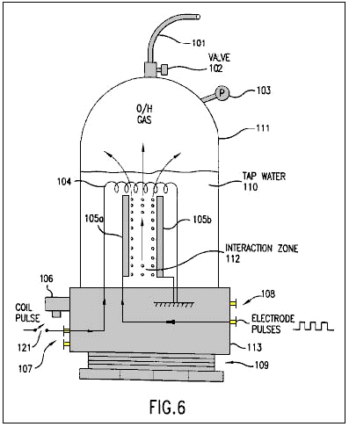

Fig.7 is a side view of a cell for producing at least parahydrogen including a coil and two pairs of electrodes according to a fifth embodiment of the present invention;
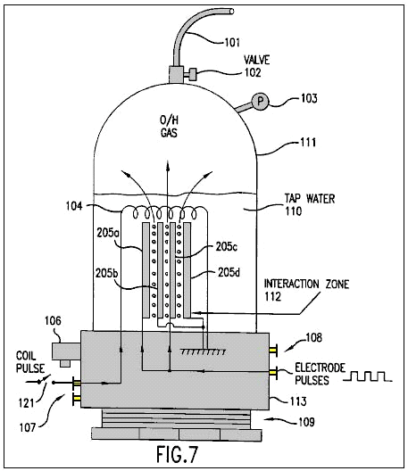
Fig.8 is a side view of a cell for producing at least parahydrogen including a coil and a pair of cylindrical-shaped electrodes according to a sixth embodiment of the present invention; and
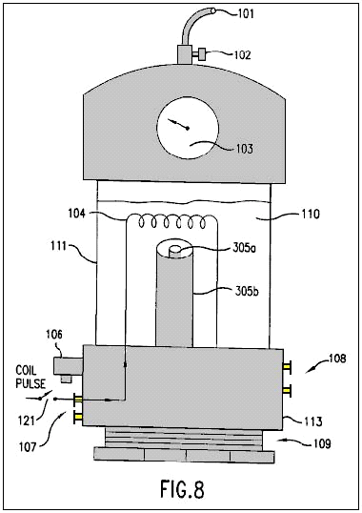
Fig.9 is as electronic circuit diagram illustrating a power supply which is connected to the coil and electrodes of Fig.6 through Fig.8.
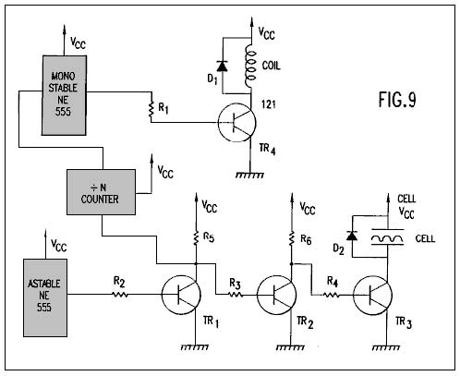

DETAILED DESCRIPTION OF THE PREFERRED EMBODIMENT

Fig.1 shows a first embodiment of the present invention including a cell for producing hydrogen and oxygen. As will be discussed below in conjunction with Figs.6-8, the production of parahydrogen requires an additional coil not shown in Fig.1. Thus, the hydrogen produced by the first embodiment of Fig.1 is orthohydrogen.

The cell includes a closed container 111 which is closed at its bottom portion by threaded plastic base 113 and screw thread base 109. The container 111 can be made of, for example, Plexiglas and might have a height of 430 mm and a width of 90 mm. The container 111 holds tap water 110.

The cell also includes a pressure gauge 103 to measure the pressure within the container 111. An outlet valve 102 is connected to the top of the container 111 to permit any gas within the container to escape into an output tube 101.

The cell also includes an over-pressure valve 106 connected to a base 113. The valve 106 provides a safety function by automatically releasing the pressure within the container 111 if the pressure exceeds a predetermined threshold. For example, the valve 106 may be set so that it will open if the pressure in the container exceeds 75 p.s.i. Since the container 111 is built to withstand a pressure of about 200 p.s.i., the cell is provided with a large safety margin.

A pair of electrodes 105a and 105b are arranged within the container 111. These electrodes are submerged under the top level of the water 110 and define an interaction zone 112 between them. The electrodes are preferably made from the same material, such as stainless steel.

In order to produce an optimum amount of hydrogen and oxygen, an equal spacing between the electrodes 105a and 105b must be maintained. Moreover, it is preferable to minimise the spacing between the electrodes. However, the electrodes cannot be positioned excessively close together, because arcing between the electrodes would occur. It has been determined that a spacing of 1 mm is the optimum spacing for producing hydrogen and oxygen. Spacing up to 5 mm can work effectively, but spacing above 5 mm has not worked well, except with excessive power.

Hydrogen and oxygen gas may be output through tube 101 to a device 120 which can use those gases, for example an internal combustion engine, such as shown in Fig.1. Instead of an internal combustion engine, device 120 may be any device using hydrogen and oxygen, including a reciprocating piston engine, a gas turbine engine, a stove, a heater, a furnace, a distillation unit, a water purification unit, a hydrogen/oxygen jet, or other device using the gases. With an adequately productive example of the present invention, any such device 120 using the output gases can be run continuously without the need for storing dangerous hydrogen and oxygen gases.

Fig.2 shows a second embodiment of the present invention which includes more than one pair of electrodes 205a-d. The spacing between the electrodes is less than 5 mm as in the embodiment of Fig.1. While Fig.2 shows only one additional pair of electrodes, it is possible to include many more pairs (e.g., as many as 40 pairs of electrodes) within the cell. The rest of the cell illustrated in Fig.2 remains the same as that illustrated in Fig.1. The multiple electrodes are preferably flat plates closely spaced, parallel to each other.

Fig.3 illustrates a cell having a cylindrically shaped electrodes 305a and 305b. The outer electrode 305b surrounds the coaxially aligned inner electrode 305a. The equal spacing of the electrodes 305a and 305b is less than 5 mm and the interactive zone is coaxially arranged between the two electrodes. While Fig.3 illustrates the top portion of the container 111 being formed by a plastic cap 301, it will be appreciated by those skilled in the art, that the cap 301 may be used in the embodiments of Fig.1 and Fig.2 and the embodiment of Fig.3 can utilise the same container 111 illustrated in Figs.1-2. As suggested by Fig.3, the electrodes can be almost any shape such as flat plates, rods, tubes or coaxial cylinders.

The electrodes 105a and 105b of Fig.1 (or electrodes 205a-d of Fig.2 or electrodes 305a and 305b of Fig.3) are respectively connected to power supply terminals 108a and 108b so that they can receive a pulsed electrical signal from a power supply. The pulsed signal can be almost any waveform and have a variable current level, voltage level, frequency and mark-space ratio (i.e., a ratio of the duration of a single pulse to the interval between two successive pulses). For example, the power supply providing power to the electrodes can be a mains 110 volts to a 12 volt supply or a car battery.

Fig.4a, Fig.4b and Fig.4c illustrate a square wave, a saw tooth wave and a triangular wave, respectively which can be applied to the electrodes 105a and 105b (or 205a-d or 305a, 305b) in accordance with the present invention. Each of the waveforms illustrated in Figs.4a-4c has a 1:1 mark-space ratio. As shown in Fig.4b, the saw tooth wave will only reach a peak voltage at the end of the pulse duration. As shown in Fig.4c, the triangular wave has a low peak voltage. It has been found that optimal results for producing hydrogen and oxygen in the present invention are obtained using a square wave.

After initiation of the pulsed signal from the power supply, the electrodes 105a and 105b continuously and almost instantaneously generate hydrogen and oxygen bubbles from the water 110 in the interaction zone 112. Moreover, the bubbles can be generated with only minimal heating of the water or any other part of the cell. These bubbles rise through the water and collect in the upper portion of the container 111.

The generated bubbles are not bunched around or on the electrodes 105a and 105b and thus readily float to the surface of the water. Therefore, there is no need to add a chemical catalyst to assist the conduction of the solution or reduce the bubble bunching around or on the electrodes. Thus, only tap water is needed for generation of the hydrogen and oxygen in the present invention.

The gases produced within the container are self-pressurising (i.e., pressure builds in the container by the production of gas, without an air pump). Thus, no additional pump is needed to be coupled to the container 111 and the produced gases do no need to be transported into a pressurised container.

The power supply in the present invention is required to provide a pulsed signal having only 12 volts at 300 mA (3.6 watts). It has been found that an optimal amount of hydrogen and oxygen has been produced when the pulsed signal has mark-space ratio of 10:1 and a frequency of 10-250 KHz. Using these parameters, the prototype cell of the present invention is capable of producing gas at the rate of 1 p.s.i. per minute. Accordingly, the cell of the present invention is capable of producing hydrogen and oxygen in a highly efficient manner, quickly and with low power requirements.

As noted above, the hydrogen produced by the embodiments of Figs.1-3 is orthohydrogen. As is well understood by those skilled in the art, orthohydrogen is highly combustible. Therefore, any orthohydrogen produced can be transported from the container 111 through valve 102 and outlet tube 101 to be used by a device such as an internal combustion engine.

The present invention, with sufficient electrodes, can generate hydrogen and oxygen fast enough to feed the gases directly into an internal combustion engine or turbine engine, and run the engine continuously without accumulation and storage of the gases. Hence, this provides for the first time a hydrogen/oxygen driven engine that is safe because it requires no storage of hydrogen or oxygen gas.

Fig.5 illustrates an exemplary power supply for providing D.C. pulsed signals such as those illustrated in Figs.4a-4c to the electrodes illustrated in Figs.1-3. As will be readily understood by those skilled in the art, any other power supply which is capable of providing the pulsed signals discussed above can be substituted.
The power supply illustrated in Fig.5 includes the following parts, components and values:

The astable circuit is connected to the base of transistor TR1 through resistor R2. The collector of transistor TR1 is connected to voltage supply Vcc through resistor R5 and the base of transistor TR2 through resistor R3. The collector of transistor TR2 is connected to voltage supply Vcc through resistor R6 and the base of transistor TR3 through resistor R4. The collector of transistor TR3 is connect to one of the electrodes of the cell and diode D2. The emitters of transistors TR1, TR2 and TR3 are connected to ground. Resistors R5 and R6 serve as collector loads for transistors TR1 and TR2, respectively. The cell serves as the collector load for transistor TR3. Resistors R2, R3 and R4 ensure that transistors TR1, TR2 and TR3 are saturated. Diode D2 protects the rest of the circuit from any induced back emf within the cell.

The astable circuit is used to generate a pulse train at a specific time and with a specific mark-space ratio. This pulse train is provided to the base of transistor TR1 through resistor R2. Transistor TR1 operates as an invert switch. Thus, when the a stable circuit produces an output pulse, the base voltage of the transistor TR1 goes high (i.e. close to Vcc or logic 1). Hence, the voltage level of the collector of transistor TR1 goes low (i.e., close to ground or logic 0).

Transistor TR2 also operates as an inverter. When the collector voltage of transistor TR1 goes low, the base voltage of transistor TR2 also goes low and transistor TR2 turns off. Hence, the collector voltage of transistor TR2 and the base voltage of Transistor TR3 go high. Therefore, transistor TR3 turns on with the same mark-space ratio as the astable circuit. When the transistor TR3 is on, one electrode of the cell is connected to Vcc and the other is connected to ground through transistor TR3. Thus, the transistor TR3 can be turned on (and off) and therefore the transistor TR3 effectively serves as a power switch for the electrodes of the cell.

Figs.6-8 illustrate additional embodiments of the cell which are similar to the embodiments of Figs.1-3, respectively. However, each of embodiments of Figs.6-8 further includes a coil 104 arranged above the electrodes and power supply terminals 107 connected to the coil 104. The dimensions of coil 104 can be, for example, 5 x 7 cm and have, for example, 1500 turns. The coil 104 is submerged under the surface of the water 110.

The embodiments of Figs.6-8 further include an optional switch 121 which can be switched on or off by the user. When the switch 121 is not closed, then the cell forms basically the same structure as Figs.1-3 and thus can be operated in the same manner described in Figs.1-3 to produce orthohydrogen and oxygen. When the switch 121 is closed, the additional coil 104 makes the cell capable of producing oxygen and either (1) parahydrogen or (2) a mixture of parahydrogen and orthohydrogen.

When the switch 121 is closed (or not included), the coil 104 is connected through terminals 106 and the switch 121 (or directly connected only through terminals 106) to a power supply so that the coil 104 can a receive a pulsed signal. As will be discussed below, this power supply can be formed by the circuit illustrated in Fig.9.

When the coil 104 and the electrodes 105a and 105b receive pulses, it is possible to produce bubbles of parahydrogen or a mixture of parahydrogen and orthohydrogen. The bubbles are formed and float to the surface of the water 110 as discussed in Figs.1-3. When the coil is pulsed with a higher current, a greater amount of parahydrogen is produced. Moreover, by varying the voltage of the coil 104, a greater/lesser percentage of orthohydrogen/parahydrogen can be produced. Thus, by controlling the voltage level, current level and frequency (discussed below) provided to the coil 104 (and the parameters such as voltage level, current level, frequency, mark-space ratio and waveform provided to the electrodes 105a and 105b as discussed above) the composition of the gas produced by the cell can be controlled. For example, it is possible to produce only oxygen and orthohydrogen by simply disconnecting the coil 104. It is also possible to produce only oxygen and parahydrogen by providing the appropriate pulsed signals to the coil 104 and the electrodes 105a and 105b. All of the benefits and results discussed in connection with the embodiments of Figs.1-3 are equally derived from the embodiments of Figs.6-8. For example, the cells of Figs.6-8 are self-pressurising, require no-chemical catalyst, do not greatly heat the water 110 or cell, and produce a large amount of hydrogen and oxygen gases from a modest amount of input power, without bubbles on the electrodes.

A considerable amount of time must pass before the next pulse provides current to the coil 104. Hence, the frequency of the pulsed signal is much lower than that provided to the electrodes 105a and 105b. Accordingly, with the type of coil 104 having the dimensions described above, the frequency of pulsed signals can be as high as 30 Hz, but is preferably 17-22 Hz to obtain optimum results.

Parahydrogen is not as highly combustible as orthohydrogen and hence is a slower burning form of hydrogen. Thus, if parahydrogen is produced by the cell, the parahydrogen can be coupled to a suitable device such as a cooker or a furnace to provide a source of power or heat with a slower flame.

Fig.9 illustrates an exemplary power supply for providing D.C. pulsed signals such as those illustrated in Figs.4a-4c to the electrodes illustrated in Figs.6-8. Additionally, the power supply can provide another pulsed signal to the coil. As will be readily understood by those skilled in the art, any other power supply which is capable of providing the pulsed signals discussed above to the electrodes of the cell and the coil can be substituted. Alternatively, the pulsed signals provided to the electrodes and the coil can be provided by two separate power supplies.

The portion of the power supply (astable circuit, R2-R6, TR1-TR3, D2) providing a pulsed signal to the electrodes of the cell is identical to that illustrated in Fig.5. The power supply illustrated in Fig.9 further includes the following parts and their respective exemplary values:

The input of the ‘divide-by-N’ counter (hereinafter "the divider") is connected to the collector of transistor TR1. The output of the divider is connected to the monostable circuit and the output of the monostable circuit is connected to the base of transistor TR4 through resistor R1. The collector of transistor TR4 is connected to one end of the coil and a diode D1. The other end of the coil and the diode D1 are connected to the voltage supply Vcc. Resistor R1 ensures that TR4 is fully saturated. Diode D2 prevents any induced back emf generated within the coil from damaging the rest of the circuit. As illustrated in Figs.6-8, a switch 121 can also incorporated into the circuit to allow the user to switch between (1) a cell which produces orthohydrogen and oxygen, and (2) a cell which produces at least parahydrogen and oxygen.

The high/low switching of the collector voltage of transistor TR1 provides a pulsed signal to the divider. The divider divides this pulsed signal by N (where N is a positive integer) to produce a pulsed output signal. This output signal is used to trigger the monostable circuit. The monostable circuit restores the pulse length so that it has a suitable timing. The output signal from the monostable circuit is connected to the base of transistor TR4 through resistor R1 to switch transistor TR4 on/off. When transistor TR4 is switched on, the coil is placed between Vcc and ground. When the transistor TR4 is switched off, the coil is disconnected from the rest of the circuit. As discussed in conjunction with Figs.6-8, the frequency of pulse signal provided to the coil is switched at a rate preferably between 17-22 Hz; i.e., much lower than the frequency of the pulsed signal provided to the electrodes.

As indicated above, it is not required that the circuit (divider, monostable circuit, R1, TR4 and D1) providing the pulsed signal to the coil be connected to the circuit (astable circuit, R2-R6, TR1-TR3, D2) providing the pulsed signal to the electrodes. However, connecting the circuits in this manner provides an easy way to initiate the pulsed signal to the coil.

A working prototype of the present invention has been successfully built and operated with the exemplary and optimal parameters indicated above to generate orthohydrogen, parahydrogen and oxygen from water. The output gas from the prototype has been connected by a tube to the manifold inlet of a small one cylinder gasoline engine, with the carburettor removed, and has thus successfully run such engine without any gasoline:

CHARLES GARRETT

US Patent 2,006,676 2nd July 1935 Inventor: Charles H. Garrett

ELECTROLYTIC CARBURETTOR

Please note that this is a re-worded excerpt from this patent. It describes an electrolyser which Charles claimed was able to generate enough gas from hydrolysis of water, to be able to run a car engine without the use of any other fuel. It should be remembered that in Garrett’s day, car electrics were all 6-volt systems.

DESCRIPTION
This invention relates to carburettors and it has particular reference to an electrolytic carburettor by means of which water may be broken up into its hydrogen and oxygen constituents and the gases so formed suitably mixed with each other and with air.

Another object of the invention is to provide a means whereby the electrolyte level in the carburettor may be maintained at a more or less constant level regardless of fluctuations in water pressure at the water inlet of the carburettor.

Another object of the invention is to provide a means whereby the relative amount of air mixed with the hydrogen and oxygen may be regulated as desired.

Still another object of the invention is the provision of a means to prevent the loss of hydrogen and oxygen gases during periods in which these gases are not being drawn from the carburettor.

Still another object of the invention is the provision of a means whereby the hydrogen and oxygen resulting from electrolysis may be formed in separate compartments, and a further object of the invention is the provision of a means to periodically reverse the direction of current flow and thereby alternate the evolution of the gases in the separate compartments, to be intermingled at a later time.

With reference to the accompanying drawings: -

Figure 1 is a view in vertical section of one form of carburettor.

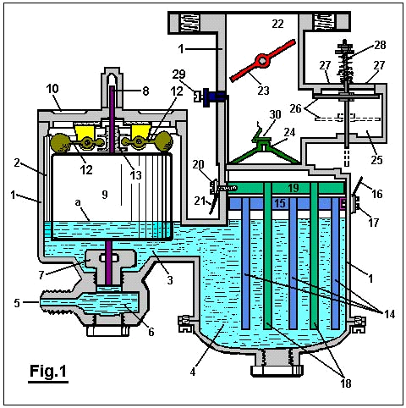

Figure 2 is a modified form.

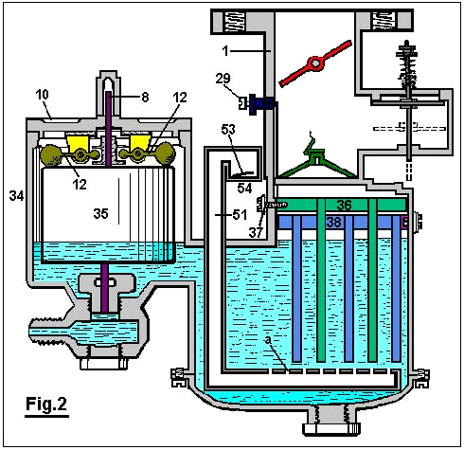

Figure 3 is a diagrammatic view of a pole changer, showing its actuating mechanism, and

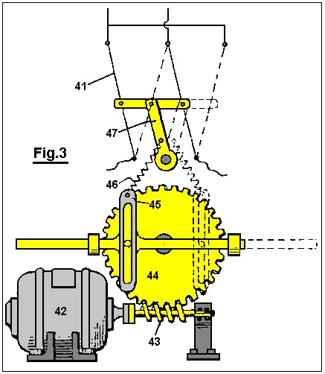

Figure 4 is a wiring diagram for the modified form of carburettor shown in Figure 2.

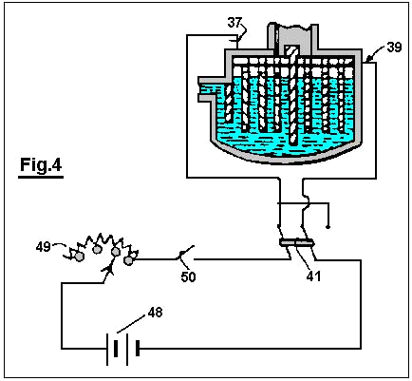

With reference to Fig.1: The reference numeral 1 designates the carburettor housing, which is preferably constructed of bakelite or other suitable insulating material. This housing is designed so as to divide the carburettor into a float chamber 2 and gas generating chamber 4, connected by a fluid passage 3.

Water under pressure is forced into the carburettor through an opening 5 which communicates with the float chamber 2 through the medium of the sediment chamber 6 and the needle valve orifice 7, which is closed by a needle valve 8 when the device is not in operation. A float 9 surrounds the needle valve 8 and is free to move vertically relative thereto. Descending from the cover 10 to the float chamber 2 are two ears 11, located at spaced intervals on opposite sides of the needle valve 8. The members 12 are pivoted to the ears 11, as shown. The weighted outer ends of the members 12 rest on top of the float 9, and their inner ends are received in an annular groove in the collar 13 which is rigidly attached to the needle valve 8.

Within the gas generating chamber 4, a series of spaced, descending plates 14 are suspended from a horizontal member 15 to which a wire 16 has electrical contact through the medium of the bolt 17, which extends inwards through housing 1 and is threaded into the horizontal member 15.
A second series of plates 18 is located between the plates 14 and attached to the horizontal member 19, and has electrical contact with the wire 20 through the bolt 21.

A gas passageway 22, in which a butterfly valve 23 is located, communicates with the gas generating chamber 4 through an orifice 24. An air inlet chamber 25 has communication with the gas passageway 22 above the orifice 24. A check valve 26 which opens downwards, controls the openings 27, and is held closed and inoperative by means of light spring 28.

An adjustable auxiliary air valve 29 is provided in the wall of the gas passageway 22, which air valve is closed by the butterfly valve 23 when the butterfly valve is closed, but communicates with the outside air when the butterfly valve is open.

The operation of the device is as follows :
The chambers 2 and 4 are first filled to the level 'a' with a solution of weak sulphuric acid (or other electrolyte not changed by the passage of current through it), and the opening 5 is connected to a tank of water (not shown).

The wire 16 is next connected to the positive pole of a storage battery or other source of direct current and the wire 20 to the negative pole. Since the solution within the carburettor is a conductor of electricity, current will flow through it and hydrogen will be given off from the negative or cathode plates 18 and oxygen from the positive or anode plates 14.

The butterfly valve 23 is opened and the gas passageway 22 brought into communication with a partial vacuum. Atmospheric pressure acting on the top of the check valve 26 causes it to be forced downwards as shown in dotted lines. The hydrogen and oxygen liberated from the water at the plates 18 and 14 are drawn upwards through the orifice 24 covered by the check valve 30 where they are mixed with air entering through the openings 27 and through the auxiliary air valve 29.

When it is desired to reduce the flow of hydrogen and oxygen from the plates 18 and 14, the current flowing through the device is reduced, and when the current is interrupted the flow ceases. When the butterfly valve 23 is moved to its ‘closed’ position, the check-valve 26 is automatically closed by the spring 28. Any excess given off during these operations is stored in the space above the fluid where it is ready for subsequent use.
Water is converted into its gaseous constituents by the device herein described, but the dilute sulphuric acid or other suitable electrolyte in the carburettor remains unchanged, since it is not destroyed by electrolysis, and the parts in contact therewith are made of bakelite and lead or other material not attacked by the electrolyte.

The structure shown in Fig.2 is substantially the same as that shown in Fig.1 with the exception that the modified structure embraces a larger gas generating chamber which is divided by means of an insulating plate 31 and is further provided with a depending baffle plate 32 which separates the gas generating chamber 33 from the float chamber 34 in which the float 35 operates in the same manner as in Fig.1. Moreover, the structure shown in Fig.2 provides a series of spaced depending plates 36 which are electrically connected to the wire 37, and a second series of similar plates 38 which are electrically connected to the wire 39 and are kept apart from the plates 36 by the insulating plate 31.

Gases generated on the surfaces of the plates 36 and 38 pass upward through the orifice 39a into the gas passageway 40 where they are mixed with air as explained in the description of Fig.1.

A pipe 51, bent as shown in Fig.2, passes downwards through the housing of the carburettor and has a series of spaced apertures 'a' in its horizontal portion beneath the plates 36 and 38. Check valve 53, with opens upwards, controls air inlet 54. When a partial vacuum exists in the chamber 33, air is drawn in through the opening 54 and then passes upwards through the apertures 'a'. This air tends to remove any bubbles of gas collecting on the plates 36 and 38 and also tends to cool the electrolyte. The check valve 53 automatically closes when a gas pressure exists within the carburettor and thereby prevents the electrolyte from being forced out of the opening 54.

In order to provide for alternate evolution of the gases from the plates 36 and 38, a pole changer 41, shown in Fig.3, is actuated periodically by the motor 42 which drives the worm 43 and the gear 44 and causes oscillations of the member 45 which is connected by a spring 46 to the arm 47, thereby causing the pole changer to snap from one position to the other.

In operation, the carburettor shown in Fig.2 is connected as shown in the wiring diagram of Fig.4. A storage battery 48 or other suitable source of direct current is connected to a variable rheostat 49, switch 50, pole changer 41 and to the carburettor as shown. Thus the rate of evolution of the gases can be controlled by the setting of the rheostat 49 and the desired alternate evolution of the gases in the compartments of the carburettor is accomplished by means of the periodically operated pole changer 41.

Manifestly, the construction shown is capable of considerable modification and such modification as is considered within the scope and meaning of the appended claims is also considered within the spirit and intent of the invention.
ARCHIE BLUE

US Patent 4,124,463 7th November 1978 Inventor: Archie H. Blue

ELECTROLYTIC CELL

Please note that this is a re-worded excerpt from this patent. It describes an electrolyser system where air is drawn through the electrolyte to dislodge bubbles from the electrodes.

ABSTRACT
In the electrolytic production of hydrogen and oxygen, air is pumped through the cell while the electrolysis is in progress so as to obtain a mixture of air, hydrogen and oxygen.

BACKGROUND AND BRIEF DESCRIPTION OF THE INVENTION
This invention relates to the production of gases which can be utilised primarily, but not necessarily, as a fuel.

To decompose water electrically, it is necessary to pass direct current between a pair of electrodes which are immersed in a suitable electrolyte. During such electrolysis, it is normal to place some form of gas barrier between the two electrodes, in order to prevent the gases produced forming an explosive mixture. However provided suitable precautions are taken, it has been found that the gases can be allowed to mix and can be fed into a storage tank for subsequent use. Because the gases when mixed form an explosive mixture, it is possible for the mixture to be utilised, for instance, as a fuel for an internal combustion engine. In such circumstances it is desirable that the gases should also be mixed with a certain proportion of air in order to control the explosive force which results when the gases are ignited.

One of the difficulties encountered with electrolysis is that bubbles of gas are liable to remain on the electrodes during the electrolysis thus effectively limiting the area of electrode which is in contact with the electrolyte and preventing optimum current flow between the electrodes. Because it is desirable that the gases evolved during the electrolysis be mixed with air, it is possible for air to be passed through the cell while electrolysis is in progress. The passage of air through the cell can be directed past the electrodes so as to pick up any gas bubbles on the electrodes.

Accordingly, the invention comprises an electrolytic cell with a gas tight casing, several electrodes supported on a central post within the cell, spaced apart and electrically insulated from each other, each alternative electrode being connected to a positive direct current source or a negative direct current source respectively and wherein the central post is in the form of a tube, one end of which is extended out of the cell and connected to a source of air under pressure, with the other end of the central post terminating in an air outlet below the electrodes. The cell also includes a gas outlet to carry the air forced into the cell through the central post and to exhaust the gases produced by electrolysis.

DETAILED DESCRIPTION OF THE INVENTION
Various forms of the invention will now be described with the aid of the accompanying drawings wherein:

Fig.1 is a diagrammatic elevational view partly in section of one form of the invention,
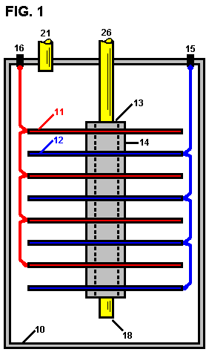

Fig.2 is a diagrammatic elevational view partly in section of a modified form of the invention,

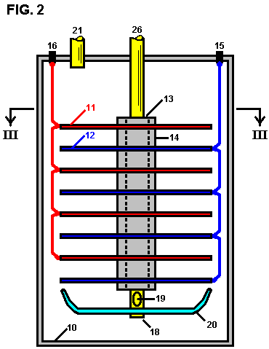

Fig.3 is a section along the line III--III of Fig.2.

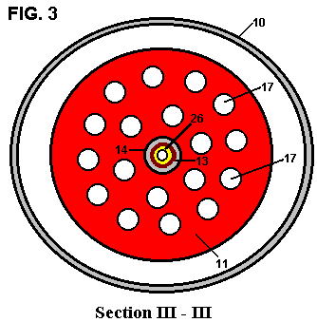

The cell as shown in Fig.1 comprises a gas-tight casing 10 which is formed from a material incapable of corrosion, such as plastic. Several cathode plates 11 and several anode plates 12 are supported within the cell on an electrically insulating central post 13, with the cathode plates and anode plates being spaced apart by means of insulating spacers 14. The anode plates 12 are all connected in parallel to a positive terminal post 15 while the cathode plates are all connected in parallel to the negative terminal post 16, these connections being indicated in dotted lines in the drawings. The cathode and anode plates are preferably in the form of discs made from a metal suited to the electrolyte, thus ensuring a satisfactory cell life. These plates may be shaped to conform with the shape of the walls of the cell which may be circular in cross section as indicated or any other desired shape.

The central post 26 is preferably in the form of a tube which extends out of the cell. The lower end of the tube 18 is open so that air can be pumped into the cell through the central post 26 and enter the cell via the lower end 18 where it will pass up through the electrolyte. This keeps the electrolyte in constant motion which assists in the rapid removal of any gas bubbles which may be adhering to the electrode plates.

In the modification shown in Fig.2 and Fig.3, each electrode plate is provided with holes 17. The central post 26 is also provided with at least one air hole 19 adjacent to its the lower end. A deflector plate 20 is also supported by the central post 26, this plate being dish shaped so as to deflect air issuing out of the air hole 19 up through the holes 17 in the electrodes. This further assists in dislodging any bubbles of gas clinging to the electrode plates.

The cell also includes a gas outlet 21 so that the air which enters the cell, together with the gases produced by electrolysis, can be taken out of the cell into a suitable storage tank (not shown in the drawings). If desired, such storage tank can be arranged to accept the gases under pressure and for this purpose the air pumped into the cell will be pumped in under the required pressure. A gas drier (not shown in the drawings) can also be interposed between the gas outlet 21 and the storage tank.

Although the electrolysis will naturally produce considerable heat, nevertheless it can be found advantageous to install a heater in the cell, preferably in the bottom of the cell, to assist and facilitate the warming up of the electrolyte so that the cell reaches its most efficient operating conditions as quickly as possible.

Preferably also, a current-control device should be employed so that the intensity of the electrolytic action can be controlled.

A mechanism may also be provided for the automatic replenishment of water within the cell as the level of the electrolytic drops during use.

While it is recognised that the mixing of hydrogen and oxygen will create a dangerous explosive mixture, nevertheless by carrying out the invention as described above, the risk of explosion is minimised. The gases produced can be utilised, for instance, as a fuel to power an internal combustion engine and for this purpose it is desirable, as already mentioned, to mix a proportion of air with the gases produced during electrolysis, so that when the mixture is ignited within the cylinder or cylinders of the engine, the explosive force so created can be of the desired amount.

While in the foregoing description reference is made to the utilisation of the mixed gases as a fuel, it will of course be understood that the gases can be separated for individual use.

